***INFORMATION GAP* DISCLOSURE OF HAZARDOUS TOXIC WASTE IN INDONESIA**

[Setianingtyas Honggowati](https://papers.ssrn.com/sol3/cf_dev/AbsByAuth.cfm?per_id=2261623)1, Djoko Suhardjanto2 , V.Wiratna Sujarweni3

1. Dosen Fakultas Ekonomi dan Bisnis, Universitas Sebelas Maret Surakarta
2. Guru Besar, Fakultas Ekonomi dan Bisnis, Universitas Sebelas Maret Surakarta
3. Mahasiswa Program Doktor Ilmu Ekonomi, Fakultas Ekonomi dan Bisnis, Universitas Sebelas Maret Surakarta; Dosen Akuntansi Universitas Respati Yogyakarta

Email:setianingtyas_h@staff.uns.ac.id

Email: [djoko.suhardjanto@yahoo.com](mailto:djoko.suhardjanto@yahoo.com)

Email: [nana_wiratna@yahoo.com](mailto:nana_wiratna@yahoo.com)

**Abstract**

This study aims to compile a disclosure index of Toxic Hazardous Waste (LB3), to examine the information gap in LB3 disclosure in Indonesia. This study uses the theory of legitimacy of the normative stakeholder approach. The research method used is quantitative. The types of data used are primary and secondary data. Preliminary data were obtained from the Discussion Group Forum (FGD), distributing questionnaires about LB3 disclosure addressed to normative stakeholders. Secondary data comes from the annual reports of companies in the manufacturing sector, oil and gas, mineral and coal mining management (minerba) on the Indonesia Stock Exchange (IDX) in 2012-2019. The sampling technique used is accidental sampling and purposive sampling. Processing of data using Cartesian diagram, independent difference test sample t-test.

These research results are the LB3 disclosure weighted index, which is 21 items. The following result is a difference in demand from stakeholders with the supply of LB3 disclosures for companies, where stakeholder demand for information on LB3 disclosures is high. In contrast, the realization of LB3 disclosures for companies is low.

Keywords: Information gap. demand and supply disclosure LB3

1. **INTRODUCTION**

The milestone in the history of environmental problems in Indonesia began withholding a seminar on ecological management and national development by Universitas Padjadjaran Bandung on 15-18 May 1972. March 11, 1982, was formulated in law, namely Law no. 4 of 1982 concerning the main provisions of environmental management. To better guarantee legal certainty and provide protection for everyone's right to a good and healthy living environment as part of protecting the whole ecosystem, amendments are made to the law on environmental management.

Pollution and environmental damage impact not only human survival now but also threaten human survival in the future, so it is necessary to protect and manage the environment correctly and consistently. Cases of environmental damage caused by LB3 companies in Indonesia, namely PT NTS, is a waste treatment service company that has disposed of solid LB3 in an unlicensed place, causing the soil to be contaminated with heavy metals (Gakum, 2020). The case of PT Green Environmental Mojokerto is a waste treatment service that disposes of liquid and solid LB3 in rivers without processing it first so that residents experience skin diseases (Mongabaya.co.id,), and many other cases occurred in Indonesia caused by because the management of LB3 is not following the procedures and does not even manage LB3.

This increasingly severe and dangerous damage requires companies and the business world to repair and conserve nature. The Indonesian government regulates by making the following regulations:

1. Law Number 40 of 2007 concerning Limited Liability Companies, which regulates the company's obligations to carry out corporate social responsibility or better known as Corporate Social Responsibility (CSR).

2. Government Regulation (PP) Number 47 of 2012 concerning Social and Environmental Responsibility for Limited Liability Companies.

A survey conducted by the Indonesian Forum for the Environment (WALHI) in 2015 provided data that during 2011 there were 107 cases of environmental violations, in 2012 there were 118 cases, from 2013 to March, there were four violations LB3 caused the majority. From several violations, 70% resulted in widespread conflict. The emergence of this conflict is due to the low quality of environmental responsibility and the standard ecological disclosure in the company's annual reports (WALHI, 2015). Environmental pollution caused by company activities creates pressure from various parties, especially the community, to provide transparent information about their ecological activities (Anggraini, 2006).

In Indonesia, the disclosure of environmental information, especially LB3, is still voluntary, and there are no standard rules that require it, as is the case with company financial statements. Disclosure of environmental waste in Indonesia is also low. Figure 1 shows the results of disclosure of waste in mining, palm oil, and hospital companies listed on the Stock Exchange in 2016 to 2018 annual reports. The graph shows that waste disclosure is low and fluctuates, increasing from average waste disclosure was 7% in 2016 to 11% in 2017 and decreasing to 10% in 2018.

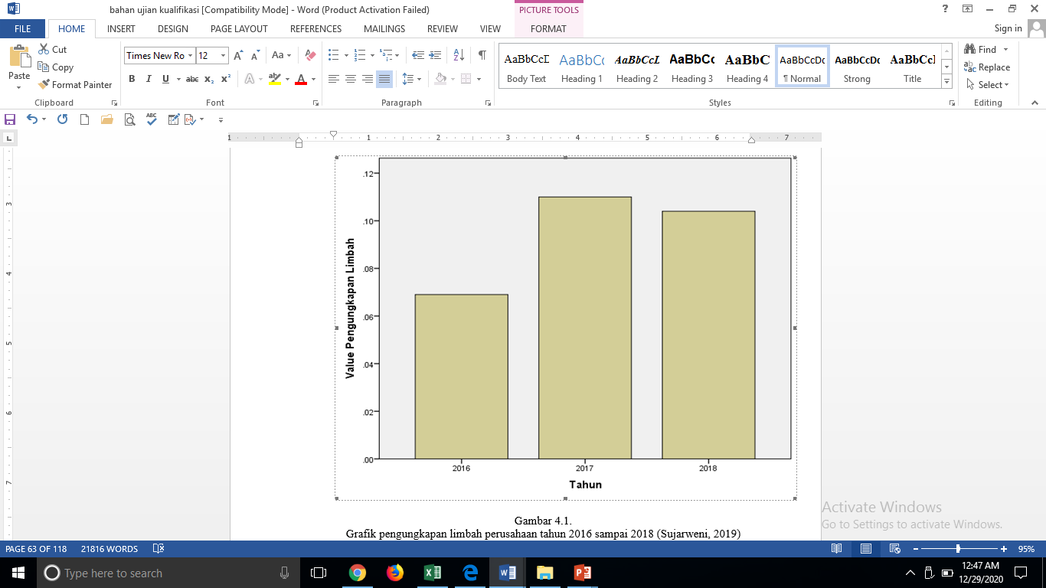

Source: Sujarweni (2019)

Figure 1 Diagram of the Results of Disclosure of Waste from Mining, Palm Oil, and Hospital Companies on the Stock Exchange in 2016-2018

Legitimacy theory states that corporate power can be obtained through various actions, including communicating with multiple stakeholders to gain the company's reputation (Ashforth & Gibbs, 1990). Phillips (2003) found the concept of legitimacy in stakeholder theory that to obtain and maintain legitimacy, and companies need to carry out social contracts based on moral responsibility to stakeholders based on justice.

Stakeholder legitimacy is divided into two, namely normative and derivative stakeholder legitimacy. Normative stakeholder legitimacy means that companies need to build and maintain legitimacy with stakeholders based on direct moral obligations and principles of justice. The company determines normative stakeholders based on the reciprocal relationship between stakeholders and the company. Legitimate normative stakeholders are suppliers, consumers, local communities, shareholders, employees. While the legitimacy of derivative stakeholders, companies need to build legitimacy in this stakeholder group. The derivative stakeholder group does not have a reciprocal relationship with the company, but if this group is ignored, it will endanger its legitimacy. The legitimacy of derivative stakeholders can affect the stability of the company and the legality of normative stakeholders (Phillips, 2003).

Derivative stakeholders do not have a reciprocal relationship with the company, and the company must maintain legitimacy to these stakeholders. If the company does not retain, it can damage the legitimacy of normative stakeholders. Examples of derivative stakeholders are radicals, environmental activists, competitors (a group that wants the company's loss or normative stakeholders), and the press. Derivative stakeholders can damage the company's legitimacy, and the company must handle it properly when derivative stakeholders take actions that harm the company's legitimacy. Suppose derivative stakeholders protest to the company, they respond well. In that case, these stakeholders realize that the company can wisely meet their demands, so the relationship between the two parties can be harmonious and establish cooperation. Derivative stakeholders can become normative stakeholders. This study chose to use normative stakeholder legitimacy theory (Phillips, 2003) as the basis for finding solutions related to LB3 disclosure.

Disclosure of social and environmental responsibility in which the company makes an LB3 disclosure has several guidelines. The disclosure guidelines include the Global Reporting Initiative (GRI). GRI contains 9 (nine) aspects of the company's impact on the environment, one of which is about LB3. Researchers have also made guidelines such as (Clarkson et al., 2008; Setiadi, 2016; Suhardjanto et al., 2007; Suhardjanto & Choiriyah, 2010; Wiseman, 1982). This study incorporates disclosure guidelines about LB3 based on previous research. Developed each item based on the Minister of Environment and Forestry Regulation No. 55 of 2015 concerning the LB3 Characteristic Test (2015); Minister of Environment and Forestry Regulation No. 63 of 2016 concerning LB3 Stockpiling Test (2016); Government Regulation No. 101 of 2014 Hazardous and Toxic Waste (2014). The next LB3 disclosure guideline item that is made is a novelty in this study.

Concern for social and environmental concerns is an essential requirement for the company to grow and develop sustainably. LB3 management is part of ecological awareness that must carry out following procedures. That is a significant part of environmental responsibility. Global business trends in the last decade have shown that concern for the environment, especially LB3 produced by companies, is a primary obligation because there are forces of demand and supply between stakeholders and companies. Stakeholder groups have the desired need to disclose environmental information while companies make disclosures according to their abilities (Lako, 2008). Previous research on the demand and supply of environmental exposures is still tiny (Suhardjanto, 2008). Previous research conducted by Suhardjanto & Choiriyah (2010) used a broader-based sample of stakeholders, including Environmental Groups, Universities, Future generations and the Press. Amelia's research & Suhardjanto (2011) use the Elite Based Stakeholders group as respondents included in the non-financial stakeholder group. The results of the two previous studies show differences in demand and supply of environmental disclosures between stakeholder demand and company supply..

.

**II. THEORETICAL FRAMEWORK**

**Stakeholder legitimacy**

The number of cases of environmental pollution caused by lack of disclosure causes companies to seek legitimacy from stakeholders, by entering into social contracts between companies and stakeholders. The social contract is in the form of LB3 management in accordance with government regulations. The management of LB3 that has been carried out by the company is then disclosed in the company's annual report. The things put forward by the researcher are in accordance with the theory of legitimacy (Phillips, 2003) which sounds like companies need to gain legitimacy through social contracts with normative stakeholders (suppliers, consumers, local communities, shareholders, employees) namely stakeholders who have relationships with the company based on relationships reciprocal. The company carries out direct moral obligations where the company's moral responsibility is addressed to stakeholders based on the principle of stakeholder justice. The principle of stakeholder justice states that whenever a person or group of people voluntarily receives benefits from a mutually beneficial cooperation scheme that requires sacrifices or contributions, an obligation of justice is created between the company and stakeholders in proportion to the benefits received (Philip, 1997)

1. **METHODE**

**Research Sample**

The research conducted a Discussion Group Forum (FGD) by inviting practitioners in the LB3 field, namely ten staff who handle corporate LB3 at the central ministry of the environment and eight academics teaching environmental accounting, two researchers who have researched on Corporate Social Responsibility (CSR). Questionnaires were distributed to several parties totalling 35 respondents consisting of normative stakeholders, namely suppliers, consumers, local communities, shareholders, employees every five respondents plus academics five respondents, staff of the ministry of environment five respondents—the sampling technique using accidental sampling. Using the purposive sampling technique, the secondary data used is LB3 disclosure data of manufacturing and mineral and coal companies listed on the Indonesia Stock Exchange in 2012-2019.

**Data and Data Resource**

The data used in this study are primary and secondary data obtained from:

1. Forum discussion group (FGD) with the ministry of the environment, academics in environmental accounting, researchers on CSR topics to formulate LB3 disclosure items.
2. Distributing questionnaires to respondents from suppliers, consumers, communities, shareholders, employees, the ministry of environment and academia on how important LB3 disclosure items are.
3. Disclosure of LB3 of manufacturing and mineral and coal companies listed on the Indonesia Stock Exchange in 2019 obtained from the website [www.idx.co.id](http://www.idx.co.id)

*.*

**Operational Definition And Variable Measurement**

**Table 1**

**Operational Definition And Variable Measurement**

|  |  |  |  |
| --- | --- | --- | --- |
| **No** | **Nama Variabel** | **Definisi Variabel** | **Pengukuran** |
| 1 | B3 waste disclosure percentage | The amount of LB3 disclosure that stakeholders expect (demand) and the company's practice (supply) regarding LB3 disclosure in the form of a percentage  (Suhardjanto & Choiriyah, 2010) (Amelia, & Suhardjanto, 2011) | Ratio data  Percentage of stakeholder expectations (demand) and company practice (supply) regarding B3 waste disclosure (Suhardjanto & Choiriyah, 2010) (Amelia, & Suhardjanto, 2011) |
|
|
| 2 | Types of Information Gaps Expectations and Practices of Disclosure of Financial Statements | Stakeholder groups have the demand they want to disclose environmental information, while companies make disclosures according to their abilities. (Lako, 2008). | Nominal Data  1= Stakeholder's expectations regarding the disclosure of B3 waste  0 = Company supply practices regarding B3 waste disclosure  (Suhardjanto & Choiriyah, 2010) (Amelia, & Suhardjanto, 2011) |
|
|
|
|

**Data Analysis Results**

**LB3 Disclosure Index Results (Unweighted)**

The following are LB3 disclosure items from the GFD results from several researchers. Based on PP No 101 of 2014 concerning LB3 management, Minister of Environment and Forestry Regulation No. 55 of 2015 LB3 characteristic test, Minister of Environment Forestry Regulation No. 63 of 2016 LB3 hoarding test.

**Tablel 2**

**Results of the Hazardous Waste Disclosure Index**

|  |  |  |
| --- | --- | --- |
| No | Disclosure items | Researcher, Regulation |
| 1 | Type/code LB3/Code | Suhardjanto, *et al.,* (2007); Permen LHK Nomor 55 tahun 2015 Uji karakteristik LB3 |
| 2 | total weight of waste by type | Setiabudi (2016) |
| 3 | waste reduction efforts | Crakson, *et al.,* (2008) |
| 4 | Waste storage | PP 101 tahun 2014 |
| 5 | Waste collection | PP 101 tahun 2014 |
| 6 | hazardous waste transport information | Wiseman (1982) |
| 7 | Waste utilization | PP 101 tahun 2015 |
| 8 | waste recycling | Crakson *et al.,* (2008); Clarkson *et al.,* (2013) |
| 9 | LB3 pengolahan processing | Clarkson *et al.,* (2013) |
| 10 | LB3 Hoarding | PP 101 tahun 2015; Permen LHK Nomor 63 tahun 2016 Uji Penimbunan LB3 |
| 11 | waste disposal method | Wiseman (1982);Crakson *et al.,* (2008); Clarkson *et al.,* (2013) |
| 12 | Total weight of waste by disposal method | GRI4 |
| 13 | Waste utilization permit | PP 101 tahun 2014 |
| 14 | percentage of waste transported for international shipping | GRI5 |
| 15 | Management of Environmental Pollution due to B3 waste | PP 101 tahun 2014 |
| 16 | Emergency Response System in LB3 Management | PP 101 tahun 2014 |
| 17 | construction | PP 101 tahun 2014 |
| 18 | supervision | PP 101 tahun 2014 |
| 19 | The total volume of the waste spill | GRI4;Clarkson *et al.,* (2013);Setiabudi (2016) |
| 20 | cause of waste | Clarkson *et al.,* (2013) |
| 21 | waste treatment | Clarkson *et al.,* (2008) |

Source: Processed Data 2021

1. **RESEARCH RESULTS AND DISCUSSION**

**Descriptive Test Results With Cartesian Diagram**

The Cartesian chart is used to see items of LB3 disclosure that are important or that are the main priority in LB3 disclosures in the company's annual report on the IDX. Calculation of demand and supply values is in appendix 8c. The results of the Cartesian demand and supply diagram for LB3 disclosure are as follows:

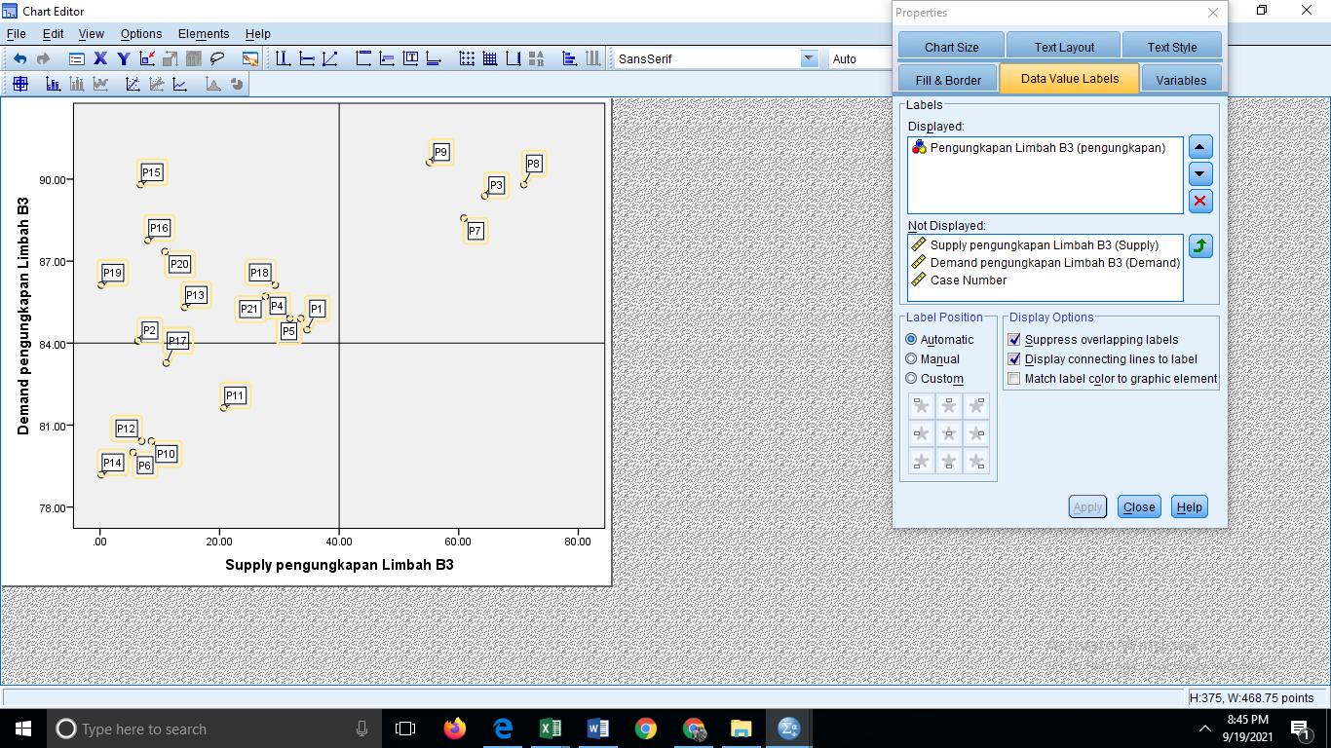

IV

III

II

I

Picture 3

Test Results of Cartesian Diagram of Demand and Supply disclosure of LB3

Quadrant I of LB3 disclosure items located in this quadrant are eight items, namely the type of waste, the total weight of waste by type, financing, prevention of environmental pollution due to LB3, emergency response system in LB3 management, supervision, the volume of LB3 spills, causes of LB3, LB3 storage, LB3 collection, LB3 treatment. Disclosure items in this quadrant mean that these disclosure items need to be prioritized by the company because the expectations (demand) are high while the realization (supply) is not in line with expectations (market), which is still low. Factors in this quadrant are considered very important, but the company has not implemented them according to the wishes of the stakeholders.

Quadrant II LB3 disclosure items in this quadrant have four items. LB3 reduction efforts, LB3 utilization, LB3 recycling, LB3 management. Disclosure items in this quadrant mean that both disclosure items need to be maintained. Factors in this quadrant are considered very important and satisfying in their implementation.

Quadrant III, LB3 disclosure items, contained in this quadrant are six items: information disclosure items for LB3 transportation, LB3 storage, LB3 disposal method, LB3 total weight based on disposal method, percentage of LB3 transported for international shipping, LB3 coaching. In this quadrant, demand considers disclosure less critical, and its implementation is less satisfying.

Quadrant IV of the LB3 disclosure items contained in this quadrant is none. If there is a meaning that the disclosure items are less important, but the implementation is excessive, it is considered less important but very satisfying the disclosure practice.

**Hypothesis Test Results Independent Sample t-test**

The results of hypothesis testing in this study were obtained as follows:

**Tabel 3**

**Independent Difference Test Results Sample t-test**

|  |  |
| --- | --- |
| Description | Value |
| sig F | 0.000 |
| tt *Equal Variance assumed* | 11.074 |
| t *Equal Variance not assumed* | 11.074 |
| sig t *Equal Variance assumed* | 0.000 |
| sig t *Equal Variance not assumed* | 0.000 |
| Mean *Demand* 85.2490 |  |
| Mean *Supply* 25.7510 |  |

Source: Processed Data 2021

There is a difference in the stakeholder's expectation (demand) for the LB3 disclosure items in the annual report of manufacturing and mineral and coal companies listed on the IDX with the realization (supply) of manufacturing and mineral and coal companies listed on the IDX. Stakeholder's expectation (demand) for LB3 disclosure items 85.2490% and company supply (supply) in disclosing LB3 in the annual financial statements 25,7510%.

**LB3 Disclosure Results Based on the Order of Highest Demand**

The difference in the stakeholder's expectations (demand) on the LB3 disclosure items in the annual report of manufacturing and mineral and coal companies listed on the IDX with the realization (supply) of manufacturing and mineral and coal companies listed on the IDX. Stakeholders' demand for the following LB3 disclosure items:

**Table 4**

**Result Value of Demand and Supply Disclosure LB3**

|  |  |  |  |
| --- | --- | --- | --- |
| Code | Description | *Demand* | *Supply* |
| P7 | Utilization of LB3 | 89.8 | 70.3 |
| P8 | LB3 recycle | 89.8 | 82.3 |
| P9 | LB3 Pengolahan Processing | 89.8 | 69.8 |
| P15 | Management of environmental pollution due to LB3 | 89.8 | 5.45 |
| P3 | LB3 reduction efforts | 89.39 | 76.36 |
| P16 | Emergency response system in the management of LB3 | 87.76 | 7.3 |
| P20 | Cause LB3 | 87.35 | 15.59 |
| P18 | Supervision | 86.12 | 30.94 |
| P19 | Total spill volume LB3 | 86.12 | 0.12 |
| P21 | LB3 Perawatan care | 85.71 | 26.61 |
| P13 | LB3 utilization permit | 85.31 | 13.99 |
| P4 | LB3 Penyimpanan Storage | 84.9 | 39.73 |
| P5 | LB3 Collection | 84.9 | 40.47 |
| P1 | Type LB3 | 84.49 | 37 |
| P2 | Total weight of waste by type | 84.08 | 6.93 |
| P17 | coaching | 83.27 | 9.9 |
| P11 | LB3 dispensing disposal method | 81.63 | 18.81 |
| P10 | LB3 Hoarding | 80.41 | 7.55 |
| P12 | Total weight of waste by disposal method | 80.41 | 6.31 |
| P6 | LB3 transport information | 80 | 6.81 |
| P14 | Percentage of waste for international shipments. | 79.18 | 0.12 |

Source: Processed Data 2021

Table 4 shows the order of the most significant demand values in the disclosure of LB3 using LB3 as a substitute for raw materials, using LB3 as a substitute for energy sources, as raw material, using LB3 by the development of science and technology. The following important disclosure item is the LB3 recycling disclosure item, which is disclosed by the company how the company carries out the process to turn a used material into a new material by, for example, making solid waste into bricks. The company also explains that this recycling is harmless and has been licensed and has added value. recycling is creating something new or a different product

**LB3 Disclosure Results Based on the Order of Highest Supply**

Differences in expectations (supply) of companies on disclosure items LB3 in the annual report of manufacturing and mineral and coal companies listed on the IDX with the realization (collection) of manufacturing and mineral and coal companies listed on the IDX. Stakeholders' demand for the following LB3 disclosure items:

**Table 5**

**LB3 Disclosure Results Based on the Order of Highest Supply**

|  |  |  |  |
| --- | --- | --- | --- |
| Code | Description | *Demand* | *Supply* |
| P8 | LB3 recycle | 89.8 | 82.3 |
| P3 | LB3 reduction efforts | 89.39 | 76.36 |
| P7 | Utilization of LB3 | 89.8 | 70.3 |
| P9 | LB3 Pengolahan Processing | 89.8 | 69.8 |
| P5 | LB3 Collection | 84.9 | 40.47 |
| P4 | LB3 Penyimpanan Storage | 84.9 | 39.73 |
| P1 | Type LB3 | 84.49 | 37 |
| P18 | Supervision | 86.12 | 30.94 |
| P21 | LB3 Perawatan care | 85.71 | 26.61 |
| P11 | LB3 dispensing disposal method | 81.63 | 18.81 |
| P20 | Cause LB3 | 87.35 | 15.59 |
| P13 | LB3 utilization permit | 85.31 | 13.99 |
| P17 | coaching | 83.27 | 9.9 |
| P10 | LB3 Hoarding | 80.41 | 7.55 |
| P16 | Emergency response system in the management of LB3 | 87.76 | 7.3 |
| P2 | Total weight of waste by type | 84.08 | 6.93 |
| P6 | LB3 transport information | 80 | 6.81 |
| P12 | Total weight of waste by disposal method | 80.41 | 6.31 |
| P15 | Control of environmental pollution due to LB3 | 89.8 | 5.45 |
| P14 | Percentage of waste transported for international shipments | 79.18 | 0.12 |
| P19 | Total spill volume LB3 | 86.12 | 0.12 |

Source: Processed Data 2021

Table 5 shows the order of supply values ​​from the largest to the smallest is the disclosure of LB3 recycling LB3 into a new form. According to company practice, this disclosure has the most significant value, meaning that the company has a lot of exposure—Furthermore, the company's efforts to reduce LB3 mention the steps to minimize LB3. The following supply is how the company utilizes LB3. How does the company process LB3, what collection activities does the company do, how to store LB3. The company produces types of LB3, How to carry out supervision, maintenance of LB3 equipment, which LB3 disposal method is used. The company revealed the cause of LB3, how it had carried out the permit for the use of LB3 in the context of managing LB3. How companies stockpile LB3, emergency response system in LB3 management, the total weight of waste by type, LB3 transportation information, percentage of LB3 transported for international shipments, Total volume of LB3 spills.

There is a difference in demand and supply for the disclosure of LB3. The difference in stakeholder demand for disclosure items LB3 in the annual report of manufacturing and mineral and coal companies listed on the IDX is high. In contrast, the supply of manufacturing and mineral and coal companies listed on the IDX is still low. This study uses normative stakeholder legitimacy theory. Companies need to gain legitimacy from normative stakeholders who have direct interests and have a reciprocal relationship between them. To gain legitimacy, companies need to take actions aimed at normative stakeholders. One way to achieve this legitimacy is to carry out environmental management activities for LB3, then report them in the company's annual report to know about them.

Information about the management of LB3 needs to be disclosed in the company's annual report, which is still voluntary. The researcher has formulated the LB3 disclosure as many as 21 LB3 disclosure items. Normative stakeholders believe that the most critical exposure is utilization, while according to company realization, the most important is LB3 recycling.

The results of the information gap, namely stakeholder demand with company realization, show that LB3 disclosure is still low in Indonesia. The results of the supply of LB3 disclosures are on average 27,2567%, far from the results desired by stakeholders, which is 85,2490%. So the result is that there are differences in demand and supply for LB3 disclosures. The difference between the two is what causes which items to be most important to be disclosed. That happens because the expectation (demand) is high while the realization (supply) is not in line with the expectation (market), which is still low.

Factors that are considered very important, but the company has not carried out according to the wishes of the stakeholders, is the disclosure item for the LB3 type. There are financing, prevention of environmental pollution due to LB3, emergency response system in LB3 management, supervision, the volume of LB3 spills, LB3 causes, LB3 storage, LB3 collection, LB3 treatment. Then the company needs to disclose the item. While four things, namely efforts to reduce LB3, LB3 utilization, LB3 recycling, and LB3 management, are considered very important and very satisfying in their implementation, these four disclosure items need to be maintained for continued disclosure by the company in the annual report. Then the item of disclosure of information on LB3 transportation, LB3 stockpiling, LB3 disposal method. The total weight of LB3 based on disposal method, percentage of LB3 transported for international shipping, LB3 coaching, the disclosure item according to demand is less critical, and the implementation of the disclosure is also less satisfying. Although it is less critical, the company still has to disclose this item in its annual report.

Stakeholder legitimacy is significant for the company considering stakeholder legitimacy has an essential role in supporting the company's goals. LB3 disclosure to normative stakeholders is one of the company's indirect responsibilities to the environment to gain company legitimacy. Therefore, companies must disclose LB3 by the demands of normative stakeholders. The company's efforts are needed to make comprehensive LB3 disclosures to obtain legitimacy. This research is consistent with previous research conducted by Amelia & Suhardjanto (2011); Suhardjanto & Choiriyah (2010). The result is that there are differences in demand and supply of environmental disclosures between stakeholder demand and company supply, where demand is high, and supply is low.

1. **CONCLUSION**

This study aims to determine the information gap of LB3 disclosure in Indonesia. The results obtained show a difference between the demand and supply of LB3 disclosures in Indonesia. The level of demand for LB3 disclosure is high. However, in reality, companies in Indonesia disclosing LB3 are still very low. The results of the information gap show that LB3 exposure is still every day in Indonesia. Companies in Indonesia are less aware of LB3 management to care for business actors to carry out environmental conservation efforts and maintain ecological balance. Thus, the information gap from LB3 disclosure can be seen from the high demand (demand) and low supply.

Suggestion The level of LB3 disclosure in Indonesia, which is still very low, requires mandatory regulations. Should be balanced The company's rapid growth d with its awareness to keep managing LB3 in its business. The government should regularly monitor the implementation of LB3 management and disclose what has been done with LB3 management so that stakeholders know about it.

For further research, so that it does not only involve normative stakeholders, it is necessary to involve other stakeholders researchers have never carried out. Future research can compare LB3 disclosures in other developing countries..

**References**

Amelia, W., & Suhardjanto, D. (2011). *Permintaan Elite Based Stakeholders Dan Praktik Pengungkapan Lingkungan Hidup di Indonesia*. Universitas Sebelas Maret Surakarta.

Anggraini, R. (2006). Pengungkapan Informasi Sosial dan Faktor – faktor yang Mempengaruhi Pengungkapan Informasi Sosial dan Laporan Keuangan Tahunan (Study Empiris pada Perusahaan – perusahaan yang Terdaftar di Bursa Efek Jakarta. *Simposium Nasional Akuntansi IX. Padang*.

Ashforth, B. E., & Gibbs, B. W. (1990). The Double-Edge of Organizational Legitimation. *Organization Science*, *1*(2), 177–194. https://doi.org/10.1287/orsc.1.2.177

Clarkson, P. M., Fang, X., Li, Y., & Richardson, G. (2013). The relevance of environmental disclosures: Are such disclosures incrementally informative? *Journal of Accounting and Public Policy*, *32*(5), 410–431. https://doi.org/10.1016/j.jaccpubpol.2013.06.008

Clarkson, P. M., Li, Y., Richardson, G. D., & Vasvari, F. P. (2008). Revisiting the relation between environmental performance and environmental disclosure: An empirical analysis. *Accounting, Organizations and Society*, *33*(4–5), 303–327. https://doi.org/10.1016/j.aos.2007.05.003

Lako, A. (2008). Kewajiban CSR dan Reformasi Paradigma Bisnis dan Akuntansi. *Usahawan*, *December*. http://repository.unika.ac.id/19998/1/Kewajiban_CSR_dan_Reformasi_Paradigma_Bisnis_dan_A-1.pdf

Peraturan Menteri. (2016). *Peraturan Menteri LHK No.63 tahun 2016 tentang uji penimbunan LB3*. Peraturan Menteri.

Peraturan Menteri RI. (2015). *Peraturan Menteri LHK No.55 tahun 2015 tentang uji karakteristik LB3*. Peraturan Menteri.

Peraturan Pemerintah RI. (2014). *Peraturan Pemerintah No 101 tahun 2014 limbah bahan berbahaya dan beracun*.

Philip, R. (1997). Stakeholder Theory and A Principle of Fairness. *Business Ethics Quarterly*, *volume 7,*.

Phillips, R. (2003). *Stakeholder Legitimacy Robert Phillips*. *13*(1), 25–41.

Setiadi, I. (2016). *Stakeholders, Pengungkapan Lingkungan, dan Nilai Perusahaan*. Universitas Sebelas Maret Surakarta.

Suhardjanto, D. (2008). Environmental Reporting Practices: An Evidence from Indonesia. *Jurnal Akuntansi Dan Bisnis*, *Vol. 8 No.*

Suhardjanto, D., & Choiriyah, U. (2010). Information Gap : Demand Supply Environmental Disclosure. *Jurnal Keuangan Dan Perbankan*, *14*(1), 36–51.

Suhardjanto, Tower, & Brown. (2007). Generating A Uniquely Indonesian Environmental Reporting Disclosure Index Using Press Coverage as An Important Proxy of Stakeholder Demand. *Paper Submission to Asian Academic Accounting Association Annual Conference Yogyakarta. Indonesia*.

Sujarweni, W. (2019). *Pengungkapan Limbah di Indonesia*. Universitas Sebelas Maret Surakarta.

WALHI. (2015). *Tinjauan Lingkungan Hidup 2015: Menagih Janji Menuntut Perubahan*. 1–48. http://www.walhi.or.id/2016/12/22/outlook-2015-menagih-janji-penuntut-perubahan/

Wiseman, J. (1982). An evaluation of environmental disclosures made in corporate annual reports. *Accounting, Organizations and Society*, *7*(1), 53–63. https://doi.org/10.1016/0361-3682(82)90025-3