Water Quality Monitoring System Hydrogenic Cultivation IoT-Based

Eko Budihartono, Arif Rakhman, Irfan Nugroho

Prodi D-3 Teknik Komputer, Politeknik Harapan Bersama, Indonesia

*Corresponding author: tara.niscita@gmail.com

**Abstract.** A cultivation system that combines a hydroponic system and without chemicals (organic), the combination of the two results in a system where plant cultivation is carried out without soil media and using natural organic fertilizers derived from fish manure that flows along with the flow of pond water through pipes. This technology is often referred to as aquaponics, which is a system that combines hydroponics with a fish farming pond below. After the material is ready, the farmer fills the pond with fish, leaving it for a week. Followed by breeding fish seeds. Considering how important water is for fish farming, water quality must be maintained and its quality is maintained. To maintain water quality, we need a tool that can monitor the water quality using Arduino Uno R3 so that hydrogenic cultivation is maintained properly. From the high losses caused, a system that can monitor water quality in hydrogenic cultivation is very much needed by the community. This requires an IoT-based real-time water quality monitoring system for hydro-organic cultivation, and with the existence of a hydro-organic aquaculture water quality monitoring system, accurate data can be obtained easily. This tool application can monitor water quality automatically. Parameters in monitoring water quality (water temperature, water pH and turbidity) so that water quality in hydrogenic cultivation can be monitored accurately and the results obtained are getting better with an accuracy of 99%.

Keywords: Arduino Uno, Temperature Sensor, pH Sensor, Turbidity Sensor, LCD, Hydrogenic

1. Introduction

Water is a source for agricultural and fishery life, even water is the foundation of the community to cultivate hydrogenic to become a source of community food such as fish cultivation. Considering how important water is for fish farming, water quality must be maintained and its quality is maintained, free from ammonia and free from acids and bases so as not to damage water quality. To maintain water quality, we need a tool that can monitor the quality of the water using an IoT-based Arduino so that in controlling water quality to hydrogenic water quality is maintained properly[1].

A monitoring system that can monitor water quality has now become a very urgent need for hydrogenic aquaculture ponds. This is due to the negative record caused by underwater activities and the water quality is not monitored in real-time which suddenly results in losses in hydrogenic cultivation. From the high losses caused, a system that can monitor the quality of hydro-organic aquaculture water is needed by the community, and with the existence of an IoT-based hydro-organic aquaculture water quality monitoring system, accurate data can be obtained easily[2].

The development of increasingly sophisticated technology at this time gave birth to a product for analyzing the quality of hydrogenic aquaculture water based on IoT using Arduino Uno R3. Various applications that are similar to computer devices can be installed in it. Including applications in water quality monitoring to be able to work accurately and maintain water quality well[3].

Based on the above background, the researchers are interested in raising the title "Water Quality Monitoring in IoT-Based Hydroganic Cultivation" so that information on changes in water quality can be made automatically monitored by the information to the LCD and Hydrogenic Website so that users will be able to know the quality of the water and the results obtained are maximized.

1. Research Methods

Research on water quality monitoring system tools in hydrogenic cultivation using Arduino programming is very important to do to execute the desired command on the Arduino Uno R3 circuit[1]. When the hardware input voltage in this case the power supply, the microcontroller will start the input and output initialization process as well as the required variables. The data that enters the Arduino Uno R3 is then processed[4]. The flowchart form can be seen in Figure 1.

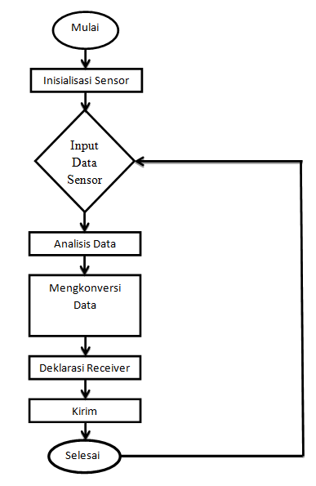

Figure 1. Illustration of how the monitoring system works

This study uses the SDLC (System Development Life Cycle) method with the following stages[5] can be seen in Figure 2.

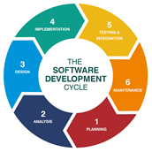

Figure 2. SDLC *Waterfall* Model

A. Planning

This stage is the stage of determining important things as the basis of the problems to be analyzed. In this stage, problem identification is carried out, data collection is in the form of literature studies, interviews and observations, determining system requirements, evaluating various alternative solutions and verifying data.

B. Analysis (analysis)

At this stage, the data model to be used and the process model to be applied are determined. At this stage will also be studied further.

C. Design (Design)

This stage is a process of inventorying and converting requirements into a characteristic form that is understood by the software before making the tool.

D. Implementation

At the implementation stage, the activities carried out are writing knowledge that has been represented (encoded) in programming languages, installation, demonstration and system implementation, user orientation, security, documentation and integration.

E. Testing

After the implementation phase has been completed, the next step is to test the results of the implementation, namely by testing the water quality in hydrogenic cultivation.

F. Maintenance

The last stage in this system is to carry out maintenance, including by correcting the design and program errors and protecting the system from possible problems in the future.

Making a Water Quality Monitoring System Tool in Hydrogenic Cultivation consists of software design and hardware design. This software design uses Arduino Uno R3 software which can be run on a Microcontroller-based operating system. The parameters measured are the water temperature sensor, pH meter, turbidity sensor (turbidity), then it will display LED Indicator information (Green: normal, Yellow: warning, Red: danger) and information displays the water temperature sensor, water Ph sensor, turbidity sensor through a 20x4 LCD and can be monitored via the hydrogenic website.

The hardware design consists of a control system, namely Arduino which acts as a sensor controller and performs data processing[6]. The system design is presented in the form of a block diagram that will assist in designing the Arduino Uno-Based Water Quality Monitoring tool. As for the use of Arduino Uno R3 as a data processor, water pH sensor and temperature sensor. This research works using the Arduino Uno R3 Microcontroller by using a power supply that can measure temperature, pH, turbidity whose output will be displayed through the LCD and the hydrogenic website. The block diagram of the Water Quality Monitoring tool in Arduino Uno R3-based hydrogenic cultivation can be seen in Figure 3.

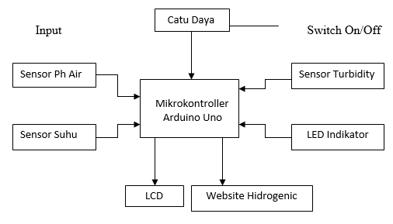

Figure 3. Water quality monitoring system tools in hydrogenic cultivation

Hardware assembly is the process of connecting all devices so that they can read sensor values to trigger output device performance. The schematic circuit of the system to be made can be seen in Figure 4.

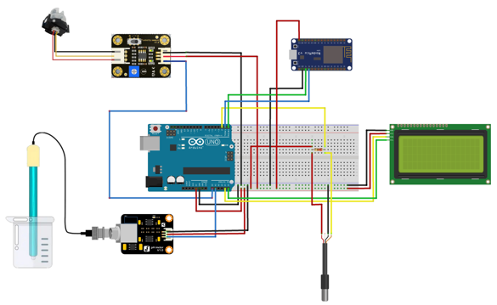

Figure 4. Schematic circuit of the entire monitoring system

The tools that will be used in the manufacture of water quality monitoring system tools in hydrogenic cultivation are as follows:

1. Temperature sensor

Temperature sensor to read water temperature.

2. PH Sensor Sensor

A pH Meter is a scientific instrument that measures the hydrogen-ion concentration (or pH) in a solution, indicating acidity or alkalinity.

3. Sensor Turbidity (Turbidity)

Measuring turbidity

4. Arduino Uno R3 . Microcontroller

The hardware design consists of a control system, namely Arduino which acts as a sensor controller and performs data processing.

5. 20x4 . LCD

Displays Output / output.

6. Hydrogenic Website

1. Results and Discussion

3.1 Tool Assembly Process

The process of assembling a water quality monitoring system tool in hydrogenic cultivation to fulfill object control can be seen in Figure 5.

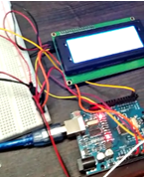

Figure 5. Assembly process of water quality monitoring system tools in hydro-organic cultivation

3.2 Installation of water quality monitoring system tools in hydrogenic cultivation

Hardware installation is a process of installing tools or assembling tools that are used in building a water quality monitoring system tool in hydrogenic cultivation. The installation of water quality monitoring system tools in hydro-organic cultivation can be seen in Figure 6.

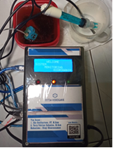

Figure 6. Installation of equipment for water quality monitoring system in Hydrogenic cultivation.

3.3. Display of water quality monitoring system tools in hydrogenic cultivation

Digital display as the main controller in sending text on the LCD display, where the text sent will be displayed on the LCD Module and Hydroganic website. Before shipping make sure the port is detected. As for the results of assembling water quality monitoring tools in hydrogenic cultivation, the hardware used to fulfill object control can be seen in Figure 7:

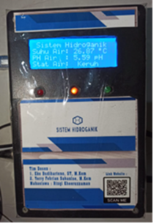

Figure 7. Display of water quality monitoring system tools in hydrogenic cultivation

3.4 Hydrogenic Website Usage

The hydrogenic Website System was created with the aim of making it easier to monitor water quality in hydrogenic cultivation so that it can be monitored via a website or cellphone so that water quality can be monitored properly.

1. Go to the website page

The steps to access the website page are as follows:

a) The user opens the browser.

b) Enter the website URL address: <https://kukuch13.github.io/hidroganic/>, can be seen in figure 8.

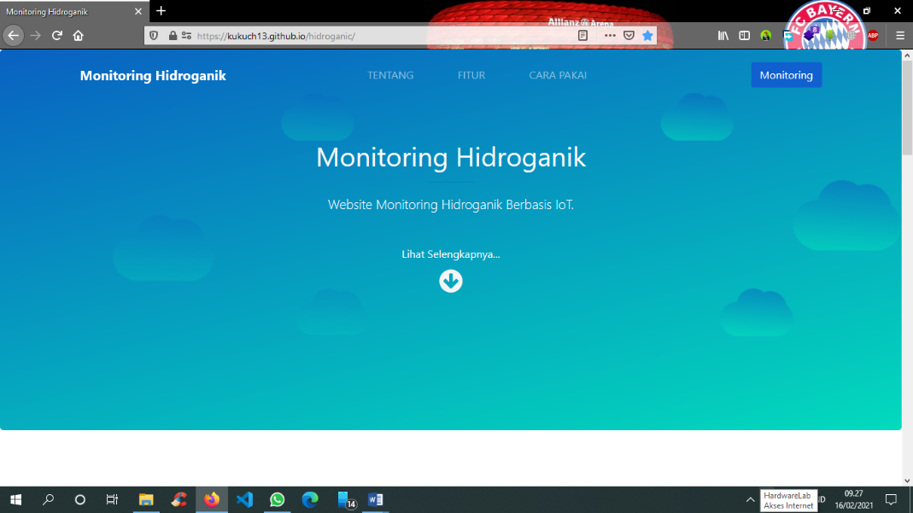

Figure 8. Go to the website page

2. Display Menu About

Displays a menu containing content about the notion of hydrogenic and tool display. The menu display about can be seen in Figure 9.

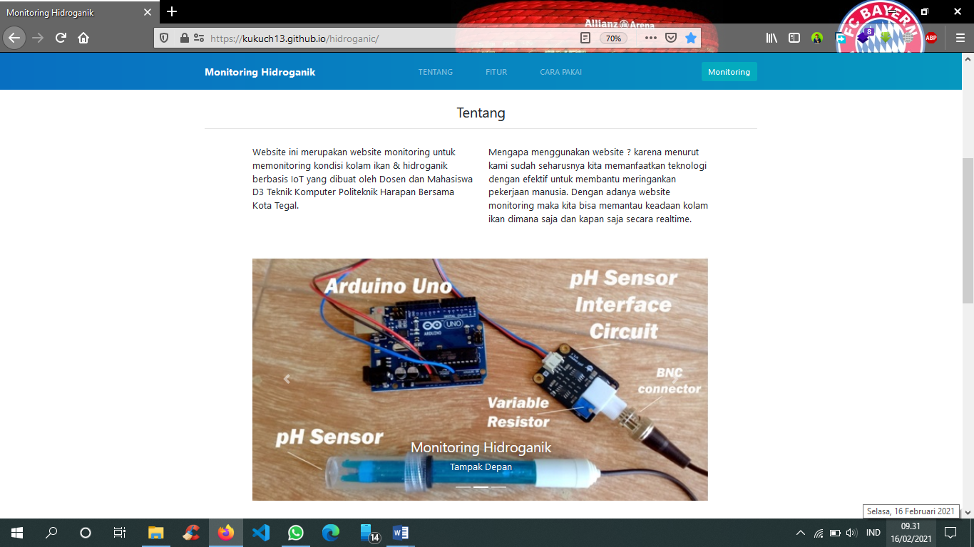

Figure 9. Display Menu About

3. Feature Menu Display

Showing what features are offered by the Hydroganic monitoring system tool, can be seen in Figure 10.

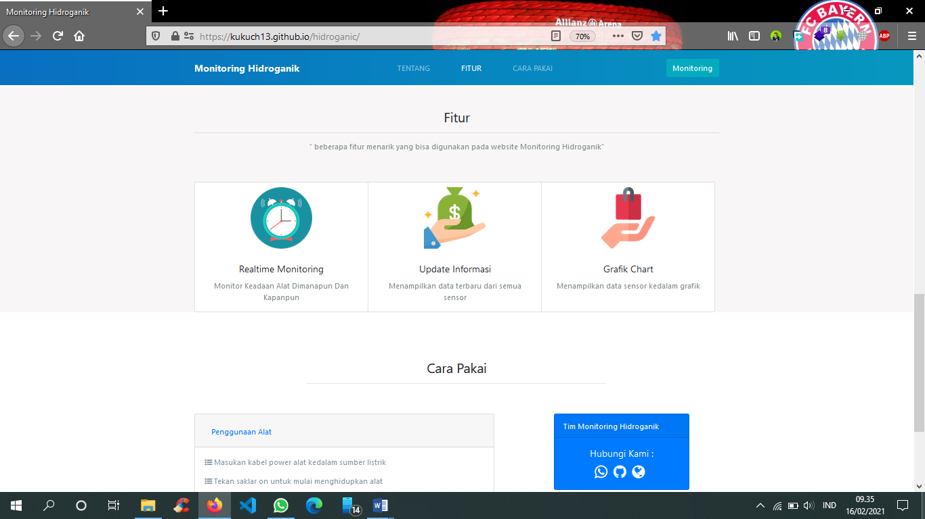

Figure 10. Feature Menu Display

4. Display Menu How to Use

Displays a menu containing the contents of the procedure for using or using the hydraulic monitoring system tool. How to use menu display can be seen in Figure 11.

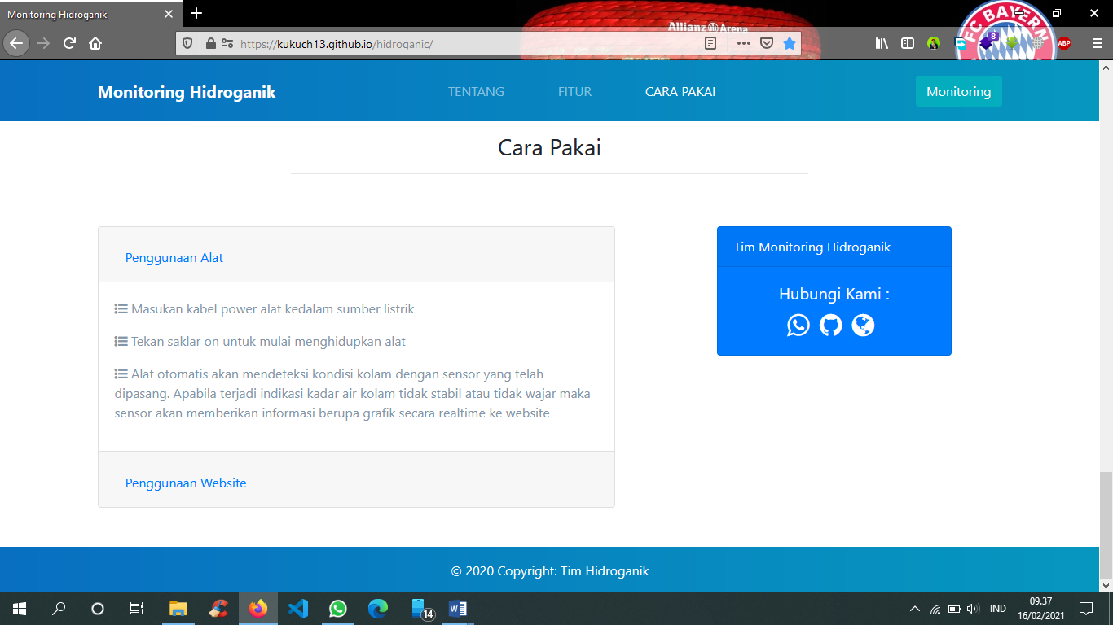

Figure 11. Display Menu How to Use

5. Monitoring Menu Display

Displays a menu containing sensor data, ranging from sensor data to water temperature, water humidity and water PH in the form of a graph. The monitoring menu display can be seen in Figure 12.

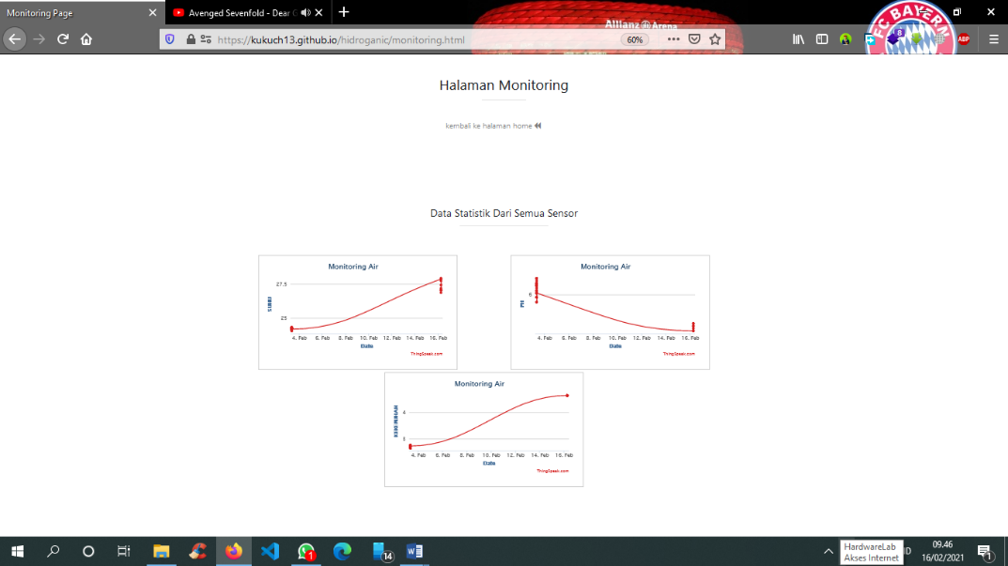

Figure 12. Monitoring Menu Display

6. Testing Tool

To find out if the software is running properly, has no errors and is as expected. Testing using the Black Box Method. This method is used to determine whether the software is functioning properly, the design of test data based on the software specifications made can be seen in table 1:

Table 1. Testing of Hydrogenic monitoring system tools

|  |  |  |  |  |
| --- | --- | --- | --- | --- |
| **No.** | **Test Input** | **Sensor Function** | **Sensor Function** | **Test results** |
| 1 | LCD test | Active | Active LCD reads text and letters | Ok |
| 2 | Temperature test | Active | Sensor detects water temperature | Ok |
| 3 | Testing the pH of the Water | Active | It is expected that the sensor detects the pH of the water | Ok |
| 4 | Turbidity test | Active | It is expected that the sensor detects turbidity | Ok |
| 5 | Hydroganic Website Application | Active | The Hydrogenic website is actively legible, written graphics and letters | Ok/  Keakuratan 99 persen |

The data from the tests that have been carried out on the performance of the tool show that the tool can work well, is easy to use and is more efficient because this tool only requires a power supply to display on the LCD screen and on the hydrogenic website, thus simplifying the process of measuring water temperature, water pH, and turbidity. water (turbidity), is expected to help the community in hydrogenic cultivation so that the results obtained are better with an accuracy of 99%.

**4. Conclusion**

Based on the research results that have been described previously, the following conclusions can be drawn:

1. Making a water quality monitoring system in Hydrogenic Cultivation can simplify the process of measuring water quality (water temperature, water pH, turbidity) to work automatically and this tool only requires a power supply.

2. This research is very useful for the community in hydrogenic cultivation in monitoring water quality so that the results obtained are more optimal in fish farming.

3. This research can be monitored remotely via a hydrogenic website via a mobile phone.

4. The accuracy of the hydraulic monitoring system tool produced is 99 percent.

**References**

[1] E. Budihartono, Y. F. Sabanise, and Arif Rakhman, “Monitoring Kualitas Air pada Budidaya Hidroganik Berbasis Arduino,” *smart comp*, vol. 10, no. 2, pp. 2–5, 2021.

[2] A. Masduki, “Hidroponik Sebagai Sarana Pemanfaatan Lahan Sempit Di Dusun Randubelang, Bangunharjo, Sewon, Bantul,” *J. Pemberdaya. Publ. Has. Pengabdi. Kpd. Masy.*, vol. 1, no. 2, p. 185, 2018, doi: 10.12928/jp.v1i2.317.

[3] U. S. Utara, “Arduino Uno Berbasis Android,” 2017.

[4] F. Djuandi, “Pengenalan arduino,” pp. 1–24, 2011.

[5] W. Dari, “Penerapan Metode System Development Life Cycle Pada Pembuatan Sistem Informasi Penjualan Produk Batik Kurowo Jakarta,” vol. 3, no. 2, pp. 222–228, 2015.

[6] E. Budihartono and I. Afriliana, “MONITORING KETINGGIAN PLATEAU BERBASIS MIKROKONTROLER MENGGUNAKAN ATMEGA 328 DAN SENSOR ALTIMETER,” *Sebatik*, vol. 23, pp. 440–446, 2019, [Online]. Available: https://jurnal.wicida.ac.id/index.php/sebatik/article/view/796.