Implementation of Android Application on Rabbit Droppings Compost Fertilizer Processing Tool

**Abstract.** Rabbits are used for meat to be consumed because it tastes very delicious and has good nutrition. And also the dirt is also used ~~to be used~~ as compost. Usually, rabbit droppings will be strewn in the cage and in the manufacture of compost using manual methods that take considerable time and energy. Then a tool is needed to collect rabbit droppings in one container and process rabbit droppings automatically to save more time and energy. But the device will continue to turn on which causes quite a hassle if you want to be turned off temporarily. To turn the tool on and off tool is made a tool to collect rabbit droppings by utilizing NodeMCU ESP8266 for dc motor controllers as conveyors and also as mixers for composting processing. This tool uses the Blynk application as an ON and OFF regulator for conveyors and mixers as well as monitoring of compost fertilizers. It also requires ultrasonic sensors and LEDs as a sign when rabbit manure collection is full, and a soil moisture sensor as a marker that the compost fertilizer is ready for use.

**Keywords**: Rabbit, Blynk, NodeMCU ESP8266, DC Motor

1. Introduction

Based on the performance of macroeconomics shows that for Gross Domestic Product (GDP) the agricultural subsector for five years (2016-2020**) showed higher growth than the GDP of the agricultural sector. The GDP of livestock subsectors in 2016 reached IDR 143,036.5 billion increased to IDR 167,084.8 billion in 2020 or increased by 4.00% per year, while the GDP of the agricultural sector in 2016 amounted to IDR 936,356.9 billion increased to IDR 1,060,823.1 billion in 2020 or increased by 3.17% per year. This shows that the livestock subsector has the opportunity as a new source of growth in the agricultural sector. Investment from Domestic Investment (PMDN) in livestock subsectors grew positively in the period 2016-2020, from IDR 465,549.30 million to IDR 5,510,911.30 million cumulatively increased by IDR 5,045,362 million. In the period 2016-2020, the average investment value of Foreign Investment (PMA) increased by 36.78% per year. Furthermore, the highest increase in PMA investment occurred in 2017 at 221.60%. The average growth per year of the livestock population in the period 2016-2020 is the largest, namely broiler chickens by 20.27% and laying breed chickens by 17.22%. The population of beef cattle and dairy cows grew positively by 2.23% and averaged 1.64% per year. For small livestock consisting of goats, sheep, and pigs each grew by 1.69%; 3.18%, and 3.53% per year. The population of livestock that experienced negative growth was buffalo by -1.00% and horses -1.85% per year [ 1].

In addition to commodities that are commonly traded, there are also commodities from livestock businesses that are quite well known, namely rabbit farming, of course, in addition to producing trade commodities, rabbit farms also produce waste in the form of livestock manure that must be handled so as not to pollute the environment. One way to manage this rabbit waste is to process it into organic fertilizer.

Organic fertilizer is the result of the decomposition of organic materials by microorganisms that produce nutrients needed for plant growth and development. Organic fertilizers play an important role in improving the physical, chemical, and biological fertility of the soil. The application of organic fertilizers can increase the efficiency of the use of inorganic fertilizers because organic fertilizers are slow-release. The quality and composition of organic fertilizers vary depending on the base material of the compost and the manufacturing process. [2].

Organic fertilizers are also able to substitute organic fertilizers that are increasingly expensive and their existence is increasingly rare. The results of Djatmiko and Anwar's research (2017) stated that the administration of bokashi rabbit waste dose of 25 tons/ha is not real from the treatment of inorganic fertilizers, urea doses of 400 kg/ha, SP36 350 kg/ha, and KCl 100 kg/ha against the weight of potato tubers. Likewise testing with sweet corn plants, the provision of rabbit waste bokashi is not real with the provision of inorganic fertilizers urea doses of 400 kg/ha, SP36 350 kg/ha, and KCl 100 kg/ha to corn production per plot [ 3 ].

In connection with the above, the treatment of rabbit manure waste into organic compost can be a means of minimizing the impact of waste generated on environmental sustainability and also increase income for rabbit farmers through the management of by-products.

This rabbit manure sewage treatment can be realized through a system that is able to collect dirt in one container and then process by a mixer that converts the dirt into organic compost, in addition, this system is able to work automatically and can be monitored by breeders independently.

1. Methods
   * 1. Research Procedures

This research uses this type of experimental research, with the following stages of research:

Analisys

Design

Testing

Implementation

**Figure 1** Research Procedure

1. Analysis

Analysis system that is done is currently processing compost fertilizer from rabbit manure still using manual means by mixing all the ingredients needed in the manufacture of compost fertilizer and then stirred manually (using simple tools), which requires considerable time and energy. Through this system is expected to be an alternative option for rabbit farmers to process rabbit droppings into compost by using an application system to turn tools ON and OFF.

1. Planning

At this stage consists of designing applications that will be applied to rabbit manure collection tools and processing into compost.

1. Testing

At this stage, tests are carried out on tools with components that have been prepared carefully and linked to the website program that has been designed. The main purpose of the trial is to make sure the tool runs well and is perfectly connected and to look for any shortcomings that may exist in the application.

1. Implementation

At this stage is the last stage of the process of application of the tool, where this stage is expected to be operated perfectly on rabbit farms.

* + 1. Materials

The material needed in this research proposal through the results of observations and surveys at Jl Samahudi Debong Tengah Rabbit Farm Rt 05 RW 1 South Tegal District of Tegal City.

* + 1. Tools

1. *Software*
   1. Arduino IDE is used for microcontroller programming from tools used for research.
   2. Blynk is used to create control applications of such research tools.
2. *Hardware* 
   1. ESP8266
   2. Motor Driver L298N
   3. DC Motor
   4. Motor Servo
   5. Soil Moisture Sensor
   6. Ultrasonic Sensors
      1. Program Flowchart

Start

Wi-Fi, ESP8266, Blynk, Soil Moisture Sensor, Ultrasonic Sensor, DC Motor, Drive L289N Motor, Servo Motor, LED Light

Data Transmission from ESP8266 and Blynk

Reading Data Processing

Data conveyor = D0, D1, D2, D3, D5 and D6

Dirt Container Data = D6, D7 and D8

Dirt Container Data = D6

Data Mixer = D0, D1, D2

Compost Mixer Data = A0

The DC motor will move forward to run the conveyor

Ultrasonic Sensor read Distance

Servo motor moves 90o

Servo motor moves stirring

The process of reading ready-made compost moisture

End

A

A

Y

Y

Y

Y

Y

T

T

T

T

T

**Figure 2** System Design Flowchart

* + 1. Block Diagram

User

Smartphone

Blynk App.

Button ON/OFF

ESP 8266

Moisture Soil Sensor

Ultrasonic Sensor

Interface Gauge

LED Light

Adaptor 12 volt 1 Ampere

Driver L289N Motor

Servo Motor

DC Motor

**Figure 3** Block Diagram System

1. Results and Discussion
2. *Hardware Implementation*

For supporting the assembly of rabbit manure collection tools and processing into compost, a schematic or circuit is needed as a reference to assemble the system to fit the plan, in the schematic will be clearly seen how the series of tools and the layout of pins or legs that must be assembled like what. There needs to be a specific picture to understand the circuit to be created so that the system can work as expected.

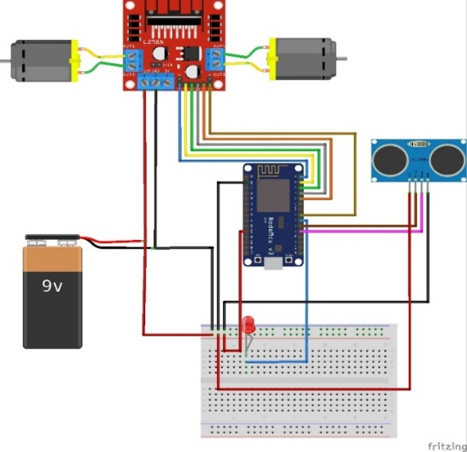

**Figure 4** Conveyor Hardware Role

Information:

1. The digital foot or pin (16) is used as an output to activate the Enable A pin on the L298N motor driver
2. The digital foot or pin (5) is used as output to activate the IN1 pin on the L298N motor driver
3. The digital foot or pin (4) is used as output to activate the IN2 pin on the L298N motor driver
4. The foot or digital pin (0) is used as an output to activate the Enable B pin on the L298N motor driver
5. The foot or digital pin (2) is used as an output to activate the IN3 pin on the L298N motor driver
6. The digital foot or pin (14) is used as an output to activate the IN4 pin on the L298N motor driver
7. The digital foot or pin (13) is used as ultrasonic signal generator
8. The digital foot or pin (15) is used as a (receiver/indicator) to detect ultrasonic reflection signals
9. The digital foot or pin (12) is used as a ground flow generator of ESP8266

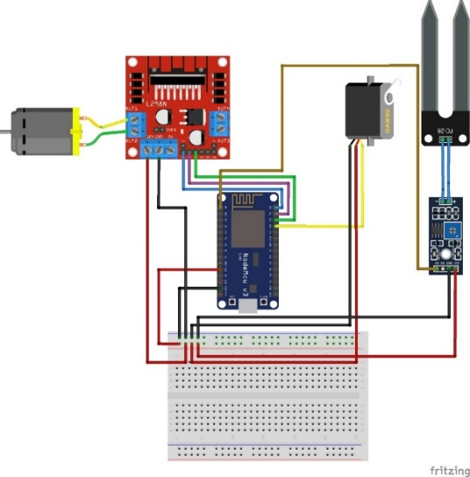

**Figure 5**Mixer Hardware Design

Information:

1. The digital foot or pin (16) is used as an output to activate the Enable A pin on the L298N motor driver
2. The foot or digital pin (5) is used as an output to activate the IN1 pin on the L98N motor driver
3. The digital foot or pin (4) is used as output to activate the IN2 pin on the L298N motor driver
4. The digital foot or pin (12) is used as the output of the servo motor, in order to drive the servo motor
5. The digital foot or pin (A0) is used as a data reader of soil moisture compost sensor
6. *Software Implementation*

The software implemented takes the form of an application built from Blynk application. The remote control application has 6 buttons that each button serves to send data to the user in the form of a control button on the rabbit manure collection tool and processing into compost that contains commands for each different function.

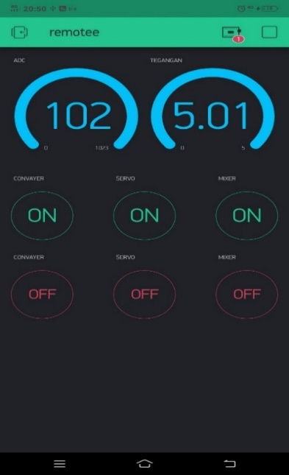

**Figure 6**Button and Gauge on the Blynk app

Information:

* 1. Download Blynk App on Play store/Appstore
  2. Open the app, and sign up for a new account or login using "Facebook"
  3. Create a new project, and choose one of the modules that will be used and module accessories that serve as a means of connecting to the internet
  4. After that drag and drop the design of this project

1. Then click Blynk to send the Auth Token by email
2. And finally check the email inbox and find the Auth Token which will be used for the program downloaded to the module / copy the Auth Token code to Arduino IDE
3. Blynk app ready to use
4. *Testing*

The final stage of system design is a trial of rabbit manure collection tools and processing into fertilizer to determine whether the system is able to run as it should. There are 2 main parts in this tool, namely the conveyor part (as a collection of rabbit feces and the mixer part (as processing into compost).

1. Conveyor Test

**Table 1** ConveyorTest

|  |  |  |
| --- | --- | --- |
| **No.** | **Voltage** | **Conveyor Speed** |
| 1 | 9 volts | Slow |
| 2 | 12 volts | Keep |

1. Mixer Testing

**Table 2** Mixer Testing

|  |  |  |  |
| --- | --- | --- | --- |
| **No.** | **Voltage** | **Motor Servo** | **Motor DC** |
| 1 | 9 volts | Keep | Keep |
| 2 | 12 volts | Keep | Fast |

1. Servo testing

**Table 3** Servo Testing

|  |  |  |
| --- | --- | --- |
| **No.** | **Servo** | **Information** |
| 1 | Position 00 | Normal state dirt container |
| 2 | Position 1800 | Open a dirt container |
| 3 | Position 900 | Close the dirt container |

1. Remote Control Application testing

**Table 4**Testing Button Remote Control Application

| **No.** | **Button** | **Condition** | **Action** | **Information** |
| --- | --- | --- | --- | --- |
| 1 | V1, V2/ ENA, ENB | 1x press ON | IN1 OFF and IN2 ON | MOVING CONVEYOR DC motor |
| 1x press OFF | IN1 OFF and IN2 OFF | DC conveyor motor stops |
| 2 | V3, V4/ D6 | 1x press ON | Servo is in position 1800 | The placeholder moves up/opens |
| 1x press OFF | Servo is in position 900 | The placeholder moves down/ closes |
| 3 | V7, V8/ ENA | 1x press ON | IN1 OFF and IN2 ON | Mixer Moves |
| 1x press OFF | IN1 OFF and IN2 OFF | Mixer stops |

1. *Discussion*

**Table 1**. For the use of conveyors on this tool use 3 pieces of wood as wheels and 2 dc motors as drive. The test is done by testing the voltage used to drive 2 DC motors on the conveyor. DC motor requires a voltage of 3.5 volts for the front to run, here uses 2 DC motors which means 7 volts to the voltage on the conveyor, and uses it simultaneously. The voltage source uses a 12-volt adapter.

**Table 2**. For the use of mixers using 1 DC motor and 1 servo motor which each also requires a voltage of 3.5 volts. The voltage source used is also a 12-volt adapter that is different from the conveyor, but in this device, the DC motor and servo motor are not run simultaneously to avoid the division of current on the voltage for dc motors and servo motors. Testing is carried out on mixers mainly in the DC motor section as the main component of rabbit manure stirrers whether it can run at the appropriate speed for compost fertilizer processing due to voltage division with servo motors.

**Table 3**. Testing for servo motors is also carried out in accordance with its function, namely to deflect the dirt shelter up or down can function properly, namely according to the angle produced by the servo motor.

**Table 4**. The Remote control application has three buttons that each serves as a conveyor, a dirt reservoir valve, and a mixer. The conveyor and mixer connected to the DC motor can be driven and turned off by calling the button and giving commands to convert the input value to ON or OFF in one of its inputs with a 1x press ON mechanism and 1x press OFF. For the dirt container valve is connected to a servo motor that is able to change the direction of the valve so that the container can open or close with a mechanism of 1x press ON and 1x press OFF through the button in the application.

1. Conclusion

The provisional conclusions reached until this progress report is made are:

1. DC motor requires a voltage of 3.5 volts for the front to run, here uses 2 DC motors which means 7 volts to the voltage on the conveyor, and uses it simultaneously.
2. The voltage source used is also a 12-volt adapter that is different from the conveyor, but in this device, the DC motor and servo motor are not run simultaneously to avoid the division of current on the voltage for dc motors and servo motors..
3. The dirt container valve is connected to a servo motor that is able to change the direction of the valve so that the container can open or close with a mechanism of 1x press ON and 1x press OFF through the button in the application.

**Acknowledgments**

Thank you to the research and community service center (P3M) of Polytechnic Harapan Bersama, the Study Program of Computer Engineering, and peers.

**References**

[1] D. Rofifah, “Laporan Kinerja Direktorat Jenderal Peternakan dan Kesehatan Hewan Tahun 2020,” *Pap. Knowl. . Towar. a Media Hist. Doc.*, pp. 12–26, 2020.

[2] N. Nurhidayati and A. Basit, “Pemanfaatan Limbah Ternak Kelinci untuk Pembuatan Pupuk Organik Padat dan Cair,” *J. Pengabdi. Kpd. Masy. (Indonesian J. Community Engag.*, vol. 6, no. 4, pp. 260–266, 2020, doi: 10.22146/jpkm.53322.

[3] R. Anwar and D. Djatmiko, “Limbah Ternak Kelinci Sebagai Bahan Baku Pupuk Organik Potensial,” *J. Agroqua Media Inf. Agron. dan Budid. Perair.*, vol. 16, no. 2, p. 152, 2018, doi: 10.32663/ja.v16i2.506.