**Reflux Extract of Cuciwis (*Brassica oleracea* L. var. *capitata f. alba* Alef) Influenced by Temperature and Time of Extraction**

H. Nurcahyo1, R. Febriyanti1, A.B. Riyanta1, H. Sutanto2, W. Herdwiani3

1 ***Department of Pharmacy, Politeknik Harapan Bersana, Tegal, Indonesia, 4Department of Pharmacy, Universitas Diponegoro, Semarang, Indonesia, 5Department of Pharmacy, Universitas Setia Budi, Surakarta, Indonesia***

*Corresponding author: herunurcahyo7770@gmail.com

**Abstract.**

The quality of the extract is influenced by the procedures utilized in the extraction process. The yield, antioxidant activity (DPPH), and total phenol of cuciwis (*Brassica oleracea* var. *capitata f. alba* Alef) extracts were all tested. The aim of the research was to determine the best temperature and time for hexane-based reflux extraction. The modeling methodology used the surface response method (RSM) with a central composite design (CCD). The best results were obtained after 3 hours at 33.85°C: 18,585, 27,848 % DPPH radical scavenging, and 3,788 mg/g total phenol.

**Keywords:** Cuciwis, reflux, RSM, DPPH, total phenol

1. **Introduction**

According to the Indonesian Ministry of Agriculture, Indonesia's vegetable exports in 2016 amounted to 40,240 tons of cabbage, mustard greens, and cauliflower, and 77 other types of vegetables were exported to Taiwan, Malaysia, Singapore, Thailand, and the Netherlands, with good economic value and trust from consumers from 29 countries. However, because the use of cuciwis cabbage in the country is still minimal, it has to be investigated as a possible health product, one of which is as an antioxidant source. Natural antioxidants can protect the body from harm caused by reactive oxygen species, prevent the onset of degenerative diseases, and stop lipid peroxides from forming in food [1].

Polyphenolic chemicals, carotenoids, and vitamins are natural antioxidants found in plants that have pharmacological actions such as anti-inflammatory, anticancer, antibacterial, and antiviral [2]. The stem of the island is one of the plants in Indonesia that has traditionally been used as medicine by the locals (*Alstonia scholaris* R. Br). The content of phenol has a positive linear connection with antioxidant activity. Fruits, vegetables, and other plants contain phenolic chemicals, particularly phenolic acids and flavonoids, which are natural antioxidants [2]. Extraction parameters are the most critical element in getting these secondary metabolites. Operating temperature, stirring speed, solid particle size, shape, and condition, and solvent type and amount are all factors that affect extraction. Mass transfer is a physical event that occurs during the extraction process. The variation in concentration from a high concentration to a lower concentration causes mass transfer. The larger the concentration difference, the faster mass transfer and equilibrium are achieved [3]. Using the Surface Response Method (RSM) with a factor of temperature, duration, and a 70 percent alcohol solvent reflux extraction method to maximize the absorption of the active substance, then antioxidant testing with diphenyl picryl hydrazil, this research was optimized to get the best antioxidant (DPPH) [4].

The lowering of the purple color was used to determine antioxidant activity. When DPPH is combined with an antioxidant, the antioxidant releases hydrogen, which is captured by DPPH and transformed into 1,1-diphenyl-2-picrihydrazil, which results in a color change from purple to yellow. The antioxidant activity parameter is the IC50 value (50 percent inhibitor concentration), which is calculated using the regression equation.This study used UV-Vis spectrophotometry to investigate the antioxidant activity of kawista fruit using the free radical scavenging technique diphenyl picryl hydrazil (DPPH) and the IC50 value.

1. Methods

The tools used in the study are UV-Vis spectrophotometry, rotary evaporators, a set of reflux tools, analytical balance sheets, micropipets, blenders, and glass tools. Ingredient Data: 70% ethanol, 1,1-Difenyl-2- Picrilhydrazil (DPPH), ABTS, and vitamin C.

**Extraction Methods**

Treatment of raw materials includes sorting, washing, and cutting of cuciwis cabbage further. Extraction is done by reflux method using 70% ethanol solvent. As much as 50 grams of cuciwis cabbage are diflux using a solvent as much as 75 mL. Reflux is carried out for 6 hours at a temperature of 70ºC. The extraction results are filtered with Whatman filter paper No. 41.

**DPPH radical scavenging activity analysis**

A 40 ppm DPPH solution with a volume of 100 ml is made by weighing 0.004 g of DPPH dissolved in 70% ethanol. Taken as much as 3 ml to observe its absorption at wavelengths of 450-600 nm. 1000 ppm of ethanol extract with maceration and sokletation is made by weighing 0.01 g of cuciwis ethanol extract and dissolved in 70% ethanol. The solution is diluted so that a concentration of 20 is obtained; 40; 60; 80 and 100 ppm. The solution is taken as much as 2 ml each and added a solution of DPPH 40 ppm as much as 4 ml, Incubated for 30 minutes and observed uptake that occurs at maximum wavelength. As a comparison is done the same way for vitamin C. The percentage of antioxidant scavenging against free radicals is calculated by the following equation:

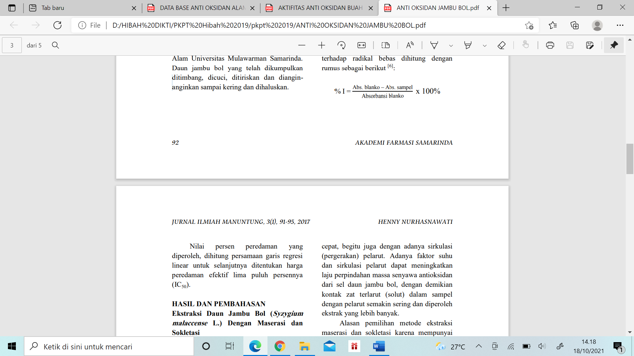

The percent value of the damping obtained, calculated the equation of the linear regression line to further determine the effective radical scavenging by IC50.

1. Results and Discussion

The Design of the experiments

In this study, experiments were carried out using the RSM approach, which can help in identifying the influence of the model used, which has two parameters and three levels, including temperature, time, and solvent. The reaction parameter test circumstances are taken at three levels: point 0 (center point), one level (+1), and one level (-1), resulting in the presentation of 13 extraction models using the reflux method. The software's percent outcome is the percent forecast result. The proportion of prediction results appears when the percentage of actual outcomes is entered into the Design Expert v.7 application and statistical analysis is done. The percentages of actual and expected results are shown in Tables 1 and 2.

Table 1. The variables and levels in experimental design

|  |  |  |  |  |  |  |
| --- | --- | --- | --- | --- | --- | --- |
|  | Factors | Level | | | | |
| -α | -1 | 0 | 1 | +α |
| Temperature (℃) | X1 | 45,9 | 50 | 60 | 70 | 74,1 |
| Time (Hour) | X2 | 0,59 | 1 | 2 | 3 | 3,41 |

Table 2. The experimental design for optimizing the extraction process

|  |  |  |  |  |  |  |  |  |
| --- | --- | --- | --- | --- | --- | --- | --- | --- |
| STD | Run | Variables | | | | Responses | | |
| Code | Actual (Hour) | Code | Actual (℃) | Yield (%) | Radical scavenging DPPH (%) | Total Phenol (mg GAE/100 gram) |
| 1 | 1 | -1 | 1 | -1 | 50 | 17,68 | 18,28 | 434,5 |
| 11 | 2 | 0 | 2 | 0 | 60 | 21,38 | 22,05 | 269,5 |
| 10 | 3 | 0 | 2 | 0 | 60 | 26,32 | 18,15 | 709,5 |
| 7 | 4 | 0 | 0,59 | -1,41421 | 60 | 18,82 | 27,28 | 324,5 |
| 8 | 5 | 0 | 3,41 | 1,41421 | 60 | 27,44 | 23,44 | 1699,5 |
| 5 | 6 | -1,41421 | 2 | 0 | 45,9 | 25,32 | 18,68 | 159,5 |
| 13 | 7 | 0 | 2 | 0 | 60 | 26,8 | 22,12 | 1039,5 |
| 12 | 8 | 0 | 2 | 0 | 60 | 27,84 | 25,83 | 2304,5 |
| 6 | 9 | 1,41421 | 2 | 0 | 74,1 | 22,22 | 24,9 | 1479,5 |
| 3 | 10 | -1 | 3 | 1 | 50 | 30,52 | 30,2 | 929,5 |
| 4 | 11 | 1 | 3 | 1 | 70 | 22,84 | 20,46 | 764,5 |
| 2 | 12 | 1 | 1 | -1 | 70 | 16,48 | 27,81 | 1424,5 |
| 9 | 13 | 0 | 2 | 0 | 60 | 14,06 | 25,5 | 819,5 |

The model in Table 2 has a significant p-value since the p-value is less than 0.05. Based on Table 3, A represents the time variable and B represents the temperature variable. The temperature variable (B) and the interaction between temperature and time are the parameter criteria relevant to the response, as seen in the ANOVA table (AB). This shows that parameters B and AB have a significant impact on the response and model used. Another thing to note is that the numbers 3 and 1 have a significant impact on the response. This shows that increasing the value of variable B (reaction temperature) has a significant impact on the response.

The linear model equations for each parameter are presented below:

Yield = 22,9-1,66A-3,92B

DPPH =23,44+1,07A-0,11B-4,82AB

Total phenol = 3,17+1,12A+0,74B

Analysis of Regression the coefficient of determination (R2) value is used to determine whether the model developed is consistent with the data; a small R2 value indicates that the independent variables' ability to explain the dependent variables are limited (Puspa Dewi & Maisaroh, 2020).

Based on Table 3, an acceptable modeling value is obtained to describe the optimization conditions, namely the linear model with a p value of 0.05 and a coefficient of determination of R2 = 0.95, indicating that the independent variables, namely temperature and extraction time, influence 95 percent of the variables in the reflux extraction. R2 is quite close to 1, showing a high degree of correlation between observation and predicted values. The accuracy of the model used is described by the lack-of-fit value of 0.986 and the lowest value of 0.5913.

Table 4. The three solutions obtained from the software

|  |  |  |  |  |  |
| --- | --- | --- | --- | --- | --- |
| Solutions | Independent Variables | | Dependent Variables | | |
| Temperature (⁰C) | Time Extraction (hour) | Yield | Radical scavenging of DPPH | Total phenol |
| Solution 1 | 50 | 3 | 17,320 | 29,437 | 3,549 |
| Solution 2 | 49,45 | 3 | 17,364 | 29,382 | 3,557 |
| Solution 3 | 33,85 | 3 | 18,585 | 27,848 | 3,788 |

The impact of independent variables on each response is presented in Figure 1. Three solutions were obtained from the expert design (Table 4). Provide a solution in which the optimal value is attained after 3 hours at 33.85°C. As the elicitation temperature rises, the antioxidant activity (IC50) and total phenol content decrease (Rijal, 2020). In the solution's results, the antioxidant activity by reducing radicals in cabbage washes was discovered to be 27.848 percent (Table 4). Based on the study, cabbage washes had a total phenol concentration of 3,788 mg/g. The results of this study are in line with previous research, which suggests that eliciting total phenol concentration at temperatures below 50 °C increases total phenol concentration. This process creates and increases the amount of phenolic compounds as well as the antioxidant activity of cabbage washing in this study [5].

The interaction between time and temperature variables based on Figure 1, it can be seen that the interaction between time and temperature has an effect on the percent of results obtained. At a temperature of 50°C and a reaction time of 3 hours, the % yield of DPPH antioxidants can be seen.

This is phenol absorption at 33.85-50 degrees Celsius with an extraction time of 3 hours, where the longer the extraction time, the higher the rate of movement of each molecule, increasing the frequency of collisions between molecules and speeding up the reaction (Melani et al., 2021).

Figure 1. All three-dimensional graphs showing the influence of temperature and extraction time on yield.

Analysis of variance (ANOVA) on the response yielded the best model, namely the quadratic model and the regression equation: Yield = 22.9-1.66A-3.92B. Based on several studies, it is stated that a high extraction temperature will cause the yield of gelatin produced to decrease. It is suspected that high temperatures cause further hydrolysis so that some of the active substances are also degraded and cause a decrease in the amount of yield. The low yield is thought to be caused by denaturation of the active substance at high temperatures during the extraction process [6].

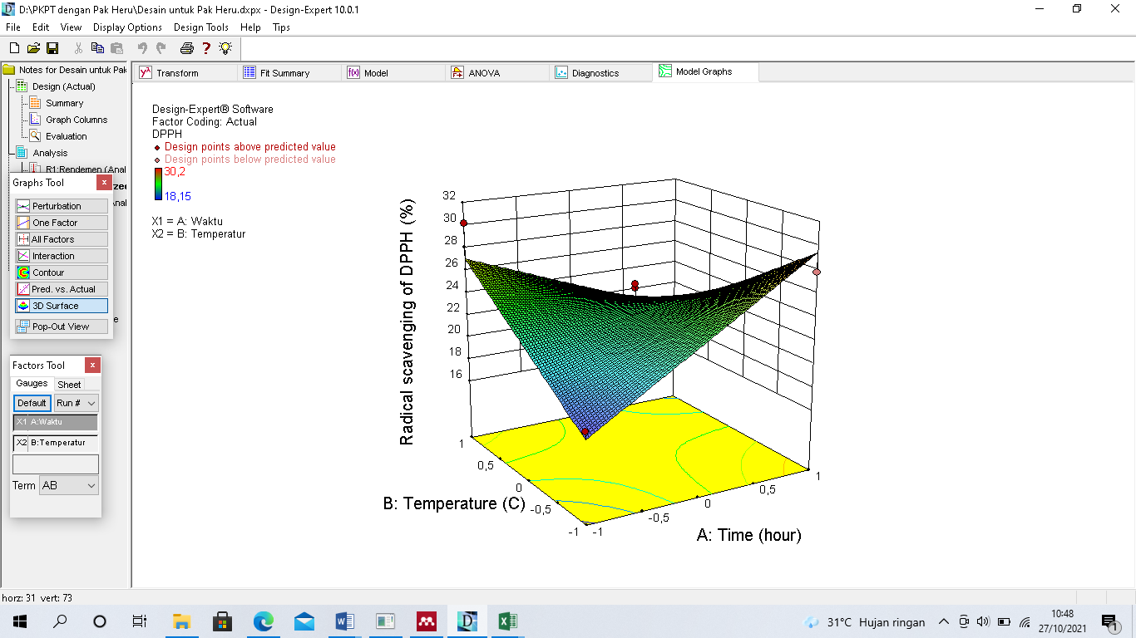

Figure 2. All three-dimensional graphs showing the effect of temperature and extraction time on DPPH's radical scavenging activity.

The best model, the quadratic model, was found using analysis of variance (ANOVA) on the response of DPPH antioxidant activity, obtaining the regression equation: DPPH = 23.44+1.07A-0.11B-4.82AB. The relationship between the two variables of temperature and time is shown on a contour plot and a surface graph of antioxidant activity response (Figure 2). Figure 2 shows the result of the observed reaction as a circular line, with the best result indicated by a red dot in the center. So it can be seen that the optimal point in the image is in the red area, or the area with the highest response data. Because it is expected that the value of radical scavenging activity will decrease at its optimal point, the center of the 3D graph will point downwards. The optimal point in the middle of the 3D graph, which is pointing upwards, indicates that the measurement of the distance range of the temperature and time variables is incorrect. When heated at a specific time, the value of radical scavenging activity will decrease.

The high temperature used in the elicitation process can cause antioxidant compounds to dissolve into the solvent. This also applies to the duration of the extraction, because the longer the extraction takes, the more cells in the material are damaged. This damage is in line with the effects of high temperatures, which can also damage cell walls and plasma membranes. The extraction solvent passes through the cell wall and vacuole, dissolving the antioxidant compounds in the solvent [7]. The dissolution of these compounds allows bioactive compounds that have antioxidant activity to also dissolve into the solvent. At a certain point, heating will open the system of cuciwis cabbage so that secondary metabolites are formed that have antioxidant activity [8].

The activation of NADPH oxidase, Mitogen Activated Protein Kinase (MAPK), and jasmonate hormone, as well as the production of Reactive Oxygen Species (ROS) and Reactive Nitrogen Species (RNS), is induced by increasing the temperature and length of extraction time (RNS). Processes that happen in the cytosol will be taken to the nucleus of the cell. The continuing induction process in the cell nucleus will regulate transcription factors, causing them to express genes that produce secondary metabolites. Secondary metabolites are generated during this process, and they have the ability to destroy free radicals up to 50%, which is known as IC50 antioxidant activity. The material's hydroxyl group is responsible for this capacity. In general, the stronger the ability to destroy free radicals, the more secondary metabolites created; however, if this is not the case, the secondary metabolite compounds formed are said to have no antioxidant activity [5].

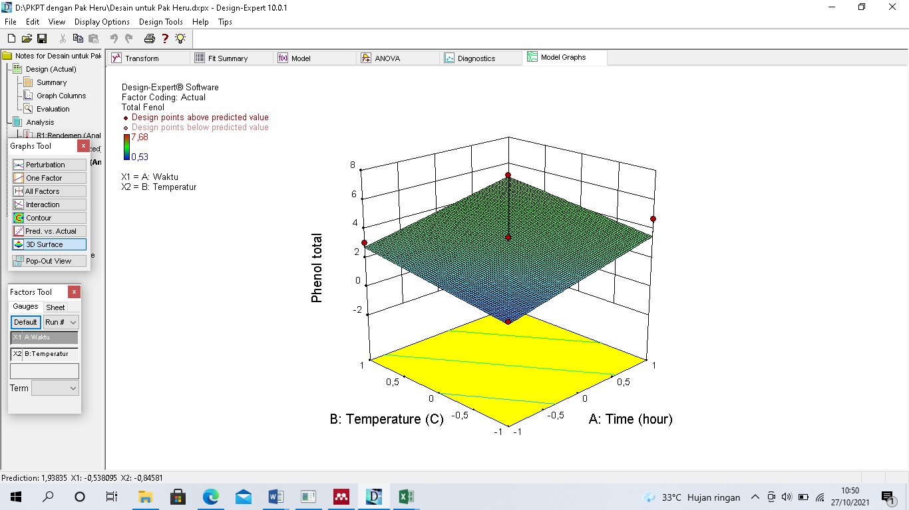

Figure 3. All three-dimensional graphs showing the effect of temperature and extraction time on total phenol

The total phenol response with analysis of variance (ANOVA) on total phenol response, the quadratic model, and the total phenol regression equation = 3.17+1.12A+0.74B were shown to be the best. Figure 3 shows a contour plot and a surface graph of the total phenol response that show the relationship between the two temperature variables and the electroshock time.

Figure 3 shows the observed response as a linear line, with the best result in the middle and a red dot indicating that the best point in the image is in the red area, or the area with the highest response data. As indicated in the diagram, the rectangular curve also opens downwards. The ideal point in the center of the 3D graph indicates that the distance ranges of the temperature and time variables have been accurately measured. The total phenol content increased as the temperature and extraction period increased.

1. Conclusion

The modeling methodology using the surface response (RSM) method with a central composite design (CCD) provides recommendations for the best results obtained after 3 hours at a temperature of 33.85 °C: 18,585, 27.848% DPPH radical scavenger, and 3.788 mg/g total phenol.

**References**

[1]. Nurcahyo, H., Sumiwi, S. A., Halimah, E., & Wilar, G. (2020). Total Flavonoid Levels of Ethanol Extract and Ethyl Acetate Fraction Dry Shallots (Allium cepa L. var. Garden Onion of Brebes) with Maceration Methods Using UV-Vis Spectrophotometry. *Systematic Reviews in Pharmacy*, *11*(10), 286–289. https://doi.org/10.31838/srp.2020.10.48

[2]. Zuraida, Z., Sulistiyani, S., Sajuthi, D., & Suparto, I. H. (2017). Fenol, Flavonoid, Dan Aktivitas Antioksidan Pada Ekstrak Kulit Batang Pulai (Alstonia scholaris R.Br). *Jurnal Penelitian Hasil Hutan*, *35*(3), 211–219. https://doi.org/10.20886/jphh.2017.35.3.211-219

[3]. Khoirunnisa, I., & Sumiwi, S. (2019). *Review Artikel: Peranflavonoid Pada Berbagai Aktivitas Farmakologi*. *17*(2), 131–142.

[4]. Indriani, L., Gunawan, E. R., & Suhendra, D. (2021). Optimasi Sintesis Asam Lemak Etanolamida Berbasis Minyak Ketapang Menggunakan Response Surface Methodology. *Jurnal Pijar Mipa*, *16*(2), 247. <https://doi.org/10.29303/jpm.v16i2.2265>

[5]. Asshidiqy, R., Putri, W. D. R., & Maligan, J. M. (2020). Optimasi Elisitasi Suhu dan Waktu Kejut Listrik untuk Meningkatkan Aktivitas Antioksidan dan Kandungan Total Fenol Kacang Kedelai (Glycine max). *Jurnal Keteknikan Pertanian Tropis Dan Biosistem*, *8*(2), 153–160. https://doi.org/10.21776/ub.jkptb.2020.008.02.05

[6]. Melani, A., Purnama, D., Muhammadiyah Palembang Jln Jenderal Ahmad Yani, U., Seberang Ulu, U. I., Plaju, K., Palembang, K., Selatan, S., & Kunci, K. (2021). *Leaching Kalium Dari Limbah Sabut Kelapa Dengan Pelarut Air (Kajian Pengaruh Variasi Temperatur Dan Waktu)* (Vol. 6, Issue 1).

[7].Yulia Senja, R., Issusilaningtyas, E., Kharis Nugroho, A., & Prawita Setyowati, E. (2014). The Comparison Of Extraction Method And Solvent Variation On Yield And Antioxidant Activity Of Brassica oleracea L. var. capitata f. rubra Extract. *Traditional Medicine Journal*, *19*(1), 2014.

[8]. Silviani, Y., & Nirwana, A. P. (2020). Aktivitas Antibakteri Ekstrak Etil Asetat Daun Sukun (*Artocarpus altilis*) Metode Perkolasi Terhadap Pseudomonas aeroginusa. In *Jurnal Kesehatan Kusuma Husada-Januari*.