Nano-Hydrogel Characterization of Chitosan-Annona Muricata Extract by Using Ionic Gelation

**Nuniek Nizmah Fajriyah1, Muhtadi2*, Fahrun Nur Rosyidand3 Eko Mugiyanto4,**

1,,4University of Muhammadiyah Pekajangan Pekalongan, Indonesia, 51172   
 2,3University of Muhammadiyah Surakarta, Indonesia, 57169

* Corresponding author: muhtadi@ums.ac.id

**Abstract.** Chitosan is a linear copolymer that is randomly distributed. It’s has many appealing properties, including good biocompatibility, biodegradability, permeation enhancing effect, cationic properties, and so on. Because of these advantages, chitosan is widely used in the pharmaceutical and tissue engineering fields. The goal of this research is to create chitosan nanoparticles incorporating with carbomer-based hydrogel using ionic gelation and tripolyphosphate (TPP) as a crosslinker in static mixers. The static mixing technique demonstrated reliable control over the ionic gelation process and 273–345 nm chitosan nanoparticles were achieved in a continuous and scalable mode. Annona muricata was used as an active ingredient and successfully loaded into the chitosan nanoparticle during the fabrication process. Our work shows that ionic gelation static mixing is a robust method for continuous and large scale production of chitosan nanoparticles for drug delivery.

Keywords: Ionic gelation, nano-hydrogel, varbopol-940, cross-linker

**Introduction**

Hydrogel polymers have functional moieties that permit binding between chains to construct stabilizing linkages, preventing gel dissolution. Non-covalent physical interactions, such as secondary forces (hydrogen, ionic, or hydrophobic bonding) and physical bonds, or covalent cross-linkages, are used to bind polymers [1]. Hydrogel dimensions can also vary greatly, spanning from nanometers to centimeters in width. They are also relatively deformable, allowing them to easily comply to the shape of any space in which they are confined [2]. Furthermore, because the physio chemistry of the hydrogel is comparable to that of the native extracellular matrix, both compositionally (as with GAGs) and mechanically, hydrogels can fulfill as dual-purpose devices, having to act as a supporting material for cells throughout tissue regeneration as well as delivering a drug cargo.

Encapsulation, in which all the polymer chains are cross-linked in the presence of the drug, protein, or macromolecule, can be used to achieve direct therapeutic loading into the hydrogel. Alternatively, after cross-linking, the therapeutic can be permitted to diffuse into the pores of the hydrogel [3]. While both of these methods are the simplest ways to introduce active agents into the hydrogel, the release of the loaded molecules is not well controlled. Classic release profiles produce rapid burst release of drugs during early hydrogel swelling following in vivo transfer, accompanied by an extended release of the residual drugs encapsulated within the gel network. These burst releases can result in losses of up to 70% of the therapeutic payload, but this can be reduced to 10–25% with improved polymer cross-linking [4]. Drug release profiles are also altered when drugs are added before or after cross-linking the polymer.

Because it is non-toxic, stable, biodegradable, and sterilizable, chitosan is an excellent compound. Because of these characteristics, chitosan is a very versatile material with a wide range of applications in the biomedical and biotechnological fields [5]. Chitosan hydrogels have been synthesized in a wide range of shapes, geometries, and preparations, including liquid gels, powders, beads, films, tablets, capsules, microspheres, microparticles, sponges, nanofibrils, textile fibers, and inorganic composites [6]. To form the hydrogel, chitosan is either physically associated or chemically cross-linked in each preparation. The following study will exploit the application oh chitosan incorporated with natural extract compound. Medicinal nature has given more affordably priced wound healing products with better safety from hypersensitive reactions when compared to conventional therapeutic drugs [7]. Annona muricata is a member of the Annonaceae family and is also recognized as soursop and graviola [8]. This tropical fruit tree's leaves are widely used within traditional medicine to treat skin diseases and abscesses [9]. Despite this, little research has been conducted on the use of A. muricata as an active component in topical applications and herbal nanoparticle preparations. As a result, the nano-sized topical drug delivery integration of A. muricata has a bright future for helping to improve activity and overcoming plant medicine problems.

**Material and method**

**Prepping of A. muricata extract.**

The tree was collected in the Indonesian province of Pekalongan. It was cultivated, ground, and extracted with 90% ethanol. Seperately, 500 g of the drug were weighed and macerated with alcohol. One day over cold maceration, the extract was then filtered, and the filtrate was concentrated by distilling the liquid until only one-third remained. The resulting mixture was filtered in a water bath at a maximum temperature of 60oC. Before being used in the experiments, the extract was left to dry in a desiccator.

**Prepping of a nano-hydrogel base**

Various amounts of Carbopol-940 (Merck) (0.5, 1.0, 2.0, and 3.0 percent) were uniformly distributed in 50 ml of distilled water with constant stirring, followed by the addition of 10 g glycerin as a moisturizing agent. To stabilize the pH, 1 g triethanolamine and 0.1 g methyl paraben were added into the solution. The solution was allowed to cool until it became a homogeneous mass.

**Prepping of nano A. muricata extract with ionic gelation method**

Chitosan nanoparticles were established using a custom designed method based on chitosan ionic gelation with sodium tripolyphosphate (NaTPP) anions [10]. Aqueous acetic acid (1 percent v/v) solution was used to solubilize low molecular weight chitosan (0.16 g) (MW 15,000). The chitosan solution was mixed for two hours at 60oC with a stirrer to create a viscous solution. The solution's pH was corrected to 4.7–4.8. 0.04 g of sodium tripolyphosphate (TPP) was dispersed in 20 mL of distilled water. The NaTPP solution was then supplemented with 0.5 g A. muricata ethanolic extract, which was agitated for an hour. Poured the entire mixture into the previously prepared chitosan solution and stirred it for 30 minutes. Until further testing, the nano Annona muricata was kept at 4°C.

**Assessment of Polymeric Nanoparticles and Hydrogels**

A digital pH meter is also used to determine the pH of the formula (digital pH meter, 335, systronics). The spreadability of a synthesized nanoparticles formulation was evaluated by measuring the size of the nano-hydrogel after one minute between two glass plates [11]. The viscosity of the nano-hydrogel was determined using a Brookfield DV-II+ Pro viscometer with spindle number 4 set to 60 revolutions per minute.

**Result and discussion**

The Annona muricata nano-hydrogel was produced by combining nano hydrogel base and nano Annona muricata extract as shown in **Figure 1**.

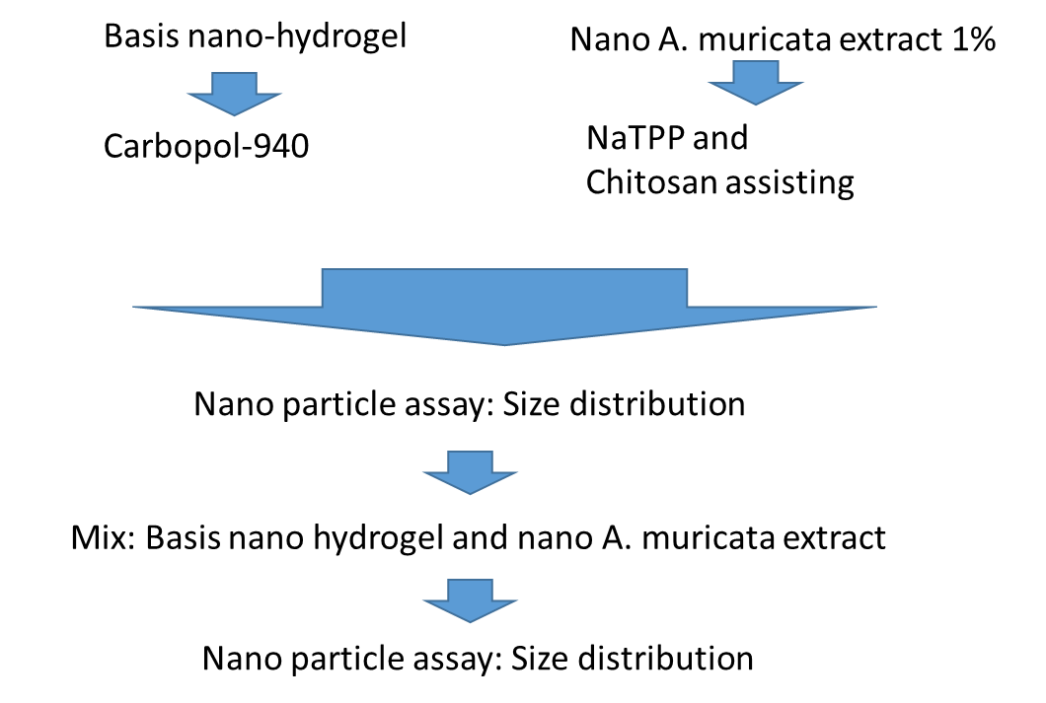

**Figure 1.** Cartoon figure of Annona muricata nano-hydrogel formulation

By stirring method, the prepared nano-hydrogel basis was integrated into nano Annona muricata extract containing carbopol-940 in various ratios. **Table 1** shows four formulations created by varying the ingredients.

**Table 1.** Formulation design of nano-hydrogel basis

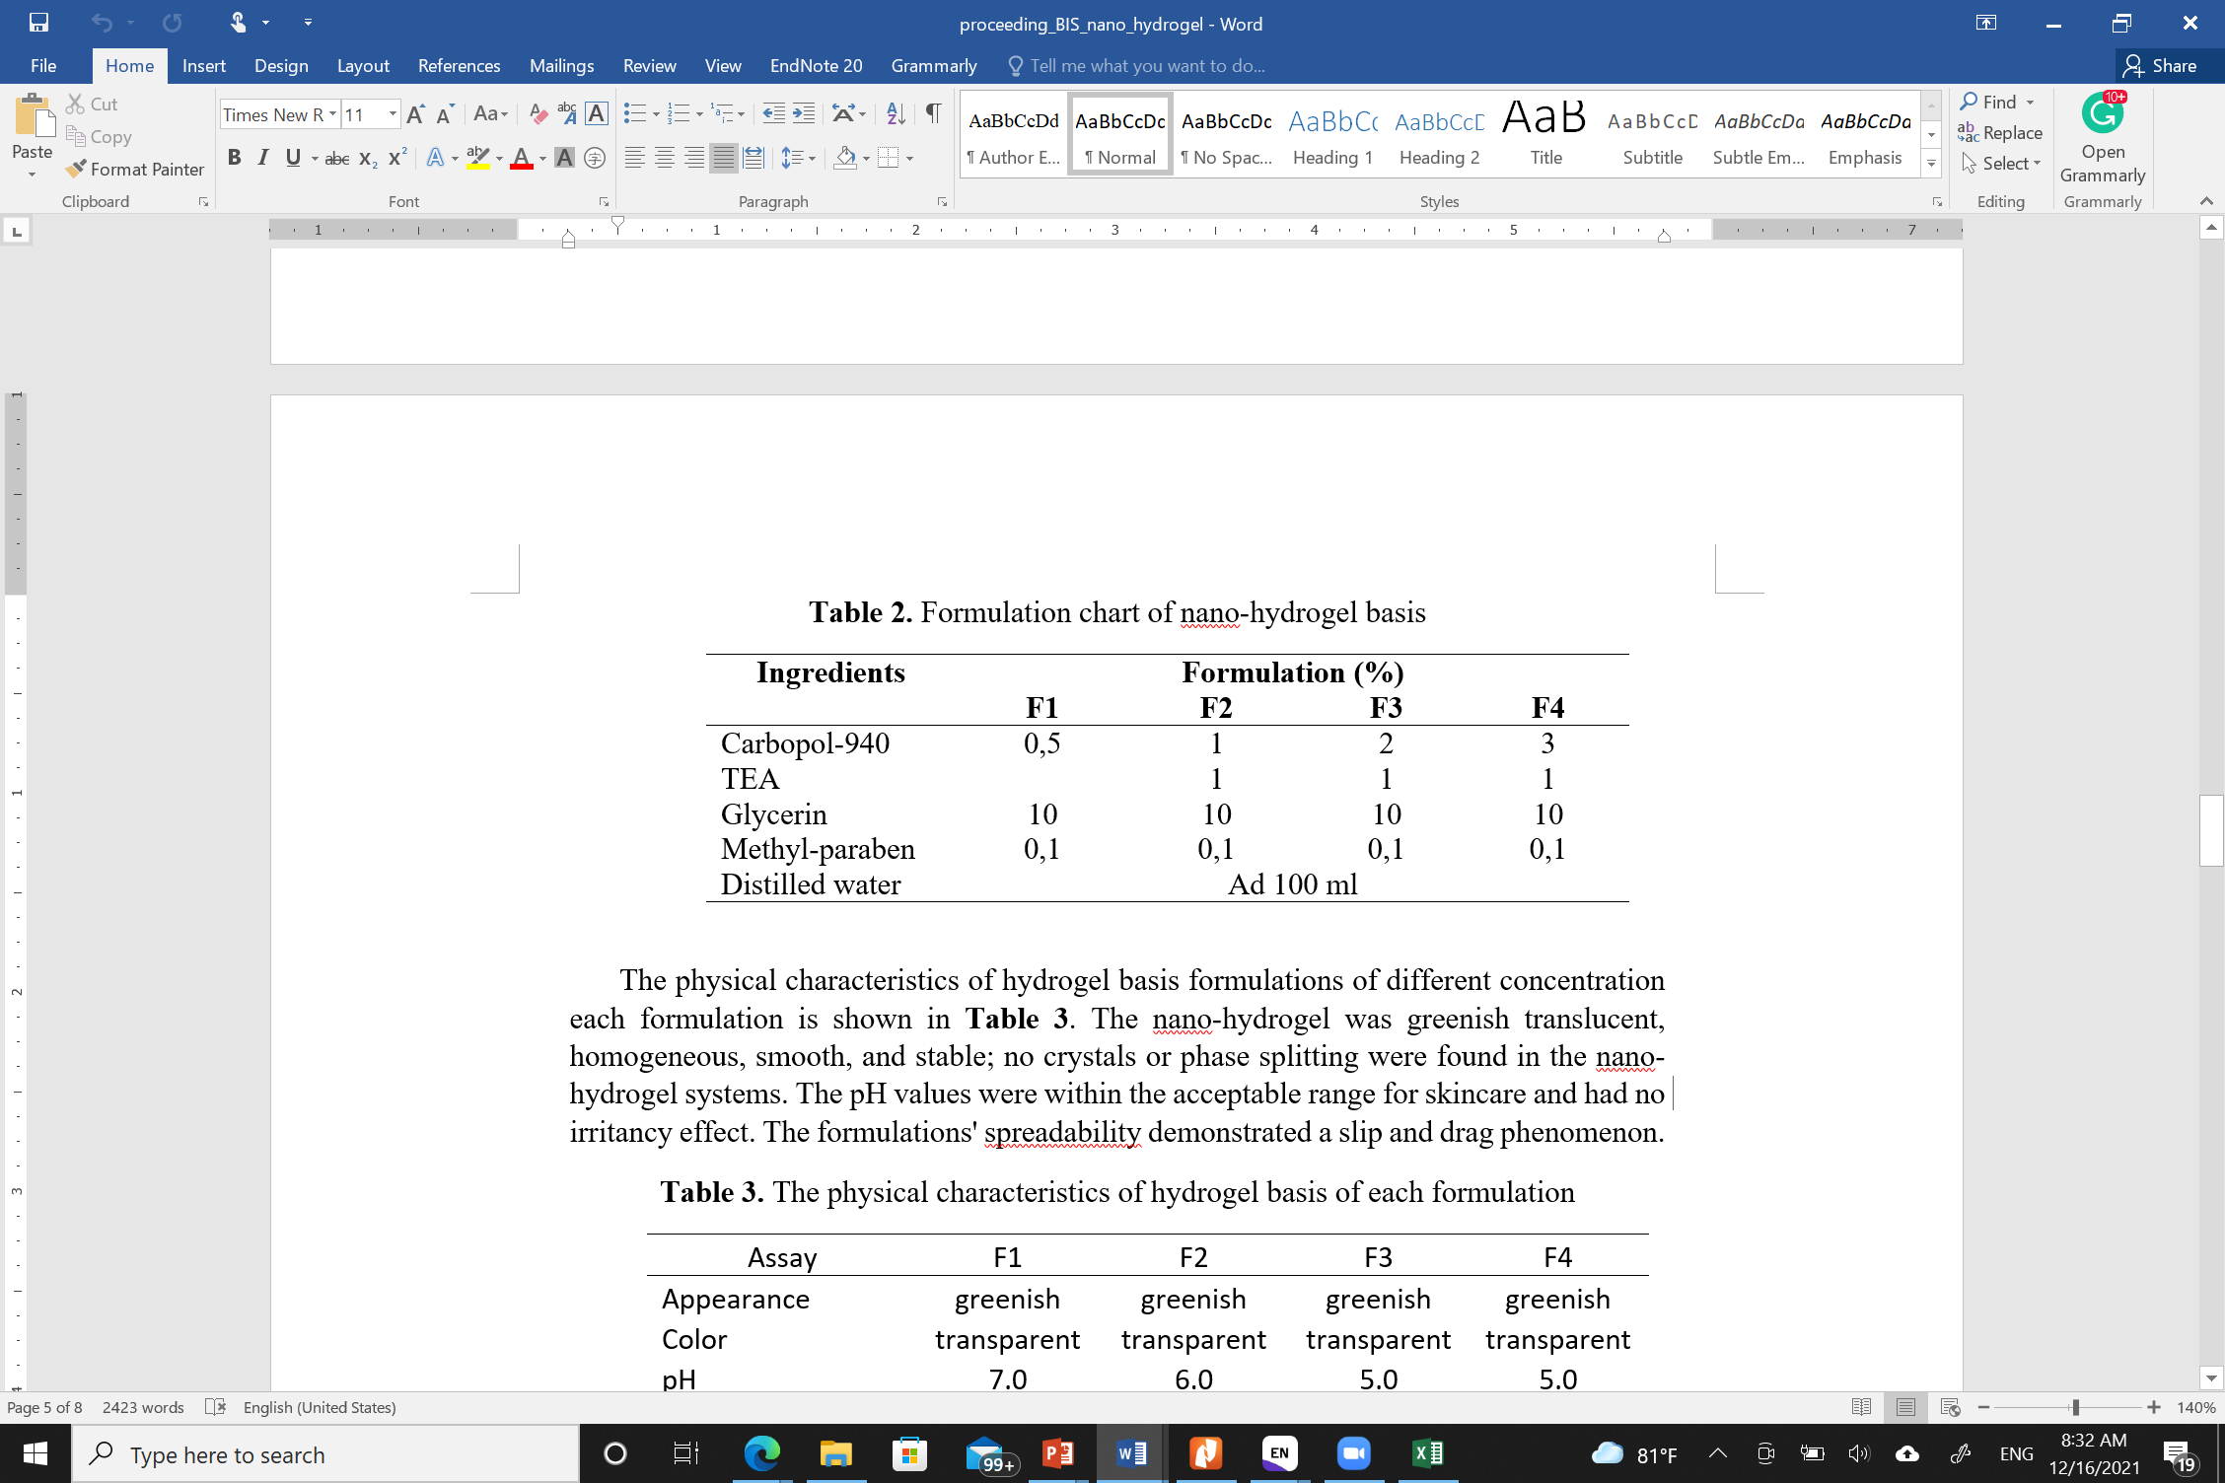

Generating of Annona muricat hydrogel is by integrating of nano Annona muricata and nano hydrogel base. Table 2 describes the characterization of Annona muricata hydrogel. According to the data, F3 produced the best results in terms of consistency and viscosity.

**Table 2.** The properties of Annona muricata hydrogel with different formulation basis

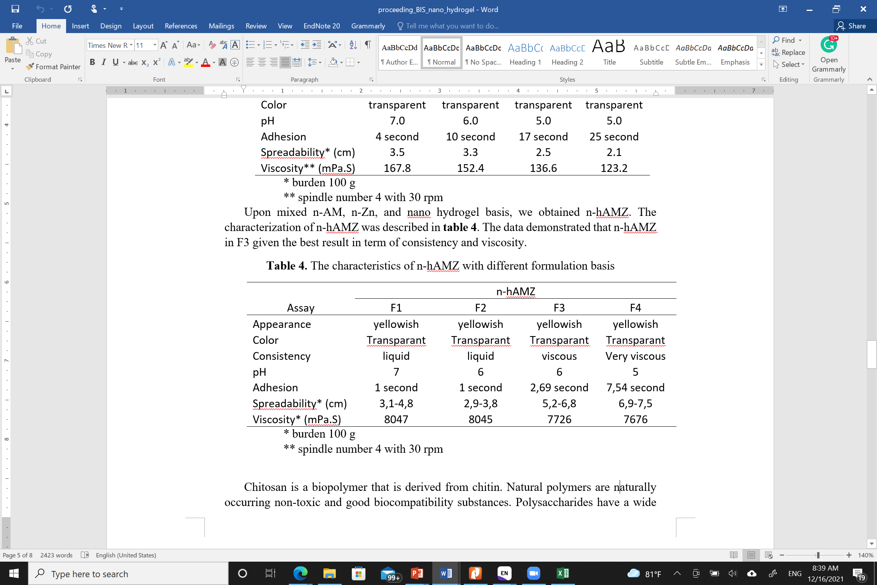

Chitosan is a natural polymer originating from the protein chitin. Biopolymers are non-toxic and biocompatible substances that occur naturally. Polysaccharides have a huge proportion of chemically customizable functional groups and a wide range of molecular weights. Polysaccharides increase the water solubility of the functionalized hydrophobic moiety, which is beneficial for drug delivery and other medical applications [12]. Using the ionic gelation method, we established chitosan nanoparticles with an average size of 282.75 12.6 nm. The characterizations of the Annona muricata nano-hydrogel components are shown in **Table 3**.

**Table 3.** The size of A. muricata nano-hydrogel incorporation

|  |  |  |  |
| --- | --- | --- | --- |
|  | nano A. muricata | Hydrogel basis | A. muricata nano hydrogel |
| Average size (nm) | 282.74±12.6 | 169.5±10.6 | 358.45±11.3 |

**Conclusion**

The nano Annona muricata formulation with ionic gelation method and incorporated with various carbopol-940 content was successfully established. F3 formulation with 2% carbopol-940 concentration is the formula of choice cause of accepted physical characteristic

Refference

[1] N. Bhattarai, J. Gunn, and M. Zhang, Chitosan-based hydrogels for controlled, localized drug delivery. Adv Drug Deliv Rev 62 (2010) 83-99.

[2] F. Khan, R.S. Tare, R.O. Oreffo, and M. Bradley, Versatile biocompatible polymer hydrogels: scaffolds for cell growth. Angew Chem Int Ed Engl 48 (2009) 978-82.

[3] C.C. Lin, and A.T. Metters, Hydrogels in controlled release formulations: network design and mathematical modeling. Adv Drug Deliv Rev 58 (2006) 1379-408.

[4] X. Huang, and C.S. Brazel, Analysis of burst release of proxyphylline from poly(vinyl alcohol) hydrogels. Chemical Engineering Communications 190 (2003) 519-532.

[5] R. Muzzarelli, and C. Muzzarelli, Chitosan Chemistry: Relevance to the Biomedical Sciences, 2005, pp. 151-209.

[6] E.B. Denkbas, and R.M. Ottenbrite, Perspectives on: Chitosan Drug Delivery Systems Based on their Geometries. Journal of Bioactive and Compatible Polymers 21 (2006) 351-368.

[7] S. Zorofchian Moghadamtousi, H. Abdul Kadir, P. Hassandarvish, H. Tajik, S. Abubakar, and K. Zandi, A Review on Antibacterial, Antiviral, and Antifungal Activity of Curcumin. BioMed Research International 2014 (2014) 186864.

[8] E. Mugiyanto, A.N. Cahyanta, I.M.A.S. Putra, S. Setyahadi, and P. Simanjuntak, Identifying active compounds of soursop ethanolic fraction as α-glucosidase inhibitor. Pharmaciana 9 (2019) 191-200.

[9] S.Z. Moghadamtousi, E. Rouhollahi, M. Hajrezaie, H. Karimian, M.A. Abdulla, and H.A. Kadir, Annona muricata leaves accelerate wound healing in rats via involvement of Hsp70 and antioxidant defence. Int J Surg 18 (2015) 110-7.

[10] F.C. Iswanti, I. Nurulita, S. Djauzi, M. Sadikin, A.B. Witarto, and T. Yamazaki, Preparation, characterization, and evaluation of chitosan-based nanoparticles as CpG ODN carriers. Biotechnology & Biotechnological Equipment 33 (2019) 390-396.

[11] P. Batheja, L. Sheihet, J. Kohn, A.J. Singer, and B. Michniak-Kohn, Topical drug delivery by a polymeric nanosphere gel: formulation optimization and in vitro and in vivo skin distribution studies. Journal of controlled release 149 (2011) 159-167.

[12] A. Basu, K.R. Kunduru, E. Abtew, and A.J. Domb, Polysaccharide-Based Conjugates for Biomedical Applications. Bioconjug Chem 26 (2015) 1396-412.