**BOOKKEEPING**

**APPLICATION DESIGN**

**ANDROID-BASED FOR MSMEs**

Yeni Priatnasari

Accounting Department

Politeknik Harapan Bersama

Tegal Indonesia

yeni.priatna@gmail.com

Hetika

Accounting Department

Politeknik Harapan Bersama

Tegal, Indonesia

[hetika_tika@gmail.com](mailto:hetika_tika@gmail.com)

Vembri Rian Diansyah

Informatic and Technology Department

Politeknik Harapan Bersama

Tegal, Indonesia

vembrivrd@gmail.com

***Abstrak*—** **This research aims to design an android-based bookkeeping business application that will be developed by Accounting study program (AKPHB Business Bookkeeping) with business recording applications that have developed on the internet.**

**The research method used is an exploratory descriptive method with several items to be designed such as display (user interface), ease of use, completeness of presentation of business reports, as well as accessibility for MSMEs engaged in several fields. This research is expected to produce a more thorough comparison so that it can be known the advantages and disadvantages of each business recording application. In the future, it is expected that the development of business recording applications (AKPHB Business Bookkeeping) can be a more complete application and make it easier for small business owners to record and to make a simple financial report.**

***Keywords: comparative studies, business recording applications, android applications, MSMEs, bookkeeping***

# introduction

# **Background of the Problem**

The development of today's business world is growing rapidly. This is due to the rapid development of the internet and triggered by the covid-19 pandemic which has caused changes in many things, changing manual work patterns into technology and internet-based work mechanisms. MSME actors have a contribution that cannot be underestimated in the economy in the city of Tegal in particular and in Indonesia in general. The role and contribution of MSMEs is mainly in their contribution to employment in the informal sector.

The ukmindonesia.id page presents data sourced from the Indonesian Ministry of Cooperatives and SMEs regarding the number of MSME units having a share of around 99.99% (62.9 million units) of the total number of business actors in Indonesia in 2017. On the other hand, large businesses only consist of approx. 5400 units or about 0.01%. Meanwhile, in terms of the level of employment, Micro Enterprises absorb around 107.2 million workers (89.2%), Small Enterprises 5.7 million (4.74%), and Medium Enterprises 3.73 million (3.11%). ); while Large Enterprises only absorb around 3.58 million people. From this, it can be concluded that cumulatively MSMEs absorb around 97% of the national workforce, while Large Enterprises only absorb about 3% of the total workforce at the national level [1].

Indonesian MSMEs faced big challenges when the opening of *securities crowd funding* which was inaugurated by President Joko Widodo on the first day of stock trading on the Indonesia Stock Exchange. On that occasion, Chairman of the Board of Commissioners of the Financial Services Authority (OJK) Wimboh Santoso said that the stock exchange authority continued to accelerate efforts to promote the capital market, both for young entrepreneurs and SMEs to raise funds from the capital market and for potential investors to start investing in the capital market [2]. The hope of launching *securities crowd funding* is that more MSMEs will receive funding for their business activities.

The thing that must be considered when these challenges are faced by MSMEs, is the existence of managerial activities that must be more reliable to be carried out by MSME actors. Some of the weaknesses possessed by MSMEs in carrying out financial records include often forgetting to save transaction evidence, mathematical errors when counting, recording errors and adjustments in transactions [3]. In addition to these weaknesses, there are other obstacles such as difficulties in using business recording applications, lack of external support and lack of accounting expertise which are common problems experienced by MSME actors[4]. Currently, several business recording applications are available on the internet. However, because the application made is a paid application, there are still many shortcomings here and there from the various kinds of business recording applications. Therefore, in this study, researchers are interested in designing an adequate business recording application for MSME actors in carrying out business records.

* 1. **Problem Formulation The**

formulation of the problem in this research activity is:

1. How is an adequate Accounting Information System for MSMEs?
2. How to design an Android-based Accounting Information System to provide convenience for MSMEs?
   1. **Research Objectives The**

Objectives of this research are:

1. To be able to find out an adequate information system for MSMEs
2. To be able to design an android-based accounting information system in order to provide convenience for MSMEs
   1. **Research Benefits**
3. Based on the theory, as a contribution to the development of science, especially in system development accounting information for SMEs.
4. In terms of practice, as a contribution to the DIII Accounting study program in product-based scientific development which can later be used as tools to assist MSMEs in recording business.

* 1. **Problem Limitation**

To sharpen the problems in this study, researchers will limit the problems of designing Accounting Information Systems for SMEs that move in the trade/retail sector.

# literature review

# **Definition of MSMEs**

# In 2020, the Employment Creation Law was passed which had a major impact on changes to the criteria for MSMEs which had been ratified by Law No. 20 of 2008. The change in MSME criteria was contained in PP No. 7 of 2021 concerning Ease, Protection, and Empowerment of Cooperatives and Micro, Small and Medium Enterprises (PP UMKM).

# The following is the definition of MSMEs according to Law No. 20 of 2008. In accordance with Law No. 20 of 2008 concerning Micro, Small and Medium Enterprises, Micro-businesses are productive businesses owned by individuals and/or individual business entities that meet the Micro-Enterprises criteria as regulated in this Law. Meanwhile, small business is a productive economic business that stands alone, which is carried out by individuals or business entities that are not subsidiaries or not branches of companies that are owned, controlled, or become a part either directly or indirectly of a medium or large business that meets the criteria. Small Business as referred to in this Law.

Law No. 20 of 2008 also explains that   
Medium Enterprises are productive economic businesses that stand alone, which are carried out by individuals or business entities that are not subsidiaries or branches of companies that are owned, controlled, or become part of either directly or indirectly. with a Small Business or a large business with a total net worth or annual sales proceeds as regulated in this Law.

Meanwhile, the current MSME criteria have changed with the issuance of the Job Creation Act and the issuance of Government Regulation No. 7 of 2021. The following is a comparison table of MSME criteria between Law No. 20 of 2008 and Government Regulation No. 7 of 2021.

Table 1 MSME criteria according to PP No. 7 of 2021

|  |  |  |
| --- | --- | --- |
| Indicators | of the MSME Law | PP MSME |
| Criteria for MSMEs | Net worth or annual sales results. Net worth is the net profit earned, after deducting all expenditure obligations. | Working capital or annual sales results. Business capital is capital that comes from own capital and borrowed capital (Explanation of Article 35 paragraph (2). |
| Net worth/Business Capital | Micro-: Maximum IDR 50 million  Small: IDR 50 million – IDR 500 million  Medium: IDR 500 million – 10 billion  Everything is not included land and buildings forbusiness | Micro: Maximum Rp1 billion  Small: Rp1 billion – Rp5 billion  Medium: Rp5 billion – 10 billion  Everything does not include land and buildings for business premises |
| Annual Sales Revenue | Micro: Maximum Rp300 million  Small: Rp300 million – Rp2.5 billion  Medium: IDR 2.5 billion – IDR 50 billion | Micro: Maximum IDR 2 billion  Small: IDR 2 billion – IDR 15 billion  Medium: IDR 15 billion – 50 billion |

Source: processed secondary data

* 1. **Accounting**

Information System Accounting Information System (SIA) is an information system that handles everything related to accounting. Accounting itself is actually an information system. According to Bodnar in Dony et al [5] provides an explanation that the information system implies users and computer technology within an organization to provide information to users.

Factors considered in the preparation of an accounting information system: The accounting information system that is prepared must meet the principles of first is fast, namely the accounting information system must provide the required information quickly and on time and can meet the needs and appropriate quality, second is safe namely the information system must be able to help maintain the security of company property. And third is cheap, which means that the cost to organize the accounting information system must be reduced so that it is relatively inexpensive [6]

* 1. **Financial**

Statements Financial statements are accountability reports made by managers or company leaders. Financial statements are the responsibility for the company's financial management entrusted to the interested parties (stakeholders) of the company. These stakeholders can be company owners (shareholders), government (tax agencies), creditors (banks or financial institutions), or other interested parties [7].

A strong business sector must be supported by adequate financial records, although according to data from the Ministry of Cooperatives and SMEs, the majority of MSME actors do not yet have adequate administrative governance and financial reports [8]. Research conducted by [9] shows that there is a positive relationship between MSMEs that use accounting information systems on taxation and banking management and have better performance measurements.

* 1. **Previous Research**

Several previous studies that became the basis of this research include the following research:

Table 2 Previous Research

|  |  |
| --- | --- |
| Author | Title |
| Latifah et al, 2016 [6] | Application of Accounting Information Systems in Small and Medium Enterprises in Kampung Kue Rungkut Surabaya |
| Elena Grande, 2011[9] | The impact of Accounting Information Systems (AIS) on performance measures: empirical evidence in Spanish SMEs |
| Pulakanam & Venkateswarlu, 2010 [4] | Implementing Accounting Software In Small Businesses In New Zealand: An Exploratory Investigation |
| Rahmayuni, 2017 [7] | The Role of Financial Reports in Supporting Improvement Income in SMEs |
| Legina & Sofia, 2020 [3] | Utilization of Accounting Bookkeeping Software as a Solution for Manual Bookkeeping Systems in |
| MSMEs Hetika, et al 2019 [8] | Application for Preparation of Android-Based Financial Statements as a Strategy to Facilitate Financial Management of MSMEs in Tegal City |

# research methods

**3.1. Types of Research This**

Type of research (according to usage) is applied research. Applied research is research that has the aim of solving practical problems or research that aims to produce new products [10]

While the applied research method carried out in this research is research and development methods. The research and development method is an applied research method carried out to develop a new product that is empirically tested [10]. This research will carry out activities in stages starting with an analysis of the needs, design, manufacture and implementation to evaluation of the feasibility of the product to be developed.

This research is the initial stage of product development in the form of analysis of needs, design and manufacture of products first. In this study, we will discuss the need for business recording applications obtained from a comparison of several business recording applications that have existed before. Furthermore, researchers will design and manufacture products in the form of business recording applications for MSMEs. Prior to this, further applied research will be conducted on the implementation and evaluation of product feasibility for further development.

This study develops an Accounting Information System using the RAD (method *Rapid Application Development*)[11]. Themodel *Rapid Application Development* is a software development process that emphasizes short development cycles [11].

**3.2 Data Collection Techniques**

To obtain the data or information needed inIn this study, researchers used the following data collection techniques:

1. Observation The

observations made in this study were to conduct trials on several business recording applications that would be compared and look for weaknesses and strengths.

1. Interviews

This research uses interviews to provide open-ended questions to the respondents. In this question, the researcher asks a question in the form of a comparison of the two business recording applications that will be analyzed, namely the book stall application and the cash book application. Researchers ask questions on 5 aspects that are used as research material, namely aspects of security, ease of use, completeness of features and quality of reports.

1. Literature review

Researchers use literature studies to enrich the understanding of the application of business records. Literature study is a data collection technique by reading literature related to previous research that can be used as a basis for analysis and formulation of theories or information related to research.

Figure 1 Research line of thought

1. research results and discussion

## **4.1. Research Results**

### 4.1.2. Business Registration Application Needs Analysis

Analysis of the business recording application needs was carried out by conducting surveys and interviews with 30 users of the business recording application, in this case the book stall application and the cash book application. The cash book and warung book applications are used as a reference in this study because these two applications occupy the highest position of the most downloaded applications on the playstore.

The following are some aspects that can be seen from the existing business recording applications, namely:

1. Security Aspects

The Cash Book and Warung Book applications use a one time password in the sign up process. In addition, back up and restore data automatically. In addition, there is also a manual back up and restore provided by the book stall business recording application. This aspect of data security is quite important because the use of *cloud computing* requires more security aspects than the use of accounting applications using a desktop.

1. Aspects of Completeness of Features that are presented

Standard features have been provided by the Cash Book application and the book stall has standard features that business recording applications should have. Such as transaction input features, adding customers and suppliers, as well as accounts payable and receivable transactions. It is better if the business recording application also provides space for various forms of transactions, including discounted prices. Both applications do not facilitate the existence of price discounts in transactions. In addition, the two applications do not provide financial statements in the form of statements of financial position, because the recording method still uses a cash basis.

1. Ease of Use Aspects

Both applications have an easy-to-use interface. However, both applications only provide Android-based applications and cannot be accessed on the web. So for MSME actors who are aged must learn to interact with smartphones.

1. Report Quality Aspects The

Reports displayed by both applications are income and expense reports and sales charts only. There are no general ledger reports available for each item of receipt or disbursement.

### 4.1.2. Design of AKPHB Business Recording Applications AKPHB

Cash Book is a digital financial bookkeeping application for MSMEs developed by the DIII Accounting study program at Harapan Bersama Polytechnic. There are several facilities or features provided by the AKPHB Cash Book application such as transaction features (income and expenses), accounts payable and receivable features, bookkeeping for more than one business, *input* customer dataand reports (cash reports, accounts payable and receivable reports and general ledger reports).

The following is the menu contained in the AKPHB Cash Book application, namely:

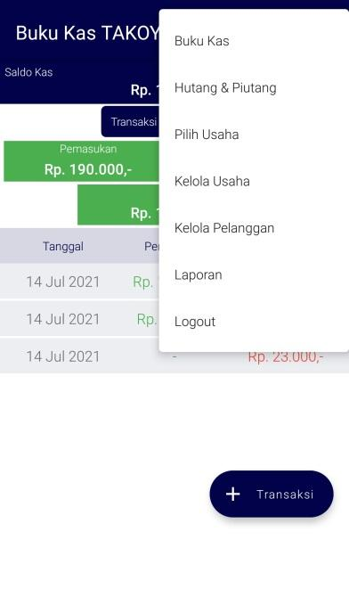

*Figure 2 AKPHB Cash Book Application menu*

Explanation of the main menu in the AKPHB cash book application:

**Main**

Menu This menu displays the start page of the Cash Book application which is used to record income and expenditure transactions).

**Accounts Payable and Receivable**

This menu is used to record accounts payable and receivable transactions. It is also equipped with features for *inputting* customer data and due date.

**Select Business**

This menu is used to select the business to be carried out by bookkeeping.

**Manage Business**

This menu is used to add business and its management (*edit* or delete).

**Manage Subscribers**

This menu is used to add to the list of customers and their management (*edit* or delete).

**Report**

This menu contains the *output* or output of the bookkeeping that has been done. There are 3 reports generated in the AKPHB Cash Book application, namely cash reports, accounts payable and receivable reports and general ledger reports.

***Logout***

This menu is used to exit the AKPHB Cash Book application as well as a form of security provided by the AKPHB Cash Book application.

The steps or how to use the AKPHB Cash Book application are as follows:

Sign Up and Log In Steps

1. Open the AKPHB Cash Book application
2. Click login AKPHB Cash Book
3. Select the email account to be used
4. The AKPHB Cash Book application is ready to use

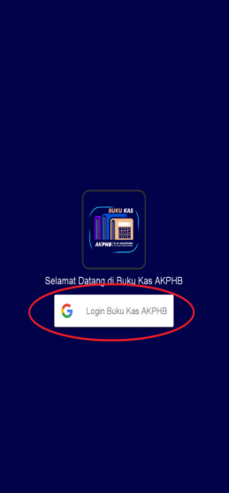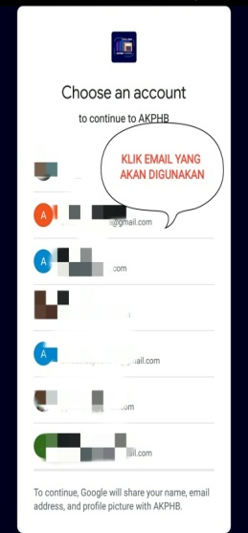

*Figure 3. Steps to Register (Sign Up) and Login (log In)*

Steps Adding Business

1. Click Manage Your Business Now
2. Click the (+) sign and enter the business name
3. Select the type of business (Services/trade/Fisheries/Livestock/Individual Business)
4. A success dialog box will appear and click ok
5. Click the arrow to the left and the AKPHB Cashbook application is ready used to record your business finances

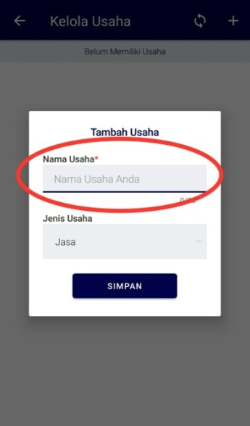

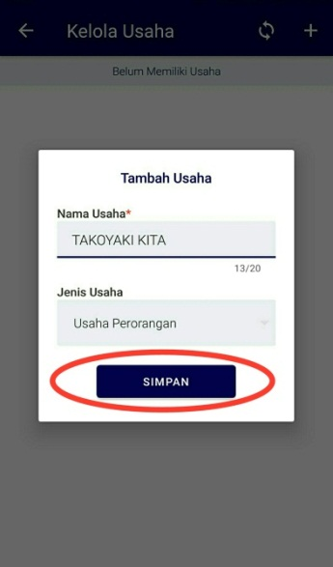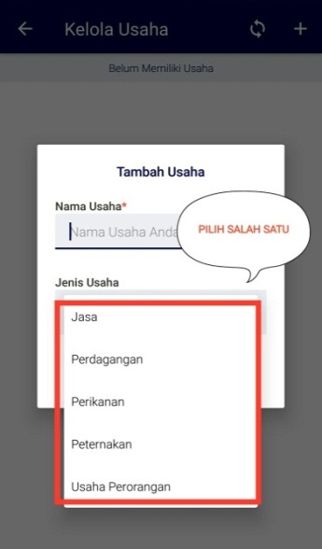



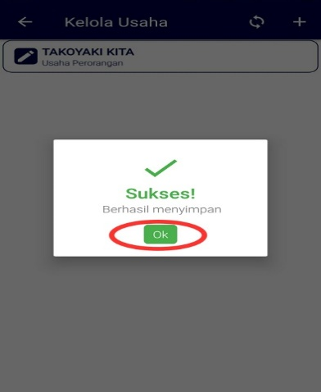

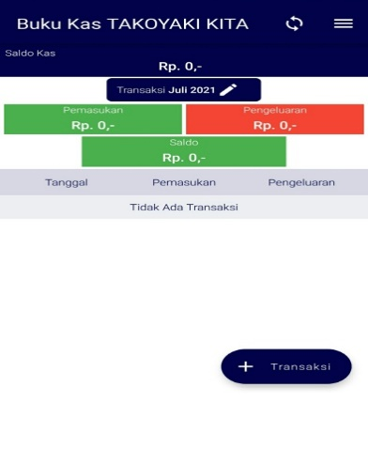

*Figure 4. Steps To Add Your Business*

Steps to Delete a Business

1. In the initial view of the Cash Book, click the 3 line in the upper right corner
2. Select manage the business
3. Select the business name to be deleted
4. Click the trash can image
5. A confirmation dialog box appears, select delete
6. A success dialog box appears and click ok

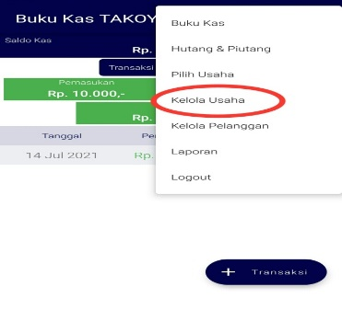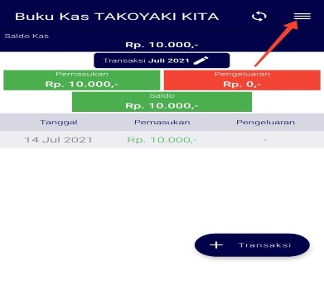

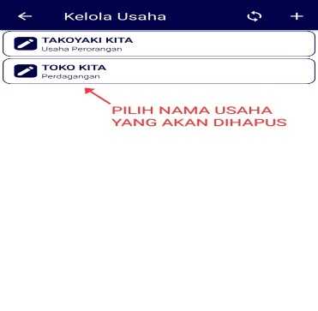

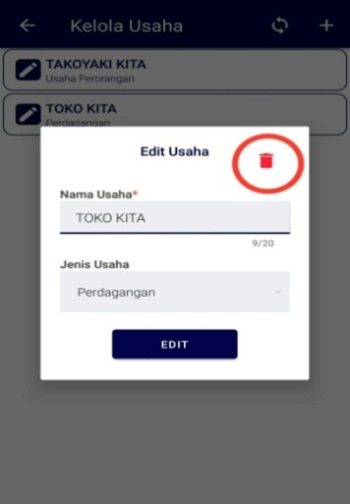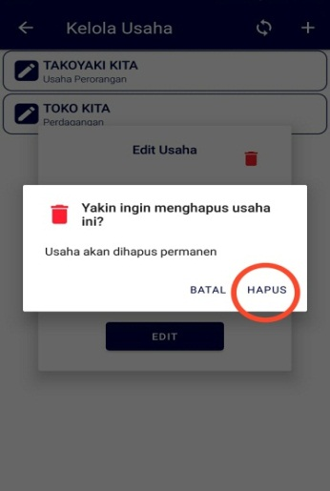

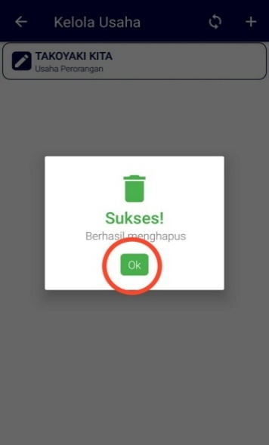

***Figure 5. Steps to Delete a Business***

Steps Input Transaction

1. Enter Open the AKPHB Cash Book application
2. Click (+ Transaction)
3. Select entry
4. Select information (cash sales/receipt of receivables/add m orking / etc)
5. Settransaction date
6. Contentstransaction records, quantity, nominal, discount (if any)
7. Total will auto and click save

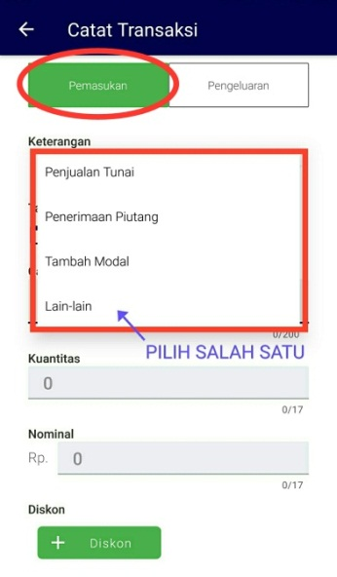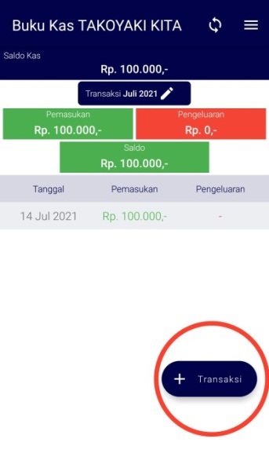

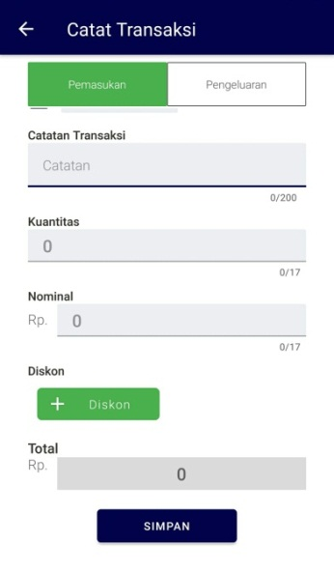

*Figure 6. Input Transaction Input steps*

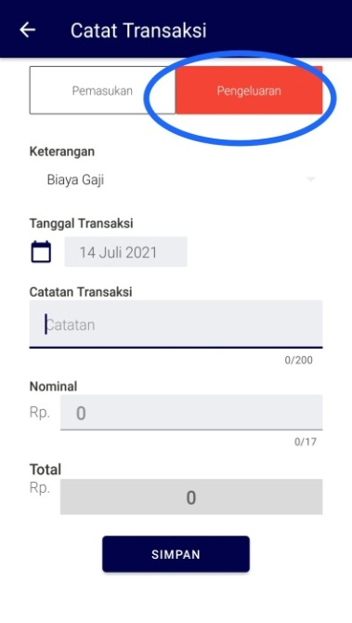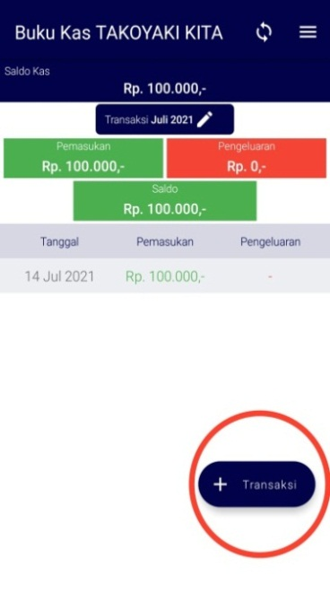

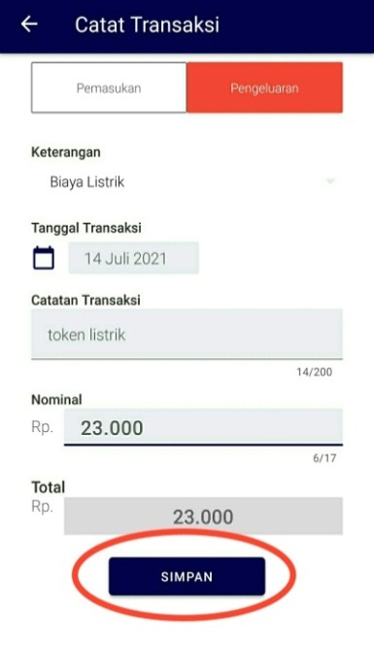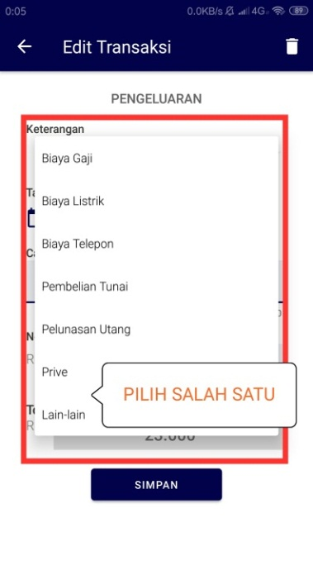

Figure 8. Step *Input* Transactions Spending

Step *Input* TransactionsSpending

1. Cash Open Books app AKPHB
2. Click (+ Transaction) and select expense
3. Select information (salary fee/ electricity fee/ telephone fee/ cash purchase/ credit settlement/ private/ others)
4. Fill in the date, note and nominal of the transaction and save the

Steps for *Input* Debt and Receivable Transactions

1. Open the AKPHB Cash Book application
2. Click line 3 in the upper right corner and select payables and receivables
3. Click (+ Accounts Payable) and enter customer data by clicking "select customer record customer debt/receivable"
4. 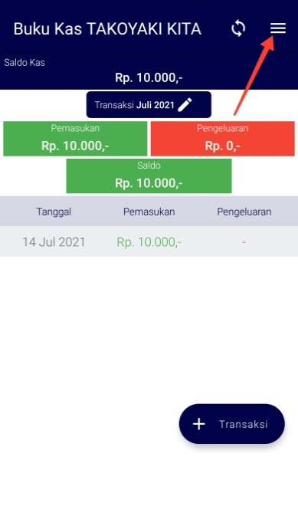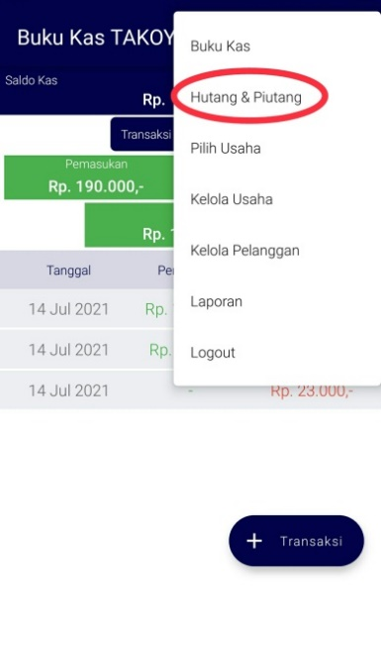If the customer's name is not yet in the customer list then click the (+) sign and enter customer data (name ,number *mobile*, address, business name (optional)) and save





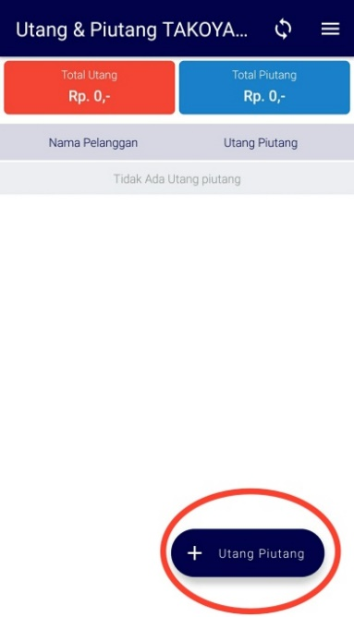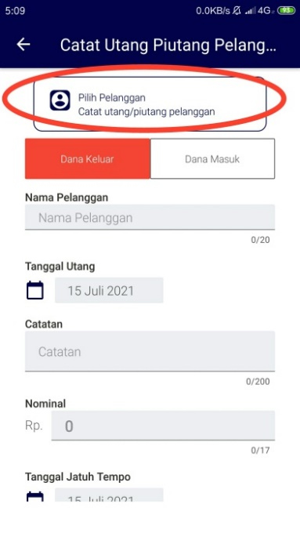

*Figure 7 1. Input Steps For Debt and Receivable Transactions*

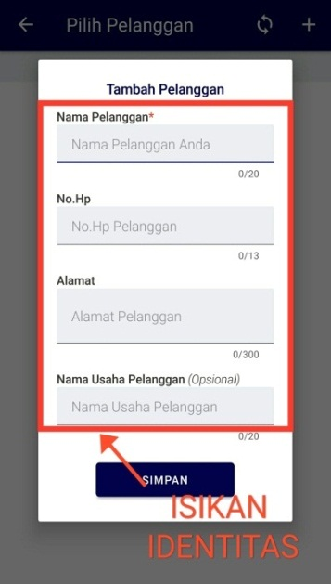

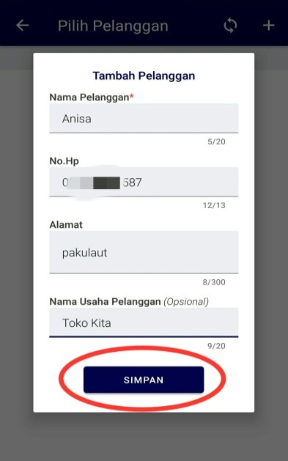

*Figure 8 1. Customer Data Input Steps*

1. If the customer's name is already in the customer list then click the name of the customer whose payables or receivables will be recorded
2. Click 'funds to outside' (debt) and 'incoming fund' (receivable) and fill in the payable/receivable date, notes, nominal and due date and click save



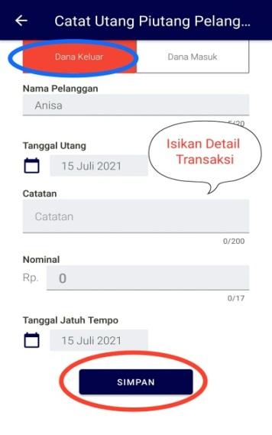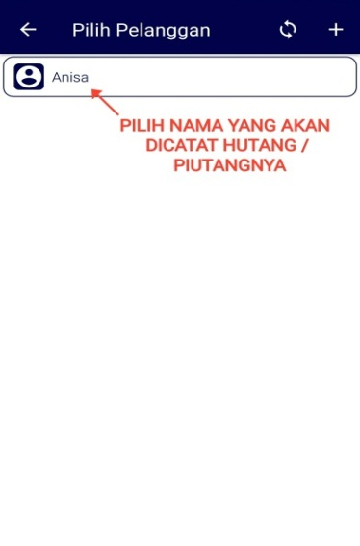

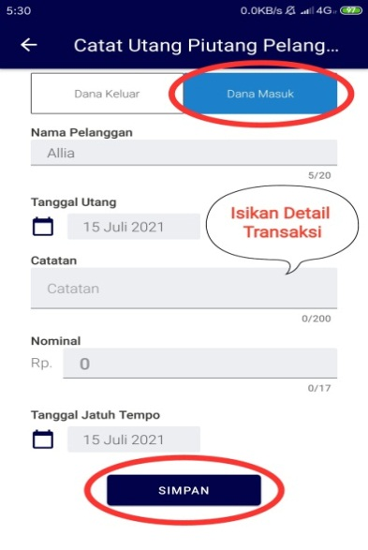

*Figure 10. Steps For Input Expenditure Transactions*

Steps to Download Report

1. Open the AKPHB Cash Book application
2. Click line 3 in the upper right corner and select 'Report'
3. Select report to be downloaded
4. If you want to view cash report then select 'Cash Report' and set the report to download (group/ungroup and report period to be downloaded) and click 'generate report'

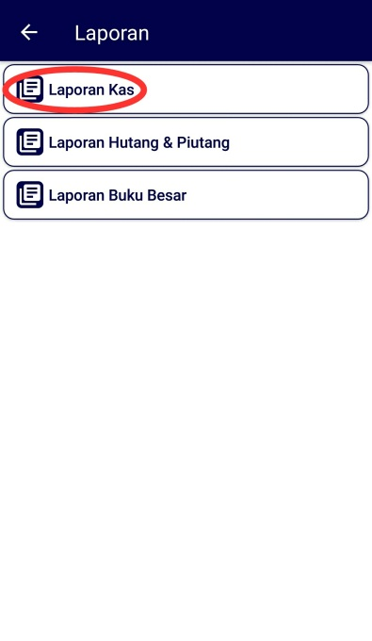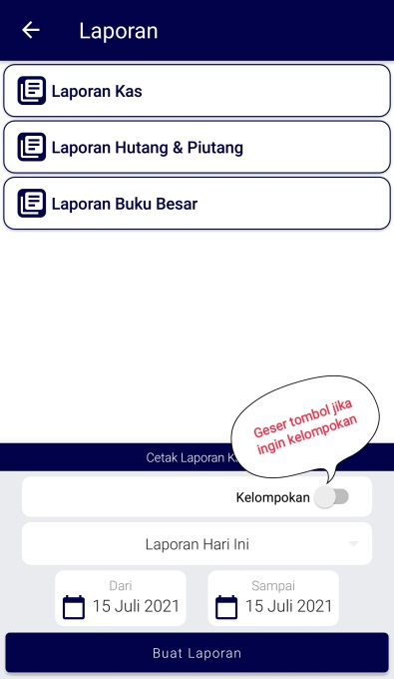



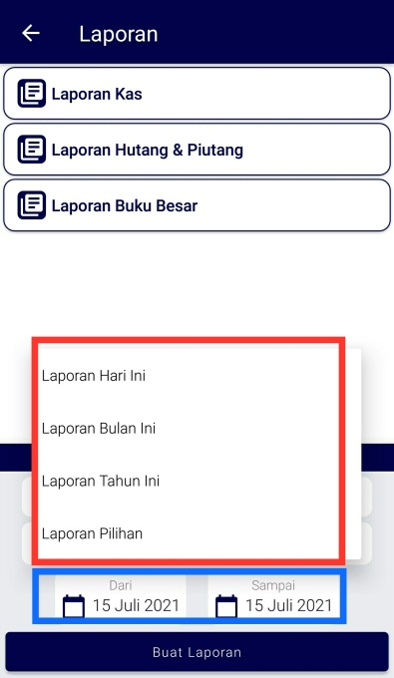

*Figure 11. Steps to Download Report*

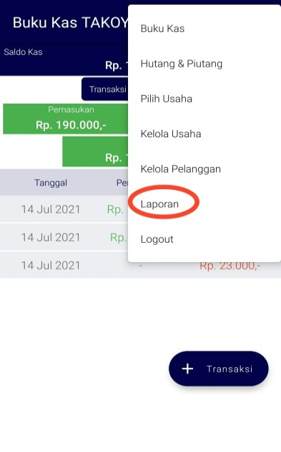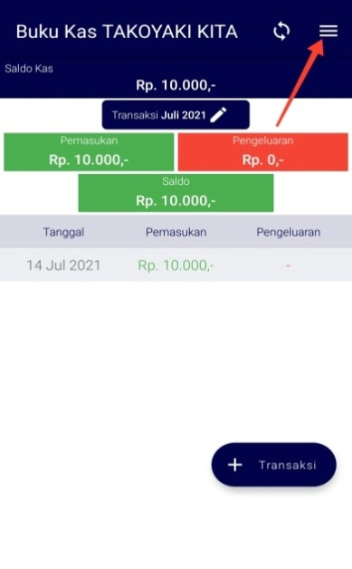

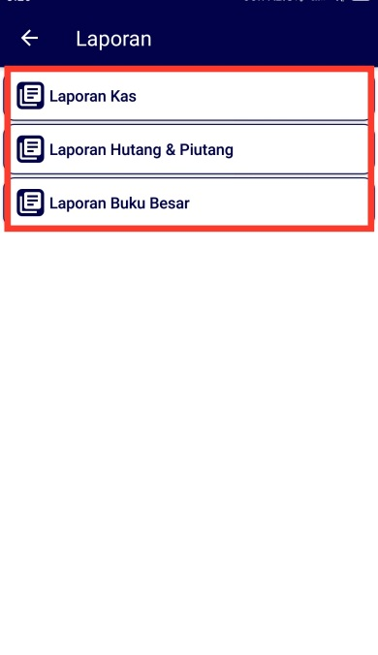

*Figure 12. Steps To Download Cash Statement*

1. If you want to view report payable and receivable then select 'Report Payables & Receivables' and set the report to be downloaded (details / no details, print all / print all customer payables / print all my debts / print off) and 'generate report'

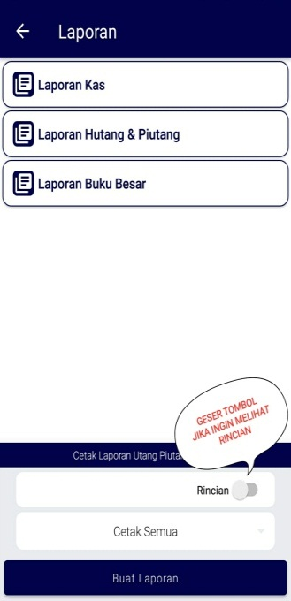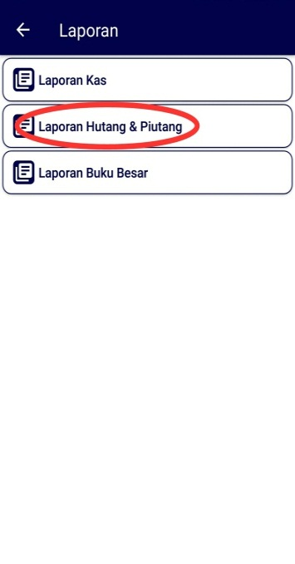

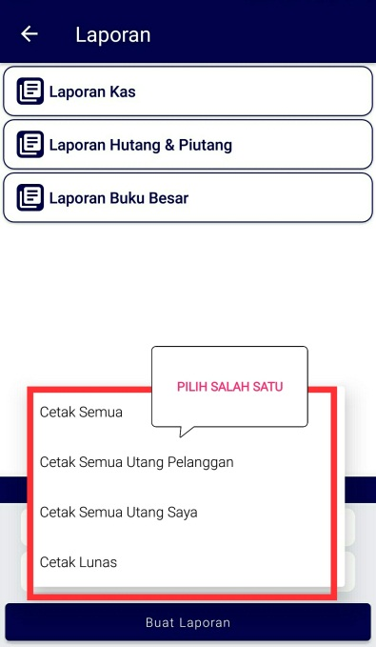

*Figure 13. Steps to Download Account Payable and Account Receivable*

1. If you want to see the general ledger report then select 'Ledger Report ' and set the report to be downloaded such as type of transaction (receipt of receivables/added capital/salary fee/electricity fee/telephone fee/cash purchase/payment of debt/prive/others), reporting period then 'create report' n'

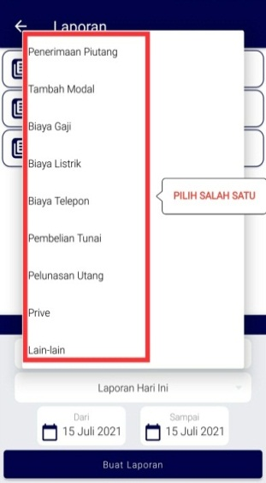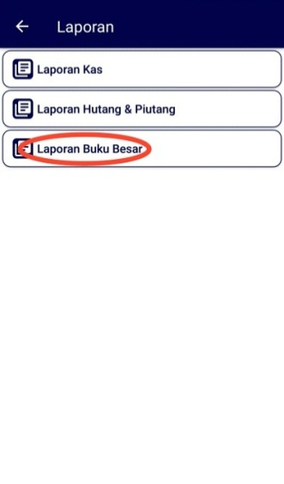

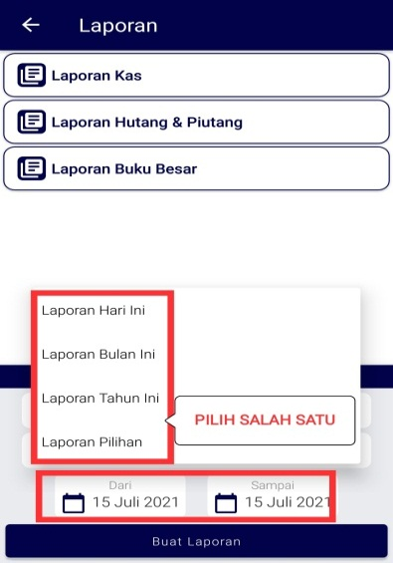



*Figure 15 1. Steps to Download Ledger Report*

## **Discussion on**

### Analysis of Business Recording Application needs

From the results of open interviews with several respondents using the application, it is known that the existing business recording applications still have shortcomings in the aspects of application security and ease of use (user friendly), completeness of features and types of reports available.

Because of the continuous development of improvements to the business record application, it must be developed. To achieve the goal that all MSMEs are able to record their business properly, this application must be used by all groups of various ages of MSME actors.

Some aspects that make it easy for MSMEs include that the application can be used using a smartphone as well as using a laptop so that users are more flexible in reading reports or conducting online transactions.

* + 1. Business Recording Application Design The

AKPHB business record application is the initial pilot of an accounting application that is being developed. In general, all standards for the existence of a business recording application have been included in the AKPHB business recording application. The AKPHB business recording application answers some of the shortcomings that currently exist in several existing business recording applications.

The following are some of the advantages of the AKPHB Cash Book Application compared to the Cash book application or book stall:

* For the AKPHB Cash Book application display, it is more attractive and clearer to read the writing compared to the cash book application display which tends to be more conspicuous so the writing is less clear
* In the AKPHB cash book application there are the discount recording feature when making sales transactions while the cash book does not have this feature
* In the AKPHB application there is a quantity column display so that it automatically calculates the total while the cash book application does not have a quantity column so that the overall calculation is calculated manually then new calculations can be recorded to the application
* In the AKPHB application to log in using email so it is much safer, while the cash book application logs in using a number so security is less guaranteed

##### conclusons ~~and suggestions~~

# **5.1 Conclusion The**

Conclusion in this study is that an adequate accounting information system for MSMEs is an information system that makes it easy for MSMEs to evaluate their business. In addition, the information system used can quickly provide information on matters needed in the business, such as the total balance of debts/receivables and other strategic matters.

While the Android-based accounting information system application needed to provide convenience for MSME actors is a simple but safe application, and easy to use by MSMEs of all ages/user ages. So that the benefits of the application are more optimal to help the development of MSMEs.

# **5.2 Suggestions**

Suggestions that can be given for further research is the need to evaluate the implementation of the AKPHB business recording application in MSMEs. Henceforth, mass trials can be carried out whether this application is reliable enough to be used by MSMEs.

Suggestions for institutions are that research for the development of this kind of application can be supported with sufficient funding to stimulate the existence of patents in the study program environment at the Harapan Bersama Polytechnic

##### References

[1]. Haryanti DM, Hidayah I. Potret UMKM Indonesia: Si Kecil yang Berperan Besar | UKM Indonesia [Internet]. www.ukmindonesia.id. 2018 [cited 2021 Mar 23]. Available from: https://www.ukmindonesia.id/baca-artikel/62

[2]. Utami DN. Securities Crowd Funding Resmi Diluncurkan [Internet]. https://market.bisnis.com/r. 2021 [cited 2021 Mar 23]. Available from: https://market.bisnis.com/read/20210104/7/1338197/securities-crowd-funding-resmi-diluncurkan

[3]. Legina X, Sofia IP. Pemanfaatan Software Pembukuan Akuntansi Sebagai Solusi Atas Sistem Pembukuan Manual Pada Umkm. J Neraca J Pendidik dan Ilmu Ekon Akunt. 2020;4(2):172.

[4]. Pulakanam V, Suraweera T. Implementing Accounting Software in Small Businesses in New Zealand: an Exploratory Investigation. Account Bus Public Interes [Internet]. 2010;9(64):98–124. Available from: https://www.academia.edu/14396489/Implementing_Accounting_Software_In_Small_Businesses_In_New_Zealand_An_Exploratory_Investigation

[5]. Waluya D, Dimas F. Perancangan Sistem Informasi Akuntansi Koperasi Dan Umkm Berbasis Technopreneur. J Ris Akunt dan Keuang. 2017;5(2):1423–40.

[6]. Rifani L, Aini N. Aplikasi sistem informasi akuntansi pada usaha kecil menengah kampung kue rungkut surabaya. Semin Nas Sist Inf Indones. 2016;427–36.

[7]. Rahmayuni S. Peranan Laporan Keuangan dalam Menunjang Peningkatan Pendapatan Pada UKM. JSHP ( J Sos Hum dan Pendidikan). 2017;1(1):93.

[8]. Hetika H, Sari YP, Faidah YA, Yasmin A. Aplikasi Penyusunan Laporan Keuangan Berbasis Android Sebagai Strategi Mempermudah Mengelola Keuangan UMKM di Kota Tegal. DIKEMAS (Jurnal Pengabdi Kpd Masyarakat) [Internet]. 2019 Oct 23 [cited 2021 Mar 23];3(2). Available from: http://journal.pnm.ac.id/index.php/dikemas/article/view/339

[9]. Grande-Urquía E, Pérez-Estébanez R, Muñoz-Colomina C. The Impact of Accounting Information Systems ( AIS ) on Performance Measures. Int J Digit Account Res. 2011;11(February):25–43.

[10]. Mulyatiningsih E. Riset Terapan. Yogyakarta; 2011.

[11]. Sardiarinto. Perancangan sistem informasi akuntasi usaha mikro kecil menengah di yogyakarta berbasis android. Bianglala Inform. 2019;7(2):123–9.