ANALYSIS OF THE EFFECTIVENESS OF CARD SHORT LEARNING METHODS USING POWER POINTS AS AN EFFORT TO INCREASE SPEAKING SKILLS IN CHILDREN OF MILD DEADLY ASSISTANCE

**Ratri wikaningtyas1, Martselani Adias Sabara2**

1, 2, Program Studi Teknik Elektronika, Politeknik Harapan Bersama

1, 2 Tegal, Jawa Tengah

[**1**wiccetegal@gmail.com](mailto:1wiccetegal@gmail.com)**,** [**2baradias@gmail.com**](mailto:2baradias@gmail.com)

**ABSTRACK**

This research is motivated by the interest and speaking ability of mild mentally retarded students who are not good. Confusion in conveying incomplete information. This lack of ability is also inseparable from the use of learning methods used by teachers in the classroom. The ability to manage the class and the use of learning methods is one of the reasons why students' interest and speaking skills are still low. Research is needed to improve the speaking skills of mild mentally retarded children, one of which is the use of the Card Short method using power point. This study aims to 1) Create and design the Card Short method.

with power points that have been adapted to the abilities of mentally retarded children. 2) Knowing the improvement of speaking skills of mentally retarded children. 3) Knowing the effectiveness of implementing the card short method at SLBN Brebes.

This research includes Research and Development (R&D) research. Research and Development (R&D) is a research method used to produce certain products and test the effectiveness of these products. Collecting data by conducting expert validation tests, limited product tests and usage tests. The results of the expert validation test obtained a score of 85 in the good category. The results of the limited product test obtained an average score of 78.33 while the product usage test obtained an average score of 83. Thus there was an increase in the product usage test so that the short Card media using power point was said to be effective.

Keywords: method, card short, mental retardation, speaking skills

1. Introduction

Children as the nation's next generation are very important assets for the family and the country. Children are human resources that will guide the journey of the Indonesian nation in the next few years. If at this time the education and development of children is not carried out optimally, the development of the Indonesian nation in the next few years will experience difficulties.[1]

Children with disabilities are usually called children with special needs (ABK). Children with special needs are children who have differences with children in general or the average child of his age. According to Heward, children with special needs are children with special characteristics. Children with special needs are children who are different from children in general or the average child of his age. Children are said to have special needs if there is something less or even more in them. different from children in general without always showing mental, emotional or physical disabilities.[2]

Special schools are one of the institutions that provide special education services for children with special needs. The learning curriculum in special schools has certainly been created and adapted according to the needs of students with special needs. Every child who goes to school, both children with disabilities and regular ones, of course has an obligation to fulfill the learning outcomes that have been determined by the school. Likewise, children with mental retardation who are educated in special schools also have an obligation to fulfill the learning outcomes that have been adapted to the children's needs. [3]

Mentally retarded children are also known as intellectually impaired children. Thus, mentally retarded children are children in groups below normal or slower than normal children, both in terms of social development and intelligence. This causes a lack of vocabulary that affects language skills, especially speaking skills. Talking is a way of communicating between humans. In communication, language plays an important role in achieving goals. Clarity of speech will clarify the meaning of someone's speech so as to reduce errors in interpreting or understanding it. As one of the language skills in learning, various problems must be found that must be overcome. One of The problem that often arises in learning speaking skills is poor speaking interest and ability or speech coherence. [4] The lack of ability is also inseparable from the use of learning methods used by teachers in the classroom. The ability to manage the class and the use of learning methods is one of the reasons why students' interest and speaking skills are still low. The choice of learning method is one of the important things for teachers to consider when teaching in the classroom. The selection of an inappropriate learning method will have an impact on the learning process itself. One way to become skilled at speaking well is to prepare a flow of thinking and mastery of concepts, practice imitating them, then practice them. The cart short learning method will help mentally retarded children to speak using logical thinking lines, mastery of concepts, classification characteristics, facts, about objects or reviewing information with a level of difficulty that has been adjusted to the condition of the mentally retarded child. The cart short method conditions the mentally retarded child to prepare a topic or content material that is delivered according to the pictures and writings that appear on the card, the use of pronunciation, intonation, diction and eloquence. Based on the problems above, the teacher must make learning improvements by determining the use of the card short method for mentally retarded children in Brebes State Special School.

1. Theoretical
2. Effectiveness

The word effectiveness comes from the English language, namely effective which means successful, appropriate or effective. According to the Big Indonesian Dictionary (KBBI) the definition of effectiveness is something that has an influence or effect, is effective, brings results and is the success of an effort or action. Expressing effectiveness is how an organization manages to obtain and utilize resources in an effort to realize operational goals. Effectiveness is often closely related to the comparison between the level of achievement of goals with a predetermined plan, or the comparison of actual results with planned results. As is well known that teaching and learning activities must always be improved in terms of effectiveness and efficiency, in order to improve the quality of education itself. Therefore, to increase the effectiveness of learning without having to take up a lot of time, a teacher must be good at choosing what method to use so that students can quickly catch what he is saying. effective means that there is an effect (consequent, effect, effect), effective or efficacious and can bring results.[8]

Effectiveness is the ability to carry out tasks, functions (operations, program activities or missions) of an organization or the like in which there is no pressure or tension between its implementation. Thus it can be concluded that effectiveness is an ability to carry out a given task to measure the effect of a variable that is tested using certain methods.

1. Card sort method

The card sort method is a collaborative activity to determine the ability of students to work together to solve a problem so that it can be seen the ability of students to find and solve a problem that is commonly used to teach concepts, characteristics, clarifications, facts about objects or review the knowledge that has been given previously. The dominant physical movement in this strategy can help excite tired students where the card is a medium in the implementation of learning.[8]

Card sort can also be called card sorting, namely card sorting. This strategy is a collaborative activity that can be used to teach concepts, characteristics, classifications, facts, about objects or review information. The dominant physical movement in this strategy can help the creativity of students in a class that is saturated and bored to become creative and dynamic. [9]

While the advantages of the card sort strategy are that it can help excite students who feel tired of the lessons that have been given, can foster students to work together and develop mutual respect for opinions, the implementation is very simple and students are easy to group the same words so it is easy to understand the subject matter. 10]

1. Mild mentally retarded children

Mental retardation is a child with intellectual mental disorders far below the average which causes developmental barriers to academic, communication, and social abilities that occur under the age of 18 years so that they require special education services. Mild mentally retarded children have IQs ranging from 50-70 or 75. Even though their intelligence is below average, mild mentally retarded children still have self-potential that can be developed. [10]

Anak tunagrahita ringan berbeda dengan anak normal pada umumnya karena anak tunagrahita ringan memiliki kemampuan intelektual di bawah rata-rata. akibat keterbatasan intelektual yang dimiliki anak tunagrahita ringan menyebabkan kemampuan belajarnya menjadi terbatas terutama pada hal yang sifatnya abstrak. Oleh sebab itu, banyak ditemukan anak tunagrahita ringan yang mengalami kesulitan belajar di sekolah. Walaupun demikian, bukan berarti mereka tidak dapat belajar. Anak tunagrahita ringan masih dapat diberikan pelatihan, bimbingan, kesempatan dan dukungan agar mereka dapat mengembangkan potensi yang ada dalam dirinya sehingga dimasa mendatang anak tunagrahita ringan dapat hidup dengan mandiri.[11]

1. Speaking Skills

Speaking skill is one aspect of basic skills in language. Speaking is an active language activity from a language user, which requires real initiatives in the use of language to express themselves orally. Speaking skills are used to express ideas, ideas, or expressions to others so that they are easy to understand or understand well. argues that speaking is an event in the process of delivering messages orally by the speaker to the recipient of the message. In other words, speaking is conveying a message through spoken language. Speaking skill is not a passive process, but an active process that requires logical and systematic thinking power. Therefore, students must be able to distinguish facts and opinions, recognize causal relationships, state arguments, and so on. In language learning at elementary school age speaking skills act as skills that support other language skills, namely listening, reading, writing. The role of speaking is very large, both in Indonesian subjects and in everyday life. Speaking skills need to be taught from an early age so that students have the confidence to speak in establishing communication as a condition for transferring knowledge both within the school environment and in the community. This needs to be considered by the teacher so that students can be more fluent and fluent in speaking.[12]

1. Method

This research includes Research and Development (R&D) research. Research and Development (R&D) is a research method used to produce certain products and test the effectiveness of these products. [14] Research and Development (R&D) is a process or steps to develop a new product or improve an existing product, which can be accounted for. [15] Then Research and Development (R&D) is a research method intentionally, systematically, to find, improve, develop, produce, or test the effectiveness of products, models, and methods / strategies / ways that are superior, new, effective, efficient, productive, and meaningful [16] Based on these opinions, Research and Development (R&D) is a research method that is carried out intentionally and systematically to improve existing products or develop a new product through testing, so that the product can be accounted for.

1. Results

The results of this study present data obtained from potential problems, data collection, product design, product validation from learning method experts, as well as the results of testing the use of methods by teachers and students in limited trials and usage trials.

1. Description of Expert Validation

ResultsBefore testing the use of the method by teachers and students, the product developed by the researcher was validated by a curriculum coordinator who was a mathematician. This validation was carried out to obtain data on the feasibility of the card short learning method using power point as an effort to improve the speaking skills of mild mentally retarded children. Comments and suggestions from the method experts were also used for the process of improving the method before testing the use of media by teachers and students. The results of the validation by material experts can be described as follows.

Table 1. Expert Test Results Method

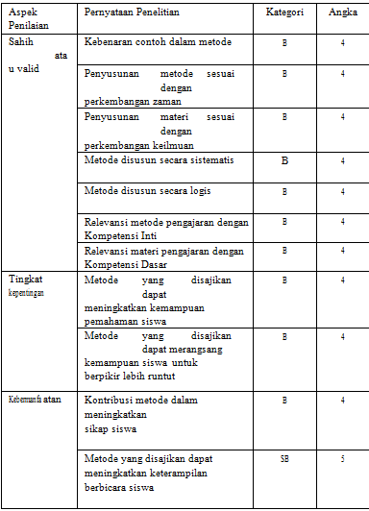

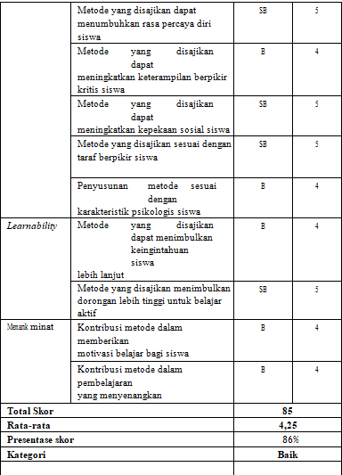

Based on the validation results above, it is known that the card short learning method uses power point. As an effort to improve the speaking skills of mild mentally retarded children, they get an average score of 4.25 with a good category. Researchers were allowed to test the use of the method after obtaining an average score of more than 3.4 or with a minimum category of good. However, before actually being tested, the card short learning method using power point. As an effort to improve the speaking skills of mild mentally retarded children, improvements still need to be made.

The score of each statement item on the aspect of the Sahih or valid level and the level of importance gets a score of 4 in the good category. In the statement items in the aspect of usefulness, of the 7 statement items, 3 items get a score of 4 or in the good category and the other 4 items get a score of 5 or in the very good category. In the statement items in Learnability, out of 2 statement items, 1 item gets a score of 4 or in the good category and the other 1 item gets a score of 5 or in the very good category. The score of each statement item on the aspect of attracting interest gets a score of 4 in the good category. The lowest score overall is 4, while the highest score is 5. This means that the card short learning method uses power point. As an effort to improve the speaking skills of mild mentally retarded children, it has been developed to meet the preparation of good learning methods.

1. Test results using limited tools

The test of the use of the method by the teacher to the students was carried out at SLB N Brebes class X C. The test of the use of the method by the teacher to the students was carried out twice, namely in a limited trial and a trial use. The test of using the method which was carried out twice was a method development process to produce a card short learning method using power point as an effort to improve the speaking skills of mentally retarded children. The limited trial was conducted by randomly selecting 6 students of class X C. The limited trial was conducted on Wednesday, December 2021. The following is a table of the results of the students' use of media in the limited trial.

Table 2. Limited Product Test Results

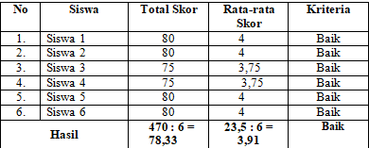

After testing the use of the method by the teacher on students in a limited trial and revision, the researcher tested the use of the method by the teacher on students in a trial of use. The usage trial was carried out at SLB N Brebes class X C1 with a total of 15 students on Tuesday, December 14, 2021. The results of the test using the media by students in the usage trial were as follows.

1. Test results of usage products

Table 3. Product Test Results Usage

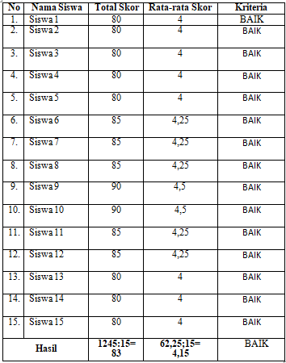

Based on the results of the test using the method by the teacher on the students above, it can be seen that the method developed went through the revision process and the use test twice. In the test of the use of the method by the teacher to students in a limited trial, the media developed obtained an average score of 3.91 with a good category, and in the test of the use of the method by the teacher on students in the use trial, it obtained an average score of 4.15 with the category good. From the results obtained, it can be said that the card short learning method uses power point. As an effort to improve the speaking skills of mentally retarded children developed by researchers, the researchers received positive responses from students. The results of the media use test by students, both in the limited trial and the usage trial, both got an average score in the good category. Thus, the quality of the card short learning method using power point as an effort to improve the speaking skills of mentally retarded children has increased.

Daftar Pustaka

[1] Michael Johanes. H Louk. 2018. Pengembangan Media Audio Visual Daalam Pembelajaran Keterampilan Motorik Kasar Pada Anak Tunagrahita Ringan. Jurnal Keolahragaan. Volume 4-Nomor1, April 2018,(24-33)

[2] Nadya Putri. 2019 Efektifitas Penggunaan Media Video Untuk Meningkatkan Pengenalan Alat Musik Daerah Pada Pembelajaran IPS Bagi Anak Tunagrahita Ringan Di SDLB 20 Kota Solok. E-Jupekhu. Volume 1, Nomor 2, Mei 2019.

[3] Muhammad Nurrohman Jauhari.2020. Dampak Pandemi Covid -19 Terhadap Pelaksanaan Pembelajaran Penjas Adaptif Di Sekolah Luar Biasa. Journal STAND. Volume 1 Nomor 1, Tahun 2020.

[4] Iip Ripai Azhuri. 2021. Survei Motivasi Belajar Pendidikan Jasmani pada Siswa Sekolah Luar Biasa di Kabupaten Karawang. Jurnal Literasi Olahraga, 2 (2), April 2021, 96-103

[5] Leni Muthe. 2019. Upaya Peningkatan Hasil Belajar Dengan Menggunakan Metode Card Sort Pada Siswa kelas IV SD Negeri no.091696 AFD Mayang Kabupaten Simalungun. Jurnal pendidikan agama islam. Vol 6 no.92.

[6] Trisia Arini. 2020. Peningkatan Hasil Belajar IPS Melalui Metode Card Short Siswa Kelas VIIB di SMP Negeri 3 Kapak. Jurnal Dinamika Penelitian: Media Komunikasi Penelitian Keagamaan Vol. 20, No 02

[7] Said Husin, Indriana Rahmawati. 2021. Penerapan Metode Cadr Sort Untuk Meningkatkan Motivasi Belajar Fiqh Siswa MTS Nabil Husain Samarinda. SIJPE. Vol.9.

[8] Elvi Rahmi, 2021 Efektivitas Penggunaan Media Big Book Untuk Meningkatkan keterampilan Berwudu di TK Harapan Ibu. Jurnal IAIN Vol. 3.

[9] Hisyami, Zaini, dkk, 2016.Strategi Pembelajaran Aktif, Yogyakarta: Pustaka Insani Madani,

[10] Syaiful Bahri, Aswan Zain, 2017. Strategi Belajar Mengajar, Jakarta: Rineka Cipta,

[11] Wardina Zahra. 2021. Efektivitas Video Tutorial Dalam Pembelajaran Membuat Tempat Buah dari Gelas Plastik Untuk anak Tunagrahita Ringan. EDUMASPUL. Vol.5 No.2

[12] Khoiriyah, P. A., & Pradipta, R. F. (2017). Media Counting Board untuk Kemampuan Berhtung Anak Tunagrahita Ringan. Jurnal Ortopedagogia, 3(2), 109-113

[13] Restu Aji, 2021. Peningkatan Keterampilan Berbicara Bahasa Indonesia Subtema kebersamaan di Tempat Wisata Melalui Penerapan Metode Demonstrasi. Indonesia Gender and Society Journal. Vol.2 No.1

[14] Sugiyono. 2016. Metode Penelitian Kuantitatif, Kualitatif dan R&D. Bandung: PT Alfabet.

[16] Sukmadinata, Nana Syaodih. 2019. Metode Penelitian Pendidikan. Bandung : Remaja Rosdakarya.

[17] Putra, Nusa.2015. Research & Development Penelitian dan Pengembangan.Jakarta: PT Raja Grafindo Persada.