Design And Build A Home-Based PLN KWH Meter Reading System As An IoT-Based Home Electricity Consumption Report

# Miftakhul Huda* , Yerry Febrian Sabanise

Department of Computer Engineering, Politeknik Harapan Bersama Tegal

*Corresponding author: [mh_iftah@poltektegal.ac.id](mailto:mh_iftah@poltektegal.ac.id)

**Abstract.**

communication advancement. KWH Meter is an electrical energy counting device that works using the magnetic field induction method. With the process of manual calculation with the

Electricity is one of the primary human needs in the era of technological and

officer in the sense of time consuming. To facilitate the recording process, Design a Home Pln Kwh Meter Reading System as a Report on The Use of IoT-Based Home Electricity (kWh Meter IoT) is needed. Research Procedure uses Analisis, design, testing and implementation. The kWh IoT meter design uses NodeMCU8266 as a controller, PZEM004Tv3 as an energy sensor and a 2x16 LCD as a display. This IoT kWh meter tool can record the use of home electricity in accordance with the recording of PLN kWh meter installed in the customer's home with an average difference of 0.021 kWh energy recording within 15 days, data can be monitored in real time through the Android Fullscreen Browser Application and or Desktop Web Browser.

**Commented [WU1]:** It needs to be repackaged so that common errors and efficiency are urgently given a solution

# Introduction

Electricity is one of the primary human needs in the era of technological and communication advancement. Almost all aspects of human life use electrically driven devices. With the diminishing natural resources of power plants, humans are expected to make savings on electricity use. The use of listri can be measured using the KWH Meter. KWH Meter is an electrical energy counting device that works using the magnetic field induction method, where the magnetic field is moving a disk made of aluminum. Watt or Kwatt gauges, commonly called Watt-meters/Kwatt meters are arranged in such a way that the voltage coils can rotate freely, thus electric power can be measured, either in WH (Watt Hour) or in KWH (KiloWatt Hour)[1]. In some uses of electricity, for example in housing, information is needed about the amount of electrical power used at a certain time to find out the increase in electricity usage. Monitoring of the use of electrical energy is necessary to reduce excessive and unprostitable use of electrical energy [2].

**Commented [WU2]:** review is too short. Looks weak, has not been able to support the substance of the research problem. Please add previous research gaps are highlighted

|  |  |  |
| --- | --- | --- |
| With officers noting one by one the use of electricity in housing, this process is felt to be time  consuming and less efficient. Therefore, to facilitate the process will be made Designing and Building Home-Based PLN KWH Meter Reading System as an IoT-Based Home Electricity | |  |
| Consumption Report | . |

# Methods

* 1. **Research Procedure**

This type of research is in the form of experimental research, with the stages of research as described in the following image:

Analisis

Design

**Commented [WU3]:** leave a review about this

Implementation

Testing

**Figure 1** Research Procedure

# Materials

This research requires materials in accordance with the results of observations and surveys in PLN customers one of the residents of Graha Bahari Housing No.A18-19 Jl. Dewi Sartika Rt.01 Rw.01 Pesurungan Kidul Tegal Barat Tegal City with PLN Customer ID 522511131099.

# Tools

* + 1. **Software**
       1. Arduino IDE is used for microcontroller programming fromtools used for research.
       2. PHP is used as a website programming.
       3. MySql is used as a database.
       4. Android Fullscreen Browser app.

# Hardware

* + - 1. ESP8266
      2. PZEM004Tv3
      3. Coil Ampere
      4. LCD 2x16
      5. Power Supply Switching 12 volt 5 ampere
      6. Access Point

**Commented [WU4]:** Please pack using a table

* 1. **IoT kWh Meter System Concept**

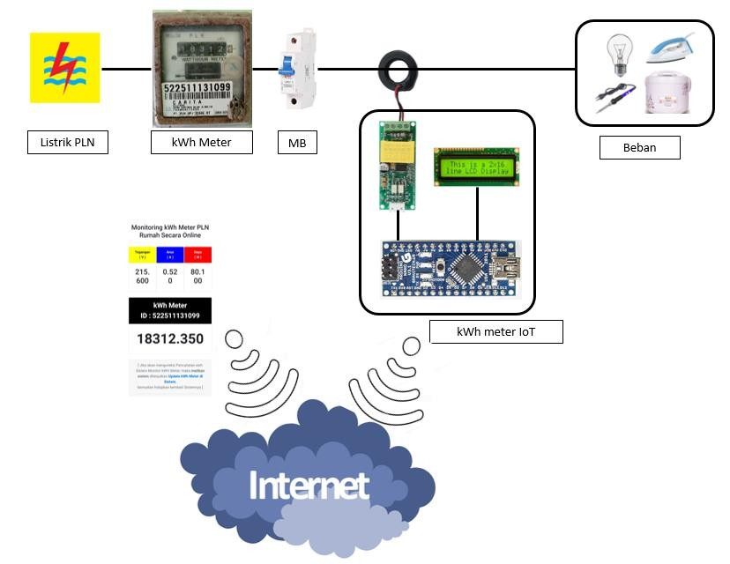

kWh meter MCB

LOAD

IoT kWh meter

PLN electricity

**Commented [WU5]:** leave a review about this

**Figure 2** Concept of IoT Meter kWh System

# Program Flow

**Figure 3** Flowchart System Design

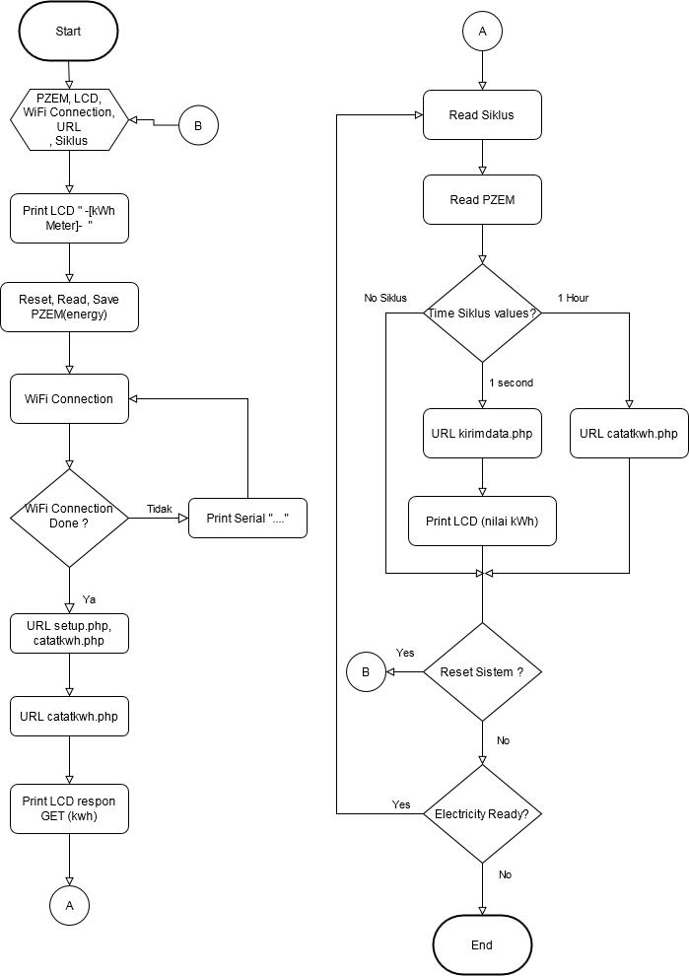

**Commented [WU6]:** leave a review about this

# Results and Discussion

* 1. **Result**

Hardware to make kWh IoT meters need a clear picture so that in the assembly of all the hardware can be done correctly then the assembly design is made in such a way that the device after assembled can work in accordance with expectations, the picture of the floor is described in Figure 4 below.

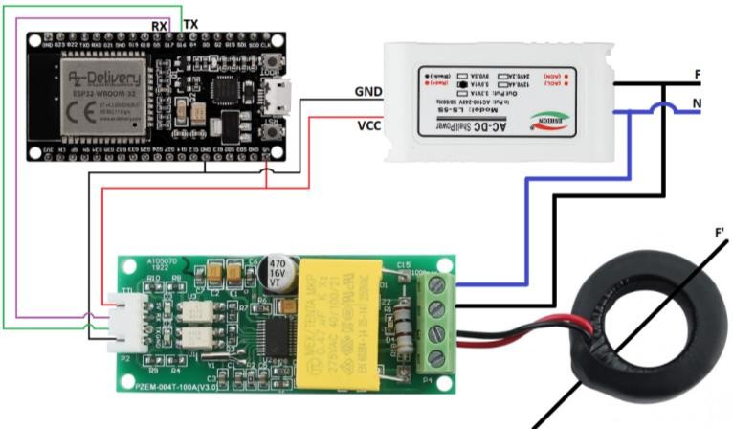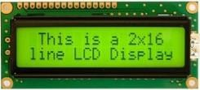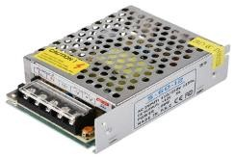

ESP8266

Power Supply Switching 12 volt 5 Ampere

PZEM004Tv3

Coil Ampere

**Figure 4** IoT Meter kWh Meter Hardware

Keterangan :

**Commented [WU7]:** busy person

1. PZEM004Tv3 data pins are installed on pins 12 and 14 (TX,RX) to send energy data
2. 2x16 character LCD used for kWh display value
3. Ampere Sensor Coil is installed on the F (Phase) line of output from PLN kWh Meter before the load of the house
4. Wifi on ESP8266 connects to the customer's home Access Point.

Software is implemented in the form of PHP-based website applications by utilizing bootstrap as its style and MySql as a database to store kWh data. There are 10 php files used to process data transmitted through ESP8266 and 1 database containing 3 tables to store data that will be used for php file needs.

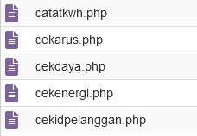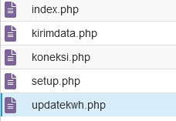

**Figure 5** File php kWh Meter IoT

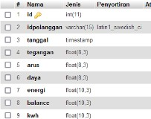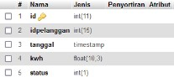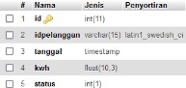

**Figure 6** MySql database table

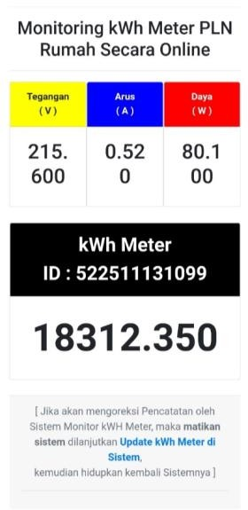

**Figure 7** Interface Monitoring kWh Meter IoT file index.php

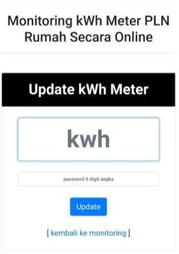

**Figure 8** Interface Update kWh Meter IoT file updatekwh.php

The kWh data during this study can be seen in terms of Figure 9.10 and the following 1.2 tables:

Comparison of kWh Meter and kWh meter IoT with comma

18.340,000

18.335,000

18.330,000

18.325,000

18.320,000

18.315,000

18.310,000

18.305,000

18.300,000

1 2 3 4 5 6 7 8 9 10 11 12 13 14 15

kWh Meter kWh Meter IoT

**Figure 9** Comparison graph between kWh Meter and kWh IoT Meter with data accompanied by comma value

Comparison of kWh Meter and kWh meter IoT without comma

18.340

18.335

18.330

18.325

18.320

18.315

18.310

18.305

18.300

1 2 3 4 5 6 7 8 9 10 11 12 13 14 15

kWh Meter kWh meter IoT

**Figure 10** Comparison graph between kWh Meter and kWh IoT Meter with data without comma value

**Table 1** Reading of kWh meter and kWh IoT meter data with data accompanied by comma value

|  |  |  |  |  |
| --- | --- | --- | --- | --- |
| **No** | **Date_hour** | **kWh Meter** | **kWh Meter IoT** | **Difference** |
| 1 | 20211128_103156 | 18.312,360 | 18.312,350 | 0,010 |
| 2 | 20211129_040332 | 18.313,575 | 18.313,541 | 0,034 |
| 3 | 20211130_055355 | 18.315,210 | 18.315,211 | (0,001) |
| 4 | 20211201_060225 | 18.316,290 | 18.316,289 | 0,001 |
| 5 | 20211202_092418 | 18.318,098 | 18.318,078 | 0,020 |
| 6 | 20211203_070946 | 18.319,485 | 18.319,461 | 0,024 |
| 7 | 20211204_093551 | 18.321,160 | 18.321,125 | 0,035 |
| 8 | 20211205_093917 | 18.323,000 | 18.322,949 | 0,051 |
| 9 | 20211207_080920 | 18.325,605 | 18.325,541 | 0,064 |
| 10 | 20211208_070631 | 18.327,050 | 18.327,037 | 0,013 |
| 11 | 20211209_055514 | 18.328,205 | 18.328,189 | 0,016 |
| 12 | 20211210_075412 | 18.329,800 | 18.329,801 | (0,001) |
| 13 | 20211211_082623 | 18.331,255 | 18.331,246 | 0,009 |
| 14 | 20211212_133530 | 18.332,700 | 18.332,688 | 0,012 |
| 15 | 20211213_082233 | 18.334,175 | 18.334,154 | 0,021 |
|  |  |  | Min | (0,001) |
|  |  |  | Max | 0,064 |
|  |  |  | Average | 0,021 |

**Table 2** Reading of kWh meter data and kWh IoT meter with data without comma value

|  |  |  |  |  |
| --- | --- | --- | --- | --- |
| No | Date_hour | kWh Meter | kWh meter IoT | Information |
| 1 | 20211128_103156 | 18.312 | 18.312 | Appropriate |
| 2 | 20211129_040332 | 18.313 | 18.313 | Appropriate |
| 3 | 20211130_055355 | 18.315 | 18.315 | Appropriate |
| 4 | 20211201_060225 | 18.316 | 18.316 | Appropriate |
| 5 | 20211202_092418 | 18.318 | 18.318 | Appropriate |
| 6 | 20211203_070946 | 18.319 | 18.319 | Appropriate |
| 7 | 20211204_093551 | 18.321 | 18.321 | Appropriate |
| 8 | 20211205_093917 | 18.323 | 18.322 | Not Appropriate |
| 9 | 20211207_080920 | 18.325 | 18.325 | Appropriate |
| 10 | 20211208_070631 | 18.327 | 18.327 | Appropriate |
| 11 | 20211209_055514 | 18.328 | 18.328 | Appropriate |
| 12 | 20211210_075412 | 18.329 | 18.329 | Appropriate |
| 13 | 20211211_082623 | 18.331 | 18.331 | Appropriate |
| 14 | 20211212_133530 | 18.332 | 18.332 | Appropriate |
| 15 | 20211213_082233 | 18.334 | 18.334 | Appropriate |

# Discussion

Figure 7 is an interface of the index file.php useful for monitoring kWh IoT meters in real time and Figure 8 is an update interface.php useful for updating the value of kWh IoT meter at the beginning of kWh IoT meter will be used.

Figure 9 and Table 1 are kWh Meter and kWh IoT data that show kWh data in the form of scented values, there is a difference in readings between kWh Meter and kWh IoT Meter with an average of 0.021 kWh within 15 days of data retrieval.

Figure 10 and Table 2 are kWh Meter and kWh Meter IoT data that shows data in the form of kWh in the form of values without commas, there is 1 that does not match the reading between kWh Meter and kWh IoT meter within 15 days of data retrieval, namely on day 8, this is because kWh Meter uses the appearance of mechanical data where the number shows in the last digit before the comma in the form of the number 3 but on kWh IoT meter is still It's still the number 2.

Figure 7 and Figure 8 are interfaces used by Registrars or customers through Gadgets or PCs / Laptops using a Browser.

**Commented [WU8]:** the analysis process has not been seen, only procedural

# 4. Conclusion

The conclusions in this study so that the tools implemented are as follows:

1. The tool made is kWh Meter ioT can report the use of electrical energy by customers to pln kWh meter registrar or PLN customer.
2. IoT kWh Meter tool design uses ESP8266 as controller and PZEM004Tv3 as energy reading sensor.
3. There is a difference in readings of kWh Meter and kWh IoT meter with an average of 0.021 kWh during the data retrieval period
4. Reading of kWh Meter and kWh IoT data with data without comma there is a difference that is when the value of comma data shows a value above 0.750 where on kWh Meter that visually uses mechanical display has shown rounding numbers.
5. The difference at point 3 can be rounded on the display in kWh IoT meter so that the value between kWh Meter and kWh IoT meter looks the same because PLN officers only record data without commas.
6. Data can be monitored in real time through the Android Fullscreen Browser App and/or The Desktop Web Browser.

**Commented [WU9]:** please pack a short and solid paragrap

# Acknowledgments

Thank you to the Research and Community Service Center (P3M) of Harapan Bersama Polytechnic.

# References

1. Bini, T., Indrawan, A. W., & Dasmawati1. (2018). Rancang Bangun Sistem Monitoring KWH Meter Berbasis Android. Prosiding Seminar Hasil Penelitian (SNP2M), 144–148.
2. Noviandi, K., Yacoub, R. R., & Junaidi. (2020). Perancangan Alat Penghitung Penggunaan Daya Listrik Pada Lampu Penerangan Jalan Umum Berbasis Sensor Arus Dan Mikrokontroler. Jurnal Teknik Elektro Universitas Tanjungpura, 1(1–11), 1–11.
3. Zulpa Arif. 2015. Prototyfe Monitoring Pengukuran Beban Dan Biaya Arus Listrik Degan Mikrokontroler Arduino Pada Pelanggan Pasca Bayar Berbasis Web. Skripsi. Teknik Informatika, Universitas Islam Negeri Syarif Hidayatullah.
4. Nurdiansyah M. Arif. 2010. Kwh Meter Digital Berbasis Mikrokontroler AT89S51. Skripsi.

Program Diploma Iii Ilmu Komputer, Universitas Sebelas Maret.

1. Wicaksono Titis. 2007. Rancang Bangun Alat Penghitung Biaya Energi Listrik Terpakai Berbasis Mikrokontroler Pic 16f877. Jurnal. Jurusan Teknik Elektro Fakultas Teknik Universitas Lampung.

**Commented [WU10]:** the citation is still weak, please add the latest one