Tensile Strength Analysis of Joints in Similar Aluminium Friction Stir Welding

Nur Aidi Ariyanto*, Andre Budhi Hendrawan, Ahmad Wijaya

Mechanical Engineering, Politeknik Harapan Bersama, Indonesia

*Corresponding author: nuraidi.ariyanto@gmail.com

**Abstract.** Friction stir welding (FSW) is a splicing process that utilizes heat energy generated by friction and pressure forces on the two surfaces of the material to be joined. In this study, friction welding with aluminum was carried out. The welding process is carried out with variations in the frictional rotation speed of 2300 rpm and 3100 rpm, at a pressure of 100 psi and a time duration of 30 seconds. Tensile tests are carried out on the welding results. From the tensile test results obtained tensile strength 85.77 N/mm2, yield strength 68.96 N/mm2, strain 7.98 % on welding with a rotation speed of 3100 rpm, breaking in the welding area. The obtained tensile strength is 81.88 N/mm2, yield strength is 75.89 N/mm2, strain is 3.66 % on welding with a rotation speed of 2300 rpm, and breaks in the welding area. The amount of rotation speed during the friction welding process affects the strength of the joint.

1. Introduction

The welding technique is one of the easy methods for making a dissimilar joint (Kimura, Ohara, et al., 2020). Welded joints occur when both metals are in a molten state (Akhmadi & Qurohman, 2009)(Sugito et al., 2016). There are several welding methods such as liquid welding, press welding, desoldering. FSW is a type of pressure welding (Satyadianto, 2015). In friction welding uses rotation and pressure so that friction occurs which causes high heat and can be used for the welding process (Setyawan et al., 2014)(Gotawala & Shrivastava, 2020).

Aluminum is a light metal with a specific gravity of 2.7 grams/cm3, heavier than Magnesium (1.7 grams/cm3) and Beryllium (1.85 grams/cm3) or about 1/3 of the specific gravity of iron or copper. Its electrical conductivity is 60% of copper so it can be used for electrical equipment. In addition, it also has good heat conduction properties so it is used in engine components and heat exchangers, has good reflective properties so it is used in reflecting mirrors, components of the chemical industry, etc (Sukmana & Sustiono, 2016). Aluminum and its alloys have better corrosion resistance than carbon steel. However, Al has relatively higher specific heat and heat conductivity, causing aluminum construction materials to have poorer weldability than carbon steel (Sukmana & Sustiono, 2016).

FSW on aluminum alloy (JIS A5083) with a diameter of 32.0 mm and 12.8 mm under friction welding conditions, namely rotation speed of 1050 rpm, frictional pressure of 80 MPa with a time of 1.6 seconds, and a compressive force when melting is 360 MPa, resulting in welding good and no cracks (Kimura et al., 2021).

FSW on the metal axle shaft (axle shaft) in welding conditions, namely rotation speed 1120 rpm, frictional compressive force 6 kg. The result of welding has a higher tensile strength of 817.32 MPa compared to the axle shaft tensile strength of 769.22 Mpa (Faisal et al., 2018).

FSW on aluminum alloy 6063 and AISI 304 stainless steel under welding conditions, a namely rotational speed of 1650 rpm and frictional pressure of 30 MPa with two variations of stress during melting conditions, namely 30 MPa and 240 MPa. The results of the tensile test in welding with a melting pressure of 30 MPa, fractures occurred at the weld joint, while in welding with a melting pressure of 240 MPa, fractures occurred in the 6063 aluminum alloy material (Kimura, Sakino, et al., 2020).

FSW on aluminum alloy plate A6061-T6 with a thickness of 6 mm and SUS304 stainless steel with a thickness of 5 mm. Friction welding uses a probe with a diameter of 6 mm which rotates at a speed of 700 rpm and a shift of 100 mm/min. There are 3 conditioning after welding, namely, (1) without heat treatment, (2) with heat treatment at 530 °C for 2 hours and aging for 10 hours, (3) heat treatment at 180 °C for 24 hours and aging for 24 hours. 10 hours. Then a tensile test is carried out. As a result, (1) there is a fault groove in the A6061-T6 material, (2) there is a fault groove in the A6061 material but very close to the welding area, (3) there is a fault groove in the welding area (Uematsu et al., 2020).

FSW on aluminum alloy A6061 and carbon steel with a diameter of 15 mm, a rotation speed of 1600 rpm, and variations in the compression force are 24 MPa, 32 MPa, and 40 MPa, as well as variations in the pressing time of 5 seconds, 7 seconds, 9 seconds, and 11 seconds (Pah et al., 2018).

1. Methods

In this study, friction welding was performed on aluminum alloy with a diameter of 19 mm and a length of 150 mm with two variations of rotation speed, namely 2300 rpm and 3100 rpm, pressing 100 PSI with a welding process duration of about 30 seconds. For each speed variation there are 3 pairs of friction welding specimens.

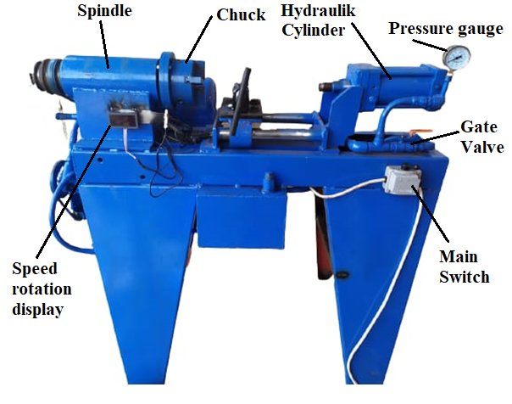

1. Friction stir welding machine

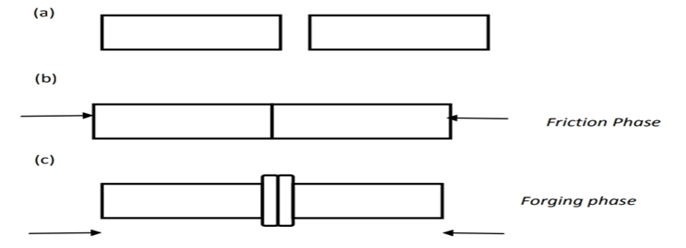

1. Stages of friction stir welding process

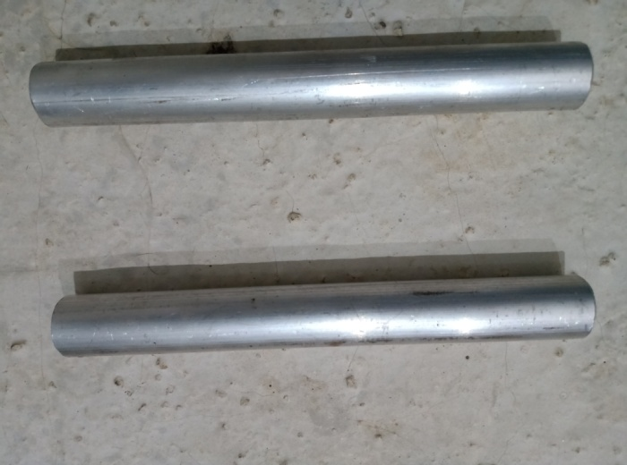

1. Aluminium rod

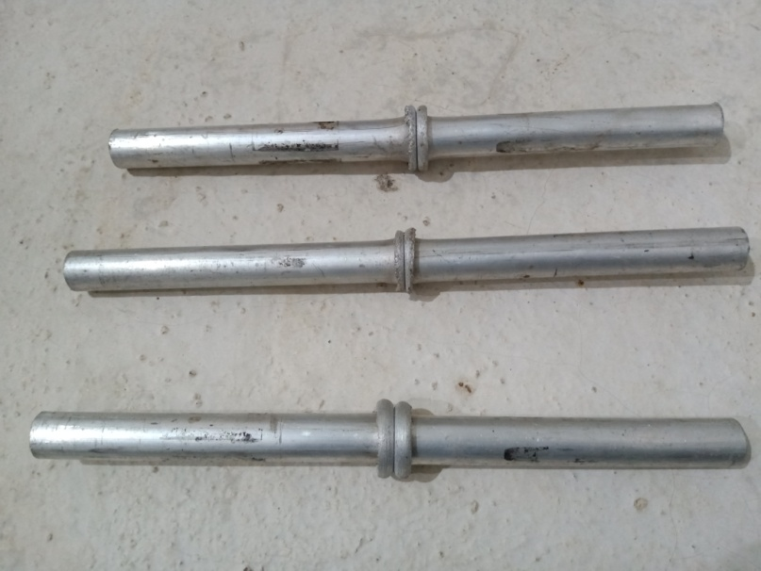

1. Aluminium after FSW

Dari hasil pengelasan kemudian specimen dibubut sesuai dengan standar specimen untuk uji tarik

1. Results and Discussion

From the results of the welding of each set of specimens, a tensile test was carried out to compare the tensile strength of the yield strength and strain. In each speed variation, there are 3 tests and the average value is taken. Table 1 shows the average tensile test results for the friction welding process at rotational speeds of 2300 rpm and 3100 rpm.

Dari hasil pengelasan tiap set specimen dilakukan pengujian tarik untuk membandingkan kekuatan tarik

1. Tensile test results for friction welding of aluminum

|  |  |  |  |
| --- | --- | --- | --- |
| Parameters | Unit | Speed 2300 rpm | Speed 3100 rpm |
| Final diameter | mm | 12,50 | 12,47 |
| Tensile strength | N/mm2 | 81,88 | 85,76 |
| Yield strength | N/mm2 | 75,89 | 68,95 |
| Strain | % | 3,66 | 8,08 |
| Notes | - | Break at welded area | Break at welded area |

* 1. **Tensile Strength**

Tensile strength is the maximum stress that an object/material can withstand when stretched or pulled. The test results above, it shows that the higher tensile strength occurs in FSW with a rotation speed of 3100 rpm, which is equal to 85.77 N/mm2.

* 1. **Yield strength**

Yield strength is the minimum stress applied to pull a material until it loses its elasticity. The test results above, it shows that the higher yield strength occurs in FSW with a rotation speed of 2300 rpm of 75.89 N/mm2.

* 1. **Strain**

Strain is the increase in the length of an object to its initial length due to a tensile force until the object breaks. The test results above show that the higher strain of FSW joint occurs at a 3100 rpm rotation speed of 3.76%.

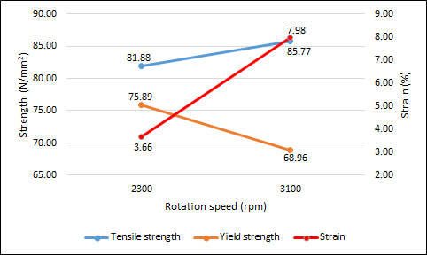

1. Graphic of tensile strength, yield strength, and strain resulting of FSW
2. Conclusion

This research is about friction welding of aluminum material with compression force conditions of 100 PSI with a duration of 30 seconds and rotational speed of 2300 rpm and 3100 rpm. It can be concluded that friction welding with different rotational speeds produces different tensile strengths, friction welding with a speed of 2300 rpm produces a tensile strength of 81.88 N/mm2 which is higher than the tensile strength of aluminum of 70.17 N/mm2. Meanwhile, friction welding with a speed of 3100 rpm produces a tensile strength of 85.76 N/mm2 which is higher than the tensile strength of aluminum at 70.17 N/mm2.

**References**

Akhmadi, A. N., & Qurohman, M. T. (2009). Analisa Hasil Pengelasan 2G Dan 3G Dengan Bahan Plat Besi ST 40 Ketebalan 10 mm dam Voltase 20 - 35 Menggunakan Mesin Las MIG. *Nozzle : Journal Mechanical Engineering*, *9*(2), 25–30. https://ejournal.poltektegal.ac.id/index.php/nozzle/article/view/2259/1242

Faisal, M., Balfas, M., & Kamil, K. (2018). Analisis Kekuatan Tarik pada Logam Axle Shaft dengan Pengelasan Gesek ( Friction Welding ). *Analisis Kekuatan Tarik Pada Logam Axle Shaft Dengan Pengelasan Gesek (Friction Welding)*, *19*(1), 25–30.

Gotawala, N., & Shrivastava, A. (2020). Analysis of material distribution in dissimilar friction stir welded joints of Al 1050 and copper. *Journal of Manufacturing Processes*, *57*(May), 725–736. https://doi.org/10.1016/j.jmapro.2020.07.043

Kimura, M., Ohara, K., Kusaka, M., Kaizu, K., & Hayashida, K. (2020). Effects of tensile strength on friction welding condition and weld faying surface properties of friction welded joints between pure copper and austenitic stainless steel. *Journal of Advanced Joining Processes*, *2*(May), 100028. https://doi.org/10.1016/j.jajp.2020.100028

Kimura, M., Sakino, S., Kusaka, M., Kaizu, K., & Hayashida, K. (2020). Characteristics of friction welded joint between 6063 aluminum alloy and AISI 304 stainless steel through post-weld heat treatment. *Journal of Manufacturing Processes*, *58*(August), 302–310. https://doi.org/10.1016/j.jmapro.2020.08.003

Kimura, M., Sano, Y., Kusaka, M., & Kaizu, K. (2021). Methods for improving joint strength of friction stud welded AA5083 alloy joints. *Journal of Advanced Joining Processes*, *5*, 100075. https://doi.org/10.1016/j.jajp.2021.100075

Pah, J. C. A., Irawan, Y. S., & Suprapto, W. (2018). Pengaruh Waktu dan Tekanan Gesek terhadap Kekuatan Tarik Sambungan Paduan Aluminium dan Baja Karbon pada Pengelasan Gesek Continuous Drive. *Jurnal Rekayasa Mesin*, *9*(1), 51–59. https://doi.org/10.21776/ub.jrm.2018.009.01.8

Satyadianto, D. (2015). *Effect of Friction Pressure , Forge Pressure , and Friction Time Variation To Impact Strength in Friction Welding Joint Using Aisi 4140 Alloy Material*.

Setyawan, P. E., Irawan, Y. S., & Suprapto, W. (2014). Kekuatan Tarik Dan Porositas Hasil Sambungan Las Gesek Aluminium 6061 Dengan Berbagai Suhu Aging. *Rekayasa Mesin*, *5*(2), pp.141-148. https://doi.org/10.21776/ub.jrm

Sugito, B., Anggoro, A. D., & Prasetyana, D. (2016). Pengaruh Kedalaman Pin ( Depth Plunge ) Terhadap Kekuatan Sambungan Las Pada Pengelasan Gesek Al . 5083. *The 3rd Universty Research Coloquium*, *3*, 94–100.

Sukmana, I., & Sustiono, A. (2016). Pengaruh Kecepatan Putar Indentor Las Gesek Puntir (Friction Stir Welding) Terhadap Kualitas Hasil Pengelasan Alumunium 1100-H18. *Jurnal Mechanical*, *7*(1), 15–19. https://doi.org/10.23960/mech.v7.i1.201603

Uematsu, Y., Kakiuchi, T., Ogawa, D., & Hashiba, K. (2020). Fatigue crack propagation near the interface between Al and steel in dissimilar Al/steel friction stir welds. *International Journal of Fatigue*, *138*, 105706. https://doi.org/10.1016/j.ijfatigue.2020.105706