Development of the IKASMA Application for Election of General Chairman in the Digitalization Era

Ida Afriliana*, Nurohim, Muhammad Bakhar, Iin Indrayanti

Department of Computer Engineering, Politeknik Harapan Bersama, Tegal, Indonesia

*Corresponding author: idaafriharahap@gmail.com

**Abstract.** The Senior High School Alumni Association from SMA N 1 Tegal, abbreviated as IKASMA, is a platform for alumni of SMA N 1 Tegal who want to keep in touch year after year. Adise from being a place to meet new people, it’s also a place to make friends. IKASMA also provides project that can provide continuity of communication as well as contribute in a variety of disciplines, such as participating in the government’s greening initiative, the program to build a prayer room for SMA N 1 Tegal, and a variety or other programs. IKASMA will be managed for three years, after which a large deliberation or MUBES will be held to elect the General Chairperson of IKASMA and its management membership. IKASMA, which had previosly primarity communicated through social media (Facebook, Instagram, and its website), held annual face-to-face meetings that were not adequately recorded. As a result, data collecting media and medium for communication between alumni and administrators are required. IKASMA apps based Android may be the best option for collecting data on alumni members from all class years and performing MUBES in 2021. This MUBES includes graduates from alumni SMA N 1 Tegal from all years, and it is the first time election of general chairman IKASMA is hosted online utilizing the Android-base IKASMA apps. There will be numerous home features in this IKASMA application, including Discount, About IKASMA, Information IKASMA’s activities, and accounts. Each IKASMA member will receive an email addrees anda have an e-card with barcode, as well as the ability to promote sales through the discount menu. On the MUBES menu, you can elected of general chairman online. The IKASMA election general chairman based on Android is extremely suitable to be executed during this pandemic era. This study will be carry out categorization of voter using Fuzzy mamdani.

Keywords : Apps, Ikasma, Android, Mubes

1. Introduction

The development of technology in the digital direction is currently growing repidly. The current era of digitazalization is very intensively implemented in several areas of life. In addition to the very rapid development of technology in the world of information and technology, it is also triggered by the pandemic conditions that have lasted for almostr two years, forcing people to be able continue their lives by utilizing technology for all areas of life. This era of digitalization is very suitable to be aplies to people’s lives today where during the pandemic it has created a pattern of life that makes it impossible to gather in large crowds or services that are only limited by space and restrictions on the number of service qoutas in public spaces.

In this digital era, humans in general have a new lifestyle that cannot be separated from all-electronic devices. Technology has become a tool that can help most of human needs. Technology has been used by humans to do make it easier to do any task and job. This is important role of technology has brought human civilization into the digital era. Challenges in the digital era have also entered varios fields such as politics, economy, socioculture, defense, security, and inforamtion technology itself.

The rapid development of technology, especially in the field of Android, has resulted in almost human life cannot be separated from Android technology. Android-based gadgets have become a necessity for humans in this millennium era, gadgets are no longer just a means of communication but are more than that. Android is an operating system for Linux-based smartphones. One of the advantages of Android compared to other smartphone operating systems is that Android is open source code so that people can customize features that are not yet available on the Android operating system according to their wishes[1]. More than 190 countries around the world use Android. Many users utilize Android to search for apps, games, and other digital content. Indonesia is one of the countries with the most active gadget users. There are 171.17 million active users, and it is about 63%of the total population of Indonesia (264.16 million) [2].

Alumni of SMA N 1 Tegal were formed in the Alumni Association of SMA N 1 Tegal which is usually abbreviated as IKASMA. IKASMA is a forum for friendship and communication between alumni from the first to the last batch, namely the alumni of class 2020. For the management of all programs carried out by IKASMA, it is managed by the IKASMA management, which is chaired by the General Chair of IKASMA. This management is elected by means of a General Meeting (MUBES) by all members of IKASMA and the board will hold a term of office for 3 years. Therefore, MUBES is held every three years. So far, MUBES has been carried out conventionally, but during this pandemic, MUBES cannot be done conventionally, so as the digitalization era advances, MUBES will be conducted using Android-based E-voting. This MUBES became one of the public services where IKASMA members consisted of the first batch from the 1950s to 2020, and almost 2000 members. IKASMA members are also spread throughout Indonesia and some are even abroad. Information on IKASMA activities is disseminated to all IKASMA members through the IKASMA website, facebook and instragram, but only limited to activity information in the form of activity information articles, even though many activities from IKASMA administrators have been programmed for IKASMA members but have not been conveyed properly, one of which is the existence of donation program and major deliberation for the election of the chairman of IKASMA every three years.

Public services as a basic need of the community in the form of service activities facilitated by the state are considered not optimal and effective. Implementation of public services, especially in terms of the implementation of democracy, namely the implementation of elections through conventional mechanisms. There are several problems in its implementation such as high levels of fraud, human error, and high funding[3]. No exception in the implementation of the IKASMA MUBES there were also several potential frauds or human errors.

Voting is a method used for decision making. Voting activities are carried out to gather aspirations with the aim of determining the solution that is considered the best in solving problems. Voting activities that are widely known by the public are elections or local elections held by the KPU, but voting activities are often also carried out on a smaller scale[4]. The meaning of e-voting in this study is electronic voting referring to the use of information technology in the voting process. In addition, e-voting can also mean a system that uses electronic devices in the digital information processing to make the ballot, voting, counting of votes, shows the tally, as well as maintain and produce audit trail [5].

In Indonesia, the implementation of the E-Voting system has been implemented since 2009. In the millennial era, several regions in Indonesia have begun to replace the manual election method by using the E-Voting method as an alternative to organizing a general election system that is more effective & efficient than before using the E-Voting system. Conventional methods have even been implemented at the lowest level, namely the election of hamlet heads and village heads [4]. Voting activities carried out conventionally have drawbacks such as a slow process because there is a lot of preparation that must be done while the process is still done manually, the amount of budget needed to finance all the needs to carry out voting, the vote counting process is less accurate and voters are required to attend directly to vote. cast their vote [4].

This research was conducted to develop an application that is used for alumni of SMA N 1 Tegal which is commonly called IKASMA to communicate and conduct major deliberation in the election of the general chairman of IKSMA based on android. The system designed and developed is an Android-based application that can provide an overview of IKASMA programs such as facilitating promotions for small or medium business, scholarships for underprivileged children, various information on IKASMA activities and even the implementation of a large deliberation for the election of the general chairman of IKASMA. E_voting activities and voters in giving their voting rights are carried out through Android where voters can participate in direct voting activities using applications and electronic devices in the form of Android smartphones connected to the internet.

1. Method

The research conducted in this research is quantitative research. There are several stages in this research, the stages used for this research are Problem Identification, Literature Study, System Design, System Testing and Scientific Article Writing, as shown in Figure 1

Identifikasi Masalah

Studi Literatur dan Pengumpulan Data

Perancangan Sistem

Pengujian Sistem

Artikel Ilmiah

Figure 1. Ikasma Application Development Research Stages

The research method carried out here has several stages, as shown in Figure 1. The stages of the research are as follows:

1. Identifying problems by conducting analysis and observations with IKASMA administrators and conducting interviews with several IKASMA administrators. Interviews were conducted simultaneously with two IKSMA administrators, asking several questions about several programs from the IKASMA management, the vision and mission of IKASMA, the list of IKASMA administrators as well as the procedures for implementing conventional MUBES that had been carried out in 2018.
2. conduct a literature study, study theories and previous research journals about android-based e_voting applications. From the literature study, it was found that the design of applications related to supporting data for the electoral system (e-voting), tools that will be used in designing the IKASMA application. Collecting the data taken, among others, there are several forms needed by the user / application user.
3. perform system design. The method used at the design stage of this research system is the SDLC method, namely the Waterfall method version of Roger S. Pressman 2010[6]. The design flow is as shown in Figure 2. Figure 2 is a picture of the design flow carried out in this research. Stage (1) Needs Analysis, namely the stage of analyzing the research object, in this case the data needed in designing the IKASMA application. Data were taken directly through interviews with IKASMA administrators. The data generated is data that contains information about user needs for the application to be designed, such as IKASMA membership features, IKASMA activity programs, IKASMA General Meetings and about IKASMA which contains the vision and mission and list of names of management and types of IKASMA management positions in the current year. .Next is stage (2) System Design, which is the design stage of the system to be built based on the results of the needs analysis using UML (Unified Modeling Language), which consists of architecture diagrams, activity diagrams, use case diagrams and class diagrams. The database design is in accordance with the data requirements by the IKASMA management. Stage (3) is application coding and the next is application testing.

Analisis Kebutuhan

Desain Sistem

Pengkodean Aplikasi

Pengujian Aplikasi

Figure 2. Metode Waterfall Pengembangan Aplikasi IKASMA

1. Perform system testing by users, this stage conducts wider system testing, where all users have implemented all menus in the application and includes trial and error on application development. Each addition of features to the application will also be updated on applications that have been registered in the Playstore. The application that was produced before development was an IKASMA version 1.0 application so that after the development of several features and databases it became an IASMA version 2.07 development.
2. Write down the research result in the form of scientific articles and be published.

1. Results and Discussion

In this part, we will discuss several items IKASMA application. The IKASMA application is a tools for communicatiing between IKASMA alumni from various years of graduation. The IKASMA management, which changes every three years, has problems with disseminating information on activities from the IKASMA management to all IKASMA members. So far, there have been coordinators for each batch who are members of the WA group, and there are also websites, facebook and instagram of IKASMA which provide updated information on IKASMA activities. However, all these activities are not properly recorded, therefore this research will design and develop the user-friendly IKASMA application so that it can be used by all ages

3.1. IKASMA Application Design.

The design of the IKASMA application has 2 actors, namely the user and the application admin. At this design stage, a system analysis is carried out, namely the need for menus required by users and admi ns. This application is designed using UML. The system creation tool is the Java Programming Language MariaDB database, and editor using android studio. To perform system/software modeling, we use UML (Unified Modeling Language) notations. UML Notations were formed from the cooperation and efforts of Graddy Booch (formerly known as his Booch notation), DR. James Rumbaugh (who was previously famous for his OMT (Object Modeling Technique) notation), and Ivar Jacobson (formerly known for OOSE (Object Oriented Software Engineering) [7].

The system design is as shown in table 1Then after that, the menu design was carried out according to the wishes of the IKASMA management. In table 1 it can be seen that there are two actors in the design of this IKASMA application, namely the user and the admin. Users are all users who have registered to become IKASMA members through the application and the admin is the application manager who can read, create, update and delete several menus of the IKASMA application.

Tabel 1. Ikasma aplication design

|  |  |  |  |
| --- | --- | --- | --- |
| **AKTOR** | **NO** | **MENU** | **KETERANGAN** |
|
| ADMIN | 1 | HOME | admin can see initial view, social media of ikasma, |
| admin can see the initial view, social media from ikasma such as facebook ikasma, instagram ikasma and Whatapps group ikasma |
| 2 | MITRA | admin can input partner form, partner form CRUD |
| 3 | PROFIL | admin can see the profile menu, namely vision, mission, legal basis, organizational structure |
| 4 | BEASISWA | admin can see the scholarship menu, namely input the scholarship form, view submissions and see the list of recipients |
| 5 | DONASI | admin can see and manage the donation menu, namely fill in the donation form. View donations and view all donations |
| 6 | MUSYAWARAH BESAR | admin can see the voting results and a list of potential partners |
| 7 | AKUN | admin can see e-card, personal data, can input social media, change password and administrator menu |
| 8 | ADMINISTRATOR | admin can CRUD members, CRUD vision and mission, CRUD organizational structure, CRUD information, CRUD scholarships, CRUD partners, CRUD donations, CRUD products and CRUD Mubes |
| USER | 1 | HOME | user can see initial view, social media of ikasma, |
| user can see the initial view, social media from ikasma such as facebook, instagram and Whatapps group ikasma |
| 2 | MITRA | user can input partner form |
| 3 | PROFIL | the user can see the profile menu, namely the vision, mission, legal basis, organizational structure |
| 4 | BEASISWA | the user can see the scholarship menu, namely input the scholarship form |
| 5 | DONASI | users can see the donation menu, namely fill in the donation form |
| 6 | MUSYAWARAH BESAR | admin can see the voting results and a list of potential partners |
| 7 | AKUN | admin can see e-cards, personal data, can input social media and change passwords |

Activity diagrams, sequence diagrams and class diagrams are not described in this research article. In this research article, we will discuss the menus that can be implemented in the IKASMA 2.0.7 application.

3.2 IKASMA Application Display

The IKASMA application is designed according to the needs of users, namely IKASMA administrators, IKASMA members and the goals and vision and mission of IKASMA. This design is carried out in stages by updating the application several times, from the IKASMA version 1.0 application to the IKASMA version 2.0.7. Each version develops according to user and admin needs. In designing the IKASMA 2.0.7 application, the server is prepared to accommodate 2500 members/users. In the discussion of this application will be presented the menus in this application. The IKASMA version 1.0 application was immediately implemented and can be accessed and downloaded on the Playstore. With various developments, finally the development of the IKASMA version 2.0.7 application was obtained.

From figure 3 until figure 9 shows display all menus at IKASMA Aplication version 2.0.7.

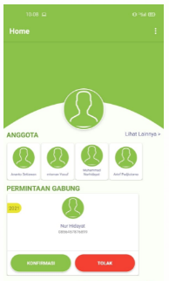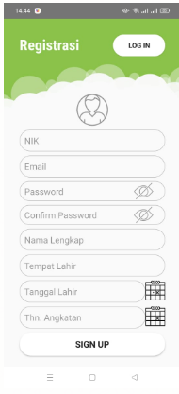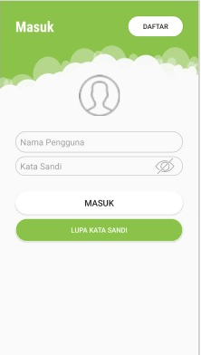

(c)

(a)

(b)

Figure 3. Initial display of the IKASMA application in the Login menu (a) initial display (b) list menu for users who have just installed the application (c) verification of IKASMA membership by admin

Figure 3 shows the appearance of the application on the login menu or login menu. In Figure 3(a) is the appearance of the IKASMA application when you first log in. If the user has never logged in or installed the IKASMA application for the first time, it will register in the REGISTER toolbox which is located on the top left. In Figure 3(b) is a menu for inputting user data. If the user has registered, the admin must confirm the registered membership. In Figure 3(c) is the admin display to confirm membership to ensure that the user is an alumni of SMA N 1 Tegal. Once confirmed, the user can login to the application and can access all menus in the application. Each IKASMA member can access 5 main menus and several sub menus in the IKASMA application.

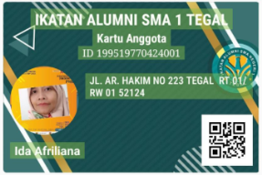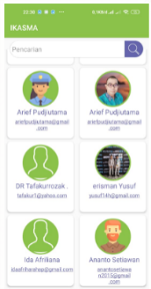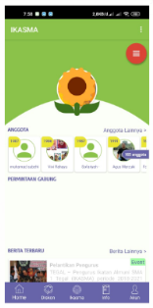

(c)

(b)

(a)

**Figure 4.** IKASMA application display (a) home user display (b) member menu display for admin (c) IKASMA membership e-card user

If the user can only see all the menus and sub menus, while the admin can view and manage all the menus and sub menus. The IKASMA version 2.0.7 application can be installed on Android 9, Android 10 and Android 11. Some of the floating menus have been improved from version 1.0 to version 2.0.7. Figure 4 shows the home menu where this home menu will appear immediately when the user has logged into the application. The display of this icon is made as simple as possible because the application user IKASMA is from several batches, from seniors who graduated in 1963 to the latest graduates in 2021.

Figure 4 shows the appearance of the IKASMA application on the dashboard or home menu. In Figure 4(a) is the display of the IKASMA application for the user, where the user can view the following information:

1. The top rightmost three dots consist of IKASMA version, guide, tell friends and exit. This version of IKASMA shows the version currently in use, namely version 2.0.7. The guide contains a manual for using the IKASMA Application in pdf format that can be accessed through the user's device. Tell a friend this will share the link of this app on social media, such as share via share me, whatapp, facebook, and others,
2. This menu will also show a photo of the user account and some friends who have registered in the IKASMA application,
3. In this menu, information about IKASMA activities will also appear,
4. In this menu, there is a Figure at the bottom which is a menu that can be used by users in this application, namely Home, Discount, Ikasma, Info and Account.

In Figure 4(b) is the admin menu that shows the members who have registered in this IKASMA application. Admin can see the data for each of these accounts. Figure 4(c) shows the e_card display for users of the IKASMA application, where the e_card is equipped with a barcode that can be used to verify data for users voting at the General Conference (MUBES).

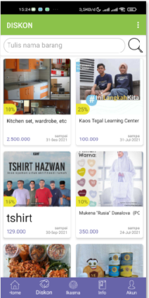

Figure 5. discount menu display

Figure 5 shows the discount menu that can be seen by all users and can also be filled in by all users. But the user can only see the promotion of all items promoted by the small or medium business. The small or medium business owners must also be members of IKASMA and discounts on goods are only given to all users with IKASMA accounts, this is part of the program owned by IKASMA. This promotional menu will be uploaded to the application, where normal item prices and discount percentages are displayed along with product photos displayed according to each promotion. If other users are interested in the goods offered, those interested can directly click on the WhatsApp number which will be directly connected to the seller or the small or medium business.

Figure 6(a) shows the IKASMA menu which contains Profile, Ikasma, Donations, Partners and General Meetings (b) shows the appearance of the IKASMA profile sub menu which contains the vision and mission of IKASMA, legal basis and names of the management in the current year.

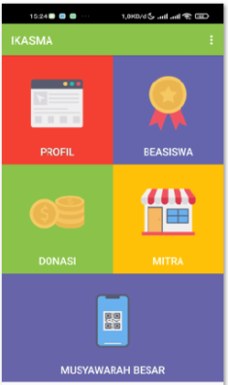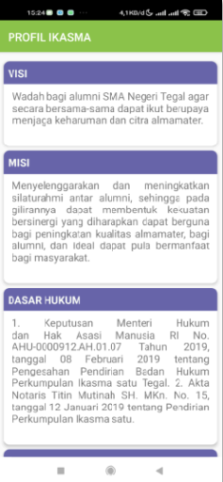

(a)

(b)

Figure 6.(a) Ikasma menus display (b) Profiles sub menus display

Figure 7(a) shows the IKASMA sub menu, namely the scholarship form input, where the user can apply for a scholarship and then it is confirmed by the admin. Meanwhile, 7(b) shows the input sub menu of the donor form, where the user can fill out this form if he wants to donate his funds for donation and the admin will confirm.

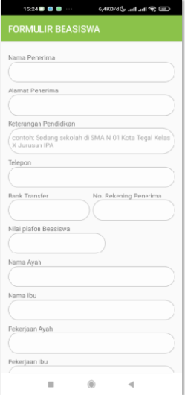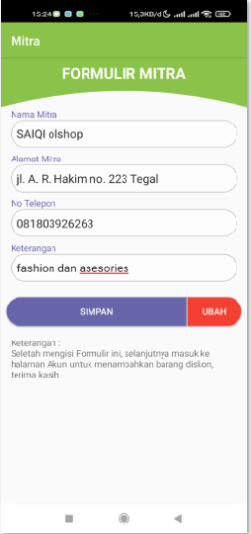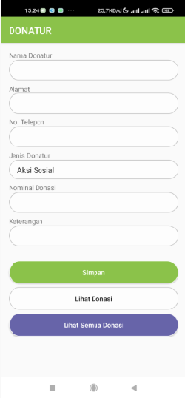

(a)

(b)

(c)

**Figure 7**.(a) Scholarship sub menu display (b) Donor sub menu display (c) Partner form sub menu display to be displayed in the discount menu

Figure 7(c) shows the partner form input sub menu, that is, users who are SMEs can promote their merchandise in this sub menu. In this menu, the user is required to upload a photo of the product and display the discount, as well as include a whatsapp number so that they can be directly connected if a user is interested in the offer.

Figure 8(a) shows the General Deliberation menu, where the user can see the candidate for general chairman, conduct e_voting for the election of the general chairman, while Figure 8(b) shows the display of the General Deliberation sub menu on the admin, where the admin can set input for the candidate for general chairman. , input voter data and make settings for the implementation of the IKASMA MUBES and can confirm voter attendance by scanning barcodes. MUBES results will be visible in real time.

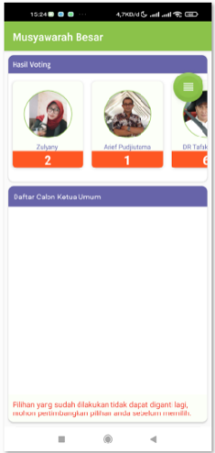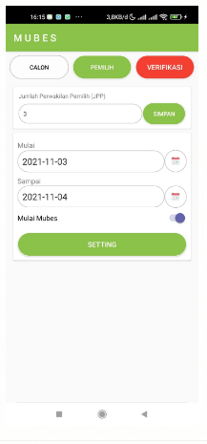

(b)

(a)

**Figure 8**.(a) Display of the large deliberation menu/MUBES (b) Display of the sub menu of the MUBES implementation settings.

With this e_voting, the list of candidates, the voter list can be done online with voter verification using a barcode.

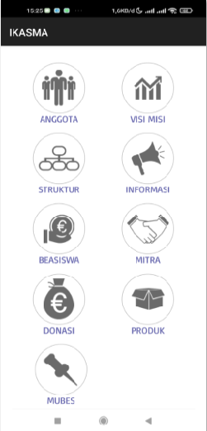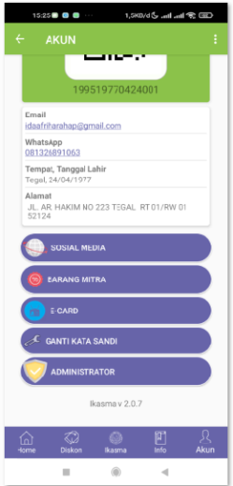

(b)

(a)

**Figure 9**.(a) Admin account sub menu display (b) Administrator sub menu display for admin

Figure 9(a) shows the sub menu on the admin account where the admin will have different sub menus with the user, the difference is that the admin sub menu is equipped with an administrator sub menu, besides there are 4 other menus namely social media, partner goods, e-cards, and change password. These four sub menus are also in the user's account, so the user can access all four of them. This administrator menu is the admin's authority to manage all sub menu data as shown in Figure 8(b).

3.3 IKASMA Application Testing

The IKASMA 2.0.7 application has begun to be tested for all batches, namely from the 1963 class to the 2021 batch. However, not many seniors have been able to use this application. Testing is done by implementing this application to all generations and all generations are asked to download this application on the playstore with the search keyword IKASMA.

The results of testing the IKASMA application are as shown in table 2 and table 3

Table 2 . IKASMA app testing for admin

|  |  |  |  |
| --- | --- | --- | --- |
| **MENUS** | **TESTING** | **MENUS** | **TESTING** |
| HOME - Home screen |  | HOME - IKASMA's social media addresses |  |
| - go to ikasma website |  | - login to ikasma's fb |  |
| - login to ikasma's ig |  | - go to wa ikasma |  |
| DISCOUNT |  | - initial view |  |
| - search |  | IKASMA |  |
| -Profile |  | - Scholarship - form |  |
| - Scholarships - view submissions |  | - Scholarships - see list of recipients |  |
| - Donate - form |  | - Donations - view submissions |  |
| - Donations - see list of recipients |  | - Partners - input partner form |  |
| - Partner - save partner form |  | - Partner - change partner form |  |
| -Great Deliberation - Voting results |  | -Great Deliberation - List of Candidates for Chairperson |  |
| -Great Deliberation - Setting the implementation of the mubes via the app |  | INFORMATION - preview |  |
| INFORMATION - News and information |  | ACCOUNT - Photo |  |
| ACCOUNT - E-card |  | ACCOUNT - edit data |  |
| ACCOUNTS - social media save |  | ACCOUNTS - partner goods (add data) |  |
| ACCOUNT - data input partner item |  | ACCOUNT - image input partner item |  |
| ACCOUNT - save |  | ACCOUNT - e-card |  |
| ACCOUNT - administrator - member |  | ACCOUNT - administrator - edit vision and mission |  |
| ACCOUNT - administrator - edit structure vision |  | ACCOUNT - administrator - edit information |  |
| ACCOUNT - administrator - edit scholarship/verification |  | ACCOUNT - administrator - edit partner |  |
| ACCOUNT - administrator - edit donation |  | ACCOUNT - administrator - edit product |  |
| ACCOUNT - administrator - edit mubes |  | ACCOUNT - download member data |  |

Table 2 shows some testing of menus and sub menus by users and admins, and everything can run well.

Table 3 shows testing of menus for user and there are 10 users for this testing. Then the result of testing were all of menus can run well.

Table 3 . IKASMA app testing for user

|  |  |  |  |
| --- | --- | --- | --- |
| **MENUS** | **TESTING** | **MENUS** | **TESTING** |
| HOME - Home screen |  | HOME - IKASMA's social media addresses |  |
| - go to ikasma website |  | - login to ikasma's fb |  |
| - login to ikasma's ig |  | - go to wa ikasma |  |
| DISCOUNT |  | - initial view |  |
| - search |  | IKASMA |  |
| -Profile |  | - Scholarship - form |  |
| - Scholarships - view submissions |  | - Scholarships - see list of recipients |  |
| - Donate - form |  | - Donations - view submissions |  |
| - Donations - see list of recipients |  | - Partners - input partner form |  |
| - Partner - save partner form |  | - Partner - change partner form |  |
| - Partners - only see other people's products, can't edit |  | -Great Deliberation - Voting results |  |
| -Grand Deliberation - view the voter list |  | -Great Deliberation - List of Candidates for Chairperson |  |
| INFORMATION - preview |  | INFORMATION - News and information |  |
| ACCOUNT - Photo |  | ACCOUNT - E-card |  |
| ACCOUNT - edit data |  | ACCOUNTS - social media save |  |
| ACCOUNTS - partner goods (add data) |  | ACCOUNT - data input partner item |  |
| ACCOUNT - image input partner item |  | ACCOUNT - save |  |
| ACCOUNT - e |  |  |  |

Of the 59 batches, the number of all IKASMA alumni cannot be known, but communication so far has only been through the batch coordinator.

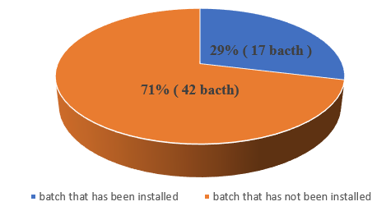

**Figure 10.**  Percentage of batches that have installed the IKASMA application

Before being called IKASMA, the designation for the alumni management of SMA N 1 was called yabhasma. The test is carried out by the force coordinator and also socialized in each class group. The result is that there are 42 batches that have installed the IKASMA application and as of December 13th, 285 members have downloaded from each batch, at least one member is a member, there are 17 batches who have not installed it as shown in Figure 10.

Age difficulties are an obstacle for the senior generation to follow directions from the administrators to install applications due to limited ability to use Android.

1. Conclusion

The design of this IKASMA application can be made with 5 main menus where each menu consists of several sub menus. All menus in this application can be implemented properly with blackbox testing. Of all the batches, only a few batches have installed the IKASMA application, which is 70%. With the MUBES menu, it is actually possible to elect the general chairman of IKSMA based on Android, but because there are 17 batches who have not been able to use this application, the implementation of the e_voting-based MUBES is still in the discourse in the following year. All menus can be functioned and accessed by all users and can run well, so that the research objective to communicate between generations has been achieved and there is a need for socialization to be able to carry out E_voting in the implementation of MUBES in the following year.

1. References

[1] I. Afriliana and E. Budihartono, ‘Pengembangan Aplikasi Jadwal Mata Kuliah Dan Alarm Notifikasi Bagi Dosen Untuk Meningkatkan Proses Pembelajaran (Studi Kasus: Prodi DIII Teknik Komputer Politeknik Harapan Bersama Tegal)’, 2019.

[2] I. Safitri, R. Pasaribu, S. S. Simamora, and K. Lubis, ‘The effectiveness of android application as a student aid tool in understanding physics project assignments’, *J. Pendidik. IPA Indones.*, vol. 8, no. 4, pp. 512–520, 2019, doi: 10.15294/jpii.v8i4.19433.

[3] R. Wati, ‘Implementasi Sistem E_voting untuk Meningkatkan Kualitas Demokrasi Indonesia’, *JPK*, vol. 8, no. 5, p. 55, 2019.

[4] R. Prananda, H. Anra, and H. S. Pratiwi, ‘Rancang Bangun Aplikasi E-Voting Berbasis Android (Studi Kasus : Pemilihan Ketua Organiasi di Lingkungan Fakultas Teknik Universitas Tanjungpura)’, *J. Sist. dan Teknol. Inf.*, vol. 5, no. 1, pp. 17–21, 2017, [Online]. Available: http://jurnal.untan.ac.id/index.php/justin/article/view/17962.

[5] T. Apriani, M. I. A. Hamudy, M. S. Rifki, and A. S. Hadi, ‘E-voting in the Village Head Election in Batanghari and Kabupaten Bogor Regencies’, *J. Bina Praja*, vol. 10, no. 2, pp. 317–326, 2018, doi: 10.21787/jbp.10.2018.317-326.

[6] R. Baxter, *Software engineering is software engineering*. 2006.

[7] H. Arfandy and S. K. Makassar, ‘Aktivitas Pada Komputer Berbasis Android’, vol. 4, no. 1, 2017.