Web-Based Public Service Information System

at Padang Barat Police

Teguh Junaidi

Department of Computer Engginering, D3 Computer Engginering Study Program, Politeknik Harapan Bersama, Tegal, Indonesia.

*Corresponding author: teguhjuned@gmail.com

**Abstract.** At the West Padang Police, if the public makes a complaint or request to the police unit SPKT (Integrated Police Service Center), the officer still uses a conventional system or has not been computerized where the shortcomings of this system are that it is very possible during the process there is an error in recording, the report is not accurate. made, delays in finding the data required for STTLP (Police Report Receipt) then the officer must rewrite it on the book for archiving, then if the public makes a second application, the officer must rewrite the applicant's data because it takes a long time to search the data. To overcome these problems, it is necessary to have a web-based public service system at the Padang Barat Police Station.

1. Introduction

Service is an activity carried out by a person or group of people on the basis of material factors through certain systems, procedures and methods in an effort to fulfill the interests of others in accordance with their rights [1]. Seeing the conditions and facts on the ground illustrates that public services provided by the government are still not in line with expectations, people still think that the services provided by the government seem less effective and efficient. Government agencies that provide services to the community regarding problems in terms of public order, law enforcement, protection, shelter are carried out by the Police [2].

The police in the SPKT (Integrated Police Service Center) field have functions which include serving complaints from the public who have been affected by criminal acts, such as reports of fraud, robbery, embezzlement, theft, loss of valuables and so on [3]. Due to the high number of public complaints at this time, the community really needs fast service at the SPKT section. Because SPKT is the spearhead of police services in providing services to the community to improve and facilitate services, software is needed [4].

At the West Padang Police, if the public makes a complaint or request to the police unit SPKT (Integrated Police Service Center), the officer still uses a conventional system or has not been computerized where the shortcomings of this system are that it is very possible during the process there is an error in recording, the report is not accurate. made, delays in finding the data required for STTLP (Police Report Receipt) then the officer must rewrite it on the book for archiving, then if the public makes a second application, the officer must rewrite the applicant's data because it takes a long time to search the data.

If the SPKT (Integrated Police Service Center) system is computerized, officers can get applicant data easily and filing is more effective, while it is easy for applicants to get information about complaints clearly, and applicants do not have to queue to make STTLP because of filling out forms and requirements [5]. done online can be anywhere. Supervision by the Head of the SPKT Administration can be directly carried out by looking at the existing reports on the system, so that they can be viewed at any time [6].

1. Research Methodology

The research framework is the concept or sequence of activities to be carried out in a study. So that the steps taken by the author in this design do not deviate from the subject matter and are easier to understand. The sequence of steps that will be made in this study can be seen in Figure 1 below:

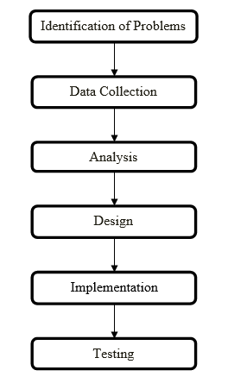

**Figure 1** Research Framework

Research stages are stages that will be carried out to facilitate research. The stages in this research are as follows:

1. Identification of Problems

Problem identification is a step taken by researchers at the beginning of the research. Researchers identify problems by explaining what problems have been found in the public service system at the Padang Barat police station so far and how these problems are measured and related to research procedures. This stage is also the initial stage of a research.

1. Data Collection

In carrying out this research, data was collected by interviewing directly at the West Padang Police. To get the right data or information regarding data relating to the existing public service system at the West Padang Police.

1. Analysis

The system analysis carried out can determine the design needed to build a public service system. So that the system can be implemented effectively and efficiently. The public service information system at the Padang Barat Police Station is built on a web-based basis.

1. Design

At this stage to find out how to design a public service system that will be run, starting from analyzing the current system, designing the UML, and designing the program that will be run.

1. Implementation

System implementation is the stage that maps the system to be ready to be operated by the user. Implementation aims to confirm the design modules, so that users can provide input on system development.

1. Testing

The process of testing and evaluation will be carried out on the resulting system to find out whether the public service system that has been designed can run correctly and in accordance with the design carried out.

1. Results and Discussion

Testing this system is done by running the menus that exist in the public service information system program at the Padang Barat Police Sector web-based, the forms of the program display are as follows:

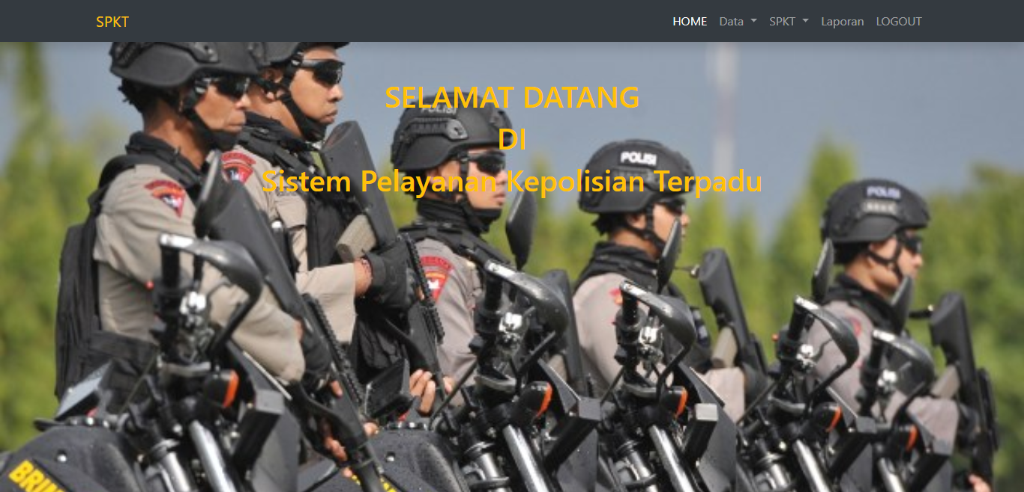

**Figure 2** Admin Main Menu, The main admin menu is a form where users can enter the system and manage the system. The following is the admin main menu form for other sub menu options, namely the data menu, SPKT, reports and logout.

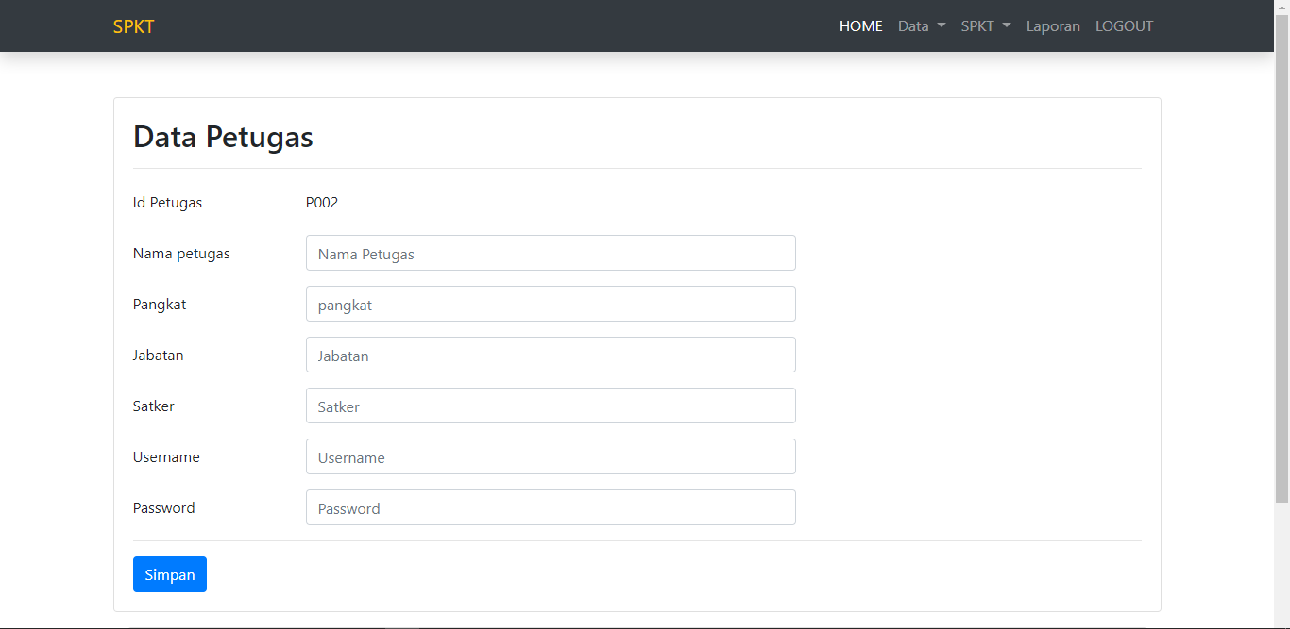

**Figure 3** Form Manage Officer Data in Admin, The following is a display of the officer data management form in the system, where the admin can add officer data, edit officer data and delete officer data.

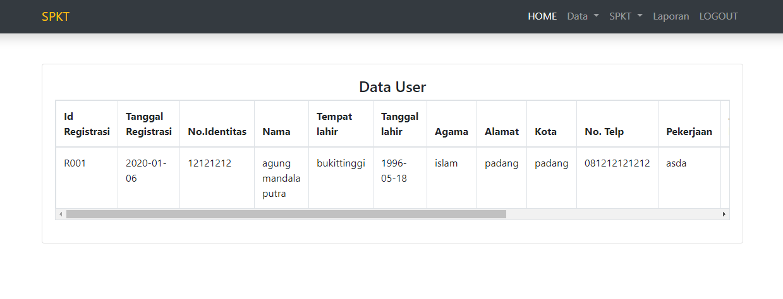

**Figure 4** Form Show User Data in Admin, The following is a display of user data, and admins can view user data.

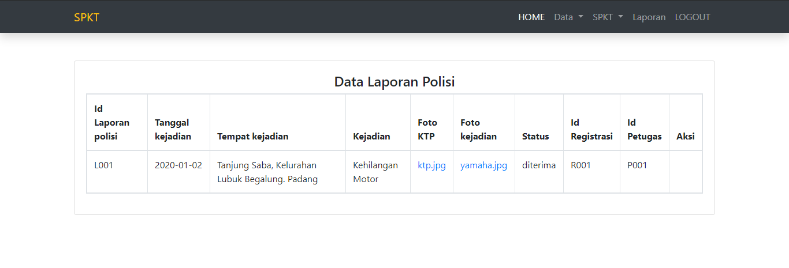

**Figure 5** Police Report Data Display Form, The following is a display of the police report form, where the admin can see community reporting data that has been successfully inputted into the system.

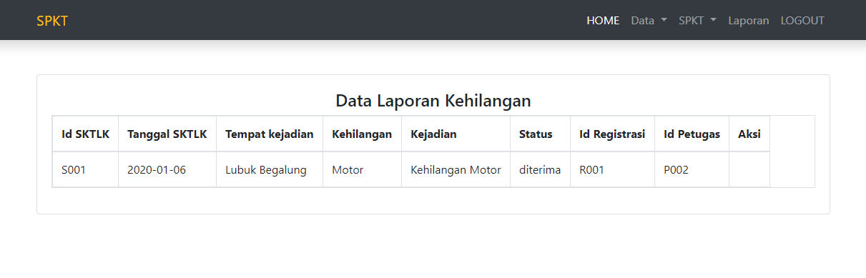

**Figure 6** Loss Report Data Display Form in Admin, The following is the form for displaying the loss report data, admins can see the loss report data that has been successfully inputted by the community in the system.

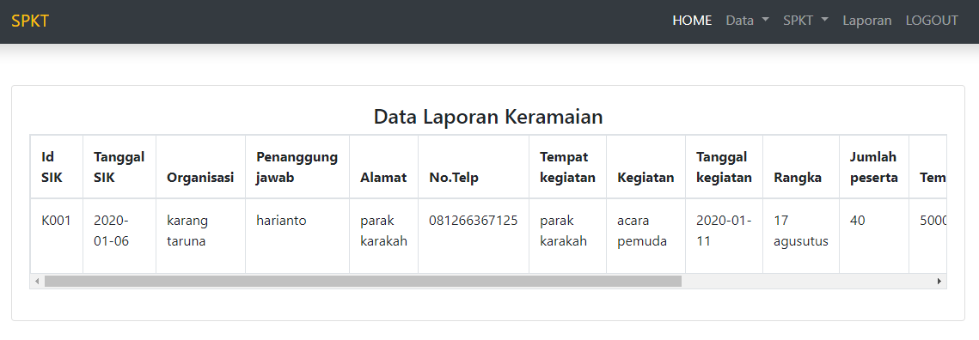

**Figure 7** Crowd Report Data Display Form in Admin, The following is a display of crowd report data on the admin, where the admin can see crowd report data that has been reported by the public and can confirm reports.

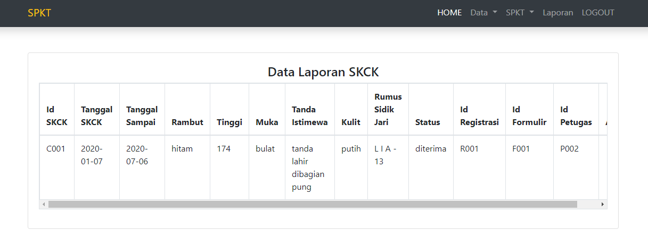

**Figure 8** SKCK Report Data Display Form, The following is a display of the SKCK report data form where the admin can see the SKCK data that has been inputted by the community in the system.

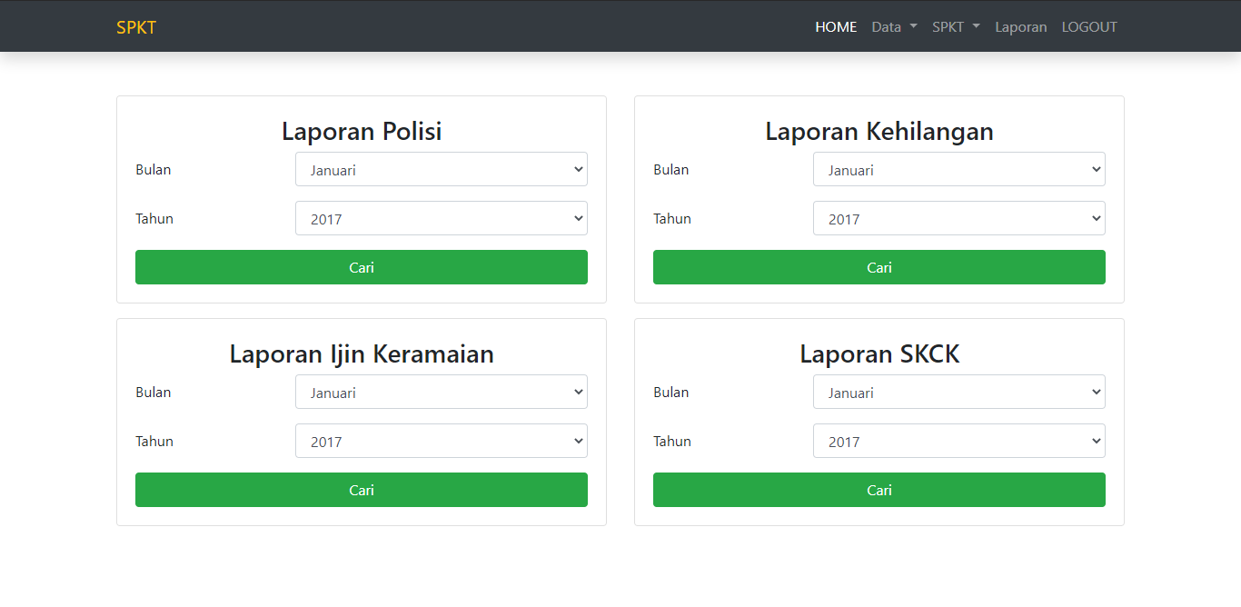

**Figure 9** Display of Report Filter Form in Admin, The following is the report filter form for the admin, where the admin can search for the desired report through the available report filters.

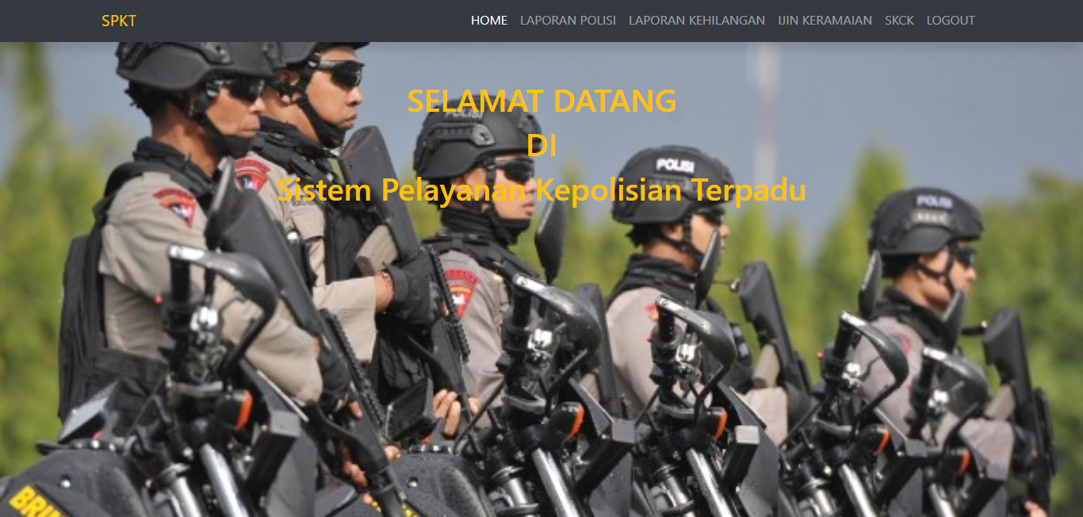

**Figure 10** Display of the Main Menu Form of the Public Service Information System, The following is the community's main menu form, where the community can input police reports, loss reports, crowd permits and fill in data for making SKCK.

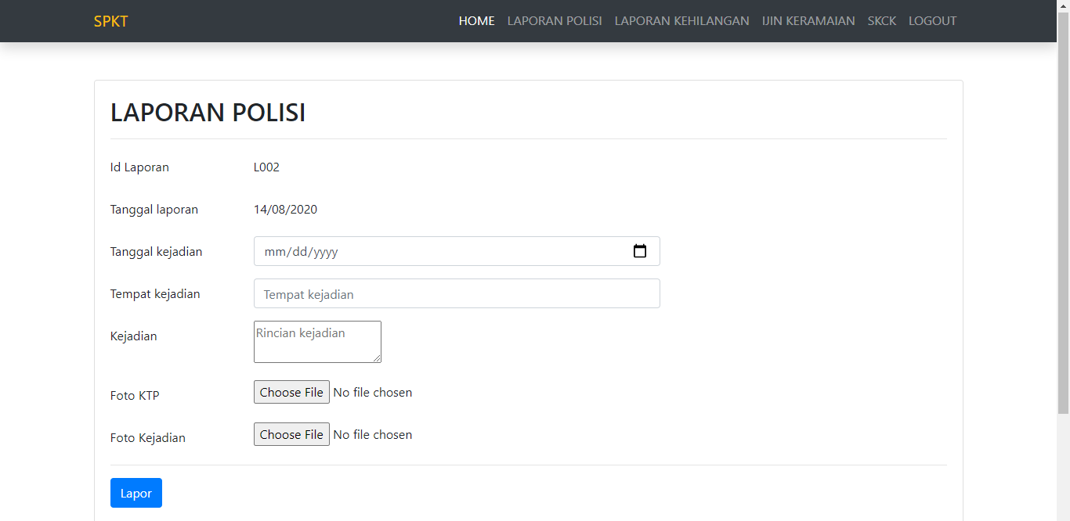

**Figure 11** Display of Police Report Input Form on Public Service Information System, The following is a police report input form to the community, where the public can fill in the report data that has been provided in the system.



**Figure 12** Display of Police Report Input Form on Public Service Information System, The following is a police report input form to the community, where the public can fill in the report data that has been provided in the system.

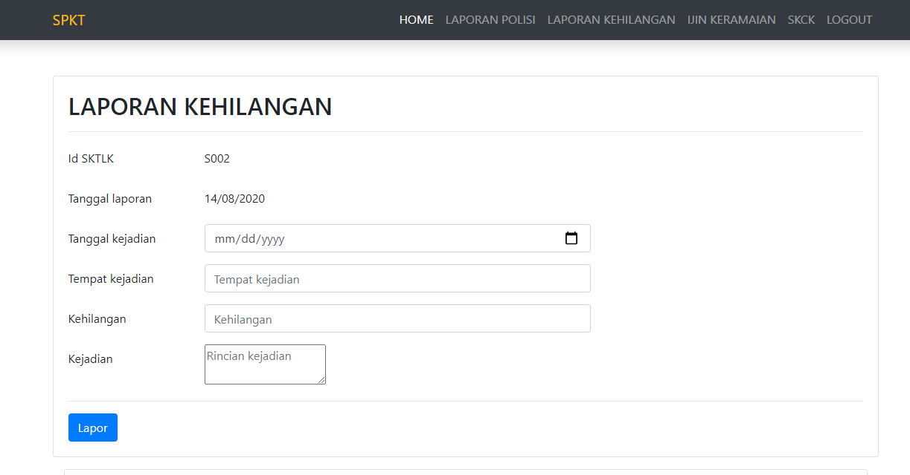

**Figure 13** Display of Loss Report Form on Public Service Information System, The following is a loss report input form, where the public can fill in lost data in the form provided in the system

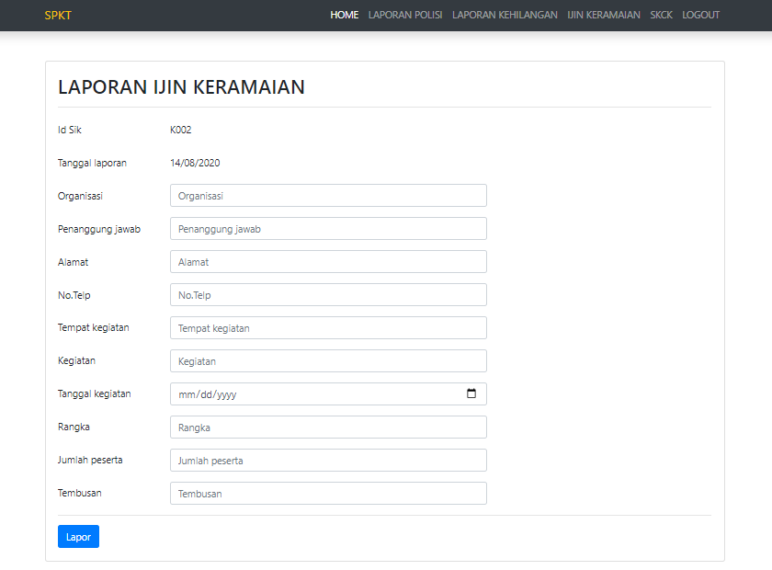

**Figure 14** Display of the Crowd Permit Report Form on the Information System, The following is the crowd permit report format, where the public can fill in the crowd permit data provided by the system.

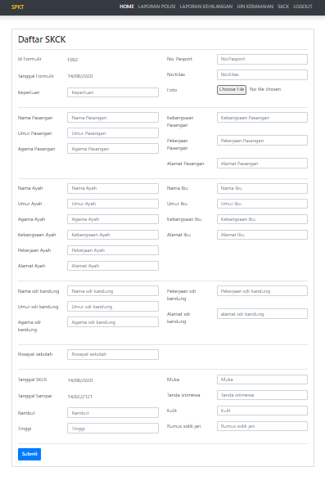

**Figure 15** Display of SKCK Data Input Form on Public Service Information System, The following is the SKCK data input form, where the public can fill in the SKCK data in the SKCK data form provided in the system.



**Figure 16** Display of the Crowd Permit Report Form on the Information System, The following is the crowd permit report format, where the public can fill in the crowd permit data provided by the system.

1. Conclusion

This application can help facilitate and assist the West Padang Police in the web-based SPKT (Integrated Police Service Center) process. The design of the SPKT application can help the community to make complaints or requests to the police. The application of the SPKT application can improve the quality of the West Padang Police regarding the quality of service delivery to the community. The existence of a computerized public service system can facilitate the work of the West Padang Police in processing data. The application of the application is very easy to understand and understand in its implementation so as to make performance more efficient.

**References**

[1] N. Almira Mayangky, A. Bsi Bandung, And P. Studi Manajemen Informatika, “Perancangan Sistem Informasi Sentra Pelayanan Kepolisian Terpadu Pada Polsek Citeureup Cimahi,” 2018.

[2] R. H. Fitri, “Sistem Informasi Pelayanan Publik Pada Polsek Amuntai Utara,” 2021, [Online]. Available: Http://Eprints.Uniska-Bjm.Ac.Id/4790/.

[3] M. Tabrani And K. Lapelia, “Implementasi Metode Waterfall Pada Sistem Informasi Sentra Pelayanan Kepolisian Terpadu(Spkt) Polsek Karawang Kota,” *Smart Comp Jurnalnya Orang Pint. Komput.*, Vol. 10, No. 1, Pp. 15–19, 2021, Doi: 10.30591/Smartcomp.V10i1.2198.

[4] N. D. Astuti, “Efektivitas Pelayanan Surat Keterangan Catatan Kepolisian (Skck) Di Polsek Driyorejo,” *Jpap J. Penelit. Adm. Publik*, Vol. 3, No. 1, 2017, Doi: 10.30996/Jpap.V3i1.1241.

[5] M. F. Nazlia Sri Wahyuni, Muharir, “Sistem Informasi Sentra Pelayanan Kepolisian Terpadu Dan Pelayanan Skck Berbasis Web Pada Polsek Angkinang,” Pp. 1–30.

[6] E. Widarti, A. K. Indarto, And A. Primahardika, “Sistem Informasi Sentra Pelayanan Kepolisian Terpadu (Spkt) Polsek Jajaran Di Polresta Surakarta,” *Go Infotech J. Ilm. Stmik Aub*, Vol. 26, No. 2, P. 119, 2020, Doi: 10.36309/Goi.V26i2.129.