Development Poin Of Sale (POS) Application Using RAD Method To Reduce Negligences In Recording Transactions

D Kuswoyo1, W Sriyanto2

1Department of Graphic Design, Politeknik Negeri Media Kreatif, Indonesia  
2Department of Graphic Engineering, Politeknik Negeri Media Kreatif, Indonesia

**Abstract.** CV. Usaha Mandiri is a company focus in the sale of paper suppliers and distributors. In sales activities, they have not used computers as a whole which are integrated with each other as work aids, so that in daily activities there are still activities that use manual recording. The purpose of this research is to replace of the out of date tools or devices into an update application on the CV. Usaha Mandiri from the aspect of software and hardware used in POS and assisting the sales department in supervising and controlling sales transactions to reduce negligence in recording transactions. The method in developing a sales information system uses the Rapid Application Development (RAD) system design method, which begins with the stages of requirements planning, system design, and implementation. Using the stages of the RAD method in the development of application, can produce a information system that is effective and efficient in providing sales information to reduce negligence in recording transactions at the sales department.

1. Introduction

Todays, information technology grows rapidly for inovation and transformation, and it becomes more sophisticated for everyday convenience.[1] The word industry 4.0 is often repeated by many people. The concept of the era industrial 4.0 for industrial firms allows computers to connect and communicate with each other to ultimately make decisions without human intervention. Currently, the use of information technology of industry 4.0 plays a very decisive role in the success of competition between companies.With the rapid development of information technology, the use of information technology will be very effective and effecient when applied to an enterprise [8].

CV. Usaha Mandiri is a company focused on the sale of paper suppliers and distributors whose address is at Jl. Ki Hajar Dewantoro No.168 RT.04/08, Gondrong-Tangerang. In sales activities, they have not used computers as a whole which are integrated with each other as work aids, so that in daily activities there are still activities that use the manual recording. The development of point of sale (POS) applications can provide better services to consumers, such as faster and faster calculation of prices and quantities of items purchased [5].

In this study, the authors propose to convert the old information system into a new information system on the CV. Usaha Mandiri from the point of view of software and hardware used in point of sale applications, and helps the sales department to monitor and control sales transactions to reduce carelessness/negligence in recording transactions. By using the steps of Rapid Application Development (RAD) methodology in developing point of sale applications, it is possible to create an efficient and effective information system for delivering sales information and to reduce negligence in recording transactions in the sales department.

1. Methods

Rapid Application Development (RAD) is a software process model that emphasizes short development cycles. RAD is a rapid adaptation of the waterfall model using a component construction approach. RAD is a combination of various structured techniques with common prototyping and application development techniques to accelerate system/application development [6].

In this research activity, the method used is RAD method which includes requirements planning, system design and implementation phases.

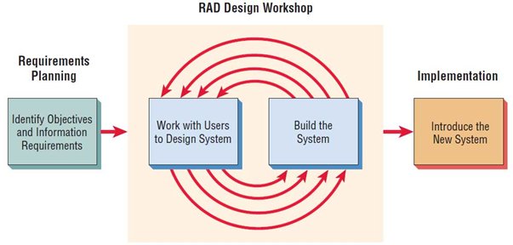

**Figure 1**. Rapid Application Development (RAD)

1. Requirements planning phase

Users and analytics meet to define the application's purpose and work towards solving business problems. At the needs analysis stage, the application's needs, limitations, and goals are determined by collecting data from sales and management.

1. System design phase

Design and improvement phase and use Application Decision Support Teams to help users agree on designs, users feedback on actual working prototypes, and fine-tuning analysis of modules Design based on user feedback. At the modeling stage, design all the activities of the overall system architecture and improve understanding of the problem based on the analysis performed.

1. Implementation phase

The newly created application is visible to the user of the application and is not parallel to the previous system. At the implementation stage, in particular, the application of applications and methods is based on the needs of the application and can be explained in the implementation of the program code and the database.

1. Results and Discussion

The activity begins with the results of the needs analysis step of the business information system performed on the CV. Usaha Mandiri is divided into the following groups:

1. Business Process

The organization of activities occurring in the sales information system includes the ordering process, the shipping process, the payment process, and the reporting process.

1. Commercial Rules
2. If more than one automobile is used for the carriage of goods, they are drawn up
3. Bill of lading equivalent to the number of cars sent.
4. Each vehicle can be driven by a different driver.
5. A customer can only request a return if the goods sent out do not match the order or are damaged during delivery.
6. There may be several deliveries in a day if there are not enough goods in stock for the customer's order.
7. Each customer delivery only once.
8. Especially for bulk deliveries, if the vehicle is not working enough, the company will hire more vehicles.
9. Documents used, as a running import and export system.
10. Entry documents including invoices, letters of weight and checks or wire transfers.
11. Exit documents including purchase orders, travel letters and receipts.

The following operation from the output of the point-of-sale application model has several steps, as follows:

Infrastructure provisioned for point-of-sale applications based on hardware specifications and software specifications.

1. Hardware specifications

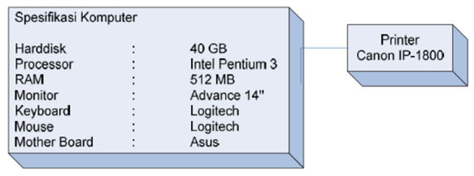

**Figure 2**. Computer Infrastructure

1. Software specifications

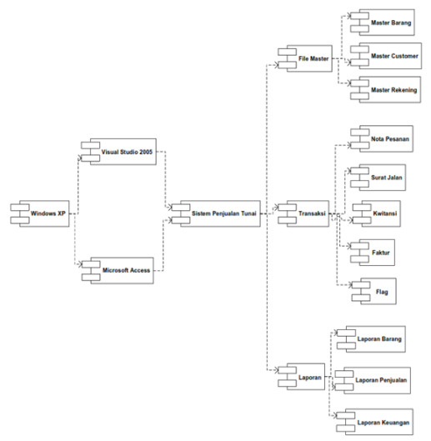

**Figure 3**. Software Infrastructure

The proposed point-of-sale application, diagram use case includes master data, transaction data, and reporting data [3].

1. Master Data.

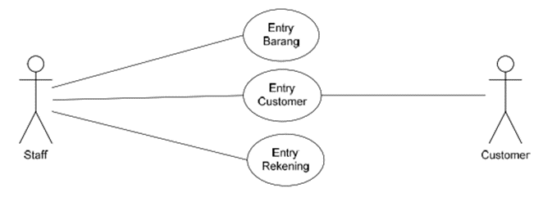

**Figure 4**. Use Case Diagram Master Data

1. Transaction Data.

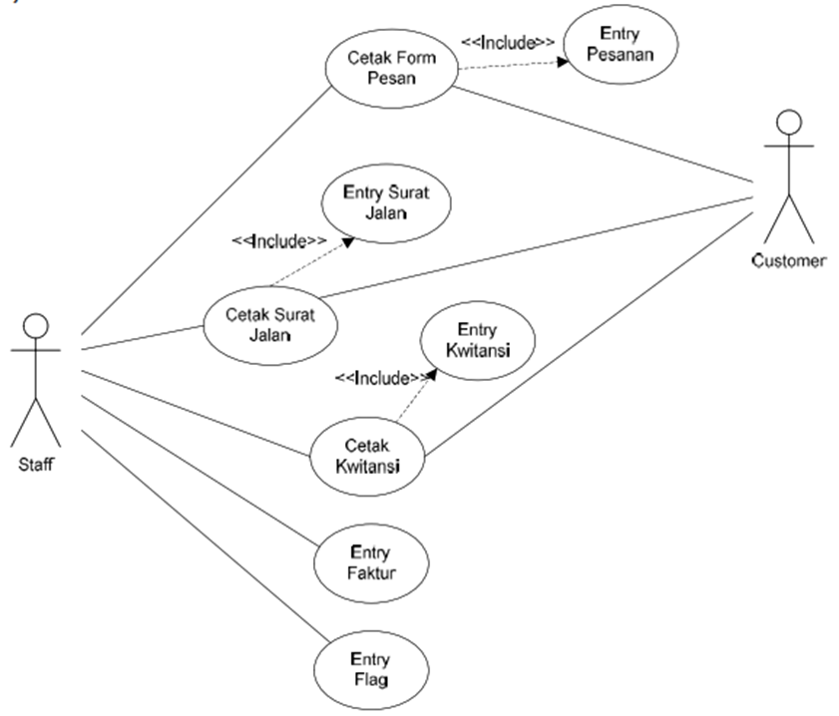

**Figure 5**. Use Case Diagram Transaction Data

1. Reporting Data.

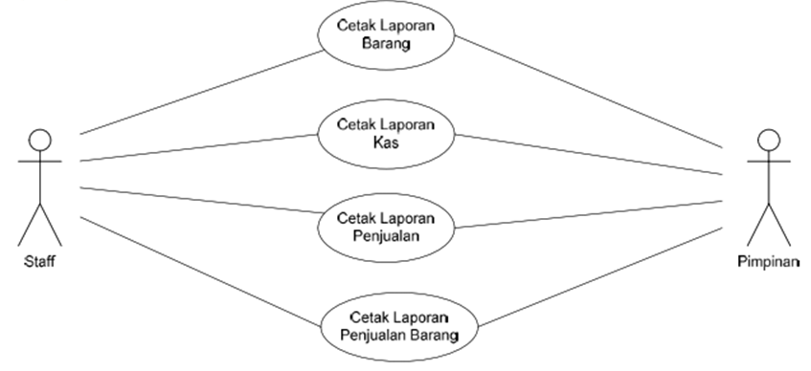

**Figure 6**. Use Case Diagram Reporting Data

The point-of-sale application database design as shown on Figure 7.

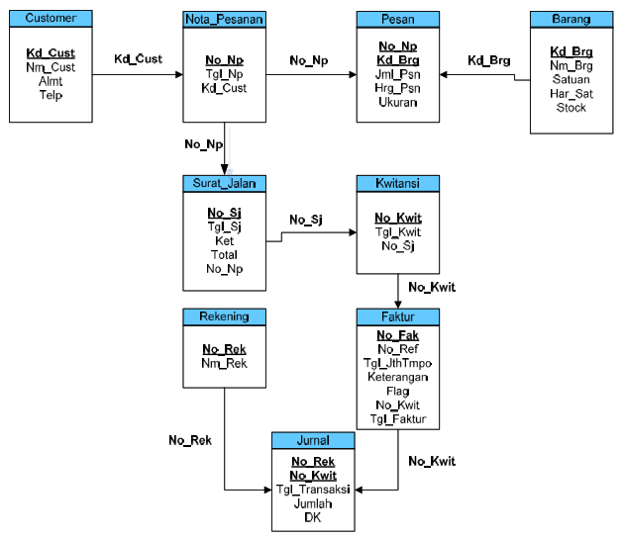

**Figure 7**. Logical Record POS Application Structure

The point-of-sale Application Display Structure Diagram as shown on Figure 8.

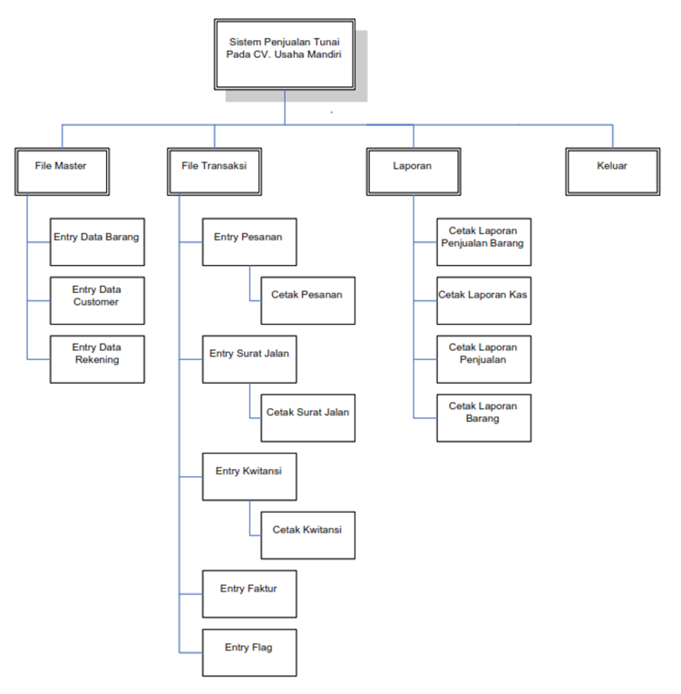

**Figure 8**. POS Application Display Structure Diagram

The application of the POS Application User Interface has several views as follows:

1. Main Menu



**Figure 9**. GUI Main Menu

1. Goods Master Data

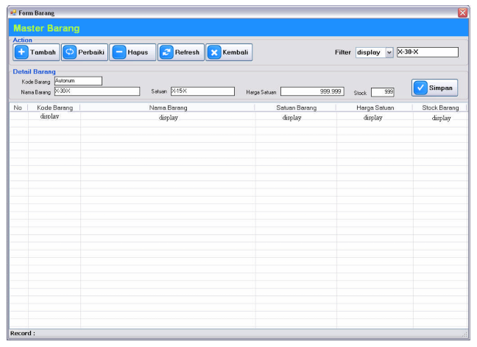

**Figure 10**. GUI Master Data

1. Item Repoting

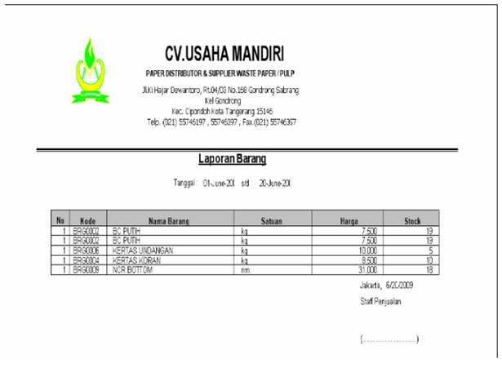

**Figure 11**. Goods Report Output Document

1. Conclusion

The results of research and development of point of sale (POS) applications using rapid application development (RAD) methods create a sales information system that can perform product sales transactions by catalog and report. Report sales transactions helps the sales department to monitor and control sales transactions, to create an effective and efficient information system to provide sales information, and to reduce confusion efficiency in recording transactions in the sales department.

**References**

1. Aptika, 2021. Revolusi Industri 4.0. https://aptika.kominfo.go.id/2020/01/revolusi-industri-4-0/ (Cited on 1st December 2021)
2. Christian, Yefita, et.al. 2021. Perancangan dan Penerapan Sistem POS (Point Of Sales) Berbasis Web pada Warung Zikry. *Conference On Community Engagement Project*, Vol.1, No. 1, 2021, ISSN: 2776-5652
3. Hidayat, R. 2010. *System Analysis Design UML. Version 2.0: An Object-Oriented Approach*. 3rd Edition. University of Michigan: John Wiley & Sons.
4. Kosasi S. 2014. Perancangan Aplikasi Point of Sale dengan Arsitektur Client/Server BerbasisLinux dan Windows. *Citec Journal*, Vol. 1, No. 2, Februari 2014 – April 2014, ISSN: 2354-5771
5. Permana, S. 2015. Analisa Dan Perancangan Aplikasi Point Of Sale (POS) Untuk Mendukung Manajemen Hubungan Pelanggan. *Jurnal Teknologi Informasi Dan Ilmu Komputer*, 2(1), 20. https://doi.org/10.25126/jtiik.201521124
6. Putri, Meidyan Permata et al. 2018. Implementasi Metode Rapid Application Development pada Website Service Guide “Waterfall Tour South Sumatera”. *Jurnal SISFOKOM*, Vol. 7, No. 2, September 2018, ISSN: 2301-7988
7. Sandi, Fitra Adhitya et al. 2021. Perancangan Sistem Informasi Point Of Sales Berbasis Web Pada Perusahaan Salon. *Compter Science(CO-SCIENCE)*, Vol. 1, No. 2, Juli 2021, E-ISSN: 2774-9711
8. Tores, Ropal et al. 2017. Peranan Sistem Informasi Dalammeningkatkan Efisiensi Danefektivitas Penyiaran Di Radiodangdut Indonesia (RDI) Sekayu. *Jurnal Ilmu Manajemen*, Vol. 7, No. 1, 2017, E-ISSN:2623-2081
9. Widyastuti, Reni dkk. 2021. Penerapan Point Of Sales pada Sistem Informasi Penjualan Kedai Sulam. *Jurnal SIBERNETIKA STMIK Muhammadiyah Jakarta*, Vol. 6, No. 1, April 2021, hal 136-154, E-ISSN: 2745-5831