Microsleep detection on drowsy-driver using convolutional neural networks (CNN)

**Hepatika Zidny Ilmadina1, Muhammad Naufal2, Dyah Apriliani3**

**1,3** Informatics Engineering, Politeknik Harapan Bersama, Margadana, Kota Tegal 52147, Indonesia

**2** Faculty of Computer Science, Universitas Dian Nuswantoro, Pendrikan Kidul, Kota Semarang 50131, Indonesia

Email: [hepatika.zidny@poltektegal.ac.id](mailto:hepatika.zidny@poltektegal.ac.id)

**Abstract.** In a sleepy state, we may often not realize that we often fall asleep while moving; this event is known as microsleep when an individual microsleep for 4 seconds at a speed of 100 km/h, the individual is driving as far as 111 meters in an unconscious state. According to data from the Traffic Directorate of the Polda Metro Jaya, there were 7,565 accident cases during 2020, with 1,565 seriously injured people and 559 deaths. 61% were caused by human error, including sleepiness, unfocused, and fatigue, 9% due to vehicle factors, and 30% due to infrastructure and environmental factors. Microsleep detection methods through eye blinks have been developed, including using eye aspect ratio, namely manual thresholding by setting the minimum second of eye closing/blinking using the Support Vector Machine and Convolutional Neural Network (Vanilla) methods. In this study, the best model for detecting microsleep was ResNet50, with an accuracy of 99%. This system is implemented with a haar cascade classifier to detect closing eyes as a sign of microsleep. The existence of this research is expected to help reduce and even prevent accidents caused by microsleep based on the blink of a person's eye.

**Keywords: *Microsleep, Convolutional Neural Network, eye aspect ratio***

1. Introduction

We may often not realize that we often fall asleep while moving; this event is known as microsleep. It is defined as episodes of behavioural sleep patterns and cessation of response to stimuli and attention lapses that can interfere with detecting and responding to stimuli at a critical event [1]. So, it is not surprising that microsleep is synonymous with poor driver performance. According to Rivera and Salas (2013), drowsy drivers alone have an elevenfold contribution to severe accidents and damage to short sleep durations ranging from 1-30 seconds [2]. When an individual microsleeps for 4 seconds at a speed of 100 km / h, the individual is driving as far as 111 meters in an unconscious state, the factors that cause microsleep are the amount of time spent making activities, the amount of sleep at night, the air temperature, the sound that affects concentration, the amount of light at the time of the incident, to oxygen levels in the brain [3].

Based on the information above, it can be concluded that microsleep is a dangerous phenomenon in driving. According to data from the Traffic Directorate of the Polda Metro Jaya, there were 7,565 accident cases during 2020, with 1,565 seriously injured and 559 people dying. 61% of accidents were caused by human error, including sleepiness, unfocused, and fatigue, 9% due to vehicle factors, and 30% due to infrastructure and environmental factors. The three factors of the accident were contributed mainly by human error, one of which was caused by disturbances caused by microsleep.

Microsleep detection techniques through eye blinks have been developed, including using eye aspect ratio, namely manual thresholding by setting the minimum second of eye closing/blinking using the Support Vector Machine and Convolutional Neural Network (Vanilla) methods [4] [5]. The previous research detected blinking as a sign of microsleep by developing Vanilla CNN and obtaining an accuracy of 85% [6], thus encouraging similar research to be carried out by developing other implementations of CNN architecture. The previous research detected blinking as a sign of microsleep by developing Vanilla CNN and obtaining an accuracy of 83.7%, thus encouraging similar research to be carried out by developing other implementations of CNN architecture. Before being more specific on detecting sleepy eyes as a sign of microsleep in drivers, facial emotion recognition was carried out by Ding, W., Xu, et al. in 2016. The research was tested using a video-based approach that implements deep learning methods and managed to get high precision better than 88% [7]. Detection of sleepy eyes is then carried out by optimizing the hardware-implemented using the Internet of Things to detect the presence of microsleep in motorists focused on the classification of emotions (facial expressions). In 2017, Lee, Song, Song, & Park [8] classified the driver's emotions through a multi-modal sensor that combines a near-infrared light camera and a thermal camera. The classification is carried out by implementing the Convolutional Neural Network (CNN) and getting an accuracy of 99% for detecting the rider's emotions.

The development of artificial intelligence began to narrow its research focusing on detecting sleepy eyes (not through facial expressions or emotions); in 2017, a model was developed to predict sleepy drivers using an artificial neural network (ANN) method. ANN was trained on 16 datasets to detect microsleep from the blink of an eye by taking up to 5 minutes with an accuracy of only 70-80% [9].

The development of computer vision and machine learning provides developments for other detection methods that are carried out by detecting the presence of microsleep through real-time video by measuring the ratio of the eyes opening and closing when blinking. The Support Vector Machine (SVM) method was developed by Maior et al. l in 2020 [4]. The dataset used is obtained from DROZY – a public database for human drowsiness with a test accuracy of 94.44%. The system's weakness is that no warning is given to wake the driver. This system only develops a model to detect sleepy eyes through aspect ratio calculations. This research is expected to help reduce and even prevent accidents caused by microsleep based on the blink of a person's eye combined with deep learning implementation.

1. Proposed Method

This study aims to detect microsleep in motorists, which is detected early through the blink of an eye classified by the deep learning method. The initial stage is image acquisition by collecting datasets of eye images that are closed or not closed through various sources. The next stage is to carry out the dataset training process on several built CNN models, such as Vanilla CNN and ResNet50. From these several models, the training process and real-time testing were carried out on closed and opened eyes. The evaluation was carried out for each CNN model tested to determine which model was the best in detecting microsleep in motorists through the blink of an eye. Proposed methodology in microsleep detection is a follow:

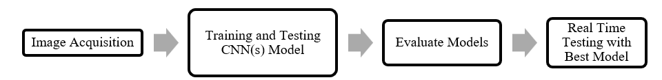

**Fig. 1.** Steps in Methodology

1. Data Acquisition

A dataset was collected for the training process to determine the best CNN model in detecting closed and opened eyes, which are signs of microsleep. Datasets are collected from various sources to support the accuracy of the method. Eye-close and open datasets were collected from UMass Amherst (13233 images) [10], Nanjing University (2423 images) [11], as well as multiple eye-opening and closing datasets from Kaggle (2900 images).

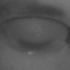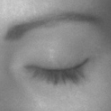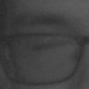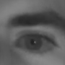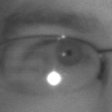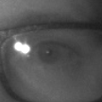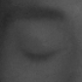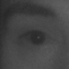

1. (b) (c) (d)

(e) (f) (g) (h)

**Fig. 2.** From left to right sample of close and open dataset; (a)-(d) Various sample of close eyes and (e)-(h) Various sample of open eyes

1. Training and Testing CNNs Model

The proposed CNN models in this study are Vanilla CNN and ResNet50. The Vanilla CNN model proposed in this study consists of 2 convolution sequences and a max-pooling layer which functions specifically as feature extraction. The convolution layer consists of 32 filters measuring 3x3 and 3 x 64 filters measuring 3x3. This architecture is based on a literature study conducted [12] [13] and from Keras documentation dog and cat classification [14], so to get good results, the researcher provides a max-pooling layer measuring 2x2 in each convolution layer. The last layer is fully-connected with a softmax activation function and binary cross-entropy as a loss function due to the binary classification for closing and opening eyes.

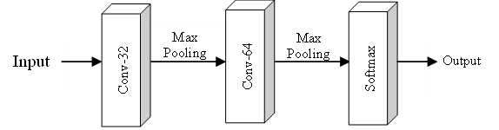

**Fig. 3.** Illustration of Vanilla CNN Model in this Study

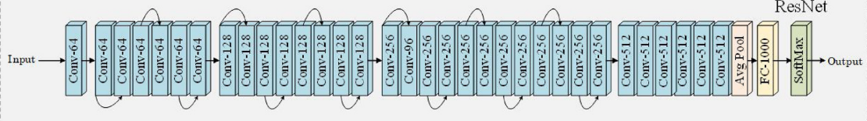As for the ResNet50 model, the model developed in the ImageNet Large Scale Visual Recognition Challenge (ILSVRC) was used by Kaiming He et al [15]. The ResNet50 architecture itself has 152 layers of high complexity, which are fine-tuned at the dense end according to the number of classes to be classified. The following is illustrated for the architecture on ResNet50 [16].

**Fig. 4.** Illustration of ResNet50 Model [16]

1. Model Evaluation

The performance evaluation compares the CNN models, which give the best accuracy values after 5 epochs. The accuracy value shows the size of the ratio of the model in classifying correctly compared to the total number of classifications. The model with the best performance evaluation will be implemented in the microsleep detection system for sleepy eyes. The accuracy performance is given by:

|  |  |
| --- | --- |
| Accuracy = | $\frac{TP+TN}{TP+FP+TN+FN}$ (1) |

1. Real Time Testing with Best Model

Based on the performance evaluation results obtained based on experiments, the model with the best performance will be implemented in detecting microsleep. The system is built by using the weight of the best model, which then detects sleepy eyes based on image processing training on eyes closed and eyes open. A threshold value is determined as a score for calculating the time eyes close, which will activate the alarm as a sign of microsleep.

1. Result and Analysis

The experiments were performed on the processor Intel® Core™ i5-8265U @1,8GHz CPU and 8GB memory running under Windows 11 OS. Implementation using Python and Keras library with a Tensorflow backend in Google Colab supported by a single 12GB NVIDIA Tesla K80 GPU. The model implementation also uses other libraries such as NumPy, sklearn, matplotlib, and pandas.

Preprocessing was applied to resize the dataset to 224x224. Vanilla CNN also set the same size and hyperparameters in the training process.

* 1. Training in Vanilla CNN and ResNet50

In training conducted with Vanilla CNN, the accuracy is described in Table 1 below.

**Table 1.** Accuracy Vanilla CNN and ResNet50

| Epoch | Accuracy | |
| --- | --- | --- |
| Vanilla CNN | ResNet50 |
| 1 | 0.9017 | 0.9738 |
| 2 | 0.9839 | 0.9921 |
| 3 | 0.9875 | 0.9932 |
| 4 | 0.9907 | 0.9955 |
| 5 | 0.9921 | 0.9954 |
| Average | **0.97118** | **0.99** |

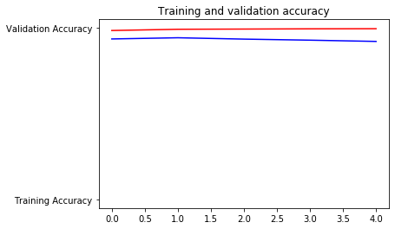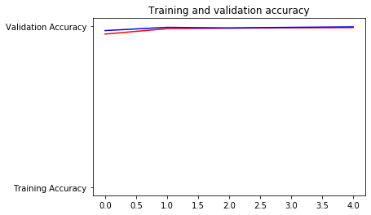Based on the training carried out in experiments with both CNN models, it was found that the performance of ResNet50 was better with an accuracy value of 0.99 (99%). The explanation of the training results based on the accuracy and loss graph is presented in the image below.

1. (b)

**Fig. 5.** From left to right. Training and validation accuracy; (a) Vanilla CNN; (b) ResNet50

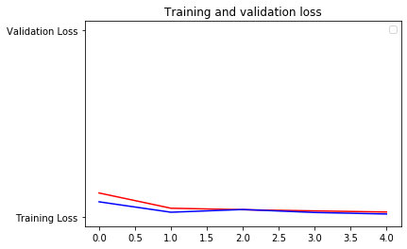Then the visualization of the loss function can be explained in the graph below.

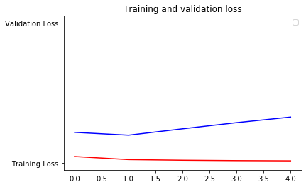

1. (b)

**Fig. 6.** From left to right. Training and validation loss; (a) Vanilla CNN; (b) ResNet50

Sleepy eyes can be identified based on the eye aspect ratio value, calculated based on the driver's blink detection [4] [5]. It can be seen from Table 1 that the results of blink eye detection, which is one of the signs of microsleep, can be classified by the ResNet50 model well. The results obtained accuracy higher than similar studies conducted in detecting sleepy eyes based on the driver's facial expression. ResNet50 has high accuracy due to the storage (residue) during the training process, making it more precise in classification.

* 1. Implementation in Microsleep Detection

The implementation of microsleep detection on drowsiness eyes is carried out with a combination of the ResNet50 model and the Haar Cascade Classifier, which is also set to wait for closing the eyes so that a warning will appear the object is sleepy. The waiting time is used as a score indicating the presence of microsleep. The score sets if the rider closes his eyes for more than 2 seconds, then a warning notification will sound. The following figures are the results of the implementation of the system.

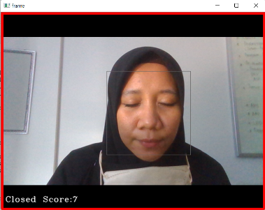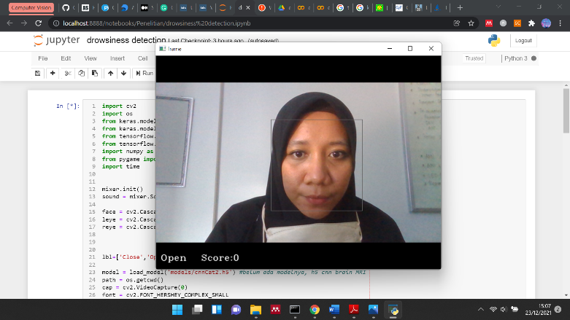

**Fig. 7.** Implementation model in drowsiness warning screen and notification

It can be seen in the figure that the bounding box has recognized faces as a result of the haar cascade classification. After the haar cascade has successfully recognized a face, the ResNet50 model detects that the eye is open or close. The classification results are shown in the information in the camera window. There will be an "Open" and "Score" indicating 0 when the eyes are open. With this condition, the alarm is not active. We can conclude that the driver in that condition is without microsleep.

The classification model will give "Closed" information on the camera window when the eyes are closed, including when the driver blinks. If the eyes are closed for more than 2 seconds, the "Score" will show the value to activate the alarm. However, when the driver only blinks, the accumulated score from the time the driver closes his eyes is no more than the specified limit so that the alarm does not sound. It is different if the eyes are closed for more than 2 seconds; the score in the system display will increase more than the threshold score. Haar Cascade and ResNet50's combined implementation provides an accurate performance in detecting microsleep based on blinking eyes. The Haar Cascade can detect the driver's face well, and the ResNet50 model can classify the eyes open and close when blinking. The addition of a predetermined score indicates blinks that are classified as microsleep signs. The higher accuracy results with CNN combined with the Haar Cascade Classifier are obtained compared to using CNN alone. This more considerable value will activate the alarm so that drivers who experience microsleep will be surprised and prevent traffic accidents. The score is the ResNet50 model, classifying closed and open eyes.

1. Conclusions and Future Work

Closing eyes for a moment is one of the signs of microsleep that drivers often do not notice. In this study, microsleep detection through closed eyes is a method that can be used to prevent a drowsy-driving accident.

This study proposed several CNN models, namely Vanilla CNN and ResNet50, where the closed-eye classification model is ResNet50. The ResNet50 architecture saves residuals during the eye-close and eye-opening training process, making it more accurate. From the training results conducted before the detection system's implementation, an accuracy of 99% was obtained. The system can detect drowsiness by giving a warning in an active alarm if the eyes are closed for more than 2 seconds.

We will combine this computer vision system with signal processing in future works. Heart rate signal is also early detection of drowsy drivers and can identify microsleep well [17] [18].

References

|  |  |
| --- | --- |
| [1] | L. N. Boyle, J. Tippin, A. Paul and M. Rizzo, “Driver performance in the moments surrounding a microsleep,” *Transportation Research Part F: Traffic Psychology and Behaviour,* vol. 11, no. 2, pp. 126-136, 2008. |
| [2] | R. Liyanage, N. SB, R. KKDS and I. Wickramasinghe, “Social impact, Attitudes and Behavioural pattern of busy life styles Due to Microsleepiness,” *International Journal for Innovation Education and Research,* pp. 106-113, 2015. |
| [3] | M. Rivera and L. Salas, “Monitoring of Micro-sleep and Sleepiness for the Drivers Using EEG Signal,” School of Innovation, Design and Engineering (IDT), Mälardalen University, Västerås, Sweden, 2013. |
| [4] | C. B. S. Maior, M. J. d. C. Moura, J. M. M. Santana and I. D. Lins, “Real-time classification for autonomous drowsiness detection using eye aspect ratio,” *Expert Systems with Applications,* p. 113505, 2020. |
| [5] | C. Ryan, B. O'Sullivan, A. Elrasad, A. Cahill, J. Lemley and E. Perot, “Real-time face & eye tracking and blink detection using event cameras,” *Neural Networks,* pp. 87-97, 2021. |
| [6] | S. P. Rajamohana, E. G. Radhika, S. Priya and S. Sangeetha, “Driver drowsiness detection system using hybrid approach of convolutional neural network and bidirectional long short term memory (CNN_BILSTM),” *Materials Today: Proceedings,* vol. 45, pp. 2897-2901, 2021. |
| [7] | S. P. Rajamohana, E. G. Radhika, S. Priya and S. Sangeetha, “Driver drowsiness detection system using hybrid approach of convolutional neural network and bidirectional long short term memory (CNN_BILSTM),” *Materials Today: Proceedings,* pp. 2897-2901, 2021. |
| [8] | K. W. Lee, o. M. Song, J. M. Song and K. R. Park, “Convolutional neural network-based classification of driver’s emotion during aggressive and smooth driving using multi-modal camera sensors,” *Sensors (Switzerland),* pp. 14-16, 2018. |
| [9] | C. Jacobé de Naurois, C. Bourdin, A. Stratulat, E. Diaz and J. L. Vercher, “Detection and prediction of driver drowsiness using artificial neural network models,” *Accident Analysis and Prevention,* pp. 95-104, 2017. |
| [10] | G. B. Huang and E. Learned-Miller., “Labeled Faces in the Wild: Updates and New Reporting Procedures,” University of Massachusetts, Amherst, 2014. |
| [11] | F. Song, X. Tan, X. Liu and S. Chen, “Eyes Closeness Detection from Still Images with Multi-scale Histograms of Principal Oriented Gradients,” *Pattern Recognition,* 2014. |
| [12] | A. K. Anaraki, M. Ayati and F. Kazemi, “Magnetic resonance imaging-based brain tumor grades classification and grading via convolutional neural networks and genetic algorithms,” *Biocybernetics and Biomedical Engineering,* pp. 63-74, 2019. |
| [13] | M. Talo, U. Baran Baloglu, Z. Yıldırım and U. Rajendra Acharya, “Application of deep transfer learning for automated brain abnormality classification using MR images,” *Cognitive Systems Research,* pp. 176-188, 2018. |
| [14] | F. Chollet, “Keras,” Keras, 27 April 2020. [Online]. Available: https://keras.io/examples/vision/image_classification_from_scratch/. [Accessed 23 December 2021]. |
| [15] | K. He, X. Zhang, S. Ren and J. Sun, “Deep Residual Learning for Image Recognition,” in *Proceedings of the IEEE Conference on Computer Vision and Pattern Recognition (CVPR)*, 2015. |
| [16] | T. Saba, A. S. Mohamed, M. El-Affendi, J. Amin and M. Sharif, “Brain tumor detection using fusion of hand crafted and deep learning features,” *Cognitive Systems Research,* pp. 221-230, 2019. |
| [17] | J. Vicente, P. Laguna and A. Bartra, “Drowsiness detection using heart rate variability,” *Med Biol Eng Comput,* vol. 54, no. 6, pp. 927-937, 2016. |
| [18] | S.-H. Jo, J.-M. Kim and D. K. Kim, “Heart Rate Change While Drowsy Driving,” *Journal of Korean Medical Science,* vol. 34, no. 8, p. 56, 2019. |