# SEIF14-Project-

**SEIF14-Project – (Whack-A-Mole) Game**

* This is a Unit 1 Project for SEIF-14 Project
* It is an JS Array-based game application via HTML,CSS and Javascript.
* Player needs to hit the grid with the mole in as many times as they can till the time runs out.

1. Javascript

* DOM Manipulations
* JS functions/Methods
* OOP

1. CSS

* Flexbox
* Grid
* **This Game is a showcase of**
* Creation of HTML for Scoreboards and Squares
* Syncing of Fonts for the folders
* Usage of a grid in an array to input, remove the mole into each “square”.
* Usage of Timer to invoke functions (Starting game, Ending game etc..)
* Flexbox and Grid Methodologies
* Pictures importing
* Game is hosted on <https://firdaussulaiman.github.io/>
* **Key references**
* MDN – Syntaxes in Functions (Foreach, if Else.)Operators (++,--,==)
* Udemy – Flexbox, Grid
* GitHub – Repositories cross reference on certain games was being done
* ChatGPT – Cleaning of Code

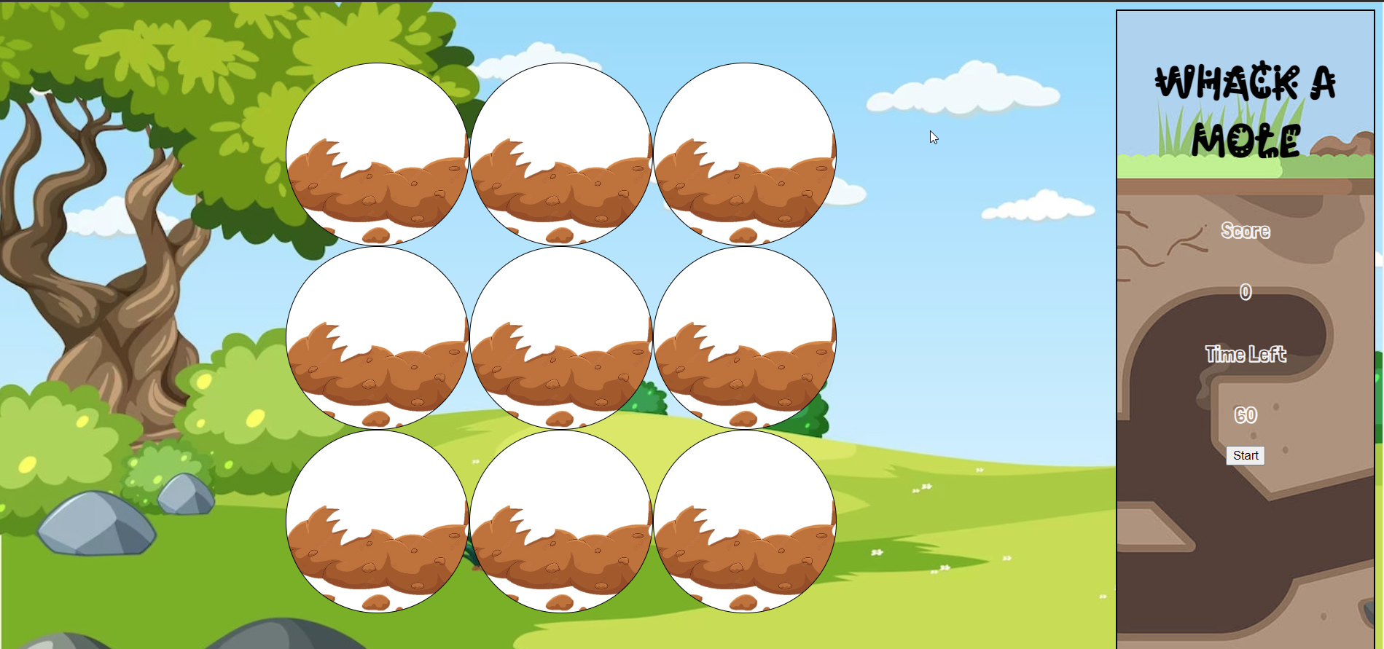

<https://www.youtube.com/watch?v=NPSFQc4yP5o>

<https://www.youtube.com/watch?v=VdwoRWrBZTE>