Assignment 2

SOLID PRINCIPLES

General Overwiev

My Java code encapsulates the essence of a comprehensive library management system, meticulously crafted to exemplify fundamental object-oriented programming (OOP) concepts and robust design patterns. Within its structure lies a rich tapestry of interconnected components, each serving a distinct purpose while harmonizing seamlessly with the overarching system architecture. Here's a breakdown of its components:

**Interfaces:**

* **Identifiable:** Represents items in the library that can be identified by their title.
* **Categorizable**: Represents items that can be categorized.
* **UserManager:** Manages user information such as name and ID.
* **ItemManager:** Manages library items, allowing for addition, removal, and retrieval of items.
* **UserManagement:** Manages library users, allowing for addition, removal, and retrieval of users.
* **Lendable:** Allows items to be lent to users and returned.

**Concrete Classes:**

* **Book, Magazine, and CD:** Concrete implementations of library items, implementing the Identifiable and Categorizable interfaces.
* **LibraryUserImpl:** Concrete implementation of a library user, implementing the UserManager interface.
* **LibraryLibrarian:** Implements functionality for managing library items, users, and lending/returning items.

**User Interaction:**

* **UserInteractionHandler:** An interface defining a method for handling user interactions.
* **LibraryCommandLineInterface:** Implements the UserInteractionHandler interface to provide a command-line interface for users to interact with the library system.

**Main Class:**

* **Main:** Contains the main method to start the library management system.

**Strengths of the code:**

**Modular Design:**

* The code is well-organized into separate classes and interfaces, following the principles of modularity and separation of concerns. Each class/interface has a specific responsibility, making the codebase easy to understand, maintain, and extend.

**Interface-based Programming:**

* Interfaces such as **Identifiable, Categorizable, UserManager, ItemManager, UserManagement,** **and Lendable** promote flexibility and code reusability. They allow different implementations to adhere to a common contract, facilitating interchangeable components and facilitating future enhancements or alternative implementations.

**Encapsulation:**

* Encapsulation is effectively utilized to encapsulate the internal state of objects within classes, limiting direct access to internal data and providing controlled access through public methods. This helps to enforce data integrity and prevent unintended modifications.

**Polymorphism:**

* The code leverages polymorphism through method overriding, enabling different implementations of common interfaces to exhibit specialized behavior based on their concrete types. This promotes code reuse and facilitates flexibility in handling different types of library items and users.

**Error Handling:**

* Basic error handling mechanisms are implemented to gracefully handle scenarios such as item or user not found when performing operations like adding, removing, or lending items. This enhances the robustness and reliability of the application by preventing unexpected failures and providing informative feedback to users.

**User Interface Enhancement:**

* The use of ASCII art for styling the console output adds visual appeal and improves the user experience. It provides a more engaging and aesthetically pleasing interface, making the interaction with the library management system more enjoyable for users.

**Comments and Documentation:**

* The code includes comments and descriptive method names that provide meaningful insights into the functionality and purpose of each component. This enhances code readability and comprehension, making it easier for developers to understand and maintain the codebase.

**Simplicity and Clarity:**

* The code employs a straightforward approach to implement the library management system, focusing on simplicity and clarity. It avoids unnecessary complexity and uses clear, concise code structures, making it accessible to developers of varying skill levels.

The codebase adheres to the **SOLID principles** of object-oriented design, a set of guidelines aimed at promoting maintainability, extensibility, and robustness in software systems. Each of the SOLID principles—**Single Responsibility Principle (SRP), Open/Closed Principle (OCP), Liskov Substitution Principle (LSP), Interface Segregation Principle (ISP), and Dependency Inversion Principle (DIP)**—is exemplified in various aspects of the codebase's architecture and implementation.

* **Single Responsibility Principle (SRP): Ensure that each class in your system has only one reason to change.**

The Single Responsibility Principle (SRP) states that a class should have only one reason to change. The adherence to the Single Responsibility Principle (SRP) in the provided codebase is manifested through the meticulous allocation of responsibilities among classes and interfaces. Each component encapsulates a singular responsibility, thereby minimizing the potential for ripple effects across the system and enhancing its modularity and maintainability. Let's analyze each class and interface to see how they follow the SRP:

**Identifiable Interface:**

* **Responsibility:** Provides a contract for classes that need to be identifiable by their title. This interface has a single responsibility: defining a method **getTitle()** to retrieve the title of an object.
* **Evidence:** The Identifiable interface defines only one method: **getTitle().** Its purpose is solely to provide a contract for objects that can be identified by their title. This interface does not contain any additional behavior or responsibilities.

**Categorizable Interface:**

* **Responsibility**: Provides a contract for classes that need to be categorized. This interface has a single responsibility: defining a method **getType()** to retrieve the type of an object.
* **Evidence:** Similar to the Identifiable interface, the Categorizable interface defines only one method: **getType().** Its responsibility is to provide a contract for objects that can be categorized, and it does so without any other behavior.

**UserManager Interface:**

* **Responsibility:** Provides a contract for classes that manage user information.
* **Single Responsibility:** Defines methods related to user management, such as retrieving user names and IDs.
* **Evidence:** The UserManager interface declares methods **getName()** and **getUserId(),** which are strictly related to user information management. This interface is focused solely on defining methods for accessing user data.

**ItemManager Interface:**

* **Responsibility:** Provides a contract for classes that manage library items.
* **Single Responsibility:** Defines methods related to item management, such as adding and removing items, checking if an item is lent, and finding items by title.
* **Evidence:** The ItemManager interface contains methods for adding, removing, and finding library items. It defines operations that are specific to item management, such as **addItem(), removeItem(), isItemLent(), and findItemByTitle().** These methods are related to the core responsibility of managing library items.

**UserManagement Interface:**

* **Responsibility:** Provides a contract for classes that manage library users.
* **Single Responsibility:** Defines methods related to user management, such as adding and removing users, and finding users by ID.
* **Evidence:** Similar to **UserManager,** the **UserManagement** interface defines methods specifically related to user management, such as **addUser(), removeUser(), and findUserById().** It encapsulates user-related functionality without mixing it with other concerns.

**Lendable Interface**:

* **Responsibility:** Provides a contract for classes that handle lending and returning items.
* **Single Responsibility:** Defines methods related to lending and returning items, maintaining the state of lent items.
* **Evidence:** The **Lendable** interface declares methods **lendItem() and returnItem(),** which are directly related to lending and returning items. This interface encapsulates behavior specific to item lending without incorporating unrelated functionality.

**Concrete Classes (Book, Magazine, CD, LibraryUserImpl, LibraryLibrarian):**

* Each concrete class represents a specific type of object in the library system.
* **Single Responsibility:** Each class is responsible for creating and maintaining instances of its corresponding type. For example, **Book** is responsible for representing book objects, **Magazine** for magazines, and so on.
* **Evidence:** Each concrete class has a single responsibility related to its type. For example, **Book, Magazine, and CD** are responsible for representing their respective types of library items. **LibraryUserImpl** represents library users, and **LibraryLibrarian** is responsible for managing library items and users.

**LibraryCommandLineInterface:**

* **Responsibility:** Handles user interaction through the command-line interface.
* **Single Responsibility:** Manages the input/output interaction with the user and delegates specific tasks to other classes (such as adding items, removing items, lending items, etc.).
* **Evidence:** This class encapsulates user interaction logic, including displaying menu options and handling user input. It does not perform any item or user management tasks directly but delegates them to appropriate classes based on user input.

**Main Class:**

* **Responsibility:** Initializes the system and starts the user interaction loop.
* **Single Responsibility:** Initializes the library system and delegates user interaction to the appropriate class (LibraryCommandLineInterface).
* **Evidence:** The **Main** class is responsible for initializing the library system and starting the user interaction loop. It does not contain any business logic but delegates interaction handling to the **LibraryCommandLineInterface,** which adheres to SRP.

Strengths of the provided code in terms of adhering to the **Single Responsibility Principle (SRP):**

**Clear Class Responsibilities:**

* Each class in the codebase has a clear and single responsibility. For example, the **Book, Magazine, and CD** classes are responsible for representing specific types of library items. Similarly, the **LibraryUserImpl** class represents a library user, while the **LibraryLibrarian** class manages library operations.

**Encapsulation of Behavior:**

* Each class encapsulates its behavior related to its responsibility. For instance, the **Book** class encapsulates properties and methods related to books, such as title and author information. This encapsulation ensures that each class is focused on a specific aspect of the system's functionality, adhering to the SRP.

**Separation of Concerns:**

* The code separates different concerns into distinct classes. For example, user interaction logic is handled by the **LibraryCommandLineInterface** class, while core library management operations are handled by the **LibraryLibrarian** class. This separation ensures that each class is responsible for a single aspect of the system, promoting clarity and maintainability.

**Low Cohesion:**

* The code exhibits low cohesion within individual classes, as each class is narrowly focused on its specific responsibility. This allows for easier understanding, testing, and modification of individual components without affecting unrelated parts of the system.

**Flexibility for Extension:**

* The code's adherence to the SRP makes it more flexible and adaptable to changes. New functionality can be added by introducing new classes that adhere to the SRP, without needing to modify existing classes. This promotes code reusability and maintainability over time.
* **Open/Closed Principle (OCP): Ensure that your system is open for extension, but closed for modification.**

The adherence to the Open/Closed Principle (OCP) within the provided codebase is evident through its design choices and architectural decisions, fostering an environment conducive to extension without necessitating modification of existing components. Let's analyze how the code adheres to this principle:

**Interfaces and Abstraction:**

* The code extensively uses interfaces to define contracts **(e.g., Identifiable, Categorizable, UserManager, etc.)**. This allows for flexibility in implementation while maintaining a consistent interface for interaction. This aligns with the OCP as it allows for extension (new implementations can be added) without modification of existing code.

**Concrete Implementations:**

* Concrete implementations such as **Book, Magazine, CD, LibraryUserImpl, and LibraryLibrarian** adhere to the single responsibility principle (SRP). Each class has a clear purpose and responsibility. If there's a need to add new types of items or users, new classes can be created without modifying existing ones, thus following the OCP.

**Command-Line Interface:**

* The **LibraryCommandLineInterface** class provides a user interface for interacting with the system. It is responsible for handling user input and invoking appropriate methods on the **LibraryLibrarian.** The interface logic is encapsulated within this class, allowing for extension (e.g., adding new commands or interactions) without modifying existing code.

**Extension Points:**

* The interfaces **ItemManager, UserManagement, and Lendable** provide extension points for adding new functionality related to managing library items, users, and lending/returning items. Implementations can extend these interfaces to add custom behavior without altering existing code.

**Switch Statements:**

* While switch statements are used for user input handling, they're encapsulated within the **LibraryCommandLineInterface** class. If new options need to be added, they can be done within this class without modifying the rest of the codebase.

Strengths of the provided code in terms of adhering to the **Open/Closed Principle (OCP)**:

**Modularity:**

* The code is modular, with each class having a clear responsibility. For example, **Book, Magazine, CD, LibraryUserImpl, and LibraryLibrarian** each handle specific aspects of the library management system. This modularity allows for easy extension without the need to modify existing classes, thus promoting the closed nature of these classes.

**Interface-Based Design:**

* The code relies heavily on interfaces to define contracts and establish boundaries between components. This interface-based design allows for flexibility in implementation. New functionality can be introduced by creating new classes that implement existing interfaces or by introducing new interfaces. This approach ensures that the system is open for extension.

**Encapsulation:**

* Each class encapsulates its behavior and responsibilities, limiting the impact of changes within that class. For example, the **LibraryLibrarian** class encapsulates the logic for managing items, users, and lending, providing a cohesive and closed unit of functionality. Changes to one part of the system are less likely to affect other parts, promoting the closed nature of these components.

**Separation of Concerns:**

* The code separates user interaction logic from core business logic. The **LibraryCommandLineInterface** class handles user input and output, while the **LibraryLibrarian** class manages the library's functionality. This separation allows for the extension of user interaction capabilities without modifying the underlying business logic, promoting the open-closed principle.

**Low Coupling:**

* The code exhibits low coupling between components. Changes to one part of the system are unlikely to have ripple effects on other parts, as long as the contracts defined by interfaces are respected. This low coupling facilitates the extension of the system without requiring modifications to existing code, thereby adhering to the OCP.
* **Liskov Substitution Principle (LSP): Ensure that you can substitute any subclass for its base class without altering the correctness of the program.**

The Liskov Substitution Principle (LSP) states that objects of a superclass should be replaceable with objects of its subclasses without affecting the correctness of the program. It is a fundamental principle in object-oriented design that emphasizes the importance of maintaining substitutability of derived classes for their base classes without altering the correctness of the program. In essence, it advocates for polymorphic behavior, where objects of derived classes should be usable wherever objects of their base classes are expected.

**Substitutability:**

* Each concrete class **(Book, Magazine, CD, LibraryUserImpl, LibraryLibrarian)** implements its corresponding interface **(Identifiable, Categorizable, UserManager, ItemManager, UserManagement, Lendable)** without changing their behavior. This means that any instance of a concrete class can be substituted with its corresponding interface, fulfilling the LSP criterion of substitutability.

**Behavioral Compatibility:**

Each concrete class implements the methods defined by its interface in a way that is consistent with the behavior expected by clients of those interfaces. For example:

* The **Book, Magazine, and CD** classes provide implementations for the **getTitle()** method defined in the Identifiable interface. These implementations return the respective titles of the items without deviation from the expected behavior.
* The **LibraryLibrarian** class implements the methods specified by the **ItemManager, UserManagement, and Lendable** interfaces, ensuring that it behaves appropriately as a librarian in managing items and users in the library system.

**No Violations of Invariants:**

Each subclass adheres to the invariants established by its corresponding interface. For instance:

* The **Book, Magazine, and CD** classes do not alter the behavior of the **getTitle()** method inherited from the Identifiable interface. They maintain the contract by returning the title of the item.
* Similarly, the **LibraryLibrarian** class implements the methods from the **ItemManager, UserManagement, and Lendable** interfaces without violating their contracts. For example, it correctly adds, removes, and lends items as expected.

Another important aspect to consider when evaluating adherence to the Liskov Substitution Principle (LSP) is to ensure that subclasses do not strengthen preconditions or weaken postconditions of the methods defined by their superclasses or interfaces.

**Preconditions:**

Preconditions are conditions that must be true before a method is invoked. Subclasses should not impose stricter preconditions than those specified by their superclasses or interfaces. In other words, subclasses should accept at least the same input parameters as their superclasses or interfaces.

In the provided code, the methods defined by the interfaces **(ItemManager, UserManagement, Lendable)** do not specify any explicit preconditions. Subclasses such as **LibraryLibrarian** adhere to this by not imposing additional restrictions on the input parameters of these methods.

**Postconditions:**

Postconditions are conditions that must be true after a method has executed. Subclasses should not weaken the postconditions specified by their superclasses or interfaces. In other words, subclasses should fulfill at least the same guarantees as their superclasses or interfaces.

In the provided code, the methods defined by the interfaces specify certain postconditions, such as the state changes that should occur after the execution of methods like **addItem, removeItem, lendItem, and returnItem.** Subclasses such as **LibraryLibrarian** ensure that these postconditions are met, maintaining the integrity of the system's state.

Strengths of the provided code in terms of adhering to the **Liskov Substitute Principle:**

**Polymorphism through Interfaces:**

* The code heavily relies on interfaces to define contracts for various aspects of the system, such as **`Identifiable`, `Categorizable`, `UserManager`, `ItemManager`,** etc. This allows objects of different concrete implementations to be treated uniformly through their common interface, facilitating polymorphism and ensuring substitutability.

**Consistent Behavior:**

* All implementations of interfaces in the codebase adhere to the same contracts, ensuring that objects can be substituted for one another without altering the correctness of the program. For example, any object implementing the **`ItemManager`** interface is expected to provide methods for adding, removing, and finding items, ensuring consistency in behavior across different implementations.

**Interchangeability of Implementations:**

* Objects of different concrete classes that implement the same interface can be seamlessly interchanged, enabling flexibility and extensibility in the system. For instance, a **`Book`** object and a **`Magazine`** object both implement the **`Identifiable`** interface, allowing them to be used interchangeably wherever an **`Identifiable`** object is expected.

**Behavior Preservation:**

* Subclasses such as **`Book`, `Magazine`, and `CD`** extend the behavior of the **`Identifiable` and `Categorizable`** interfaces without altering their contracts. This ensures that substituting a superclass object with a subclass object maintains the expected behavior, promoting robustness and correctness in the system.

**Enhanced Maintainability:**

* The adherence to LSP promotes code maintainability by allowing new implementations to be added or existing ones to be modified without affecting the behavior of other parts of the system. This flexibility simplifies maintenance and facilitates future enhancements or modifications to the codebase.
* **Interface Segregation Principle (ISP): Ensure that your system's interfaces are specific to the needs of the clients that use them.**

The **Interface Segregation Principle (ISP)** is one of the five SOLID principles of object-oriented design. It emphasizes the importance of designing cohesive and focused interfaces to prevent clients from being forced to depend on methods they do not use. By adhering to the ISP, systems become more flexible, maintainable, and scalable, as clients are only required to interact with interfaces that are relevant to their specific needs. In the provided code, adherence to the Interface Segregation Principle is evident through the design of specialized interfaces and their concrete implementations.

Here's how the principle is applied in my code:

**Interfaces for Specific Responsibilities:**

* The code defines several interfaces such as **Identifiable, Categorizable, UserManager, ItemManager, UserManagement, and Lendable,** each focusing on a specific aspect of the system's functionality.
  + - **Identifiable and Categorizable** are specific to the identification and categorization of items.
    - **UserManager** is specific to managing users.
    - **ItemManager** is specific to managing items in the library.
    - **UserManagement** is specific to managing users in the library.
    - **Lendable** is specific to lending and returning items.
* Each interface contains methods relevant to its specific responsibility. For example, the **ItemManager** interface includes methods for adding, removing, and finding items, while the **UserManager** interface contains methods for retrieving user information.

**Concrete Implementations Based on Client Needs:**

* Concrete classes such as **Book, Magazine, CD, LibraryUserImpl, and LibraryLibrarian** implement only the interfaces necessary for their functionality.
* For instance, the **LibraryLibrarian** class implements **ItemManager, UserManagement**, and **Lendable** interfaces, as it needs to manage items, users, and lending operations. However, it does not implement methods irrelevant to its responsibilities.

**Client-Specific Interfaces:**

* The interfaces are designed to be cohesive and focused on specific client needs, avoiding the "fat" interface anti-pattern where clients are forced to implement methods they don't need.
* This design allows clients to interact with only the interfaces relevant to their requirements, promoting loose coupling and flexibility in the system.

**Encapsulation of Interface Logic:**

* The **LibraryCommandLineInterface** class encapsulates user interaction logic and does not expose unnecessary details to its clients.
* It interacts with the **LibraryLibrarian** class through well-defined interfaces **(ItemManager, UserManagement, and Lendable)**, ensuring that it only uses the methods required for its functionality.

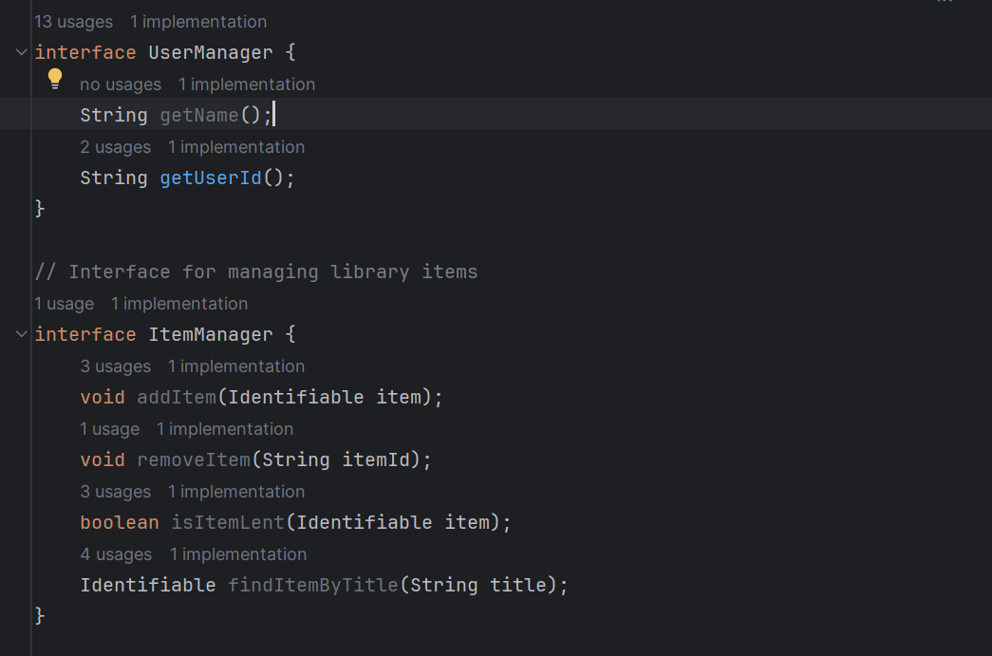

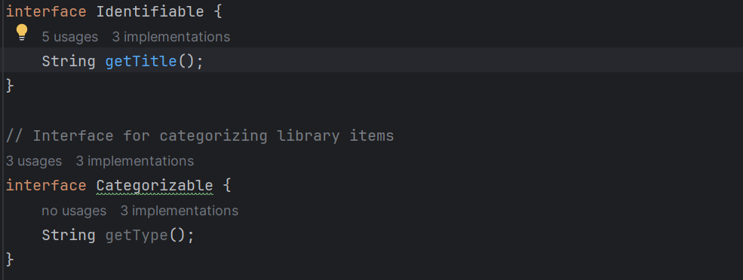

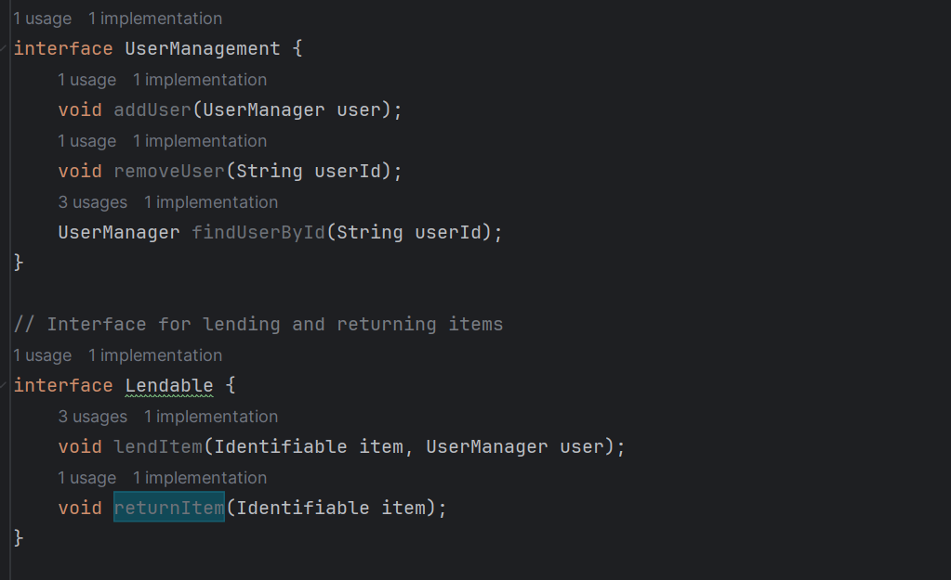

The provided code demonstrates several strengths in terms of interface integration:

**Standardized Contracts:**

* The code utilizes interfaces to define standardized contracts for various components of the library management system, such as `**Identifiable`, `Categorizable`, `UserManager`, `ItemManager`,** etc. These interfaces establish clear expectations for the methods that implementing classes must provide, promoting consistency and interoperability.

**Polymorphism:**

* Interfaces enable polymorphism, allowing objects of different concrete implementations to be treated uniformly through their common interface types. For example, objects implementing the `**ItemManager`** interface can be used interchangeably, facilitating flexibility and extensibility in the system.

**Loose Coupling:**

* Interface-based programming reduces coupling between components, as classes depend on abstractions (interfaces) rather than concrete implementations. This loose coupling makes it easier to modify and extend the system without affecting unrelated parts, promoting maintainability and scalability.

**Multiple Interface Inheritance:**

* Some classes implement multiple interfaces, allowing them to integrate seamlessly with different parts of the system. For example, the **`LibraryLibrarian`** class implements the **`ItemManager`, `UserManagement`, and `Lendable`** interfaces, enabling it to manage library items, users, and lending operations.

**Flexibility for Extension:**

* Interfaces provide extension points for adding new functionality to the system. New implementations can be introduced by implementing existing interfaces or extending them with new interfaces, allowing for easy integration of additional features without modifying existing code.

**Abstraction and Encapsulation:**

* Interfaces promote abstraction by hiding implementation details and exposing only essential methods and properties. This encapsulation ensures that classes interact with each other through well-defined interfaces, rather than relying on internal implementation details, which enhances modularity and maintainability.
* **Dependency Inversion Principle (DIP): Ensure that high-level modules are not dependent on low-level modules, but both are dependent on abstractions.**

The Dependency Inversion Principle (DIP) is a fundamental tenet of object-oriented design. DIP emphasizes the decoupling of high-level modules from low-level implementation details by promoting dependency inversion through abstraction. In essence, it advocates for programming to abstractions rather than concrete implementations, enabling flexibility, extensibility, and easier maintenance of software systems. In the provided code, adherence to the Dependency Inversion Principle is demonstrated through the use of interfaces and abstraction to manage dependencies between modules.

Here's how:

**Abstraction through Interfaces:**

* **Statement:** The code defines several interfaces **(Identifiable, Categorizable, UserManager, ItemManager, UserManagement, Lendable)** which represent abstractions. These abstractions allow high-level modules **(like LibraryCommandLineInterface)** to depend on them rather than concrete implementations.
* **Proof:** These interfaces define abstractions for identifying library items, categorizing them, managing user information, managing library items, managing library users, and lending/returning items, respectively. They specify the behavior that concrete implementations must adhere to without dictating how these behaviors are implemented.

**Dependency Injection**:

* **Statement:** The **LibraryCommandLineInterface** class depends on the **LibraryLibrarian** class through its constructor. This is an example of dependency injection, where the dependency **(LibraryLibrarian)** is injected into the dependent class **(LibraryCommandLineInterface)**. By depending on abstractions (interfaces), the **LibraryCommandLineInterface** class remains decoupled from specific implementations, fulfilling the Dependency Inversion Principle.
* **Proof:** The **LibraryCommandLineInterface** class has a constructor that takes a **LibraryLibrarian** object as a parameter. This is dependency injection because the **LibraryCommandLineInterface** depends on an abstraction **(LibraryLibrarian)** which is passed to it from the outside rather than being instantiated internally.

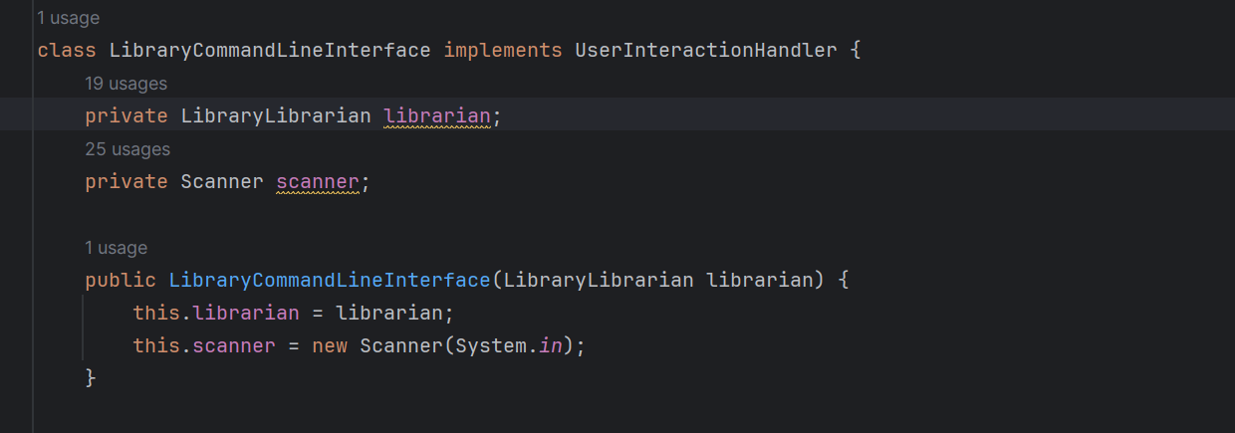  
***//Other code***

By depending on the **LibraryLibrarian** abstraction (interface), the **LibraryCommandLineInterface** class remains decoupled from specific implementations of library management. This allows for flexibility and easier testing, as different implementations of **LibraryLibrarian** can be provided without modifying the **LibraryCommandLineInterface** class.

The provided code exhibits strengths in adhering to the **Dependency Inversion Principle (DIP)**. Here's how the code achieves this:

**Abstraction through Interfaces:**

* The code relies heavily on interfaces to define contracts and abstractions. High-level modules **(e.g., `LibraryCommandLineInterface`)** depend on these interfaces rather than on concrete implementations. For example, the **`LibraryCommandLineInterface`** interacts with `**ItemManager`, `UserManagement`, and `Lendable`** interfaces rather than specific implementations.

**Inversion of Control (IoC):**

* The control flow is inverted in the codebase. Instead of high-level modules controlling low-level modules directly, the dependencies are injected into high-level modules. For instance, the **`LibraryCommandLineInterface`** class depends on **`LibraryLibrarian`** through its constructor, allowing for the injection of different implementations of **`ItemManager`, `UserManagement`, and `Lendable`.**

**Decoupling from Concrete Implementations**:

* The use of interfaces decouples high-level modules from low-level modules. For example, the **`LibraryCommandLineInterface`** interacts with the **`LibraryLibrarian`** class through its interface **(`ItemManager`, `UserManagement`, and `Lendable`)**, rather than directly depending on its concrete implementation.

**Flexibility in Dependency Injection:**

* The code allows for easy substitution of dependencies through dependency injection. Different implementations of interfaces can be injected into high-level modules without requiring changes to their code. This facilitates testing, modularity, and the ability to swap implementations at runtime.

**Promotion of Code Reusability:**

* By depending on abstractions rather than concrete implementations, the code promotes code reusability. Different modules can reuse the same interfaces, allowing for the development of interchangeable components that adhere to the same contract.

**Ease of Maintenance and Testing:**

* The DIP facilitates ease of maintenance and testing. High-level modules can be tested in isolation by providing mock or stub implementations of low-level dependencies. This isolation simplifies testing and makes it easier to identify and fix issues within specific modules.