**Object Oriented Programming in Python**:

Till now, we have been dealing with Procedural Programming where we have functions, procedures, variables… Computer working from top-to-bottom and jumping on to the functions as needed.

E.g.: Fortran, Cobol

OO paradigm comes in very handy to help us deal with complex codes.

**How to use OOP: Classes and Objects**

Waiter – class

Object:

Attributes: is_holding_plate = True

tables_responsible = [4, 5, 6]

Methods: def take_order(table, order):

# takes order to chef

Def take_payment(amount):

#add money to restaurant

(Variables, functions)

In OOP, we model real-life Objects that can HAVE things & that can DO things.

**Constructing Objects and Accessing their Attributes and Methods:**

Class is a blue print; From the class we can generate as many objects as we want.

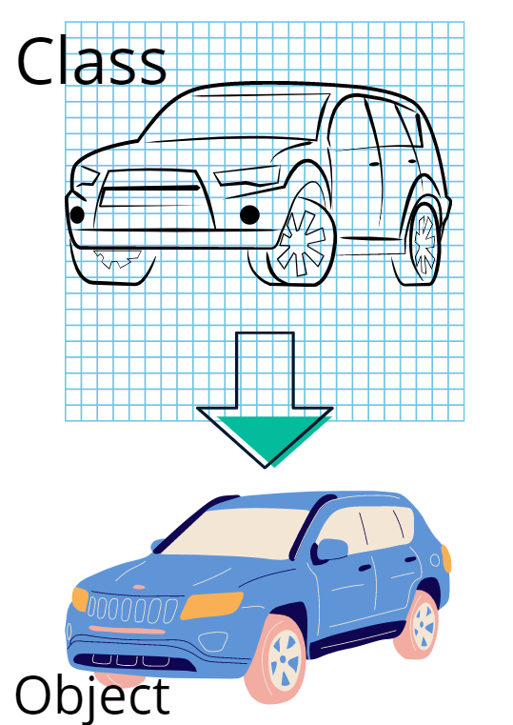

Attributes:

Object Methods:

speed = 0

fuel = 32

def move():

speed = 60

def stop():

speed = 0

Class is written in Pascal case

Class

car = CarBluePrint()

Object

OBJECT ATTRIBUTES:

car.speed

Attribute

Object

OBJECT METHODS:

car.stop()

Method

Object

**Adding Python Packages and using PyPi:**

pypi.org

* Installing the Package for Pretty table:

This is a library that helps to display data in ASCII table format.

Unlike turtle, we need to install these packages. It is not pre-installed like that of turtle.

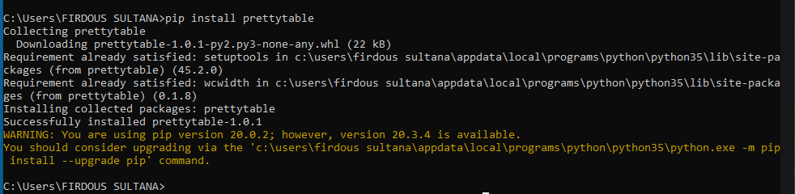

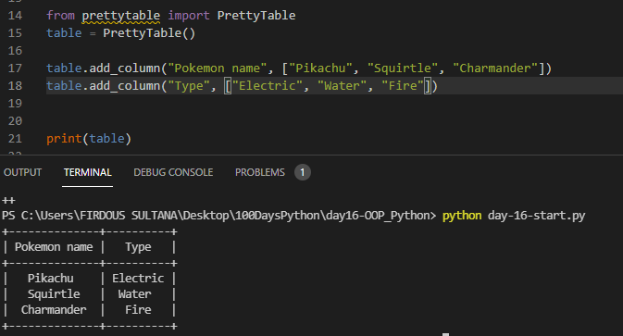

We can change the objects Attribute :

<https://pypi.org/project/prettytable/>

