**Python Primitive Data Types:**

String : “hello” -- A string of characters

“hello”[1] gives ‘e’ . This is known as **subscript**ing

print(“123” + “345”) -- 123345

Integer : print(123 + 345) -- 486

If there are very large integers(such that they need comma separation); then we can

Use _ for this purpose. E.g.: 123_456_789 for easier visualization

Float : has decimal point

Bool : only has 2 possible values; True False

**Type Error, Type Checking and Type Conversion:**

type() function returns the type of data.

Type conversion: print(str(70) + str(100)) -- 70100

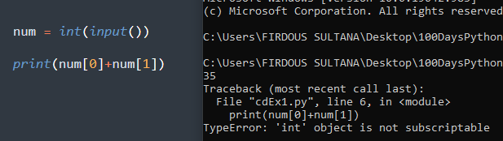

**Mathematical Operations in Python:**

+, -, * / **

PEMDAS (Left to Right)

Parenthesis

Exponent

Multiplication

Division

Addition

Subtraction

()

**

* /

+ -

**Number Manipulation and F Strings in Python:**

In Python, we use round() function to round any number.

e.g.: round(8/3) -- gives 3  
We can also specify the number of digits we want to round up to. E.g.: round(8/3, 3) – gives 2.667

Instead of dividing, we can also use floor division. E.g,: print(8 // 3) --- gives 2 [just chops off ones after decimal places]

**F Strings:**

e.g.:

score = 0

height = 1.8

isWinning = True

#printing everything in 1 line; in string: f-string

print(f”your score is {score}:)

-- gives: your score is 0

Print (f”your score is {score}, your height is {height}, you are winning is {isWinning})

-- gives: your score is 0, your height is 1.8, you are winning is True