**CONTROL FLOW & LOGIC OPERATORS**

**Conditional if/else statement:**

If condition:

Do this

else:

do this

**Nested if statements and elif statements:**

If condition:

if condition:

do this

else:

do this

else:

do this

if condition1:

do A

elif condition2:

do B

else:

do this

LEAP YEAR

every year that is evenly divisible by 4

**except** every year that is evenly divisible by 100

**unless** the year is also evenly divisible by 400

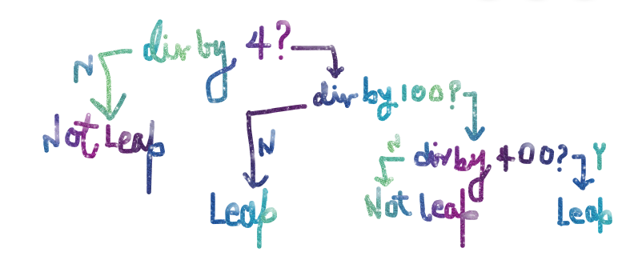

**Multiple If Statements in Succession:**

If condition1:

Do A

If condition2:

Do B

If condition3:

Do C

**Logical Operators:**

Checking for multiple conditions in the same line of statements.

A and B

A or B

not B