**PYTHON FUNCTIONS & KAREL**

(Karel the robot)

**Defining and Calling Python Functions:**

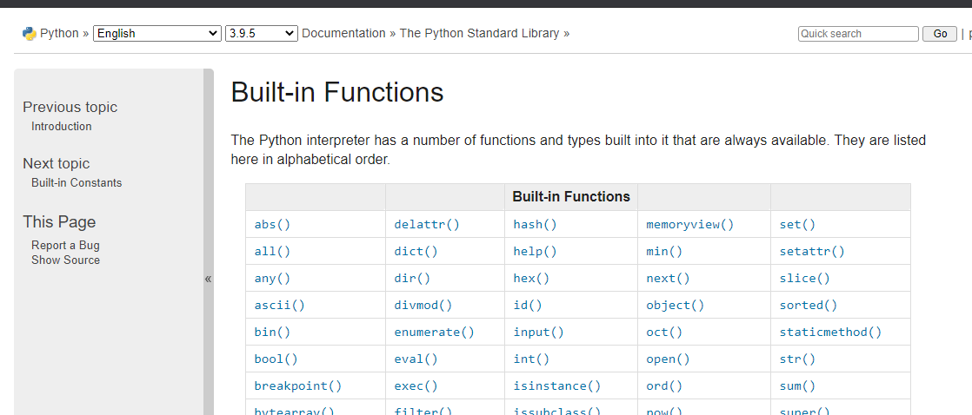

Def function_name():

Function body

Defining functions 🡪 Calling Functions

**Indentation in Python:**

4 spaces for 1 indentation.

**While Loops:**

while something_is_true:

do_smthng_repeatedly