**DICTIONARIES & NESTING, SILENT AUCTION GAME**

**The Python Dictionary:**

Dictionaries allow us to group together and tag related piece of information.

Key-value pairs.

Think of dictionary like a table.

Write your dictionary as:

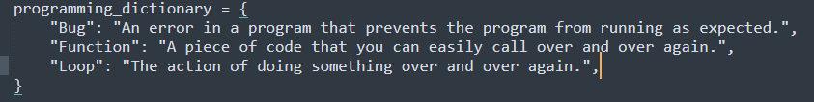

Dictionaries are identified by their keys.

#Retrieving elements from a dictionary:

print(programming_dictionary[“Function”])

#Adding new elements to the dictionary

programming_dictionary[“Variable”] = “Storing values.”

Very often when you write code, it can be very helpful to start off with an empty dictionary. Just as you did for the list ( by creating empty_list = [])

#Creating an empty dictionary

empty_dictionary = {}

#Wiping an existing dictionary

programming_dictionary = {}

#Editing an item in a dictionary

programming_dictionary[“Bug”] = “A moth in your computer.”

#Loop through a dictionary

for key in programming_dictionary:

print(key)

print(programming_dictionary[key])

---- Bug

Value at bug

Function

Value at function

Loop

Value at loop

**Nesting Lists and Dictionaries:**

{

Key = [list],

Key2 = {dictionary},

}

[{

Key: [List],

Key2: {Dict},

},

{

key : value,

key2: Value,

}]

