Lets be a better software developer

Hi Friends let us learn new technology which will help us to be a better software developer.
Technology and software Language we will learn here are.

1. HTML
2. CSS ( Bootstrap )
3. Javascript (Javascript,EcmaScript and Typescript)
4. Reactjs
5. Nodejs (Mongodb,Mysql)
6. SpringBoot (Mysql,Postgres)
7. Microservices
8. Docker
9. Service Discovery
10. CI/CD Jenkin Pipeline
11. Cloud Concept
12. Analytic
13. AI
14. Mini Project
15. E-commerce Project

HTML: HyperText Markup Language

HTML (HyperText Markup Language) is the most basic building block of the Web. It defines the meaning and structure of web content.

Other technologies besides HTML are generally used to describe a web page's appearance/presentation (CSS) or functionality/behavior (JavaScript).

"Hypertext" refers to links that connect web pages to one another, either within a single website or between websites. Links are a fundamental aspect of the Web. By uploading content to the Internet and linking it to pages created by other people, you become an active participant in the World Wide Web.

HTML uses "markup" to annotate text, images, and other content for display in a Web browser.

HTML markup includes special "elements" such as <head>, <title>, <body>, <header>, <footer>, <article>, <section>, <p>, <div>, <span>, <img>, <aside>, <audio>, <canvas>, <datalist>, <details>, <embed>, <nav>, <search>, <output>, <progress>, <video>, <ul>, <ol>, <li> and many others.

An HTML element is set off from other text in a document by "tags", which consist of the element name surrounded by "<" and ">". The name of an element inside a tag is case-insensitive. That is, it can be written in uppercase, lowercase, or a mixture.
For example, the <title> tag can be written as <Title>, <TITLE>, or in any other way. However, the convention and recommended practice is to write tags in lowercase.

So what is HTML?
HTML is a markup language that defines the structure of your content. HTML consists of a series of elements, which you use to enclose, or wrap, different parts of the content to make it appear a certain way, or act a certain way. The enclosing tags can make a word or image hyperlink to somewhere else, can italicize words, can make the font bigger or smaller, and so on. For example, take the following line of content:
My cat is very grumpy
If we wanted the line to stand by itself, we could specify that it is a paragraph by enclosing it in paragraph tags:
HTML
Copy to Clipboard
<p>My cat is very grumpy</p>

Anatomy of an HTML element
Let's explore this paragraph element a bit further.
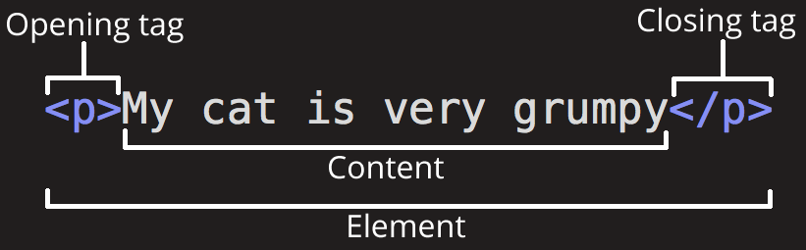
The main parts of our element are as follows:
- The opening tag: This consists of the name of the element (in this case, p), wrapped in opening and closing angle brackets. This states where the element begins or starts to take effect — in this case where the paragraph begins.
- The closing tag: This is the same as the opening tag, except that it includes a forward slash before the element name. This states where the element ends — in this case where the paragraph ends. Failing to add a closing tag is one of the standard beginner errors and can lead to strange results.
- The content: This is the content of the element, which in this case, is just text.
- The element: The opening tag, the closing tag, and the content together comprise the element.
Elements can also have attributes that look like the following:
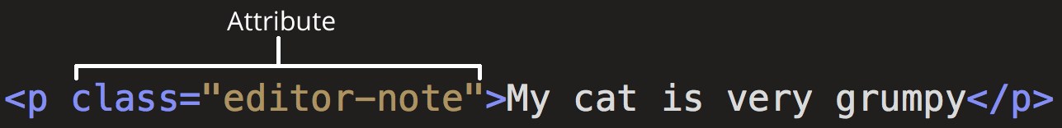
Attributes contain extra information about the element that you don't want to appear in the actual content. Here, class is the attribute name and editor-note is the attribute value. The class attribute allows you to give the element a non-unique identifier that can be used to target it (and any other elements with the same class value) with style information and other things. Some attributes have no value, such as required.
Attributes that set a value always have:
- A space between it and the element name (or the previous attribute, if the element already has one or more attributes).
- The attribute name followed by an equal sign.
- The attribute value wrapped by opening and closing quotation marks.
Note: Simple attribute values that don't contain ASCII whitespace (or any of the characters " ' ` = < >) can remain unquoted, but it is recommended that you quote all attribute values, as it makes the code more consistent and understandable.

Nesting elements
You can put elements inside other elements too — this is called nesting. If we wanted to state that our cat is very grumpy, we could wrap the word "very" in a <strong> element, which means that the word is to be strongly emphasized:
HTML
Copy to Clipboard
<p>My cat is <strong>very</strong> grumpy.</p>
You do however need to make sure that your elements are properly nested. In the example above, we opened the <p> element first, then the <strong> element; therefore, we have to close the <strong> element first, then the <p> element. The following is incorrect:
HTML
Copy to Clipboard
<p>My cat is <strong>very grumpy.</p></strong>
The elements have to open and close correctly so that they are clearly inside or outside one another. If they overlap as shown above, then your web browser will try to make the best guess at what you were trying to say, which can lead to unexpected results. So don't do it!

Void elements
Some elements have no content and are called void elements. Take the <img> element that we already have in our HTML page:
HTML
Copy to Clipboard
<img src="images/firefox-icon.png" alt="My test image" />
This contains two attributes, but there is no closing </img> tag and no inner content. This is because an image element doesn't wrap content to affect it. Its purpose is to embed an image in the HTML page in the place it appears.

Anatomy of an HTML document
That wraps up the basics of individual HTML elements, but they aren't handy on their own. Now we'll look at how individual elements are combined to form an entire HTML page. Let's revisit the code we put into our index.html example (which we first met in the Dealing with files article):
HTML
Copy to Clipboard
<!doctype html>
<html lang="en-US">
<head>
<meta charset="utf-8" />
<meta name="viewport" content="width=device-width" />
<title>My test page</title>
</head>
<body>
<img src="images/firefox-icon.png" alt="My test image" />
</body>
</html>
Here, we have the following:
- <!DOCTYPE html> — doctype. It is a required preamble. In the mists of time, when HTML was young (around 1991/92), doctypes were meant to act as links to a set of rules that the HTML page had to follow to be considered good HTML, which could mean automatic error checking and other useful things. However, these days, they don't do much and are basically just needed to make sure your document behaves correctly. That's all you need to know for now.
- <html></html> — the <html> element. This element wraps all the content on the entire page and is sometimes known as the root element. It also includes the lang attribute, setting the primary language of the document.
- <head></head> — the <head> element. This element acts as a container for all the stuff you want to include on the HTML page that isn't the content you are showing to your page's viewers. This includes things like keywords and a page description that you want to appear in search results, CSS to style our content, character set declarations, and more.
- <meta charset="utf-8"> — This element sets the character set your document should use to UTF-8 which includes most characters from the vast majority of written languages. Essentially, it can now handle any textual content you might put on it. There is no reason not to set this, and it can help avoid some problems later on.
- <meta name="viewport" content="width=device-width"> — This viewport element ensures the page renders at the width of viewport, preventing mobile browsers from rendering pages wider than the viewport and then shrinking them down.
- <title></title> — the <title> element. This sets the title of your page, which is the title that appears in the browser tab the page is loaded in. It is also used to describe the page when you bookmark/favorite it.
- <body></body> — the <body> element. This contains all the content that you want to show to web users when they visit your page, whether that's text, images, videos, games, playable audio tracks, or whatever else.

Images
Let's turn our attention to the <img> element again:
HTML
Copy to Clipboard
<img src="images/firefox-icon.png" alt="My test image" />
As we said before, it embeds an image into our page in the position it appears. It does this via the src (source) attribute, which contains the path to our image file.
We have also included an alt (alternative) attribute. In the alt attribute, you specify descriptive text for users who cannot see the image, possibly because of the following reasons:
- They are visually impaired. Users with significant visual impairments often use tools called screen readers to read out the alt text to them.
- Something has gone wrong causing the image not to display. For example, try deliberately changing the path inside your src attribute to make it incorrect. If you save and reload the page, you should see something like this in place of the image:

The keywords for alt text are "descriptive text". The alt text you write should provide the reader with enough information to have a good idea of what the image conveys. In this example, our current text of "My test image" is no good at all. A much better alternative for our Firefox logo would be "The Firefox logo: a flaming fox surrounding the Earth."
Try coming up with some better alt text for your image now.
Note: Find out more about accessibility in our accessibility learning module.

Marking up text
This section will cover some essential HTML elements you'll use for marking up the text.

Headings
Heading elements allow you to specify that certain parts of your content are headings — or subheadings. In the same way that a book has the main title, chapter titles, and subtitles, an HTML document can too. HTML contains 6 heading levels, <h1> - <h6>, although you'll commonly only use 3 to 4 at most:
HTML
Copy to Clipboard
<!-- 4 heading levels: -->
<h1>My main title</h1>
<h2>My top level heading</h2>
<h3>My subheading</h3>
<h4>My sub-subheading</h4>
Note: Anything in HTML between <!-- and --> is an HTML comment. The browser ignores comments as it renders the code. In other words, they are not visible on the page - just in the code. HTML comments are a way for you to write helpful notes about your code or logic.
Now try adding a suitable title to your HTML page just above your <img> element.
Note: You'll see that your heading level 1 has an implicit style. Don't use heading elements to make text bigger or bold, because they are used for accessibility and other reasons such as SEO. Try to create a meaningful sequence of headings on your pages, without skipping levels.

Paragraphs
As explained above, <p> elements are for containing paragraphs of text; you'll use these frequently when marking up regular text content:
HTML
Copy to Clipboard
<p>This is a single paragraph</p>
Add your sample text (you should have it from What will your website look like?) into one or a few paragraphs, placed directly below your <img> element.

Lists
A lot of the web's content is lists and HTML has special elements for these. Marking up lists always consists of at least 2 elements. The most common list types are ordered and unordered lists:
- Unordered lists are for lists where the order of the items doesn't matter, such as a shopping list. These are wrapped in a <ul> element.
- Ordered lists are for lists where the order of the items does matter, such as a recipe. These are wrapped in an <ol> element.
Each item inside the lists is put inside an <li> (list item) element.
For example, if we wanted to turn the part of the following paragraph fragment into a list
HTML
Copy to Clipboard
<p>
At Mozilla, we're a global community of technologists, thinkers, and builders
working together…
</p>
We could modify the markup to this
HTML
Copy to Clipboard
<p>At Mozilla, we're a global community of</p>

<ul>
<li>technologists</li>
<li>thinkers</li>
<li>builders</li>
</ul>

<p>working together…</p>
Try adding an ordered or unordered list to your example page.

Links
Links are very important — they are what makes the web a web! To add a link, we need to use a simple element — <a> — "a" being the short form for "anchor". To make text within your paragraph into a link, follow these steps:
- Choose some text. We chose the text "Mozilla Manifesto".
- Wrap the text in an <a> element, as shown below:
HTML
Copy to Clipboard
<a>Mozilla Manifesto</a>
- Give the <a> element an href attribute, as shown below:
HTML
Copy to Clipboard
<a href="">Mozilla Manifesto</a>
- Fill in the value of this attribute with the web address that you want the link to point to:
HTML
Copy to Clipboard
<a href="https://www.mozilla.org/en-US/about/manifesto/">
Mozilla Manifesto
</a>
You might get unexpected results if you omit the https:// or http:// part, called the protocol, at the beginning of the web address. After making a link, click it to make sure it is sending you where you wanted it to.
Note: href might appear like a rather obscure choice for an attribute name at first. If you are having trouble remembering it, remember that it stands for hypertext reference.
Add a link to your page now, if you haven't already done so.

Conclusion
If you have followed all the instructions in this article, you should end up with a page that looks like the one below (you can also view it here):
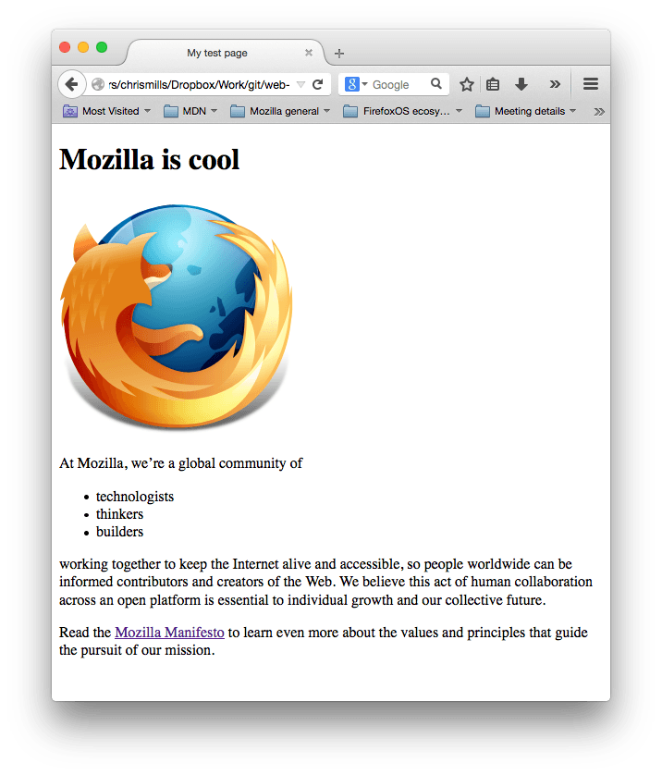
Please Create One HTML Page By Your Own.

Structuring the web with HTML
To build websites, you should know about HTML — the fundamental technology used to define the structure of a webpage. HTML is used to specify whether your web content should be recognized as a paragraph, list, heading, link, image, multimedia player, form, or one of many other available elements or even a new element that you define.

After learning HTML, you can then move on to learning about more advanced topics such as:
- CSS, and how to use it to style HTML (for example, alter your text size and fonts used, add borders and drop shadows, layout your page with multiple columns, add animations and other visual effects).
- JavaScript, and how to use it to add dynamic functionality to web pages (for example, find your location and plot it on a map, make UI elements appear/disappear when you toggle a button, save users' data locally on their computers, and much more).

What's in the head? Metadata in HTML

The head of an HTML document is the part that is not displayed in the web browser when the page is loaded.
It contains information such as the page <title>, links to CSS (if you choose to style your HTML content with CSS), links to custom favicons, and other metadata (data about the HTML, such as the author, and important keywords that describe the document).
Web browsers use information contained in the head to render the HTML document correctly.

In this article we'll cover all of the above and more, in order to give you a good basis for working with markup.

Prerequisites: | Basic HTML familiarity, as covered in Getting started with HTML.
Objective: | To learn about the HTML head, its purpose, the most important items it can contain, and what effect it can have on the HTML document.

What is the HTML head?
Let's revisit the simple HTML document we covered in the previous article:
HTML
Copy to Clipboard
<!doctype html>
<html lang="en-US">
<head>
<meta charset="utf-8" />
<title>My test page</title>
</head>
<body>
<p>This is my page</p>
</body>
</html>
The HTML head is the contents of the <head> element. Unlike the contents of the <body> element (which are displayed on the page when loaded in a browser), the head's content is not displayed on the page. Instead, the head's job is to contain metadata about the document. In the above example, the head is quite small:
HTML
Copy to Clipboard
<head>
<meta charset="utf-8" />
<title>My test page</title>
</head>
In larger pages however, the head can get quite large. Try going to some of your favorite websites and use the developer tools to check out their head contents. Our aim here is not to show you how to use everything that can possibly be put in the head, but rather to teach you how to use the major elements that you'll want to include in the head, and give you some familiarity. Let's get started.

Adding a title
We've already seen the <title> element in action — this can be used to add a title to the document. This however can get confused with the h1 element, which is used to add a top level heading to your body content — this is also sometimes referred to as the page title. But they are different things!
- The h1 element appears on the page when loaded in the browser — generally this should be used once per page, to mark up the title of your page content (the story title, or news headline, or whatever is appropriate to your usage.)
- The <title> element is metadata that represents the title of the overall HTML document (not the document's content.)

Active learning: Inspecting a simple example
- To start off this active learning, we'd like you to go to our GitHub repo and download a copy of our title-example.html page. To do this, either
  - Copy and paste the code out of the page and into a new text file in your code editor, then save it in a sensible place.
  - Press the "Raw" button on the GitHub page, which causes the raw code to appear (possibly in a new browser tab). Next, choose your browser's Save Page As… menu and choose a sensible place to save the file.
- Now open the file in your browser. You should see something like this: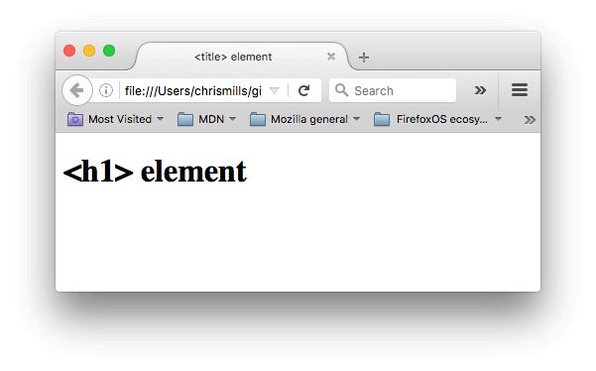It should now be completely obvious where the <h1> content appears and where the <title> content appears!
- You should also try opening the code up in your code editor, editing the contents of these elements, then refreshing the page in your browser. Have some fun with it.
The <title> element contents are also used in other ways. For example, if you try bookmarking the page (Bookmarks > Bookmark This Page or the star icon in the URL bar in Firefox), you will see the <title> contents filled in as the suggested bookmark name.
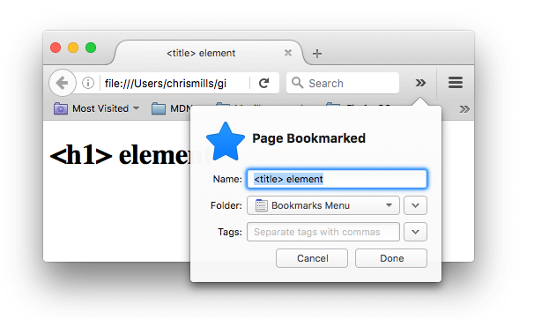
The <title> contents are also used in search results, as you'll see below.

Metadata: the <meta> element
Metadata is data that describes data, and HTML has an "official" way of adding metadata to a document — the <meta> element. Of course, the other stuff we are talking about in this article could also be thought of as metadata too. There are a lot of different types of <meta> elements that can be included in your page's <head>, but we won't try to explain them all at this stage, as it would just get too confusing. Instead, we'll explain a few things that you might commonly see, just to give you an idea.

Specifying your document's character encoding
In the example we saw above, this line was included:
HTML
Copy to Clipboard
<meta charset="utf-8" />
This element specifies the document's character encoding — the character set that the document is permitted to use. utf-8 is a universal character set that includes pretty much any character from any human language. This means that your web page will be able to handle displaying any language; it's therefore a good idea to set this on every web page you create! For example, your page could handle English and Japanese just fine:
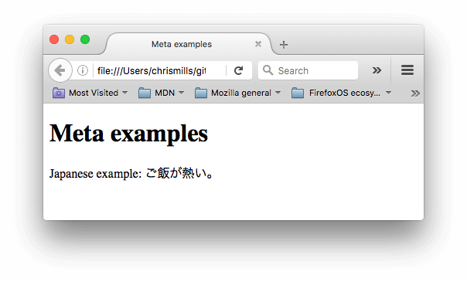If you set your character encoding to ISO-8859-1, for example (the character set for the Latin alphabet), your page rendering may appear all messed up:
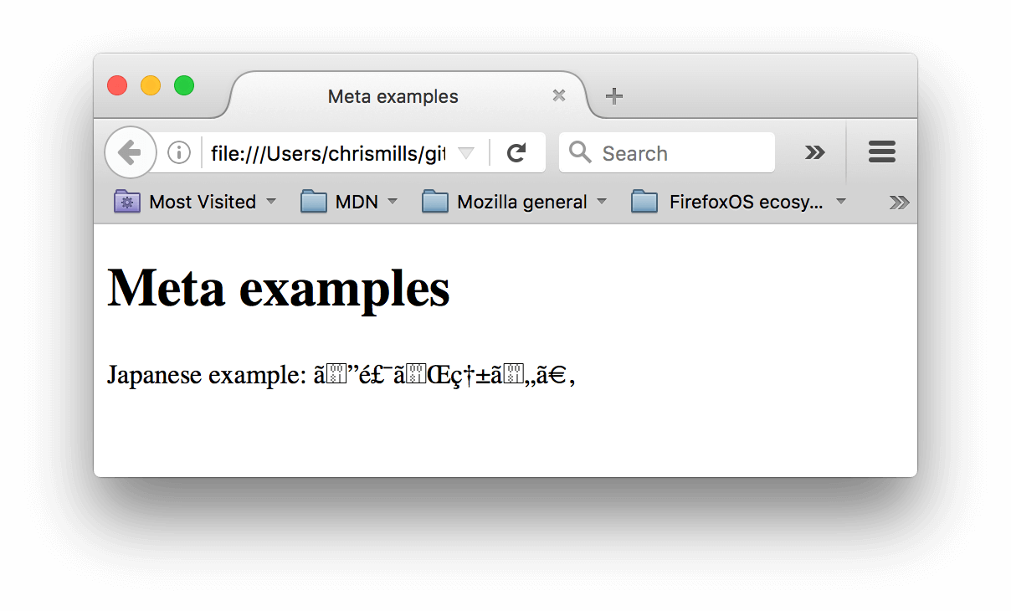
Note: Some browsers (like Chrome) automatically fix incorrect encodings, so depending on what browser you use, you may not see this problem. You should still set an encoding of utf-8 on your page anyway to avoid any potential problems in other browsers.

Active learning: Experiment with character encoding
To try this out, revisit the simple HTML template you obtained in the previous section on <title> (the title-example.html page), try changing the meta charset value to ISO-8859-1, and add the Japanese to your page. This is the code we used:
HTML
Copy to Clipboard
<p>Japanese example: ご飯が熱い。</p>

Adding an author and description
Many <meta> elements include name and content attributes:
- name specifies the type of meta element it is; what type of information it contains.
- content specifies the actual meta content.
Two such meta elements that are useful to include on your page define the author of the page, and provide a concise description of the page. Let's look at an example:
HTML
Copy to Clipboard
<meta name="author" content="Chris Mills" />
<meta
name="description"
content="The MDN Web Docs Learning Area aims to provide
complete beginners to the Web with all they need to know to get
started with developing websites and applications." />
Specifying an author is beneficial in many ways: it is useful to be able to understand who wrote the page, if you have any questions about the content and you would like to contact them. Some content management systems have facilities to automatically extract page author information and make it available for such purposes.
Specifying a description that includes keywords relating to the content of your page is useful as it has the potential to make your page appear higher in relevant searches performed in search engines (such activities are termed Search Engine Optimization, or SEO.)
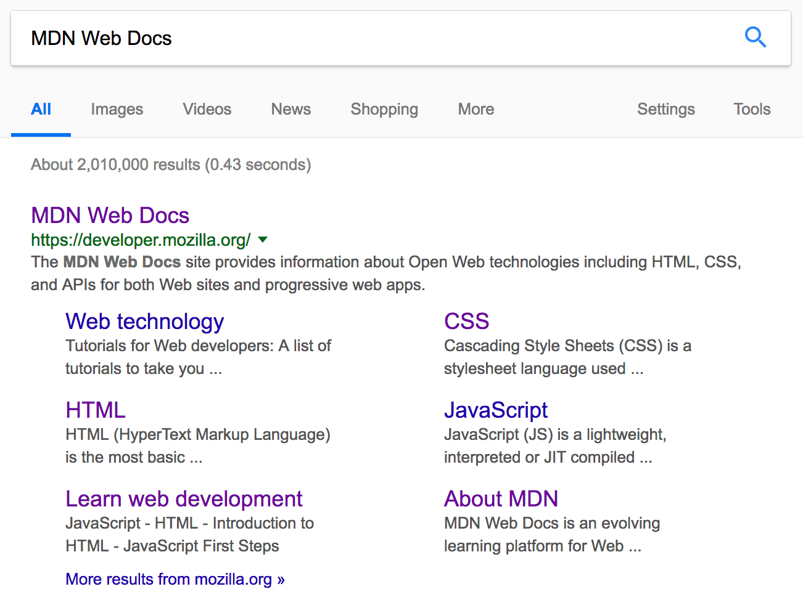
Note: In Google, you will see some relevant subpages of MDN Web Docs listed below the main homepage link — these are called sitelinks, and are configurable in Google's webmaster tools — a way to make your site's search results better in the Google search engine.
Note: Many <meta> features just aren't used anymore. For example, the keyword <meta> element (<meta name="keywords" content="fill, in, your, keywords, here">) — which is supposed to provide keywords for search engines to determine the relevance of that page for different search terms — is ignored by search engines, because spammers were just filling the keyword list with hundreds of keywords, biasing results.

Other types of metadata
As you travel around the web, you'll find other types of metadata, too. Many of the features you'll see on websites are proprietary creations designed to provide certain sites (such as social networking sites) with specific information they can use.
For example, Open Graph Data is a metadata protocol that Facebook invented to provide richer metadata for websites. In the MDN Web Docs sourcecode, you'll find this:
HTML
Copy to Clipboard
<meta
property="og:image"
content="https://developer.mozilla.org/mdn-social-share.png" />
<meta
property="og:description"
content="The Mozilla Developer Network (MDN) provides
information about Open Web technologies including HTML, CSS, and APIs for both websites
and HTML Apps." />
<meta property="og:title" content="Mozilla Developer Network" />
One effect of this is that when you link to MDN Web Docs on Facebook, the link appears along with an image and description: a richer experience for users.
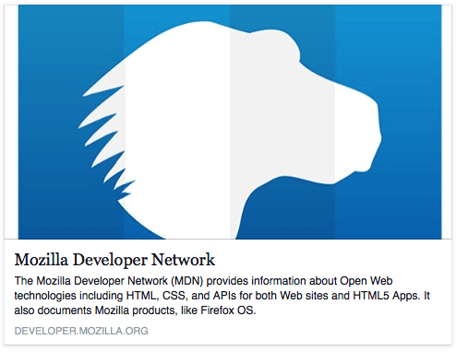

Adding custom icons to your site
To further enrich your site design, you can add references to custom icons in your metadata, and these will be displayed in certain contexts. The most commonly used of these is the favicon (short for "favorites icon", referring to its use in the "favorites" or "bookmarks" lists in browsers).
The humble favicon has been around for many years. It is the first icon of this type: a 16-pixel square icon used in multiple places. You may see (depending on the browser) favicons displayed in the browser tab containing each open page, and next to bookmarked pages in the bookmarks panel.
A favicon can be added to your page by:
- Saving it in the same directory as the site's index page, saved in .ico format (most also support favicons in more common formats like .gif or .png)
- Adding the following line into your HTML's <head> block to reference it:
HTML
Copy to Clipboard
<link rel="icon" href="favicon.ico" type="image/x-icon" />
Here is an example of a favicon in a bookmarks panel:
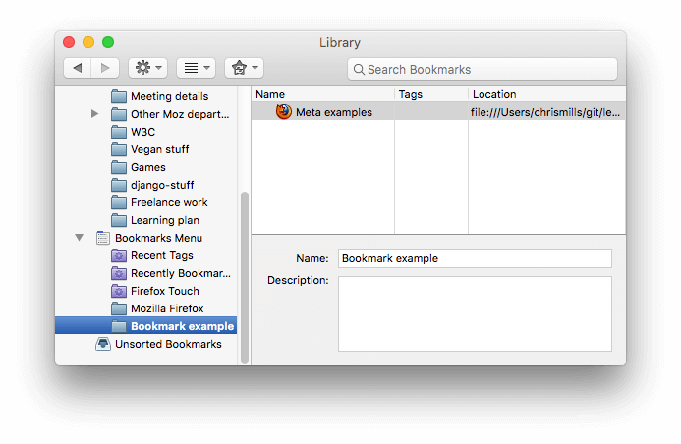
There are lots of other icon types to consider these days as well. For example, you'll find this in the source code of the MDN Web Docs homepage:
HTML
<!-- third-generation iPad with high-resolution Retina display: -->
<link
rel="apple-touch-icon"
sizes="144x144"
href="https://developer.mozilla.org/static/img/favicon144.png" />
<!-- iPhone with high-resolution Retina display: -->
<link
rel="apple-touch-icon"
sizes="114x114"
href="https://developer.mozilla.org/static/img/favicon114.png" />
<!-- first- and second-generation iPad: -->
<link
rel="apple-touch-icon"
sizes="72x72"
href="https://developer.mozilla.org/static/img/favicon72.png" />
<!-- non-Retina iPhone, iPod Touch, and Android 2.1+ devices: -->
<link
Copy to Clipboard
rel="apple-touch-icon"
href="https://developer.mozilla.org/static/img/favicon57.png" />
<!-- basic favicon -->
<link
rel="icon"
href="https://developer.mozilla.org/static/img/favicon32.png" />
The comments explain what each icon is used for — these elements cover things like providing a nice high resolution icon to use when the website is saved to an iPad's home screen.
Don't worry too much about implementing all these types of icon right now — this is a fairly advanced feature, and you won't be expected to have knowledge of this to progress through the course. The main purpose here is to let you know what such things are, in case you come across them while browsing other websites' source code.
Note: If your site uses a Content Security Policy (CSP) to enhance its security, the policy applies to the favicon. If you encounter problems with the favicon not loading, verify that the Content-Security-Policy header's img-src directive is not preventing access to it.

Applying CSS and JavaScript to HTML
Just about all websites you'll use in the modern day will employ CSS to make them look cool, and JavaScript to power interactive functionality, such as video players, maps, games, and more. These are most commonly applied to a web page using the <link> element and the <script> element, respectively.
- The <link> element should always go inside the head of your document. This takes two attributes, rel="stylesheet", which indicates that it is the document's stylesheet, and href, which contains the path to the stylesheet file:
HTML
Copy to Clipboard
<link rel="stylesheet" href="my-css-file.css" />
- The <script> element should also go into the head, and should include a src attribute containing the path to the JavaScript you want to load, and defer, which basically instructs the browser to load the JavaScript after the page has finished parsing the HTML. This is useful as it makes sure that the HTML is all loaded before the JavaScript runs, so that you don't get errors resulting from JavaScript trying to access an HTML element that doesn't exist on the page yet. There are actually a number of ways to handle loading JavaScript on your page, but this is the most reliable one to use for modern browsers (for others, read Script loading strategies).
HTML
Copy to Clipboard
<script src="my-js-file.js" defer></script>
Note: The <script> element may look like a void element, but it's not, and so needs a closing tag. Instead of pointing to an external script file, you can also choose to put your script inside the <script> element.

Active learning: applying CSS and JavaScript to a page
- To start this active learning, grab a copy of our meta-example.html, script.js and style.css files, and save them on your local computer in the same directory. Make sure they are saved with the correct names and file extensions.
- Open the HTML file in both your browser, and your text editor.
- By following the information given above, add <link> and <script> elements to your HTML, so that your CSS and JavaScript are applied to your HTML.
If done correctly, when you save your HTML and refresh your browser you should be able to see that things have changed:
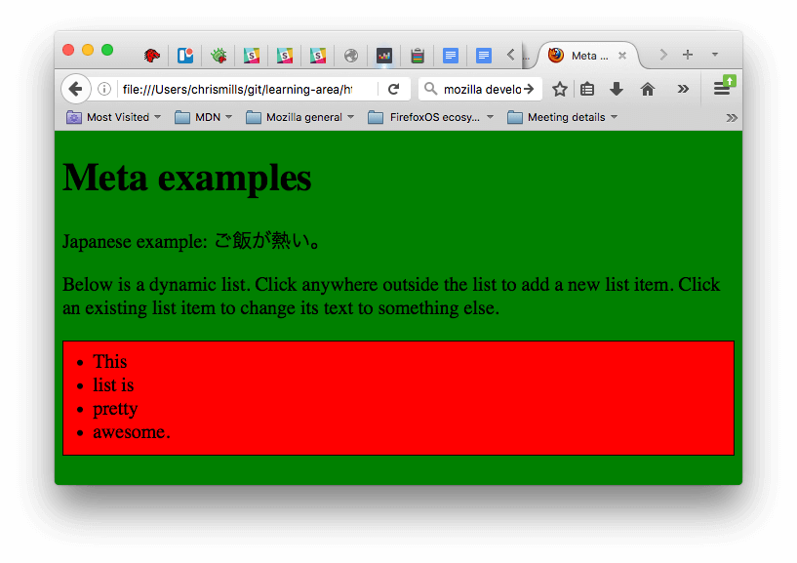
- The JavaScript has added an empty list to the page. Now when you click anywhere outside the list, a dialog box will pop up asking you to enter some text for a new list item. When you press the OK button, a new list item will be added to the list containing the text. When you click on an existing list item, a dialog box will pop up allowing you to change the item's text.
- The CSS has caused the background to go green, and the text to become bigger. It has also styled some of the content that the JavaScript has added to the page (the red bar with the black border is the styling the CSS has added to the JS-generated list.)
Note: If you get stuck in this exercise and can't get the CSS/JS to apply, try checking out our css-and-js.html example page.

Setting the primary language of the document
Finally, it's worth mentioning that you can (and really should) set the language of your page. This can be done by adding the lang attribute to the opening HTML tag (as seen in the meta-example.html and shown below.)
HTML
Copy to Clipboard
<html lang="en-US">
…
</html>
This is useful in many ways. Your HTML document will be indexed more effectively by search engines if its language is set (allowing it to appear correctly in language-specific results, for example), and it is useful to people with visual impairments using screen readers (for example, the word "six" exists in both French and English, but is pronounced differently.)
You can also set subsections of your document to be recognized as different languages. For example, we could set our Japanese language section to be recognized as Japanese, like so:
HTML
Copy to Clipboard
<p>Japanese example: <span lang="ja">ご飯が熱い。</span>.</p>
These codes are defined by the ISO 639-1 standard. You can find more about them in Language tags in HTML and XML.

Summary
That marks the end of our quickfire tour of the HTML head — there's a lot more you can do in here, but an exhaustive tour would be boring and confusing at this stage, and we just wanted to give you an idea of the most common things you'll find in there for now! In the next article, we'll be looking at HTML text fundamentals.

HTML text fundamentals

One of HTML's main jobs is to give text structure so that a browser can display an HTML document the way its developer intends.
This article explains the way HTML can be used to structure a page of text by adding headings and paragraphs, emphasizing words, creating lists, and more.
Prerequisites: | Basic HTML familiarity, as covered in Getting started with HTML.
Objective: | Learn how to mark up a basic page of text to give it structure and meaning — including paragraphs, headings, lists, emphasis, and quotations.

The basics: headings and paragraphs
Most structured text consists of headings and paragraphs, whether you are reading a story, a newspaper, a college textbook, a magazine, etc.
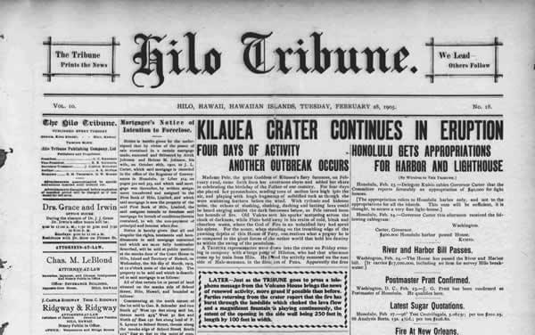
Structured content makes the reading experience easier and more enjoyable.
In HTML, each paragraph has to be wrapped in a <p> element, like so:
HTML
Copy to Clipboard
<p>I am a paragraph, oh yes I am.</p>
Each heading has to be wrapped in a heading element:
HTML
Copy to Clipboard
<h1>I am the title of the story.</h1>
There are six heading elements: h1, h2, h3, h4, h5, and h6. Each element represents a different level of content in the document; <h1> represents the main heading, <h2> represents subheadings, <h3> represents sub-subheadings, and so on.

Implementing structural hierarchy
For example, in this story, the <h1> element represents the title of the story, the <h2> elements represent the title of each chapter, and the <h3> elements represent subsections of each chapter:
HTML
Copy to Clipboard
<h1>The Crushing Bore</h1>

<p>By Chris Mills</p>

<h2>Chapter 1: The dark night</h2>

<p>
It was a dark night. Somewhere, an owl hooted. The rain lashed down on the…
</p>

<h2>Chapter 2: The eternal silence</h2>

<p>Our protagonist could not so much as a whisper out of the shadowy figure…</p>

<h3>The specter speaks</h3>

<p>
Several more hours had passed, when all of a sudden the specter sat bolt
upright and exclaimed, "Please have mercy on my soul!"
</p>
It's really up to you what the elements involved represent, as long as the hierarchy makes sense. You just need to bear in mind a few best practices as you create such structures:
- Preferably, you should use a single <h1> per page—this is the top level heading, and all others sit below this in the hierarchy.
- Make sure you use the headings in the correct order in the hierarchy. Don't use <h3> elements to represent subheadings, followed by <h2> elements to represent sub-subheadings—that doesn't make sense and will lead to weird results.
- Of the six heading levels available, you should aim to use no more than three per page, unless you feel it is necessary. Documents with many levels (for example, a deep heading hierarchy) become unwieldy and difficult to navigate. On such occasions, it is advisable to spread the content over multiple pages if possible.

Why do we need structure?
To answer this question, let's take a look at text-start.html—the starting point of our running example for this article (a nice hummus recipe). You should save a copy of this file on your local machine, as you'll need it for the exercises later on. This document's body currently contains multiple pieces of content. They aren't marked up in any way, but they are separated with line breaks (Enter/Return pressed to go onto the next line).
However, when you open the document in your browser, you'll see that the text appears as a big chunk!
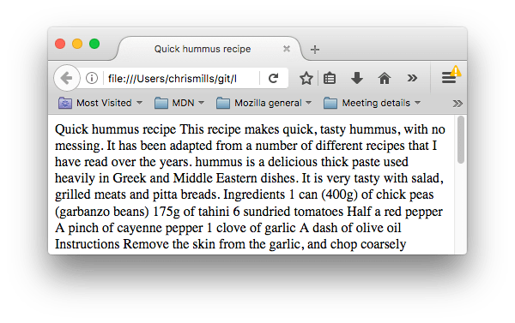
This is because there are no elements to give the content structure, so the browser does not know what is a heading and what is a paragraph. Furthermore:
- Users looking at a web page tend to scan quickly to find relevant content, often just reading the headings, to begin with. (We usually spend a very short time on a web page.) If they can't see anything useful within a few seconds, they'll likely get frustrated and go somewhere else.
- Search engines indexing your page consider the contents of headings as important keywords for influencing the page's search rankings. Without headings, your page will perform poorly in terms of SEO (Search Engine Optimization).
- Severely visually impaired people often don't read web pages; they listen to them instead. This is done with software called a screen reader. This software provides ways to get fast access to given text content. Among the various techniques used, they provide an outline of the document by reading out the headings, allowing their users to find the information they need quickly. If headings are not available, they will be forced to listen to the whole document read out loud.
- To style content with CSS, or make it do interesting things with JavaScript, you need to have elements wrapping the relevant content, so CSS/JavaScript can effectively target it.
Therefore, we need to give our content structural markup.

Active learning: Giving our content structure
Let's jump straight in with a live example. In the example below, add elements to the raw text in the Input field so that it appears as a heading and two paragraphs in the Output field.
If you make a mistake, you can always reset it using the Reset button. If you get stuck, press the Show solution button to see the answer.

Why do we need semantics?
Semantics are relied on everywhere around us—we rely on previous experience to tell us what the function of an everyday object is; when we see something, we know what its function will be. So, for example, we expect a red traffic light to mean "stop," and a green traffic light to mean "go." Things can get tricky very quickly if the wrong semantics are applied. (Do any countries use red to mean "go"? We hope not.)
In a similar way, we need to make sure we are using the correct elements, giving our content the correct meaning, function, or appearance. In this context, the h1 element is also a semantic element, which gives the text it wraps around the role (or meaning) of "a top level heading on your page."
HTML
Copy to Clipboard
<h1>This is a top level heading</h1>
By default, the browser will give it a large font size to make it look like a heading (although you could style it to look like anything you wanted using CSS). More importantly, its semantic value will be used in multiple ways, for example by search engines and screen readers (as mentioned above).
On the other hand, you could make any element look like a top level heading. Consider the following:
HTML
Copy to Clipboard
<span style="font-size: 32px; margin: 21px 0; display: block;">
Is this a top level heading?
</span>
This is a <span> element. It has no semantics. You use it to wrap content when you want to apply CSS to it (or do something to it with JavaScript) without giving it any extra meaning. (You'll find out more about these later on in the course.) We've applied some CSS to it to make it look like a top level heading, but since it has no semantic value, it will not get any of the extra benefits described above. It is a good idea to use the relevant HTML element for the job.

Lists
Now let's turn our attention to lists. Lists are everywhere in life—from your shopping list to the list of directions you subconsciously follow to get to your house every day, to the lists of instructions you are following in these tutorials! Lists are everywhere on the web, too, and we've got three different types to worry about.

Unordered
Unordered lists are used to mark up lists of items for which the order of the items doesn't matter. Let's take a shopping list as an example:
milk
eggs
bread
hummus
Every unordered list starts off with a <ul> element—this wraps around all the list items:
HTML
Copy to Clipboard
<ul>
milk
eggs
bread
hummus
</ul>
The last step is to wrap each list item in a <li> (list item) element:
HTML
Copy to pboard
<ul>
<li>milk</li>
<li>eggs</li>
<li>bread</li>
<li>hummus</li>
</ul>

Active learning: Marking up an unordered list
Try editing the live sample below to create your very own HTML unordered list.

Ordered
Ordered lists are lists in which the order of the items does matter. Let's take a set of directions as an example:
Drive to the end of the road
Turn right
Go straight across the first two roundabouts
Turn left at the third roundabout
The school is on your right, 300 meters up the road
The markup structure is the same as for unordered lists, except that you have to wrap the list items in an <ol> element, rather than <ul>:
HTML
Copy to Clipboard
<ol>
<li>Drive to the end of the road</li>
<li>Turn right</li>
<li>Go straight across the first two roundabouts</li>
<li>Turn left at the third roundabout</li>
<li>The school is on your right, 300 meters up the road</li>
</ol>

Active learning: Marking up an ordered list
Try editing the live sample below to create your very own HTML ordered list.

Description
Description lists enclose groups of terms and descriptions. Common uses for this element are implementing a glossary or displaying metadata (a list of key-value pairs). Let's consider some fishes with their interesting characteristics:
Albacore Tuna
The albacore is a very fast swimmer.

Asian Carp
Asian carp can consume 40% of their body weight in food a day!

Barracuda
Can grow to nearly 2 meters long!
The list is enclosed in a <dl> element, terms are enclosed in <dt> elements, and descriptions are enclosed in <dd> elements:
HTML
Copy to Clipboard
<dl>
<dt>Albacore Tuna</dt>
<dd>The albacore is a very fast swimmer.</dd>
<dt>Asian Carp</dt>
<dd>Asian carp can consume 40% of their body weight in food a day!</dd>
<dt>Barracuda</dt>
<dd>Can grow to nearly 2 meters long!</dd>
</dl>

Active learning: Marking up a description list
Try editing the live sample below to create your very own HTML description list.

Active learning: Marking up our recipe page
So at this point in the article, you have all the information you need to mark up our recipe page example. You can choose to either save a local copy of our text-start.html starting file and do the work there or do it in the editable example below. Doing it locally will probably be better, as then you'll get to save the work you are doing, whereas if you fill it in to the editable example, it will be lost the next time you open the page. Both have pros and cons.
If you get stuck, you can always press the Show solution button, or check out our text-complete.html example on our GitHub repo.

Nesting lists
It is perfectly OK to nest one list inside another one. You might want to have some sub-bullets sitting below a top-level bullet. Let's take the second list from our recipe example:
HTML
Copy to Clipboard
<ol>
<li>Remove the skin from the garlic, and chop coarsely.</li>
<li>Remove all the seeds and stalk from the pepper, and chop coarsely.</li>
<li>Add all the ingredients into a food processor.</li>
<li>Process all the ingredients into a paste.</li>
<li>If you want a coarse "chunky" hummus, process it for a short time.</li>
<li>If you want a smooth hummus, process it for a longer time.</li>
</ol>
Since the last two bullets are very closely related to the one before them (they read like sub-instructions or choices that fit below that bullet), it might make sense to nest them inside their own unordered list and put that list inside the current fourth bullet. This would look like so:
HTML
Copy to Clipboard
<ol>
<li>Remove the skin from the garlic, and chop coarsely.</li>
<li>Remove all the seeds and stalk from the pepper, and chop coarsely.</li>
<li>Add all the ingredients into a food processor.</li>
<li>
Process all the ingredients into a paste.
<ul>
<li>
If you want a coarse "chunky" hummus, process it for a short time.
</li>
<li>If you want a smooth hummus, process it for a longer time.</li>
</ul>
</li>
</ol>
Try going back to the previous active learning example and updating the second list like this.

Emphasis and importance
In human language, we often emphasize certain words to alter the meaning of a sentence, and we often want to mark certain words as important or different in some way. HTML provides various semantic elements to allow us to mark up textual content with such effects, and in this section, we'll look at a few of the most common ones.

Emphasis
When we want to add emphasis in spoken language, we stress certain words, subtly altering the meaning of what we are saying. Similarly, in written language we tend to stress words by putting them in italics. For example, the following two sentences have different meanings.
I am glad you weren't late.
I am glad you weren't late.
The first sentence sounds genuinely relieved that the person wasn't late. In contrast, the second one, with both the words "glad" and "late" in italics, sounds sarcastic or passive-aggressive, expressing annoyance that the person arrived a bit late.
In HTML we use the <em> (emphasis) element to mark up such instances. As well as making the document more interesting to read, these are recognized by screen readers, which can be configured to speak them in a different tone of voice. Browsers style this as italic by default, but you shouldn't use this tag purely to get italic styling. To do that, you'd use a <span> element and some CSS, or perhaps an <i> element (see below).
HTML
Copy to Clipboard
<p>I am <em>glad</em> you weren't <em>late</em>.</p>

Strong importance
To emphasize important words, we tend to stress them in spoken language and bold them in written language. For example:
This liquid is highly toxic.
I am counting on you. Do not be late!
In HTML we use the <strong> (strong importance) element to mark up such instances. As well as making the document more useful, again these are recognized by screen readers, which can be configured to speak them in a different tone of voice. Browsers style this as bold text by default, but you shouldn't use this tag purely to get bold styling. To do that, you'd use a <span> element and some CSS, or perhaps a <b> element (see below).
HTMLPlay
Copy to Clipboard
<p>This liquid is <strong>highly toxic</strong>.</p>

<p>I am counting on you. <strong>Do not</strong> be late!</p>
You can nest strong and emphasis inside one another if desired:
HTMLPlay
Copy to Clipboard
<p>This liquid is <strong>highly toxic</strong> — if you drink it, <strong>you may <em>die</em></strong>.</p>

Active learning: Let's be important
In this active learning section, we've provided an editable example. Inside it, we'd like you to try adding emphasis and strong importance to the words you think need them, just to have some practice.

Italic, bold, underline…
The elements we've discussed so far have clear-cut associated semantics. The situation with <b>, <i>, and <u> is somewhat more complicated. They came about so people could write bold, italics, or underlined text in an era when CSS was still supported poorly or not at all. Elements like this, which only affect presentation and not semantics, are known as presentational elements and should no longer be used because, as we've seen before, semantics is so important to accessibility, SEO, etc.
HTML5 redefined <b>, <i>, and <u> with new, somewhat confusing, semantic roles.
Here's the best rule you can remember: It's only appropriate to use <b>, <i>, or <u> to convey a meaning traditionally conveyed with bold, italics, or underline when there isn't a more suitableelement; and there usually is. Consider whether <strong>, <em>, <mark>, or <span> might be more appropriate.
Always keep an accessibility mindset. The concept of italics isn't very helpful to people using screen readers, or to people using a writing system other than the Latin alphabet.
- <i> is used to convey a meaning traditionally conveyed by italic: foreign words, taxonomic designation, technical terms, a thought…
- <b> is used to convey a meaning traditionally conveyed by bold: keywords, product names, lead sentence…
- <u> is used to convey a meaning traditionally conveyed by underline: proper name, misspelling…
Note: People strongly associate underlining with hyperlinks. Therefore, on the web, it's best to only underline links. Use the <u> element when it's semantically appropriate, but consider using CSS to change the default underline to something more appropriate on the web. The example below illustrates how it can be done.
HTMLPlay
Copy to Clipboard
<!-- scientific names -->
<p>
The Ruby-throated Hummingbird (<i>Archilochus colubris</i>) is the most common
hummingbird in Eastern North America.
</p>

<!-- foreign words -->
<p>
The menu was a sea of exotic words like <i lang="uk-latn">vatrushka</i>,
<i lang="id">nasi goreng</i> and <i lang="fr">soupe à l'oignon</i>.
</p>

<!-- a known misspelling -->
<p>Someday I'll learn how to <u class="spelling-error">spel</u> better.</p>

<!-- term being defined when used in a definition -->
<dl>
<dt>Semantic HTML</dt>
<dd>
Use the elements based on their <b>semantic</b> meaning, not their
appearance.
</dd>
</dl>

Test your skills!
You've reached the end of this article, but can you remember the most important information? You can find some further tests to verify that you've retained this information before you move on — see Test your skills: HTML text basics.

Summary
That's it for now! This article should have given you a good idea of how to start marking up text in HTML and introduced you to some of the most important elements in this area. There are a lot more semantic elements to cover in this area, and we'll look at a lot more in our Advanced text formatting article later on in the course. In the next article, we'll be looking in detail at how to create hyperlinks, possibly the most important element on the web.

Creating hyperlinks

Hyperlinks are really important — they are what makes the Web a web. This article shows the syntax required to make a link, and discusses link best practices.
Prerequisites: | Basic HTML familiarity, as covered in Getting started with HTML. HTML text formatting, as covered in HTML text fundamentals.
Objective: | To learn how to implement a hyperlink effectively, and link multiple files together.

What is a hyperlink?

Hyperlinks are one of the most exciting innovations the Web has to offer. They've been a feature of the Web since the beginning, and are what makes the Web a web. Hyperlinks allow us to link documents to other documents or resources, link to specific parts of documents, or make apps available at a web address. Almost any web content can be converted to a link so that when clicked or otherwise activated the web browser goes to another web address (URL).
Note: A URL can point to HTML files, text files, images, text documents, video and audio files, or anything else that lives on the Web. If the web browser doesn't know how to display or handle the file, it will ask you if you want to open the file (in which case the duty of opening or handling the file is passed to a suitable native app on the device) or download the file (in which case you can try to deal with it later on).
For example, the BBC homepage contains many links that point not only to multiple news stories, but also different areas of the site (navigation functionality), login/registration pages (user tools), and more.
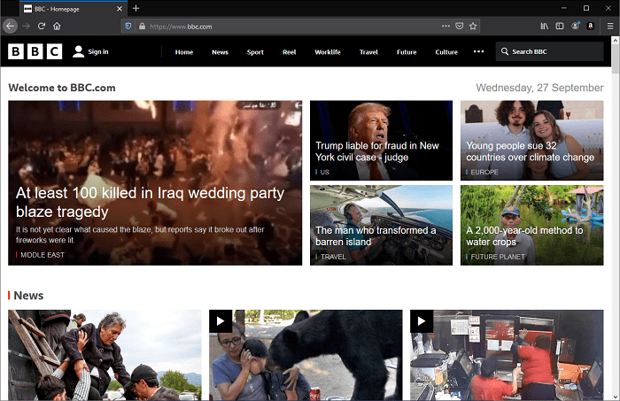

Anatomy of a link
A basic link is created by wrapping the text or other content inside an <a> element and using the href attribute, also known as a Hypertext Reference, or target, that contains the web address.
HTML
Copy to Clipboard
<p>
I'm creating a link to
<a href="https://www.mozilla.org/en-US/">the Mozilla homepage</a>.
</p>
This gives us the following result:
I'm creating a link to the Mozilla homepage.

Block level links
As mentioned before, almost any content can be made into a link, even block-level elements. If you want to make a heading element a link then wrap it in an anchor (<a>) element as shown in the following code snippet:
HTMLPlay
Copy to Clipboard
<a href="https://developer.mozilla.org/en-US/">
<h1>MDN Web Docs</h1>
</a>
<p>
Documenting web technologies, including CSS, HTML, and JavaScript, since 2005.
</p>

Image links
If you have an image you want to make into a link, use the <a> element to wrap the image file referenced with the <img> element. The example below uses a relative path to reference a locally stored SVG image file.
HTMLPlay
Copy to Clipboard
<a href="https://developer.mozilla.org/en-US/">
<img src="mdn_logo.svg" alt="MDN Web Docs" />
</a>
This makes the MDN logo a link:
Note: You'll find out more about using images on the Web in a future article.

Adding supporting information with the title attribute
Another attribute you may want to add to your links is title. The title contains additional information about the link, such as which kind of information the page contains, or things to be aware of on the website.
HTMLPlay
Copy to Clrd
<p>
I'm creating a link to
<a
href="https://www.mozilla.org/en-US/"
title="The best place to find more information about Mozilla's
mission and how to contribute">
the Mozilla homepage</a>.
</p>
This gives us the following result and hovering over the link displays the title as a tooltip:

Note: A link title is only revealed on mouse hover, which means that people relying on keyboard controls or touchscreens to navigate web pages will have difficulty accessing title information. If a title's information is truly important to the usability of the page, then you should present it in a manner that will be accessible to all users, for example by putting it in the regular text.

Active learning: creating your own example link
Create an HTML document using your local code editor and our getting started template.
- Inside the HTML body, add one or more paragraphs or other types of content you already know about.
- Change some of the content into links.
- Include title attributes.

A quick primer on URLs and paths
To fully understand link targets, you need to understand URLs and file paths. This section gives you the information you need to achieve this.
A URL, or Uniform Resource Locator is a string of text that defines where something is located on the Web. For example, Mozilla's English homepage is located at https://www.mozilla.org/en-US/.
URLs use paths to find files. Paths specify where the file you're interested in is located in the filesystem. Let's look at an example of a directory structure, see the creating-hyperlinks directory.
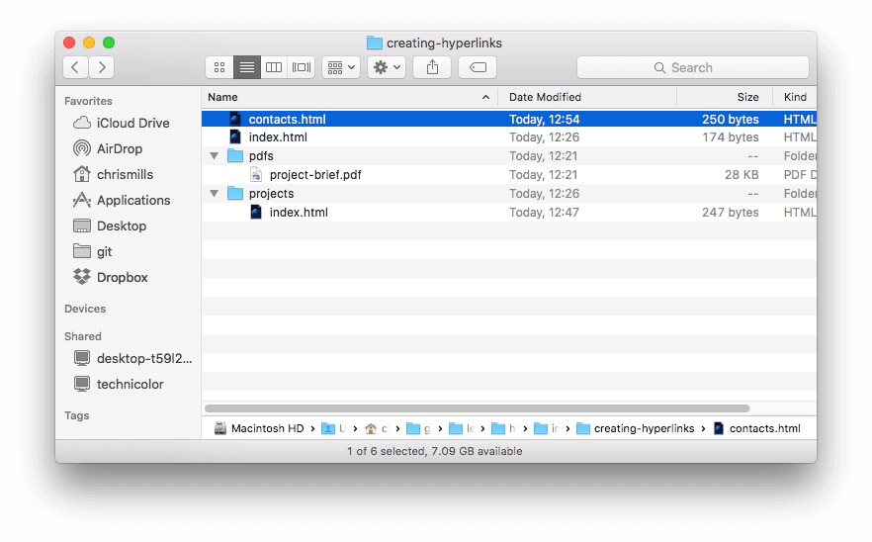
The root of this directory structure is called creating-hyperlinks. When working locally with a website, you'll have one directory that contains the entire site. Inside the root, we have an index.html file and a contacts.html. In a real website, index.html would be our home page or landing page (a web page that serves as the entry point for a website or a particular section of a website.).
There are also two directories inside our root — pdfs and projects. These each have a single file inside them — a PDF (project-brief.pdf) and an index.html file, respectively. Note that you can have two index.html files in one project, as long as they're in different filesystem locations. The second index.html would perhaps be the main landing page for project-related information.
- Same directory: If you wanted to include a hyperlink inside index.html (the top level index.html) pointing to contacts.html, you would specify the filename that you want to link to, because it's in the same directory as the current file. The URL you would use is contacts.html:
HTML
Copy to Clipboard
<p>
Want to contact a specific staff member? Find details on our
<a href="contacts.html">contacts page</a>.
</p>
- Moving down into subdirectories: If you wanted to include a hyperlink inside index.html (the top level index.html) pointing to projects/index.html, you would need to go down into the projects directory before indicating the file you want to link to. This is done by specifying the directory's name, then a forward slash, then the name of the file. The URL you would use is projects/index.html:
HTML
Copy to Clipboard
<p>Visit my <a href="projects/index.html">project homepage</a>.</p>
- Moving back up into parent directories: If you wanted to include a hyperlink inside projects/index.html pointing to pdfs/project-brief.pdf, you'd have to go up a directory level, then back down into the pdfs directory. To go up a directory, use two dots — .. — so the URL you would use is ../pdfs/project-brief.pdf:
HTML
Copy to Clipboard
<p>A link to my <a href="../pdfs/project-brief.pdf">project brief</a>.</p>
Note: You can combine multiple instances of these features into complex URLs, if needed, for example: ../../../complex/path/to/my/file.html.

Document fragments
It's possible to link to a specific part of an HTML document, known as a document fragment, rather than just to the top of the document. To do this you first have to assign an id attribute to the element you want to link to. It normally makes sense to link to a specific heading, so this would look something like the following:
HTML
Copy to Clipboard
<h2 id="Mailing_address">Mailing address</h2>
Then to link to that specific id, you'd include it at the end of the URL, preceded by a hash/pound symbol (#), for example:
HTML
Copy to Clipboard
<p>
Want to write us a letter? Use our
<a href="contacts.html#Mailing_address">mailing address</a>.
</p>
You can even use the document fragment reference on its own to link to another part of the current document:
HTML
Copy to Clipboard
<p>
The <a href="#Mailing_address">company mailing address</a> can be found at the
bottom of this page.
</p>

Absolute versus relative URLs
Two terms you'll come across on the Web are absolute URL and relative URL:
absolute URL: Points to a location defined by its absolute location on the web, including protocol and domain name. For example, if an index.html page is uploaded to a directory called projects that sits inside the root of a web server, and the website's domain is https://www.example.com, the page would be available at https://www.example.com/projects/index.html (or even just https://www.example.com/projects/, as most web servers just look for a landing page such as index.html to load if it isn't specified in the URL.)

An absolute URL will always point to the same location, no matter where it's used.

relative URL: Points to a location that is relative to the file you are linking from, more like what we looked at in the previous section. For example, if we wanted to link from our example file at https://www.example.com/projects/index.html to a PDF file in the same directory, the URL would just be the filename — project-brief.pdf — no extra information needed.

If the PDF was available in a subdirectory inside projects called pdfs, the relative link would be pdfs/project-brief.pdf (the equivalent absolute URL would be

https://www.example.com/projects/pdfs/project-brief.pdf.)
A relative URL will point to different places depending on the actual location of the file you refer from — for example if we moved our index.html

file out of the projects directory and into the root of the website (the top level, not in any directories), the pdfs/project-brief.pdf relative URL link inside it would now point to a file located at https://www.example.com/pdfs/project-brief.pdf, not a file located at https://www.example.com/projects/pdfs/project-brief.pdf.
Of course, the location of the project-brief.pdf file and pdfs folder won't suddenly change because you moved the index.html file — this would make your link point to the wrong place, so it wouldn't work if clicked on. You need to be careful!

Link best practices
There are some best practices to follow when writing links. Let's look at these now.

Use clear link wording
It's easy to throw links up on your page. That's not enough. We need to make our links accessible to all readers, regardless of their current context and which tools they prefer. For example:
- Screen reader users like jumping around from link to link on the page, and reading links out of context.
- Search engines use link text to index target files, so it is a good idea to include keywords in your link text to effectively describe what is being linked to.
- Visual readers skim over the page rather than reading every word, and their eyes will be drawn to page features that stand out, like links. They will find descriptive link text useful.
Let's look at a specific example:
Good link text: Download Firefox
HTML
Copy to Clipboard
<p><a href="https://www.mozilla.org/firefox/">Download Firefox</a></p>
Bad link text: Click here to download Firefox
HTML
Copy to Clipboard
<p>
<a href="https://www.mozilla.org/firefox/">Click here</a> to download Firefox
</p>
Other tips:
- Don't repeat the URL as part of the link text — URLs look ugly, and sound even uglier when a screen reader reads them out letter by letter.
- Don't say "link" or "links to" in the link text — it's just noise. Screen readers tell people there's a link. Visual users will also know there's a link, because links are generally styled in a different color and underlined (this convention generally shouldn't be broken, as users are used to it).
- Keep your link text as short as possible — this is helpful because screen readers need to interpret the entire link text.
- Minimize instances where multiple copies of the same text are linked to different places. This can cause problems for screen reader users, if there's a list of links out of context that are labeled "click here", "click here", "click here".

Linking to non-HTML resources — leave clear signposts
When linking to a resource that will be downloaded (like a PDF or Word document), streamed (like video or audio), or has another potentially unexpected effect (opens a popup window), you should add clear wording to reduce any confusion.
For example:
- If you're on a low bandwidth connection, click a link, and then a multiple megabyte download starts unexpectedly.
Let's look at some examples, to see what kind of text can be used here:
HTML
Copy to Clipboard
<p>
<a href="https://www.example.com/large-report.pdf">
Download the sales report (PDF, 10MB)
</a>
</p>

<p>
<a href="https://www.example.com/video-stream/" target="_blank">
Watch the video (stream opens in separate tab, HD quality)
</a>
</p>

Use the download attribute when linking to a download
When you are linking to a resource that's to be downloaded rather than opened in the browser, you can use the download attribute to provide a default save filename. Here's an example with a download link to the latest Windows version of Firefox:
Copy to Clipboard
HTML
<a
href="https://download.mozilla.org/?product=firefox-latest-ssl&os=win64&lang=en-US"
download="firefox-latest-64bit-installer.exe">
Download Latest Firefox for Windows (64-bit) (English, US)
</a>

Active learning: creating a navigation menu
For this exercise, we'd like you to link some pages together with a navigation menu to create a multipage website. This is one common way in which a website is created — the same page structure is used on every page, including the same navigation menu, so when links are clicked it gives the impression that you are staying in the same place, and different content is being brought up.
You'll need to make local copies of the following four pages, all in the same directory. For a complete file list, see the navigation-menu-start directory:
- index.html
- projects.html
- pictures.html
- social.html
You should:
- Add an unordered list in the indicated place on one page that includes the names of the pages to link to. A navigation menu is usually just a list of links, so this is semantically OK.
- Change each page name into a link to that page.
- Copy the navigation menu across to each page.
- On each page, remove just the link to that same page — it's confusing and unnecessary for a page to include a link to itself. And, the lack of a link acts a good visual reminder of which page you are currently on.
The finished example should look similar to the following page:
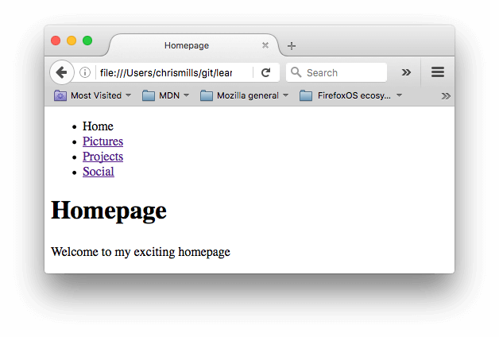
Note: If you get stuck, or aren't sure if you have got it right, you can check the navigation-menu-marked-up directory to see the correct answer.

Email links
It's possible to create links or buttons that, when clicked, open a new outgoing email message rather than linking to a resource or page. This is done using the <a> element and the mailto: URL scheme.
In its most basic and commonly used form, a mailto: link indicates the email address of the intended recipient. For example:
HTML
Copy to Clipboard
<a href="mailto:nowhere@mozilla.org">Send email to nowhere</a>
This results in a link that looks like this: Send email to nowhere.
In fact, the email address is optional. If you omit it and your href is "mailto:", a new outgoing email window will be opened by the user's email client with no destination address. This is often useful as "Share" links that users can click to send an email to an address of their choosing.

Specifying details
In addition to the email address, you can provide other information. In fact, any standard mail header fields can be added to the mailto URL you provide. The most commonly used of these are "subject", "cc", and "body" (which is not a true header field, but allows you to specify a short content message for the new email). Each field and its value is specified as a query term.
Here's an example that includes a cc, bcc, subject and body:
HTML
Copy to Clipboard
<a
href="mailto:nowhere@mozilla.org?cc=name2@rapidtables.com&bcc=name3@rapidtables.com&subject=The%20subject%20of%20the%20email&body=The%20body%20of%20the%20email">
Send mail with cc, bcc, subject and body
</a>
Note: The values of each field must be URL-encoded with non-printing characters (invisible characters like tabs, carriage returns, and page breaks) and spaces percent-escaped. Also, note the use of the question mark (?) to separate the main URL from the field values, and ampersands (&) to separate each field in the mailto: URL. This is standard URL query notation. Read The GET method to understand what URL query notation is more commonly used for.
Here are a few other sample mailto URLs:
- mailto:
- mailto:nowhere@mozilla.org
- mailto:nowhere@mozilla.org,nobody@mozilla.org
- mailto:nowhere@mozilla.org?cc=nobody@mozilla.org
- mailto:nowhere@mozilla.org?cc=nobody@mozilla.org&subject=This%20is%20the%20subject

Test your skills!
You've reached the end of this article, but can you remember the most important information? You can find some further tests to verify that you've retained this information before you move on — see Test your skills: Links.

Summary
That's it for links, for now anyway! You'll return to links later on in the course when you start to look at styling them. Next up for HTML, we'll return to text semantics and look at some more advanced/unusual features that you'll find useful — Advanced text formatting is your next stop.

Advanced text formatting

There are many other elements in HTML for formatting text, which we didn't get to in the HTML text fundamentals article. The elements described in this article are less known, but still useful to know about (and this is still not a complete list by any means). Here you'll learn about marking up quotations, description lists, computer code and other related text, subscript and superscript, contact information, and more.
Prerequisites: | Basic HTML familiarity, as covered in Getting started with HTML. HTML text formatting, as covered in HTML text fundamentals.
Objective: | To learn how to use lesser-known HTML elements to mark up advanced semantic features.

Description lists
In HTML text fundamentals, we walked through how to mark up basic lists in HTML, but we didn't mention the third type of list you'll occasionally come across — description lists. The purpose of these lists is to mark up a set of items and their associated descriptions, such as terms and definitions, or questions and answers. Let's look at an example of a set of terms and definitions:
soliloquy
In drama, where a character speaks to themselves, representing their inner thoughts or feelings and in the process relaying them to the audience (but not to other characters.)
monologue
In drama, where a character speaks their thoughts out loud to share them with the audience and any other characters present.
aside
In drama, where a character shares a comment only with the audience for humorous or dramatic effect. This is usually a feeling, thought or piece of additional background information
Description lists use a different wrapper than the other list types — <dl>; in addition each term is wrapped in a <dt> (description term) element, and each description is wrapped in a <dd> (description definition) element.

Description list example
Let's finish marking up our example:
HTMLPlay
Copy to Clipboard
<dl>
<dt>soliloquy</dt>
<dd>
In drama, where a character speaks to themselves, representing their inner
thoughts or feelings and in the process relaying them to the audience (but
not to other characters.)
</dd>
<dt>monologue</dt>
<dd>
In drama, where a character speaks their thoughts out loud to share them
with the audience and any other characters present.
</dd>
<dt>aside</dt>
<dd>
In drama, where a character shares a comment only with the audience for
humorous or dramatic effect. This is usually a feeling, thought, or piece of
additional background information.
</dd>
</dl>
The browser default styles will display description lists with the descriptions indented somewhat from the terms.

Multiple descriptions for one term
Note that it is permitted to have a single term with multiple descriptions, for example:
HTMLPlay
Copy to Clipboard
<dl>
<dt>aside</dt>
<dd>
In drama, where a character shares a comment only with the audience for
humorous or dramatic effect. This is usually a feeling, thought, or piece of
additional background information.
</dd>
<dd>
In writing, a section of content that is related to the current topic, but
doesn't fit directly into the main flow of content so is presented nearby
(often in a box off to the side.)
</dd>
</dl>

Active learning: Marking up a set of definitions
It's time to try your hand at description lists; add elements to the raw text in the Input field so that it appears as a description list in the Output field. You could try using your own terms and descriptions if you like.
If you make a mistake, you can always reset it using the Reset button. If you get really stuck, press the Show solution button to see the answer.

Quotations
HTML also has features available for marking up quotations; which element you use depends on whether you are marking up a block or inline quotation.

Blockquotes
If a section of block level content (be it a paragraph, multiple paragraphs, a list, etc.) is quoted from somewhere else, you should wrap it inside a <blockquote> element to signify this, and include a URL pointing to the source of the quote inside a cite attribute. For example, the following markup is taken from the MDN <blockquote> element page:
HTMLPlay
Copy to Clipboard
<p>
The <strong>HTML <code>&lt;blockquote&gt;</code> Element</strong> (or
<em>HTML Block Quotation Element</em>) indicates that the enclosed text is an
extended quotation.
</p>
To turn this into a block quote, we would just do this:
HTMLPlay
Copy to Clipboard
<p>Here is a blockquote:</p>
<blockquote
cite="https://developer.mozilla.org/en-US/docs/Web/HTML/Element/blockquote">
<p>
The <strong>HTML <code>&lt;blockquote&gt;</code> Element</strong> (or
<em>HTML Block Quotation Element</em>) indicates that the enclosed text is
an extended quotation.
</p>
</blockquote>
Browser default styling will render this as an indented paragraph, as an indicator that it is a quote; the paragraph above the quotation is there to demonstrate that.

Inline quotations
Inline quotations work in exactly the same way, except that they use the <q> element. For example, the below bit of markup contains a quotation from the MDN <q> page:
HTMLPlay
Copy to Clipboard
<p>
The quote element — <code>&lt;q&gt;</code> — is
<q cite="https://developer.mozilla.org/en-US/docs/Web/HTML/Element/q">
intended for short quotations that don't require paragraph breaks.
</q>
</p>
Browser default styling will render this as normal text put in quotes to indicate a quotation, like so:

Citations
The content of the cite attribute sounds useful, but unfortunately browsers, screen readers, etc. don't really do much with it. There is no way to get the browser to display the contents of cite, without writing your own solution using JavaScript or CSS. If you want to make the source of the quotation available on the page you need to make it available in the text via a link or some other appropriate way.
There is a <cite> element, but this is meant to contain the title of the resource being quoted, e.g. the name of the book. There is no reason, however, why you couldn't link the text inside <cite> to the quote source in some way:
HTMLPlay
Copy to Clipboard
<p>
According to the
<a href="/en-US/docs/Web/HTML/Element/blockquote">
<cite>MDN blockquote page</cite></a>:
</p>

<blockquote
cite="https://developer.mozilla.org/en-US/docs/Web/HTML/Element/blockquote">
<p>
The <strong>HTML <code>&lt;blockquote&gt;</code> Element</strong> (or
<em>HTML Block Quotation Element</em>) indicates that the enclosed text is
an extended quotation.
</p>
</blockquote>

<p>
The quote element — <code>&lt;q&gt;</code> — is
<q cite="https://developer.mozilla.org/en-US/docs/Web/HTML/Element/q">
intended for short quotations that don't require paragraph breaks.
</q>
— <a href="/en-US/docs/Web/HTML/Element/q"><cite>MDN q page</cite></a>.
</p>
Citations are styled in italic font by default.

Active learning: Who said that?
Time for another active learning example! In this example we'd like you to:
- Turn the middle paragraph into a blockquote, which includes a cite attribute.
- Turn "The Need To Eliminate Negative Self Talk" in the third paragraph into an inline quote, and include a cite attribute.
- Wrap the title of each source in <cite> tags and turn each one into a link to that source.
The citation sources you need are:
- http://www.brainyquote.com/quotes/authors/c/confucius.html for the Confucius quote
- http://example.com/affirmationsforpositivethinking for "The Need To Eliminate Negative Self Talk".
If you make a mistake, you can always reset it using the Reset button. If you get really stuck, press the Show solution button to see the answer.

Abbreviations
Another fairly common element you'll meet when looking around the Web is <abbr> — this is used to wrap around an abbreviation or acronym. When including either, provide a full expansion of the term in plain text on first use, along with the <abbr> to mark up the abbreviation. This provides a hint to user agents on how to announce/display the content while informing all users what the abbreviation means.
If providing the expansion in addition to the abbreviation makes little sense, and the abbreviation or acronym is a fairly shortened term, provide the full expansion of the term as the value of title attribute:

Abbreviation example
Let's look at an example.
HTMLPlay
Copy to Clipboard
<p>
We use <abbr>HTML</abbr>, Hypertext Markup Language, to structure our web
documents.
</p>

<p>
I think <abbr title="Reverend">Rev.</abbr> Green did it in the kitchen with
the chainsaw.
</p>
These will come out looking something like this:

Note: Earlier versions of html also included support for the <acronym> element, but it was removed from the HTML spec in favor of using <abbr> to represent both abbreviations and acronyms. <acronym> should not be used.

Active learning: marking up an abbreviation
For this simple active learning assignment, we'd like you to mark up an abbreviation. You can use our sample below, or replace it with one of your own.

Marking up contact details
HTML has an element for marking up contact details — <address>. This wraps around your contact details, for example:
HTML
Copy to Clipboard
<address>Chris Mills, Manchester, The Grim North, UK</address>
It could also include more complex markup, and other forms of contact information, for example:
HTML
Copy to Clipboard
<address>
<p>
Chris Mills<br />
Manchester<br />
The Grim North<br />
UK
</p>

<ul>
<li>Tel: 01234 567 890</li>
<li>Email: me@grim-north.co.uk</li>
</ul>
</address>
Note that something like this would also be OK, if the linked page contained the contact information:
HTML
Copy to Clipboard
<address>
Page written by <a href="../authors/chris-mills/">Chris Mills</a>.
</address>
Note: The <address> element should only be used to provide contact information for the document contained with the nearest <article> or <body> element. It would be correct to use it in the footer of a site to include the contact information of the entire site, or inside an article for the contact details of the author, but not to mark up a list of addresses unrelated to the content of that page.

Superscript and subscript
You will occasionally need to use superscript and subscript when marking up items like dates, chemical formulae, and mathematical equations so they have the correct meaning. The <sup> and <sub> elements handle this job. For example:
HTMLPlay
Copy tipboard
<p>My birthday is on the 25<sup>th</sup> of May 2001.</p>
<p>
Caffeine's chemical formula is
C<sub>8</sub>H<sub>10</sub>N<sub>4</sub>O<sub>2</sub>.
</p>
<p>If x<sup>2</sup> is 9, x must equal 3 or -3.</p>
The output of this code looks like s

Representing computer code
There are a number of elements available for marking up computer code using HTML:
- <code>: For marking up generic pieces of computer code.
- <pre>: For retaining whitespace (generally code blocks) — if you use indentation or excess whitespace inside your text, browsers will ignore it and you will not see it on your rendered page. If you wrap the text in <pre></pre> tags however, your whitespace will be rendered identically to how you see it in your text editor.
- <var>: For specifically marking up variable names.
- <kbd>: For marking up keyboard (and other types of) input entered into the computer.
- <samp>: For marking up the output of a computer program.
Let's look at examples of these elements and how they're used to represent computer code. If you want to see the full file, take a look at the other-semantics.html sample file. You can download the file and open it in your browser to see for yourself, but here is a snippet of the code:
HTMLPlay
Copy to Clipboard
<pre><code>const para = document.querySelector('p');

para.onclick = function() {
alert('Owww, stop poking me!');
}</code></pre>

<p>
You shouldn't use presentational elements like <code>&lt;font&gt;</code> and
<code>&lt;center&gt;</code>.
</p>

<p>
In the above JavaScript example, <var>para</var> represents a paragraph
element.
</p>

<p>Select all the text with <kbd>Ctrl</kbd>/<kbd>Cmd</kbd> + <kbd>A</kbd>.</p>

<pre>$ <kbd>ping mozilla.org</kbd>
<samp>PING mozilla.org (63.245.215.20): 56 data bytes
64 bytes from 63.245.215.20: icmp_seq=0 ttl=40 time=158.233 ms</samp></pre>
The above code will look like so:

Marking up times and dates
HTML also provides the <time> element for marking up times and dates in a machine-readable format. For example:
HTML
Copy to Clipboard
<time datetime="2016-01-20">20 January 2016</time>
Why is this useful? Well, there are many different ways that humans write down dates. The above date could be written as:
- 20 January 2016
- 20th January 2016
- Jan 20 2016
- 20/01/16
- 01/20/16
- The 20th of next month
- 20e Janvier 2016
- 2016 年 1 月 20 日
- And so on
But these different forms cannot be easily recognized by computers — what if you wanted to automatically grab the dates of all events in a page and insert them into a calendar? The <time> element allows you to attach an unambiguous, machine-readable time/date for this purpose.
The basic example above just provides a simple machine readable date, but there are many other options that are possible, for example:
HTML
Copy to Clipboard
<!-- Standard simple date -->
<time datetime="2016-01-20">20 January 2016</time>
<!-- Just year and month -->
<time datetime="2016-01">January 2016</time>
<!-- Just month and day -->
<time datetime="01-20">20 January</time>
<!-- Just time, hours and minutes -->
<time datetime="19:30">19:30</time>
<!-- You can do seconds and milliseconds too! -->
<time datetime="19:30:01.856">19:30:01.856</time>
<!-- Date and time -->
<time datetime="2016-01-20T19:30">7.30pm, 20 January 2016</time>
<!-- Date and time with timezone offset -->
<time datetime="2016-01-20T19:30+01:00">
7.30pm, 20 January 2016 is 8.30pm in France
</time>
<!-- Calling out a specific week number -->
<time datetime="2016-W04">The fourth week of 2016</time>

Test your skills!
You've reached the end of this article, but can you remember the most important information? You can find some further tests to verify that you've retained this information before you move on — see Test your skills: Advanced HTML text.

Summary
That marks the end of our study of HTML text semantics. Bear in mind that what you have seen during this course is not an exhaustive list of HTML text elements — we wanted to try to cover the essentials, and some of the more common ones you will see in the wild, or at least might find interesting. To find way more HTML elements, you can take a look at our HTML element reference (the Inline text semantics section would be a great place to start). In the next article, we'll look at the HTML elements you'd use to structure the different parts of an HTML document.

Document and website structure
- Previous
- Overview: Introduction to HTML
- Next
In addition to defining individual parts of your page (such as "a paragraph" or "an image"), HTML also boasts a number of block level elements used to define areas of your website (such as "the header", "the navigation menu", "the main content column"). This article looks into how to plan a basic website structure, and write the HTML to represent this structure.
Prerequisites: | Basic HTML familiarity, as covered in Getting started with HTML. HTML text formatting, as covered in HTML text fundamentals. How hyperlinks work, as covered in Creating hyperlinks.
Objective: | Learn how to structure your document using semantic tags, and how to work out the structure of a simple website.

Basic sections of a document
Webpages can and will look pretty different from one another, but they all tend to share similar standard components, unless the page is displaying a fullscreen video or game, is part of some kind of art project, or is just badly structured:
header:
Usually a big strip across the top with a big heading, logo, and perhaps a tagline. This usually stays the same from one webpage to another.
navigation bar:
Links to the site's main sections; usually represented by menu buttons, links, or tabs. Like the header, this content usually remains consistent from one webpage to another — having inconsistent navigation on your website will just lead to confused, frustrated users. Many web designers consider the navigation bar to be part of the header rather than an individual component, but that's not a requirement; in fact, some also argue that having the two separate is better for accessibility, as screen readers can read the two features better if they are separate.
main content:
A big area in the center that contains most of the unique content of a given webpage, for example, the video you want to watch, or the main story you're reading, or the map you want to view, or the news headlines, etc. This is the one part of the website that definitely will vary from page to page!
sidebar:
Some peripheral info, links, quotes, ads, etc. Usually, this is contextual to what is contained in the main content (for example on a news article page, the sidebar might contain the author's bio, or links to related articles) but there are also cases where you'll find some recurring elements like a secondary navigation system.
footer:
A strip across the bottom of the page that generally contains fine print, copyright notices, or contact info. It's a place to put common information (like the header) but usually, that information is not critical or secondary to the website itself. The footer is also sometimes used for SEO purposes, by providing links for quick access to popular content.
A "typical website" could be structured something like this:
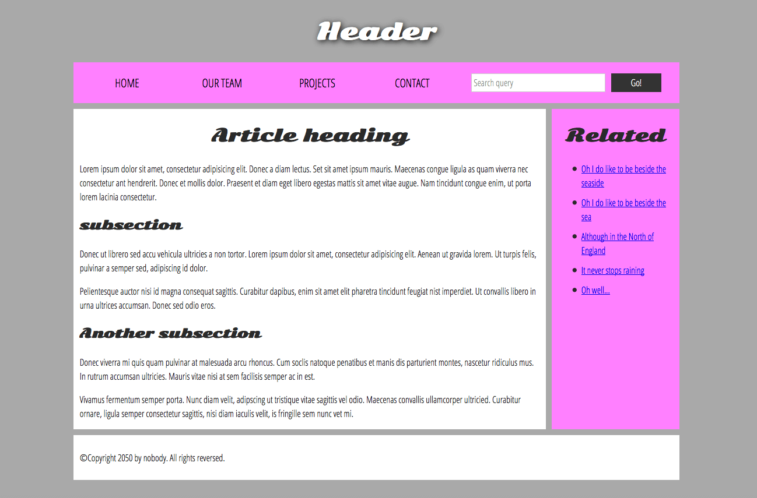
Note: The image above illustrates the main sections of a document, which you can define with HTML. However, the appearance of the page shown here - including the layout, colors, and fonts - is achieved by applying CSS to the HTML.
In this module we're not teaching CSS, but once you have an understanding of the basics of HTML, try diving into our CSS first steps module to start learning how to style your site.

HTML for structuring content
The simple example shown above isn't pretty, but it is perfectly fine for illustrating a typical website layout example. Some websites have more columns, some are a lot more complex, but you get the idea. With the right CSS, you could use pretty much any elements to wrap around the different sections and get it looking how you wanted, but as discussed before, we need to respect semantics and use the right element for the right job.
This is because visuals don't tell the whole story. We use color and font size to draw sighted users' attention to the most useful parts of the content, like the navigation menu and related links, but what about visually impaired people for example, who might not find concepts like "pink" and "large font" very useful?
Note: Roughly 8% of men and 0.5% of women are colorblind; or, to put it another way, approximately 1 in every 12 men and 1 in every 200 women. Blind and visually impaired people represent roughly 4-5% of the world population (in 2015 there were 940 million people with some degree of vision loss, while the total population was around 7.5 billion).
In your HTML code, you can mark up sections of content based on their functionality — you can use elements that represent the sections of content described above unambiguously, and assistive technologies like screen readers can recognize those elements and help with tasks like "find the main navigation", or "find the main content." As we mentioned earlier in the course, there are a number of consequences of not using the right element structure and semantics for the right job.
To implement such semantic mark up, HTML provides dedicated tags that you can use to represent such sections, for example:
- header: <header>.
- navigation bar: <nav>.
- main content: <main>, with various content subsections represented by <article>, <section>, and <div> elements.
- sidebar: <aside>; often placed inside <main>.
- footer: <footer>.

Active learning: exploring the code for our example
Our example seen above is represented by the following code (you can also find the example in our GitHub repository). We'd like you to look at the example above, and then look over the listing below to see what parts make up what section of the visual.
HTML
Copy to Clipboard
<!doctype html>
<html lang="en-US">
<head>
<meta charset="utf-8" />
<meta name="viewport" content="width=device-width" />

<title>My page title</title>
<link
href="https://fonts.googleapis.com/css?family=Open+Sans+Condensed:300|Sonsie+One"
rel="stylesheet" />
<link rel="stylesheet" href="style.css" />
</head>

<body>
<!-- Here is our main header that is used across all the pages of our website -->

<header>
<h1>Header</h1>
</header>

<nav>
<ul>
<li><a href="#">Home</a></li>
<li><a href="#">Our team</a></li>
<li><a href="#">Projects</a></li>
<li><a href="#">Contact</a></li>
</ul>

<!-- A Search form is another common non-linear way to navigate through a website. -->

<form>
<input type="search" name="q" placeholder="Search query" />
<input type="submit" value="Go!" />
</form>
</nav>

<!-- Here is our page's main content -->
<main>
<!-- It contains an article -->
<article>
<h2>Article heading</h2>

<p>
Lorem ipsum dolor sit amet, consectetur adipisicing elit. Donec a diam
lectus. Set sit amet ipsum mauris. Maecenas congue ligula as quam
viverra nec consectetur ant hendrerit. Donec et mollis dolor. Praesent
et diam eget libero egestas mattis sit amet vitae augue. Nam tincidunt
congue enim, ut porta lorem lacinia consectetur.
</p>

<h3>Subsection</h3>

<p>
Donec ut librero sed accu vehicula ultricies a non tortor. Lorem ipsum
dolor sit amet, consectetur adipisicing elit. Aenean ut gravida lorem.
Ut turpis felis, pulvinar a semper sed, adipiscing id dolor.
</p>

<p>
Pelientesque auctor nisi id magna consequat sagittis. Curabitur
dapibus, enim sit amet elit pharetra tincidunt feugiat nist imperdiet.
Ut convallis libero in urna ultrices accumsan. Donec sed odio eros.
</p>

<h3>Another subsection</h3>

<p>
Donec viverra mi quis quam pulvinar at malesuada arcu rhoncus. Cum
soclis natoque penatibus et manis dis parturient montes, nascetur
ridiculus mus. In rutrum accumsan ultricies. Mauris vitae nisi at sem
facilisis semper ac in est.
</p>

<p>
Vivamus fermentum semper porta. Nunc diam velit, adipscing ut
tristique vitae sagittis vel odio. Maecenas convallis ullamcorper
ultricied. Curabitur ornare, ligula semper consectetur sagittis, nisi
diam iaculis velit, is fringille sem nunc vet mi.
</p>
</article>

<!-- the aside content can also be nested within the main content -->
<aside>
<h2>Related</h2>

<ul>
<li><a href="#">Oh I do like to be beside the seaside</a></li>
<li><a href="#">Oh I do like to be beside the sea</a></li>
<li><a href="#">Although in the North of England</a></li>
<li><a href="#">It never stops raining</a></li>
<li><a href="#">Oh well…</a></li>
</ul>
</aside>
</main>

<!-- And here is our main footer that is used across all the pages of our website -->

<footer>
<p>©Copyright 2050 by nobody. All rights reversed.</p>
</footer>
</body>
</html>
Take some time to look over the code and understand it — the comments inside the code should also help you to understand it. We aren't asking you to do much else in this article, because the key to understanding document layout is writing a sound HTML structure, and then laying it out with CSS. We'll wait for this until you start to study CSS layout as part of the CSS topic.

HTML layout elements in more detail
It's good to understand the overall meaning of all the HTML sectioning elements in detail — this is something you'll work on gradually as you start to get more experience with web development. You can find a lot of detail by reading our HTML element reference. For now, these are the main definitions that you should try to understand:
- <main> is for content unique to this page. Use <main> only once per page, and put it directly inside <body>. Ideally this shouldn't be nested within other elements.
- <article> encloses a block of related content that makes sense on its own without the rest of the page (e.g., a single blog post).
- <section> is similar to <article>, but it is more for grouping together a single part of the page that constitutes one single piece of functionality (e.g., a mini map, or a set of article headlines and summaries), or a theme. It's considered best practice to begin each section with a heading; also note that you can break <article>s up into different <section>s, or <section>s up into different <article>s, depending on the context.
- <aside> contains content that is not directly related to the main content but can provide additional information indirectly related to it (glossary entries, author biography, related links, etc.).
- <header> represents a group of introductory content. If it is a child of <body> it defines the global header of a webpage, but if it's a child of an <article> or <section> it defines a specific header for that section (try not to confuse this with titles and headings).
- <nav> contains the main navigation functionality for the page. Secondary links, etc., would not go in the navigation.
- <footer> represents a group of end content for a page.
Each of the aforementioned elements can be clicked on to read the corresponding article in the "HTML element reference" section, providing more detail about each one.

Non-semantic wrappers
Sometimes you'll come across a situation where you can't find an ideal semantic element to group some items together or wrap some content. Sometimes you might want to just group a set of elements together to affect them all as a single entity with some CSS or JavaScript. For cases like these, HTML provides the <div> and <span> elements. You should use these preferably with a suitable class attribute, to provide some kind of label for them so they can be easily targeted.
<span> is an inline non-semantic element, which you should only use if you can't think of a better semantic text element to wrap your content, or don't want to add any specific meaning. For example:
HTML
Copy to Clipboard
<p>
The King walked drunkenly back to his room at 01:00, the beer doing nothing to
aid him as he staggered through the door.
<span class="editor-note">
[Editor's note: At this point in the play, the lights should be down low].
</span>
</p>
In this case, the editor's note is supposed to merely provide extra direction for the director of the play; it is not supposed to have extra semantic meaning. For sighted users, CSS would perhaps be used to distance the note slightly from the main text.
<div> is a block level non-semantic element, which you should only use if you can't think of a better semantic block element to use, or don't want to add any specific meaning. For example, imagine a shopping cart widget that you could choose to pull up at any point during your time on an e-commerce site:
HTML
Copy to Clipboard
<div class="shopping-cart">
<h2>Shopping cart</h2>
<ul>
<li>
<p>
<a href=""><strong>Silver earrings</strong></a>: $99.95.
</p>
<img src="../products/3333-0985/thumb.png" alt="Silver earrings" />
</li>
<li>…</li>
</ul>
<p>Total cost: $237.89</p>
</div>
This isn't really an <aside>, as it doesn't necessarily relate to the main content of the page (you want it viewable from anywhere). It doesn't even particularly warrant using a <section>, as it isn't part of the main content of the page. So a <div> is fine in this case. We've included a heading as a signpost to aid screen reader users in finding it.
Warning: Divs are so convenient to use that it's easy to use them too much. As they carry no semantic value, they just clutter your HTML code. Take care to use them only when there is no better semantic solution and try to reduce their usage to the minimum otherwise you'll have a hard time updating and maintaining your documents.

Line breaks and horizontal rules
Two elements that you'll use occasionally and will want to know about are <br> and <hr>.

<br>: the line break element
<br> creates a line break in a paragraph; it is the only way to force a rigid structure in a situation where you want a series of fixed short lines, such as in a postal address or a poem. For example:
HTMLPlay
Copy to Clipboard
<p>
There once was a man named O'Dell<br />
Who loved to write HTML<br />
But his structure was bad, his semantics were sad<br />
and his markup didn't read very well.
</p>
Without the <br> elements, the paragraph would just be rendered in one long line (as we said earlier in the course, HTML ignores most whitespace); with <br> elements in the code, the markup renders like this:

Play

<hr>: the thematic break element
<hr> elements create a horizontal rule in the document that denotes a thematic change in the text (such as a change in topic or scene). Visually it just looks like a horizontal line. As an example:
HTMLPlay
Copy to Clipboard
<p>
Ron was backed into a corner by the marauding netherbeasts. Scared, but
determined to protect his friends, he raised his wand and prepared to do
battle, hoping that his distress call had made it through.
</p>
<hr />
<p>
Meanwhile, Harry was sitting at home, staring at his royalty statement and
pondering when the next spin off series would come out, when an enchanted
distress letter flew through his window and landed in his lap. He read it
hazily and sighed; "better get back to work then", he mused.
</p>
Would render like this:

Play

Planning a simple website
Once you've planned out the structure of a simple webpage, the next logical step is to try to work out what content you want to put on a whole website, what pages you need, and how they should be arranged and link to one another for the best possible user experience. This is called Information architecture. In a large, complex website, a lot of planning can go into this process, but for a simple website of a few pages, this can be fairly simple, and fun!
- Bear in mind that you'll have a few elements common to most (if not all) pages — such as the navigation menu, and the footer content. If your site is for a business, for example, it's a good idea to have your contact information available in the footer on each page. Note down what you want to have common to every page.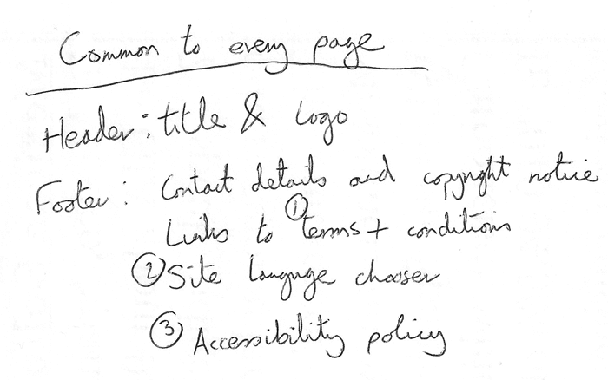
- Next, draw a rough sketch of what you might want the structure of each page to look like (it might look like our simple website above). Note what each block is going to be.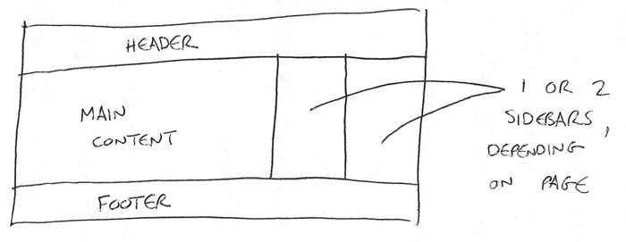
- Now, brainstorm all the other (not common to every page) content you want to have on your website — write a big list down.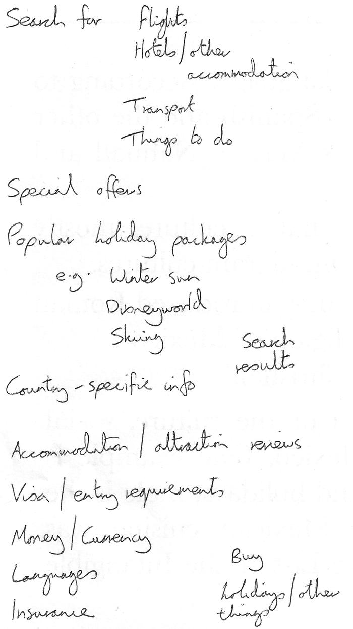
- Next, try to sort all these content items into groups, to give you an idea of what parts might live together on different pages. This is very similar to a technique called Card sorting.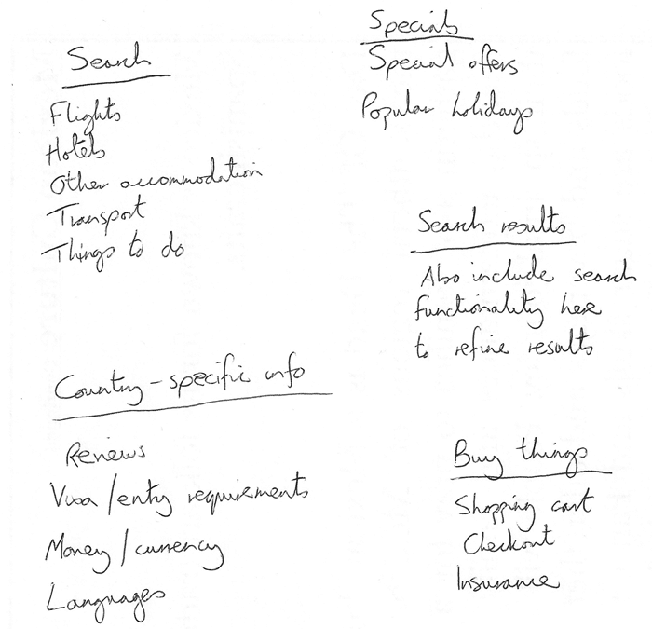
- Now try to sketch a rough sitemap — have a bubble for each page on your site, and draw lines to show the typical workflow between pages. The homepage will probably be in the center, and link to most if not all of the others; most of the pages in a small site should be available from the main navigation, although there are exceptions. You might also want to include notes about how things might be presented.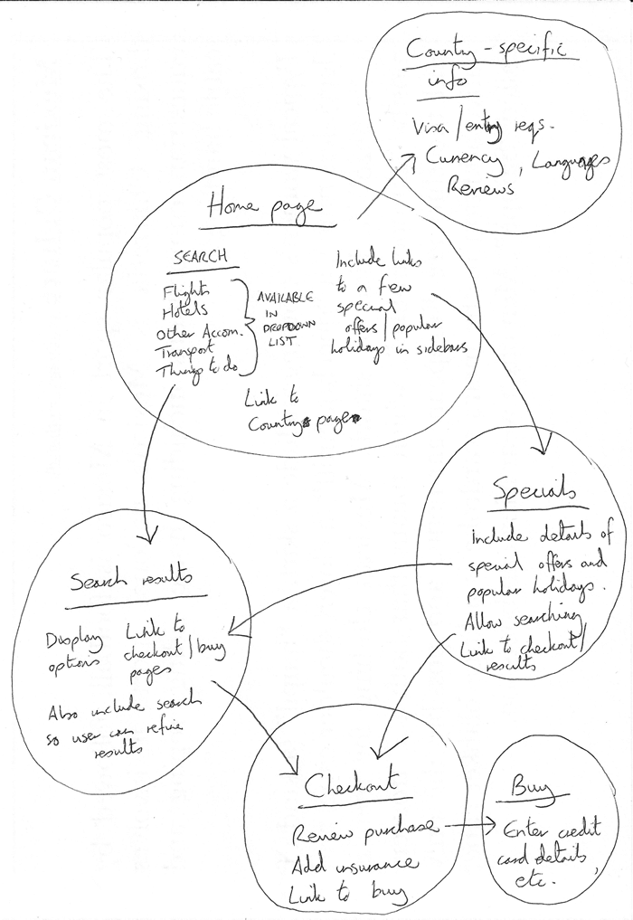

Active learning: create your own sitemap
Try carrying out the above exercise for a website of your own creation. What would you like to make a site about?
Note: Save your work somewhere; you might need it later on.

Summary
At this point, you should have a better idea about how to structure a web page/site. In the next article of this module, we'll learn how to debug HTML.

TO VALIDATE AND DEBUG YOUR HTML USE :
https://validator.w3.org/

Video and audio content

Now that we are comfortable with adding simple images to a webpage, the next step is to start adding video and audio players to your HTML documents! In this article we'll look at doing just that with the <video> and <audio> elements; we'll then finish off by looking at how to add captions/subtitles to your videos.

Prerequisites: | Basic software installed, basic knowledge of working with files, familiarity with HTML fundamentals (as covered in Getting started with HTML) and Images in HTML.
Objective: | To learn how to embed video and audio content into a webpage, and add captions/subtitles to video.

Video and audio on the web
The first influx of online videos and audio were made possible by proprietary plugin-based technologies like Flash and Silverlight. Both of these had security and accessibility issues, and are now obsolete, in favor of native HTML solutions <video> and <audio> elements and the availability of JavaScript APIs for controlling them. We'll not be looking at JavaScript here — just the basic foundations that can be achieved with HTML.
We won't be teaching you how to produce audio and video files — that requires a completely different skill set. We have provided you with sample audio and video files and example code for your own experimentation, in case you are unable to get hold of your own.
Note: Before you begin here, you should also know that there are quite a few OVPs (online video providers) like YouTube, Dailymotion, and Vimeo, and online audio providers like Soundcloud. Such companies offer a convenient, easy way to host and consume videos, so you don't have to worry about the enormous bandwidth consumption. OVPs even usually offer ready-made code for embedding video/audio in your webpages; if you use that route, you can avoid some of the difficulties we discuss in this article. We'll be discussing this kind of service a bit more in the next article.

The <video> element
The <video> element allows you to embed a video very easily. A really simple example looks like this:
HTML
Copy to Clipboard
<video src="rabbit320.webm" controls>
<p>
Your browser doesn't support HTML video. Here is a
<a href="rabbit320.webm">link to the video</a> instead.
</p>
</video>
The features of note are:
src
In the same way as for the <img> element, the src (source) attribute contains a path to the video you want to embed. It works in exactly the same way.
controls
Users must be able to control video and audio playback (it's especially critical for people who have epilepsy.) You must either use the controls attribute to include the browser's own control interface, or build your interface using the appropriate JavaScript API. At a minimum, the interface must include a way to start and stop the media, and to adjust the volume.
The paragraph inside the <video> tags
This is called fallback content — this will be displayed if the browser accessing the page doesn't support the <video> element, allowing us to provide a fallback for older browsers. This can be anything you like; in this case, we've provided a direct link to the video file, so the user can at least access it some way regardless of what browser they are using.
The embedded video will look something like this:
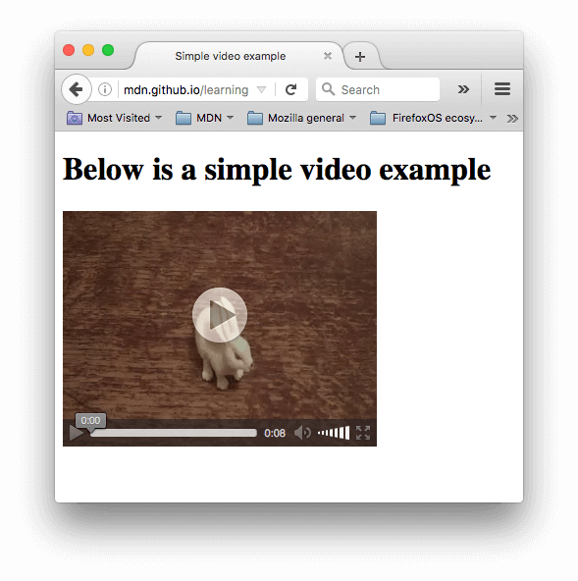
You can try the example live here (see also the source code.)

Using multiple source formats to improve compatibility
There's a problem with the above example. It is possible that the video might not play for you, because different browsers support different video (and audio) formats. Fortunately, there are things you can do to help prevent this from being an issue.

Contents of a media file
First, let's go through the terminology quickly. Formats like MP3, MP4 and WebM are called container formats. They define a structure in which the audio and/or video tracks that make up the media are stored, along with metadata describing the media, what codecs are used to encode its channels, and so forth.

A WebM file containing a movie which has a main video track and one alternate angle track, plus audio for both English and Spanish, in addition to audio for an English commentary track can be conceptualized as shown in the diagram below. Also included are text tracks containing closed captions for the feature film, Spanish subtitles for the film, and English captions for the commentary.
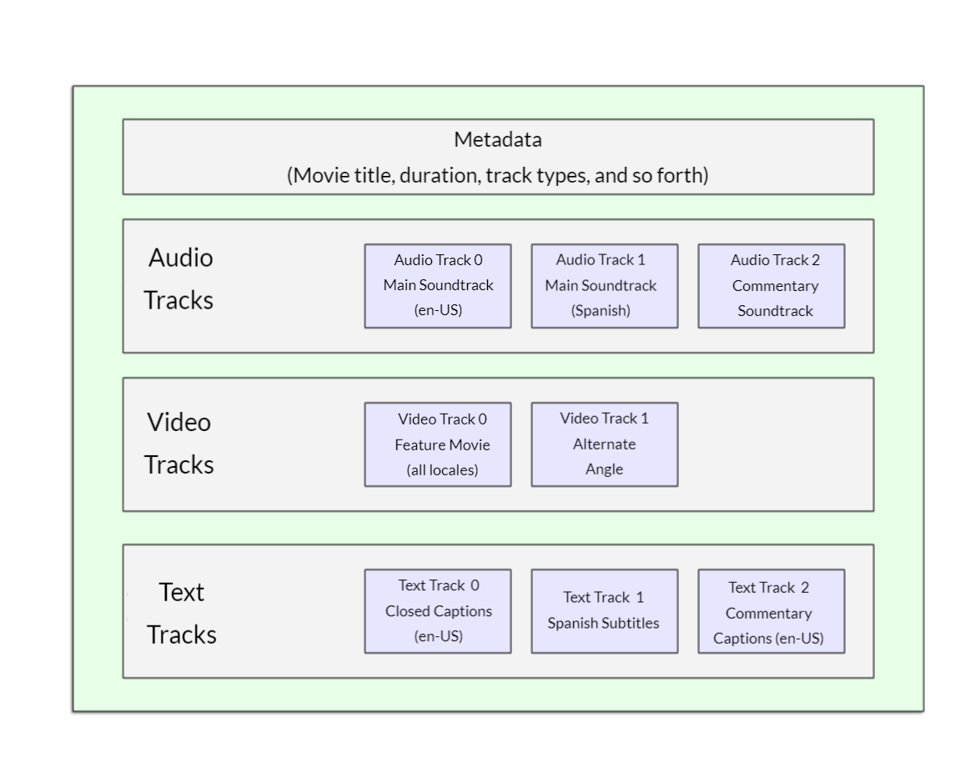
The audio and video tracks within the container hold data in the appropriate format for the codec used to encode that media. Different formats are used for audio tracks versus video tracks. Each audio track is encoded using an audio codec, while video tracks are encoded using (as you probably have guessed) a video codec. As we talked about before, different browsers support different video and audio formats, and different container formats (like MP3, MP4, and WebM, which in turn can contain different types of video and audio).
For example:
- A WebM container typically packages Vorbis or Opus audio with VP8/VP9 video. This is supported in all modern browsers, though older versions may not work.
- An MP4 container often packages AAC or MP3 audio with H.264 video. This is also supported in all modern browsers.
- The Ogg container tends to use Vorbis audio and Theora video. This is best supported in Firefox and Chrome, but has basically been superseded by the better quality WebM format.
There are some special cases. For example, for some types of audio, a codec's data is often stored without a container, or with a simplified container. One such instance is the FLAC codec, which is stored most commonly in FLAC files, which are just raw FLAC tracks.
Another such situation is the always-popular MP3 file. An "MP3 file" is actually an MPEG-1 Audio Layer III (MP3) audio track stored within an MPEG or MPEG-2 container. This is especially interesting since while most browsers don't support using MPEG media in the <video> and <audio> elements, they may still support MP3 due to its popularity.
An audio player will tend to play an audio track directly, e.g. an MP3 or Ogg file. These don't need containers.

Media file support in browsers
Note: Several popular formats, such as MP3 and MP4/H.264, are excellent but are encumbered by patents; that is, there are patents covering some or all of the technology that they're based upon. In the United States, patents covered MP3 until 2017, and H.264 is encumbered by patents through at least 2027.
Because of those patents, browsers that wish to implement support for those codecs must pay typically enormous license fees. In addition, some people prefer to avoid restricted software and prefer to use only open formats. Due to these legal and preferential reasons, web developers find themselves having to support multiple formats to capture their entire audience.
The codecs described in the previous section exist to compress video and audio into manageable files, since raw audio and video are both exceedingly large. Each web browser supports an assortment of codecs, like Vorbis or H.264, which are used to convert the compressed audio and video into binary data and back. Each codec offers its own advantages and drawbacks, and each container may also offer its own positive and negative features affecting your decisions about which to use.
Things become slightly more complicated because not only does each browser support a different set of container file formats, they also each support a different selection of codecs. In order to maximize the likelihood that your website or app will work on a user's browser, you may need to provide each media file you use in multiple formats. If your site and the user's browser don't share a media format in common, your media won't play.
Due to the intricacies of ensuring your app's media is viewable across every combination of browsers, platforms, and devices you wish to reach, choosing the best combination of codecs and container can be a complicated task. See Choosing the right container for help selecting the container file format best suited for your needs; similarly, see Choosing a video codec and Choosing an audio codec for help selecting the first media codecs to use for your content and your target audience.
One additional thing to keep in mind: mobile browsers may support additional formats not supported by their desktop equivalents, just like they may not support all the same formats the desktop version does. On top of that, both desktop and mobile browsers may be designed to offload handling of media playback (either for all media or only for specific types it can't handle internally). This means media support is partly dependent on what software the user has installed.
So how do we do this? Take a look at the following updated example (try it live here, also):
HTML
Copy to Clipboard
<video controls>
<source src="rabbit320.mp4" type="video/mp4" />
<source src="rabbit320.webm" type="video/webm" />
<p>
Your browser doesn't support this video. Here is a
<a href="rabbit320.mp4">link to the video</a> instead.
</p>
</video>
Here we've taken the src attribute out of the actual <video> tag, and instead included separate <source> elements that point to their own sources. In this case the browser will go through the <source> elements and play the first one that it has the codec to support. Including WebM and MP4 sources should be enough to play your video on most platforms and browsers these days.
Each <source> element also has a type attribute. This is optional, but it is advised that you include it. The type attribute contains the MIME type of the file specified by the <source>, and browsers can use the type to immediately skip videos they don't understand. If type isn't included, browsers will load and try to play each file until they find one that works, which obviously takes time and is an unnecessary use of resources.
Refer to our guide to media types and formats for help selecting the best containers and codecs for your needs, as well as to look up the right MIME types to specify for each.

Other <video> features
There are a number of other features you can include when displaying an HTML video. Take a look at our next example:
HTML
Copy to Clipboard
<video
controls
width="400"
height="400"
autoplay
loop
muted
preload="auto"
poster="poster.png">
<source src="rabbit320.mp4" type="video/mp4" />
<source src="rabbit320.webm" type="video/webm" />
<p>
Your browser doesn't support this video. Here is a
<a href="rabbit320.mp4">link to the video</a> instead.
</p>
</video>
The resulting UI looks something like this:
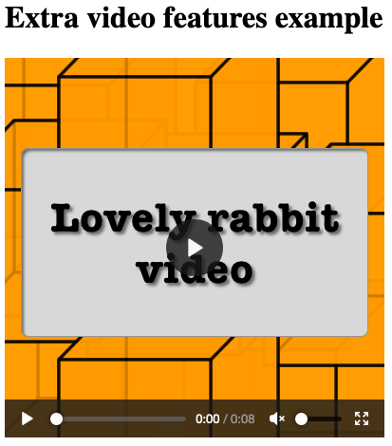
Features include:
width and height
You can control the video size either with these attributes or with CSS. In both cases, videos maintain their native width-height ratio — known as the aspect ratio. If the aspect ratio is not maintained by the sizes you set, the video will grow to fill the space horizontally, and the unfilled space will just be given a solid background color by default.
autoplay
Makes the audio or video start playing right away, while the rest of the page is loading. You are advised not to use autoplaying video (or audio) on your sites, because users can find it really annoying.
loop
Makes the video (or audio) start playing again whenever it finishes. This can also be annoying, so only use if really necessary.
muted
Causes the media to play with the sound turned off by default.
poster
The URL of an image which will be displayed before the video is played. It is intended to be used for a splash screen or advertising screen.
preload
Used for buffering large files; it can take one of three values:
- "none" does not buffer the file
- "auto" buffers the media file
- "metadata" buffers only the metadata for the file
You can find the above example available to play live on GitHub (also see the source code.) Note that we haven't included the autoplay attribute in the live version — if the video starts to play as soon as the page loads, you don't get to see the poster!

The <audio> element
The <audio> element works just like the <video> element, with a few small differences as outlined below. A typical example might look like so:
HTML
Copy to Clipboard
<audio controls>
<source src="viper.mp3" type="audio/mp3" />
<source src="viper.ogg" type="audio/ogg" />
<p>
Your browser doesn't support this audio file. Here is a
<a href="viper.mp3">link to the audio</a> instead.
</p>
</audio>
This produces something like the following in a browser:
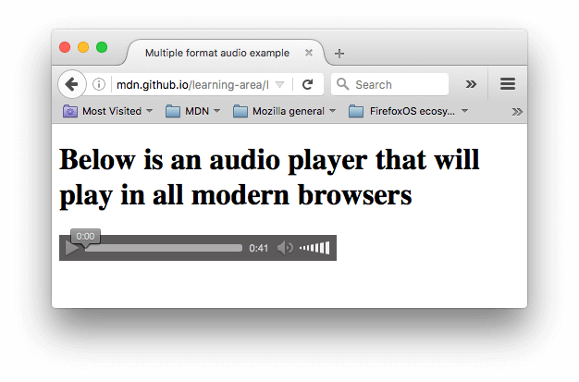
Note: You can run the audio demo live on GitHub (also see the audio player source code.)
This takes up less space than a video player, as there is no visual component — you just need to display controls to play the audio. Other differences from HTML video are as follows:
- The <audio> element doesn't support the width/height attributes — again, there is no visual component, so there is nothing to assign a width or height to.
- It also doesn't support the poster attribute — again, no visual component.
Other than this, <audio> supports all the same features as <video> — review the above sections for more information about them.

Displaying video text tracks
Now we'll discuss a slightly more advanced concept that is really useful to know about. Many people can't or don't want to hear the audio/video content they find on the Web, at least at certain times. For example:
- Many people have auditory impairments (such as being hard of hearing or deaf) so can't hear the audio clearly if at all.
- Others may not be able to hear the audio because they are in noisy environments (like a crowded bar when a sports game is being shown).
- Similarly, in environments where having the audio playing would be a distraction or disruption (such as in a library or when a partner is trying to sleep), having captions can be very useful.
- People who don't speak the language of the video might want a text transcript or even translation to help them understand the media content.
Wouldn't it be nice to be able to provide these people with a transcript of the words being spoken in the audio/video? Well, thanks to HTML video, you can. To do so we use the WebVTT file format and the <track> element.
Note: "Transcribe" means "to write down spoken words as text." The resulting text is a "transcript."
WebVTT is a format for writing text files containing multiple strings of text along with metadata such as the time in the video at which each text string should be displayed, and even limited styling/positioning information. These text strings are called cues, and there are several kinds of cues which are used for different purposes. The most common cues are:
subtitles
Translations of foreign material, for people who don't understand the words spoken in the audio.
captions
Synchronized transcriptions of dialog or descriptions of significant sounds, to let people who can't hear the audio understand what is going on.
timed descriptions
Text which should be spoken by the media player in order to describe important visuals to blind or otherwise visually impaired users.
A typical WebVTT file will look something like this:
WEBVTT

1
00:00:22.230 --> 00:00:24.606
This is the first subtitle.

2
00:00:30.739 --> 00:00:34.074
This is the second.

…
To get this displayed along with the HTML media playback, you need to:
- Save it as a .vtt file in a sensible place.
- Link to the .vtt file with the <track> element. <track> should be placed within <audio> or <video>, but after all <source> elements. Use the kind attribute to specify whether the cues are subtitles, captions, or descriptions. Further, use srclang to tell the browser what language you have written the subtitles in. Finally, add label to help readers identify the language they are searching for.
Here's an example:
HTML
Copy to Clipboard
<video controls>
<source src="example.mp4" type="video/mp4" />
<source src="example.webm" type="video/webm" />
<track kind="subtitles" src="subtitles_es.vtt" srclang="es" label="Spanish" />
</video>
This will result in a video that has subtitles displayed, kind of like this:
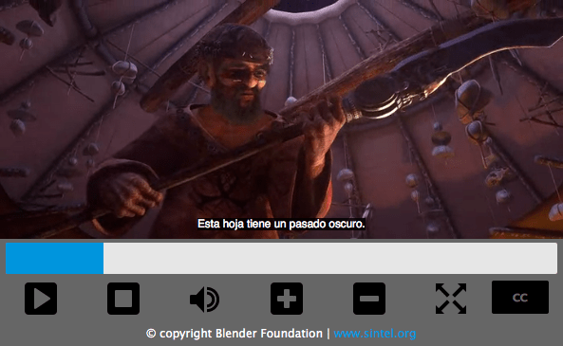
For more details, including on how to add labels please read Adding captions and subtitles to HTML video. You can find the example that goes along with this article on GitHub, written by Ian Devlin (see the source code too.) This example uses some JavaScript to allow users to choose between different subtitles. Note that to turn the subtitles on, you need to press the "CC" button and select an option — English, Deutsch, or Español.
Note: Text tracks also help you with SEO, since search engines especially thrive on text. Text tracks even allow search engines to link directly to a spot partway through the video.

Active learning: Embedding your own audio and video
For this active learning, we'd (ideally) like you to go out into the world and record some of your own video and audio — most phones these days allow you to record audio and video very easily and, provided you can transfer it on to your computer, you can use it. You may have to do some conversion to end up with a WebM and MP4 in the case of video, and an MP3 and Ogg in the case of audio, but there are enough programs out there to allow you to do this without too much trouble, such as Miro Video Converter and Audacity. We'd like you to have a go!
If you are unable to source any video or audio, then you can feel free to use our sample audio and video files to carry out this exercise. You can also use our sample code for reference.
We would like you to:
- Save your audio and video files in a new directory on your computer.
- Create a new HTML file in the same directory, called index.html.
- Add <audio> and <video> elements to the page; make them display the default browser controls.
- Give both of them <source> elements so that browsers will find the audio format they support best and load it. These should include type attributes.
- Give the <video> element a poster that will be displayed before the video starts to be played. Have fun creating your own poster graphic.
For an added bonus, you could try researching text tracks, and work out how to add some captions to your video.

Test your skills!
You've reached the end of this article, but can you remember the most important information? You can find some further tests to verify that you've retained this information before you move on — see Test your skills: Multimedia and embedding. Note that the third assessment question in this test assumes knowledge of some of the techniques covered in the next article, so you may want to read that before attempting it.

Summary
And that's a wrap — we hope you had fun playing with video and audio in web pages! In the next article, we'll look at other ways of embedding content on the Web, using technologies like <iframe> and <object>.

See also
- The HTML media elements: <audio>, <video>, <source>, and <track>
- Adding captions and subtitles to video
- Audio and Video delivery: A LOT of detail about putting audio and video onto web pages using HTML and JavaScript.
- Audio and Video manipulation: A LOT of detail about manipulating audio and video using JavaScript (for example adding filters.)
- Web media technologies
- Guide to media types and formats on the web
- Event reference > Media

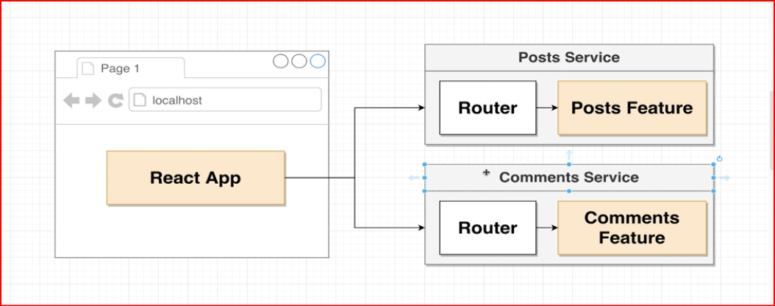

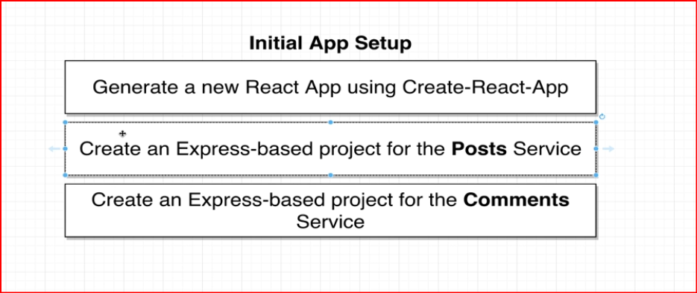
Complete initial Setup
Step 1 : create react app using
npx create-react-app client
step 2 : Setup Nodejs Posts Service
a. mkdir posts
b. cd posts
c. npm init -y
d. npm install express cors axios nodemon

step 3 : Setup Nodejs Comments Service
a. mkdir Comments
b. cd Comments
c. npm init -y
d. npm install express cors axios nodemon

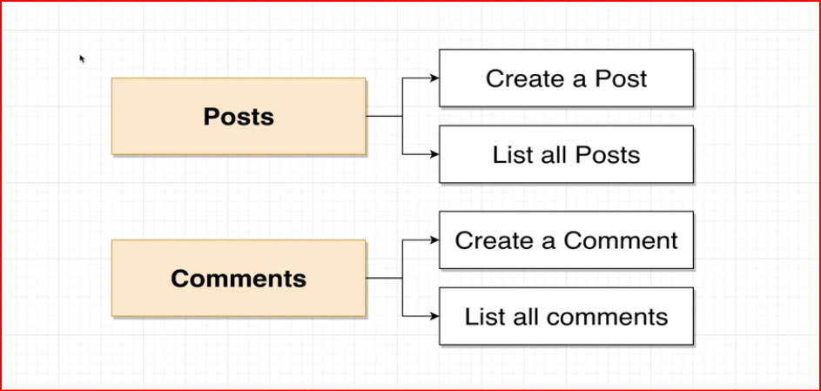
as per above
for post service we need two URL one to save post and one to retrieve post

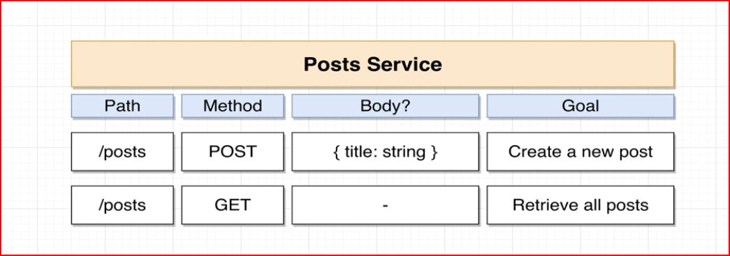
Let’s Create the following Path In our Posts Service

Go to Posts Service
create One File (Index.js) and initial Express code
GoTo package.json file
script : nodemon index.js

Let Us Implement Comments Service

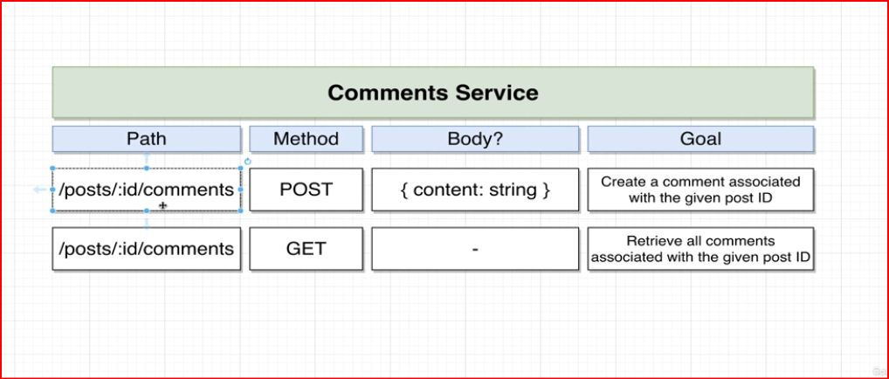

so here we will try to add comments based on postId i.e one post may contain multiple comments

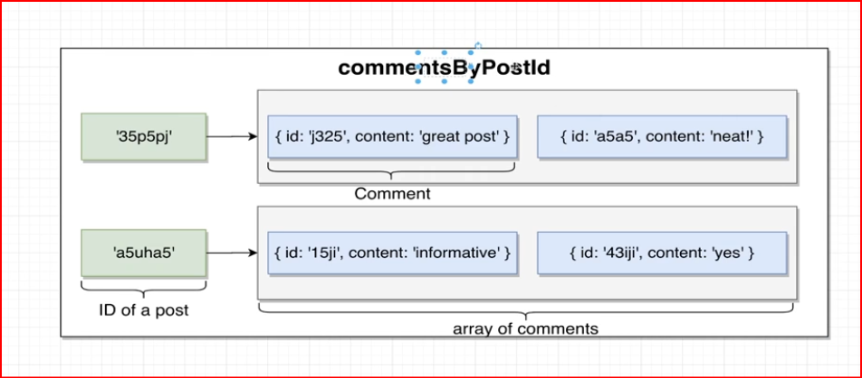

Create React app

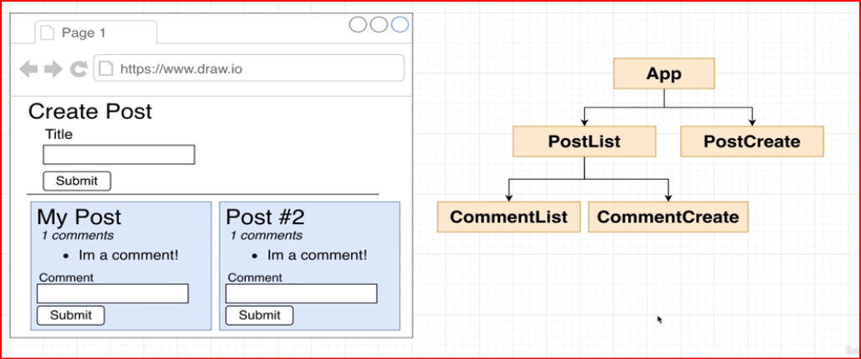

at the end of the Mini Project of branch ProjDay1
we end up making multiple calls

