

BRITISH COLUMBIA INSTITUTE OF TECHNOLOGY | COMP-1536 & ACIT-1620
School of Computing and Academic Studies | Assignment #2
Program: CST & CIT | Due: Friday Oct 21, 2011 by 3:00 PM

Your second assignment is to create a website for Marina’s coffee shop. This assignment will be done in pairs of two individuals. Partners will be selected randomly by your lab instructor.

Requirements
Marina Santos is the owner of the Marina Café in Kelowna BC, a gourmet coffee shop that serves snacks, coffee, tea, and soft drinks. Local music performances are held every Thursday night. The customers of Marina Café are mainly college students and young professionals. Marina would like a web presence for her café that will display her services and provide a calendar for the performances. She wants the following pages:
- A home page
- Menu page
- Performance schedule page
- And a job opportunities page

A site map for the Marina Café web site is shown below:

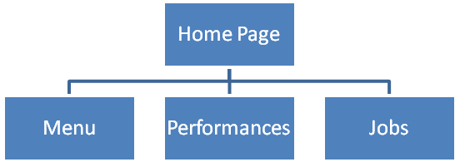
Figure 1

The site map describes the architecture of the web site, a Home page, with three main sub pages: Menu, Performances, and Jobs.

Below is a sample layout for the Home page. It contains a site logo, a navigation area, a content area, and a footer area for copyright information:
Site Logo

Navigation
Footer

Content

Figure 2

Bob Smith, the web designer, sat with Marina Santos. After that meeting Bob came up with the following prototype:

The Home page:
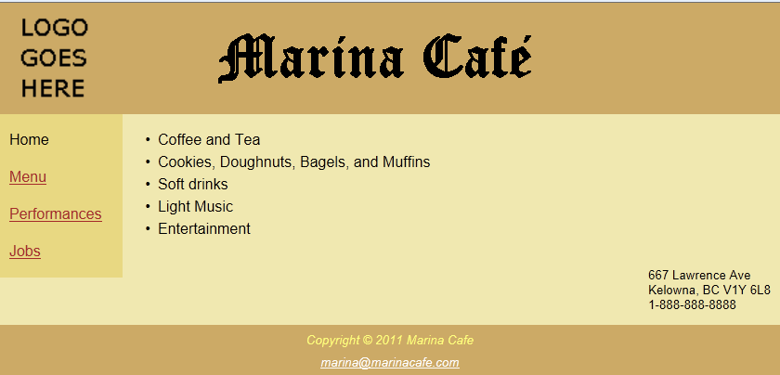
Figure 3

The Menu page:
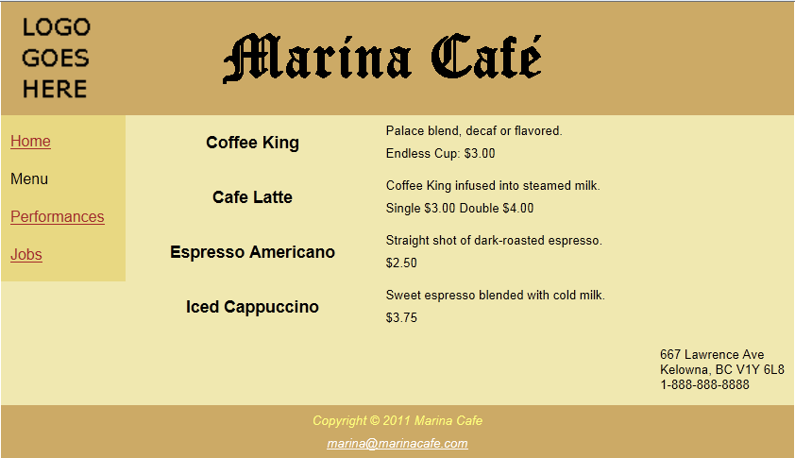
Figure 4

The performances page:
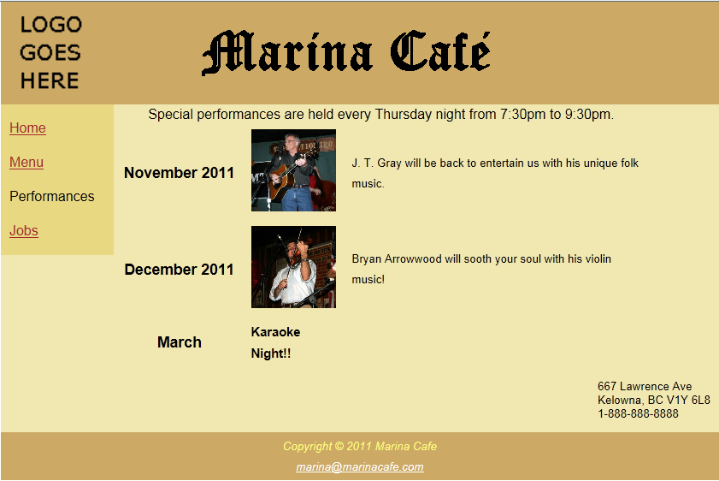
Figure 5
NOTE: Download a zip file named performers.zip which contains pictures of the two performers shown above.

The Jobs page:
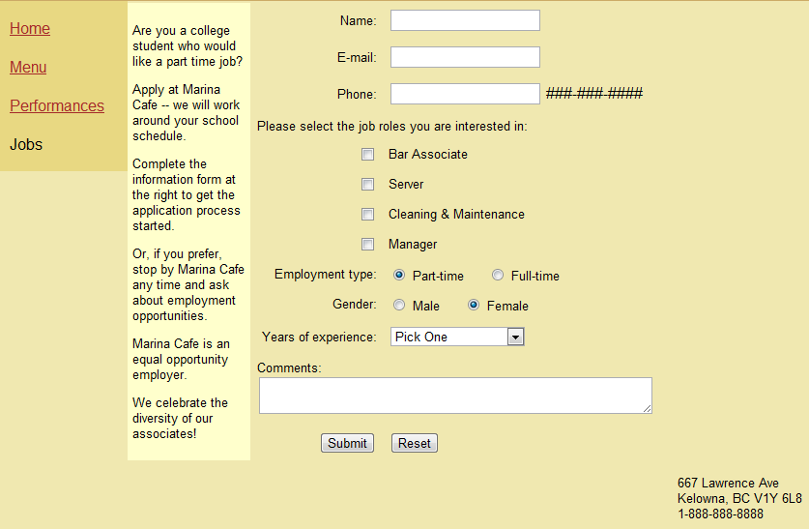
Figure 6
Your team has been asked to create a website for Marina Café with the following specifications:
- You are not allowed to use <table> tags for the main page layout described in figure 2. You must use <div> tags instead. You are, however, allowed to use <table> tags for other purposes not related to high-level page layout.
- Create a transparent logo for Marina Café that matches the hip audience that Mrs. Santos wishes to attract to her eatery. You are free to create any design that you see fit. The name “Marina Café” must be inscribed on this original logo.
- The “Marina Café” text that displays on the header of each page beside the logo must use the “Old English Text MT” font with 48 point size. You can give it any foreground color to match your logo design
- The home page layout must be similar to that shown in figure 2.
- The website primary and secondary fonts must be Arial and Sans-serif respectively
- Use any analogous colors for the site. Analogous colors are colors that are side by side on a 12-part color wheel.
- All pages must use the same font, layout and color scheme
- Marina Santos is concerned that her email may be harvested by spam engines. Therefore, her email address must be coded in such a manner that it is not easily harvested by spam engines.
- Marina Café provide free parking at the rear entrance of the establishment and free WiFi for their customers. You shall add a blurb about this services on the home page.
- You must use relative addressing for all of your internal page links
- The main home page must be named “index.html”.
- All web pages must conform to the XHTML strict standards.
- The Jobs page will contain a form (as shown in figure 6) that will post to a non-existent page named job_applications.php. We will develop this page when we start learning PHP during the second half of this course.
- The “Years of experience” contains the following options: No experience, Less than 1 year, and More than 1 year

Your solution need not look exactly like the Bob’s prototype. You are encouraged to go wild with your imagination and creativity. However, your solution should conform to the following:

- You must hand code the HTML and CSS. You are not allowed to use any IDE such as “Dream Weaver” or “Expression Studio”.
- Follow best HTML coding practices such as:
- do not display the default table borders
- Use cascading style sheets for all formatting. It is also good practice to use an external style sheet for common formatting.
- Include a readme.txt file in the root of your web site. The readme.txt file must include the following information:
  - Your names, student numbers, email addresses, and set
  - What you have completed
  - What you have not completed
- Any major challenges
- Your submission consists of a ZIP file named: “FirstNameLastName(1)_FirstNameLastName(2)_set_assign02.zip”. (example: JaneDoe_JohnDoe_1B_assign02.zip)
- Your ZIP file will include all directories and files comprising your entire website. This includes all images, html, and style files.
- Submit your ZIP file into the BCIT share-in directory.

COMP-1536 & ACIT-1620 Assignment 2 marking guide:
Set ______
Name 1: _______________________________________________________________

Name 2: _______________________________________________________________

Task | Max Mark | Actual Mark
Web site presentation and visual quality  - Page Layout  - Correct font  - Complementary colors  - navigation from one page to another | 6
Marina Café transparent logo | 4
Requirements fulfilled  - four pages  - form posts to job_applications.php  - main page index.html  - blurb about parking & WiFi | 4
Best practices  - external style sheet  - relative addressing  - every page has a title | 2
Conformance to XHTML strict standards | 2
Email not easily harvested by spam engines | 2
TOTAL: | 20

If your submission does not comply with submission rules then you will lose 10% of the mark. Also, if you work on this assignment individually then you will also lose another 10% of the mark.

