Content based item filtering recommendation engine for video recommendation

SUBMITTED IN PARTIAL FULFILLMENT FOR THE REQUIREMENT OF THE AWARD OF DEGREE OF

BACHELOR OF TECHNOLOGY
IN
INFORMATION TECHNOLOGY



Submitted by

GOPAL NARAYANAM
1302913046

Supervised by

PROFESSOR YUGAL KUMAR
SHASHANK RAI
Session 2016-17

DEPARTMENT OF INFORMATION TECHNOLOGY
KIET Group of Institutions, Ghaziabad
CONSENT LETTER

I hereby agree to guide Mr Gopal Narayanam University Roll No. 1302913046 Student of B. Tech Final Year IT for the project work entitled Content based item filtering recommendation engine for video recommendation in partial fulfilment of the B. Tech. degree course in Information Technology.
I will guide him /her for the entire duration of his/her project work and will supervise him/her throughout the completion of project.

Name and Designation of Supervisor

List of Figures

1.1 | Collaborative filtering process | 2
1.2 | Matrix layout for item and user filters | 6

List of Acronyms

CF | Collaborative Filtering
MAE | Mean Absolute Error
RMSE | Root Mean Square Error
LSI | Latent Semantic Indexing

Abstract
Recommender systems use a knowledge base for recommending items videos or products during a live scenario. Recommendation systems, specially CF and k- nearest neighbour based system have gained widespread popularity throughout the web. The tremendous growth in the amount of available information and the number of visitors to Web sites in recent years poses some key challenges for recommender systems. These are: producing high quality recommendations, performing many recommendations per second for millions of users and items and achieving high coverage in the face of data sparsity. In traditional collaborative filtering systems, the amount of work increases with the number of participants in the system. New recommender system technologies are needed that can quickly produce high quality recommendations, even for very large-scale problems. To address these issues item-based collaborative filtering techniques were developed. Item-based techniques first analyse the user-item matrix to identify relationships between different items, and then use these relationships to indirectly compute recommendations for users. Although Item Filtering based techniques have proved their metal in producing recommendations en mass a more advanced recommendation system is widely sought after for producing highly personalized recommendations. In this project, we will analyse item based CF techniques and the improvement that could be achieved by using Association rules and rule based filters in synchronization with item filtering engines. We will have a look into different techniques for computing item-item similarities (item-item correlation vs. cosine similarities between item vectors) and different techniques for obtaining recommendations from them (weighted sum vs. regression model) and various rule based factors that can affect recommendations. Our experiments suggest that item-based algorithms when clubbed together with rule based associative engines provide dramatically better performance than user-based algorithms, while at the same time providing better quality than the best available recommendation algorithms.

CONTENTS

 | Page No.
Consent Letter | i
List of Figures | ii
Acronym | iii
Abstract | iv
Introduction  1.1 Collaborative Filtering  1.1.1 Memory-based Collaborative Filtering Algorithms  1.1.2 Model-based Collaborative Filtering Algorithms  1.1.3 Evaluation Metrics  1.1.4 Challenges of User-based Collaborative Filtering Algorithms  1.2 Item-based Collaborative Filtering Algorithm  1.2.1 Item Similarity Computation | 1  1  3  3  3  4  4  5
Motivation | 5
Literature Review | 6
Objective | 6
Planning of Work | 6
References | 8

1. Introduction
Recommender system is a system performing information filtering to bring information items such as movies, music, books, news, images, web pages, tools to a user. This information is filtered so that it is likely to interest the user. The aim of a recommender system is often to help consumers learn about new products and desirable ones among myriad of choices.
Generally, recommender systems are categorized into content-based versus collaborative-filtering-based systems:
- Content based approach: the characteristics originate from the information item
- Collaborative filtering approach: the characteristics originate from the user environment (social, user preferences, patterns, etc.)
One of the main issues for with both approaches is the cold-start problem. New users have to interact with the system before to have a profile built-up and the system becomes efficient for their needs. Hybrid approach is often considered, by combining features from collaborative and content-filtering methods, to prevent such limitations. In this paper we have tried to build one such hybrid approach that uses content user profiles as well as association rules to combine these two in order to generate a versatile yet highly personalized recommendation for various items however in this paper we will take the example of videos as items that are to be recommended to particular users. The videos are custom user uploaded videos whereas users profiling data is gathered from Facebook profiles of users via secure login. After data collection and user profiling user clusters are created on the basis of k nearest neighbour approach in order to group users into specific clusters and these clusters are further associated to video clusters developed by using item based filtering techniques.
1.1 Collaborative Filtering
Recommender systems apply data analysis techniques to the problem of helping users find the items they would like to purchase at E-Commerce sites by producing a predicted likeliness score or a list of top-N recommended items for a given user. Item recommendations can be made using different methods. Recommendations can be based on demographics of the users, overall top selling items, or past buying habit of users as a predictor of future items. Collaborative Filtering is the most successful recommendation technique to date. The basic idea of CF-based algorithms is to provide item recommendations or predictions based on the opinions of other like-minded users. The opinions of users can be obtained explicitly from the users or by using some implicit measures.
The goal of a collaborative filtering algorithm is to suggest new items or to predict the utility of a certain item for a particular user based on the user's previous likings and the opinions of other like-minded users.
In a typical CF scenario, there is a list of m users
and a list of n items
.
Each user ui has a list of items Iui, which the user has expressed his/her opinions about. Opinions can be explicitly given by the user as a rating score, generally within a certain numerical scale, or can be implicitly derived from purchase records, by analysing timing logs, by mining web hyperlinks and so on. Note that and it is possible for Iui to be a null-set. There exists a distinguished user called the active user for whom the task of a collaborative filtering algorithm is to find an item likeliness that can be of two forms.
Prediction is a numerical value, Pa,j, expressing the predicted likeliness of item for the active user ua. This predicted value is within the same scale (e.g., from 1 to 5) as the opinion values provided by ua.
Recommendation is a list of N items, , that the active user will like the most. Note that the recommended list must be on items not already purchased by the active user, i.e., . This interface of CF algorithms is also known as Top-N recommendation.

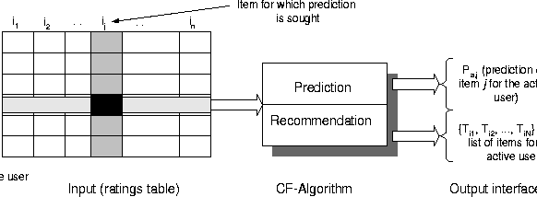
Fig 1.1 Collaborative filtering process
Each entry ai,j represent the preference score (ratings) of the ith user on the jth item. Each individual ratings is within a numerical scale and it can as well be 0 indicating that the user has not yet rated that item. Researchers have devised a number of collaborative filtering algorithms that can be divided into two main Categories-Memory-based (user-based) and Model-based (item-based) algorithms. In this section, we provide a detailed analysis of CF-based recommender system algorithms.
1.1.1 Memory-based Collaborative Filtering Algorithms
Memory-based algorithms utilize the entire user-item database to generate a prediction. These systems employ statistical techniques to find a set of users, known as neighbours, that have a history of agreeing with the target user (i.e., they either rate different items similarly or they tend to buy similar sets of items). Once a neighbourhood of users is formed, these systems use different algorithms to combine the preferences of neighbours to produce a prediction or top-N recommendation for the active user. The techniques, also known as nearest-neighbour or user-based collaborative filtering are more popular and widely used in practice.
1.1.2 Model-based Collaborative Filtering Algorithms
Model-based collaborative filtering algorithms provide item recommendation by first developing a model of user ratings. Algorithms in this category take a probabilistic approach and envision the collaborative filtering process as computing the expected value of a user prediction, given his/her ratings on other items. The model building process is performed by different machine learning algorithms such as Bayesian network, clustering, and rule-based approaches. The Bayesian network model formulates a probabilistic model for collaborative filtering problem. The clustering model treats collaborative filtering as a classification problem and works by clustering similar users in same class and estimating the probability that a particular user is in a particular class C, and from there computes the conditional probability of ratings. The rule-based approach applies association rule discovery algorithms to find association between co-purchased items and then generates item recommendation based on the strength of the association between items.
1.1.3 Evaluation Metrics
Recommender systems research has used several types of measures for evaluating the quality of a recommender system. They can be mainly categorized into two classes:
- Statistical accuracy metrics evaluate the accuracy of a system by comparing the numerical recommendation scores against the actual user ratings for the user-item pairs in the test dataset. Mean Absolute Error (MAE) between ratings and predictions is a widely used metric. MAE is a measure of the deviation of recommendations from their true user-specified values. For each ratings-prediction pair <pi,qi> this metric treats the absolute error between them i.e., |pi-qi| equally. The MAE is computed by first summing these absolute errors of the N corresponding ratings-prediction pairs and then computing the average. Formally,
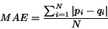
The lower the MAE, the more accurately the recommendation engine predicts user ratings. Root Mean Squared Error (RMSE), and Correlation are also used as statistical accuracy metric
- Decision support accuracy metrics evaluate how effective a prediction engine is at helping a user select high-quality items from the set of all items. These metrics assume the prediction process as a binary operation--either items are predicted (good) or not (bad). With this observation, whether a item has a prediction score of 1.5 or 2.5 on a five-point scale is irrelevant if the user only chooses to consider predictions of 4 or higher. The most commonly used decision support accuracy metrics are reversal rate, weighted errors and ROC sensitivity.
We used MAE as our choice of evaluation metric to report prediction experiments because it is most commonly used and easiest to interpret directly. In our previous experiments, we have seen that MAE and ROC provide the same ordering of different experimental schemes in terms of prediction quality.
1.1.4 Challenges of User-based Collaborative Filtering Algorithms
User-based collaborative filtering systems have been very successful in past, but their widespread use has revealed some real challenges such as:
- Sparsity: - In practice, many commercial recommender systems are used to evaluate large item sets (e.g., Amazon.com recommends books and CDnow.com recommends music albums). In these systems, even active users may have purchased well under 1% of the items. Accordingly, a recommender system based on nearest neighbour algorithms may be unable to make any item recommendations for a particular user. As a result, the accuracy of recommendations may be poor.
- Scalability: - Nearest neighbour algorithms require computation that grows with both the number of users and the number of items. With millions of users and items, a typical web-based recommender system running existing algorithms will suffer serious scalability problems.
The weakness of nearest neighbour algorithm for large, sparse databases led us to explore alternative recommender system algorithms. Our first approach attempted to bridge the sparsity by incorporating semi-intelligent filtering agents into the system. These agents evaluated and rated each item using syntactic features. By providing a dense ratings set, they helped alleviate coverage and improved quality. The filtering agent solution, however, did not address the fundamental problem of poor relationships among like-minded but sparse-rating users. To explore that we took an algorithmic approach and used Latent Semantic Indexing (LSI) to capture the similarity between users and items in a reduced dimensional space. In this paper, we look into another technique, the model-based approach, in addressing these challenges, especially the scalability challenge. The main idea here is to analyse the user-item representation matrix to identify relations between different items and then to use these relations to compute the prediction score for a given user-item pair. The intuition behind this approach is that a user would be interested in purchasing items that are similar to the items the user liked earlier and would tend to avoid items that are similar to the items the user didn't like earlier. These techniques don't require to identify the neighborhood of similar users when a recommendation is requested, as a result, they tend to produce much faster recommendations.
1.2 Item-based Collaborative Filtering Algorithm
In this section, we study a class of item-based recommendation algorithms for producing predictions to users. Unlike the user-based collaborative filtering algorithm discussed in Section, the item-based approach looks into the set of items the target user has rated and computes how similar they are to the target item i and then selects k most similar items . At the same time, their corresponding similarities are also computed. Once the most similar items are found, the prediction is then computed by taking a weighted average of the target user's ratings on these similar items. We describe these two aspects namely, the similarity computation and the prediction generation in details here.
1.2.1 Item Similarity Computation
One critical step in the item-based collaborative filtering algorithm is to compute the similarity between items and then to select the most similar items. The basic idea in similarity computation between two items i and j is to first isolate the users who have rated both of these items and then to apply a similarity computation technique to determine the similarity si,j.
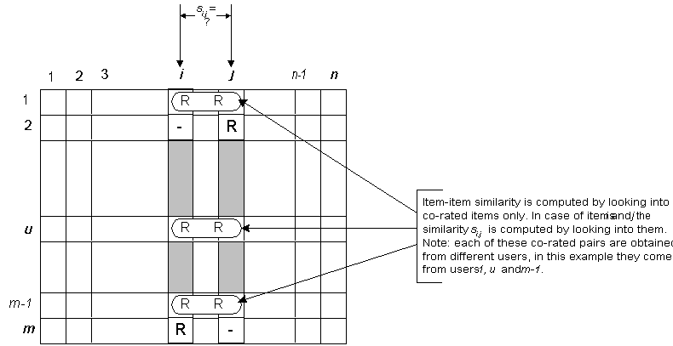
Fig 1.2 Matrix layout for item and user filters
There are a number of different ways to compute the similarity between items. Here we present three such methods. These are cosine-based similarity, correlation-based similarity and adjusted-cosine similarity.
2. Motivation
With the vast amount of data that the world has nowadays, institutions are looking for more and more accurate ways of using this data. Companies like Amazon use their huge amounts of data to give recommendations for users. Based on similarities among items, systems can give predictions for a new item’s rating. Recommender systems use the user, item, and ratings information to predict how other users will like a particular item. Recommender systems are now pervasive and seek to make profit out of customers or successfully meet their needs. However, to reach this goal, systems need to parse a lot of data and collect information, sometimes from different resources, and predict how the user will like the product or item. The computation power needed is considerable. Also, companies try to avoid flooding customer mailboxes with hundreds of products each morning, thus they are looking for one email or text that will make the customer look and act.
3. Literature Review
Many researchers have attempted to mitigate the cold start problem in collaborative filtering by incorporating content-based features. We review some recent work in this area of research. Wang et al. [4] extend probabilistic matrix factorization [5] with a topic model prior on the latent factor vectors of the items, and apply this model to scientific article recommendation. Topic proportions obtained from the content of the articles are used instead of latent factors when no usage data is available. The entire system is trained jointly, allowing the topic model and the latent space learned by matrix factorization to adapt to each other. Our approach is sequential instead: we first obtain latent factor vectors for songs for which usage data is available and use these to train a regression model. Because we reduce the incorporation of content information to a regression problem, we are able to use a deep convolutional network. McFee et al. [1] define an artist-level content-based similarity measure for music learned from a sample of collaborative filter data using metric learning to rank [3]. They use a variation on the typical bag-of-words approach for audio feature extraction. Their results corroborate that relying on usage data to train the model improves content-based recommendations. For audio data they used the CAL10K dataset, which consists of 10,832 songs, so it is comparable in size to the subset of the MSD that we used for our initial experiments Weston et al. [2] investigate the problem of recommending items to a user given another item as a query, which they call ‘collaborative retrieval’. They optimize an item scoring function using a ranking loss and describe a variant of their method that allows for content features to be incorporated. They also use the bag-of-words approach to extract audio features and evaluate this method on a large proprietary dataset. They find that combining collaborative filtering and content-based information does not improve the accuracy of the recommendations over collaborative filtering alone. Both McFee et al. and Weston et al. optimized their models using a ranking loss. We have opted to use quadratic loss functions instead because we found their optimization to be more easily scalable. Using a ranking loss instead is an interesting direction of future research, although we suspect that this approach may suffer from the same problems as the WPE objective (i.e. popular songs will have an unfair advantage).
4. Objective
Present day recommendation systems use item filters, collaborative filters or rule based filtering approach for recommending services or products to users. It has been observed that these recommendations are often void or are mildly effective yet they bring in a large chunk of sales on e-commerce sites. Hence, based on the above problems outlined in previous sections, the main objective of this project is as follows:
- To extract content from videos.
- To form item clusters based on content and user predesposition.
- To hybridize the above two for enhancing the quality of recommendations.
5. Planning of Work
Methodology will include the steps to be followed to achieve the objective of the project during the project development. The whole year (July 2016-May 2017) project planning will be specified.
The project is to be completed within the academic year 2016-2017. Hence the tasks are distributed and planned as follows:

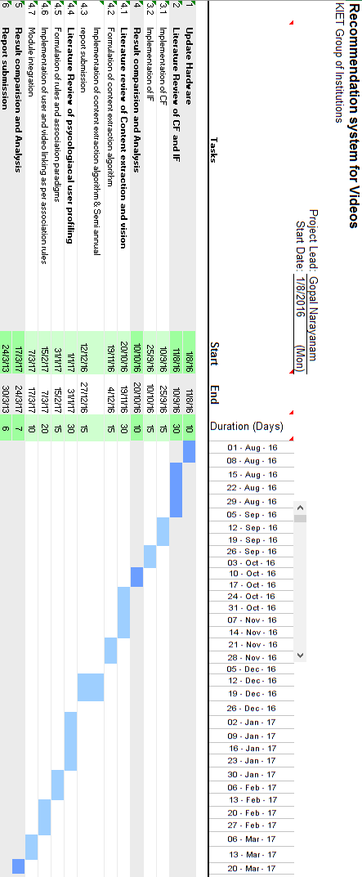6. References
[1] Brian McFee, Luke Barrington, and Gert R. G. Lanckriet. Learning content similarity for music
recommendation. IEEE Transactions on Audio, Speech & Language Processing, 20(8), 2012.
[2] Jason Weston, Chong Wang, Ron Weiss, and Adam Berenzweig. Latent collaborative retrieval. In Proceedings of the 29th international conference on Machine learning, 2012.
[3] Brian McFee and Gert R. G. Lanckriet. Metric learning to rank. In Proceedings of the 27 th International Conference on Machine Learning, 2010.
[4] Chong Wang and David M. Blei. Collaborative topic modeling for recommending scientific articles. In Proceedings of the 17th ACM SIGKDD international conference on Knowledge discovery and data mining, 2011.
[5] Ruslan Salakhutdinov and Andriy Mnih. Probabilistic matrix factorization. In Advances in Neural Information Processing Systems, volume 20, 2008.

