1

select D.calmonth,C.addrcatcode1, sum(I.QUANTITY)as tot_qun, sum(I.EXTCOST) as tot_extcost
from date_dim D inner join inventory_fact I on D.DATEKEY = I.DATEKEY
inner join cust_vendor_dim C on C.CUSTVENDORKEY = I.CUSTVENDORKEY
where D.CALYEAR = 2011
group by cube(D.calmonth,C.addrcatcode1);
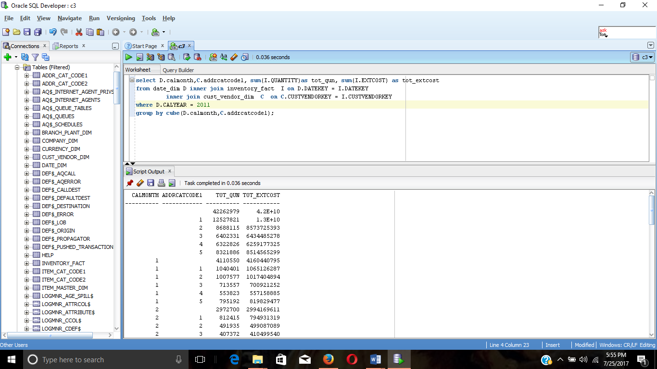

2
select D.CALQUARTER,C.ZIP,C.NAME, count(*) as num_transactions, sum(I.EXTCOST) as tot_extcost
from date_dim D inner join inventory_fact I on D.DATEKEY = I.DATEKEY
inner join cust_vendor_dim C on C.CUSTVENDORKEY = I.CUSTVENDORKEY
where (D.CALYEAR = 2011 or D.CALYEAR = 2012) and I.TRANSTYPEKEY = 5
group by grouping sets((D.CALQUARTER,C.ZIP,C.NAME),(D.CALQUARTER,C.ZIP),(C.ZIP,C.NAME),
(D.CALQUARTER,C.NAME),(D.CALQUARTER),(C.ZIP),(C.NAME),());
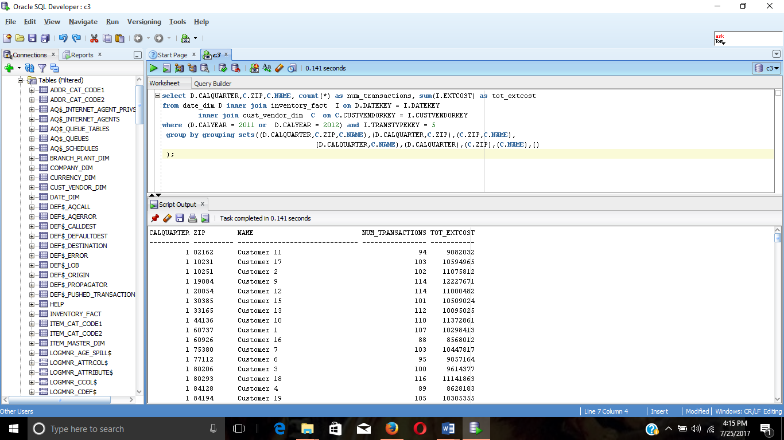
3
select B.BPNAME,C.COMPANYNAME, sum(I.QUANTITY) as tot_qunty, sum(I.EXTCOST) as tot_extcost
from BRANCH_PLANT_DIM B inner join COMPANY_DIM C on B.COMPANYKEY = C.COMPANYKEY
inner join inventory_fact I on B.BRANCHPLANTKEY= I.BRANCHPLANTKEY
where I.TRANSTYPEKEY = 2
group by rollup(C.COMPANYNAME,B.BPNAME);
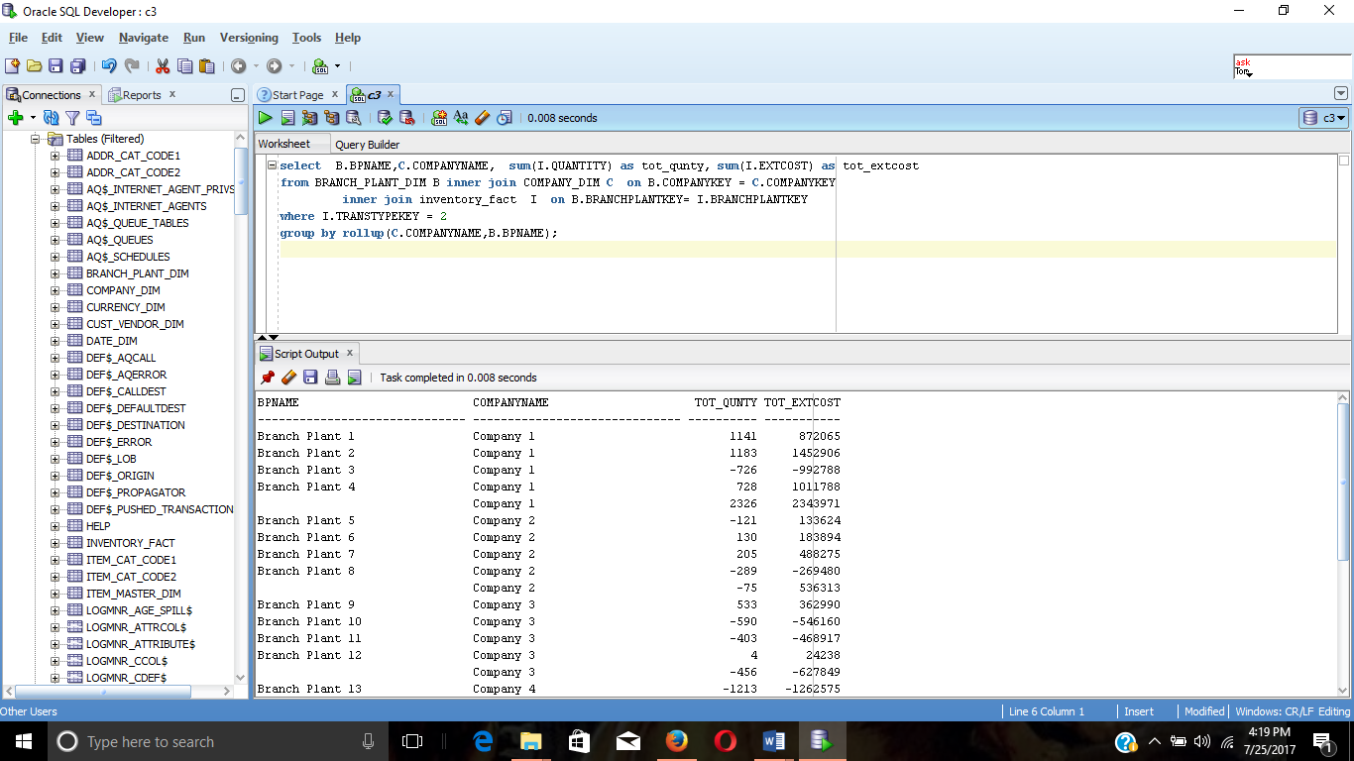

4
select T.TRANSDESCRIPTION,C.COMPANYNAME,B.BPNAME, count(*) as num_transac, sum(I.EXTCOST) as tot_extcost
from BRANCH_PLANT_DIM B inner join COMPANY_DIM C on B.COMPANYKEY = C.COMPANYKEY
inner join inventory_fact I on B.BRANCHPLANTKEY= I.BRANCHPLANTKEY
inner join TRANS_TYPE_DIM T on T.TRANSTYPEKEY=I.TRANSTYPEKEY
group by grouping sets((T.TRANSDESCRIPTION,C.COMPANYNAME,B.BPNAME),T.TRANSDESCRIPTION,C.COMPANYNAME,B.BPNAME,());
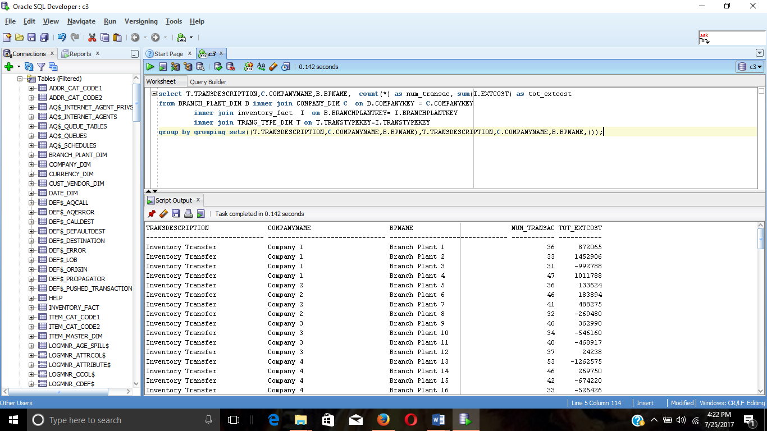

5
select C.NAME,D.CALYEAR,D.CALQUARTER, count(*) as num_transactions, sum(I.EXTCOST) as tot_extcost from date_dim D inner join inventory_fact I on D.DATEKEY = I.DATEKEY
inner join cust_vendor_dim C on C.CUSTVENDORKEY = I.CUSTVENDORKEY
where (D.CALYEAR = 2011 or D.CALYEAR = 2012) and I.TRANSTYPEKEY = 5
group by C.NAME, ROLLUP(D.CALYEAR,D.CALQUARTER);
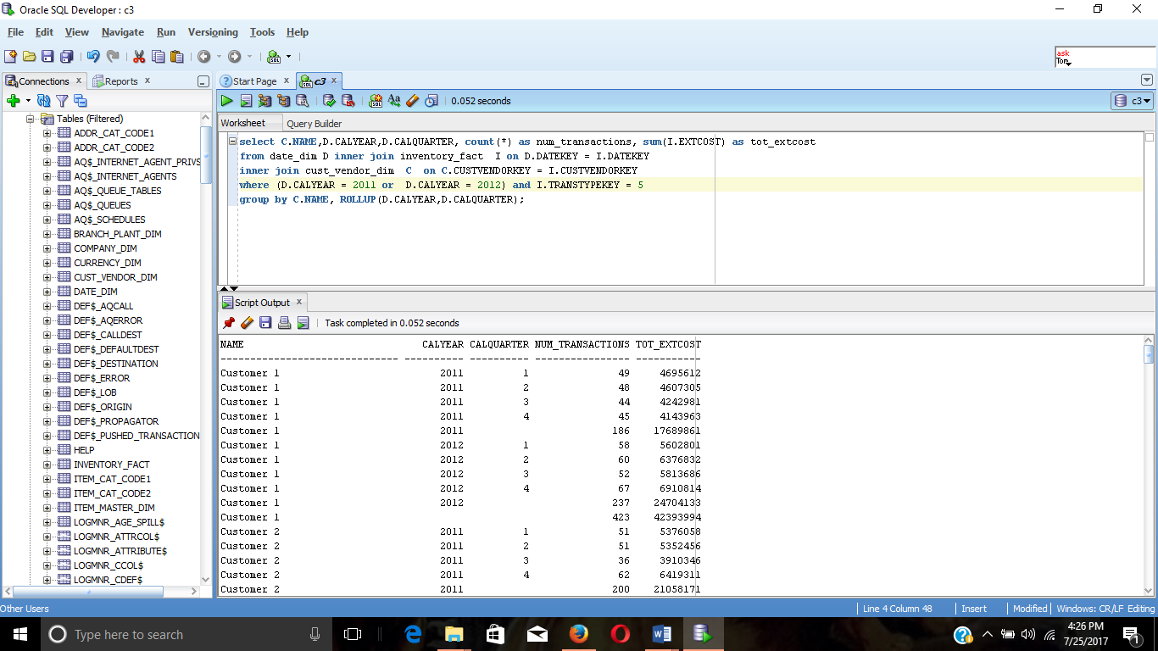

6
select D.calmonth,NULL, sum(I.QUANTITY)as tot_qun, sum(I.EXTCOST) as tot_extcost
from date_dim D inner join inventory_fact I on D.DATEKEY = I.DATEKEY
inner join cust_vendor_dim C on C.CUSTVENDORKEY = I.CUSTVENDORKEY
where D.CALYEAR = 2011
group by D.calmonth
UNION
select NULL,C.addrcatcode1, sum(I.QUANTITY)as tot_qun, sum(I.EXTCOST) as tot_extcost
from date_dim D inner join inventory_fact I on D.DATEKEY = I.DATEKEY
inner join cust_vendor_dim C on C.CUSTVENDORKEY = I.CUSTVENDORKEY
where D.CALYEAR = 2011
group by C.addrcatcode1
UNION
select D.calmonth,C.addrcatcode1, sum(I.QUANTITY)as tot_qun, sum(I.EXTCOST) as tot_extcost
from date_dim D inner join inventory_fact I on D.DATEKEY = I.DATEKEY
inner join cust_vendor_dim C on C.CUSTVENDORKEY = I.CUSTVENDORKEY
where D.CALYEAR = 2011
group by D.calmonth,C.addrcatcode1
UNION
select NULL,NULL, sum(I.QUANTITY)as tot_qun, sum(I.EXTCOST) as tot_extcost
from date_dim D inner join inventory_fact I on D.DATEKEY = I.DATEKEY
inner join cust_vendor_dim C on C.CUSTVENDORKEY = I.CUSTVENDORKEY
where D.CALYEAR = 2011;

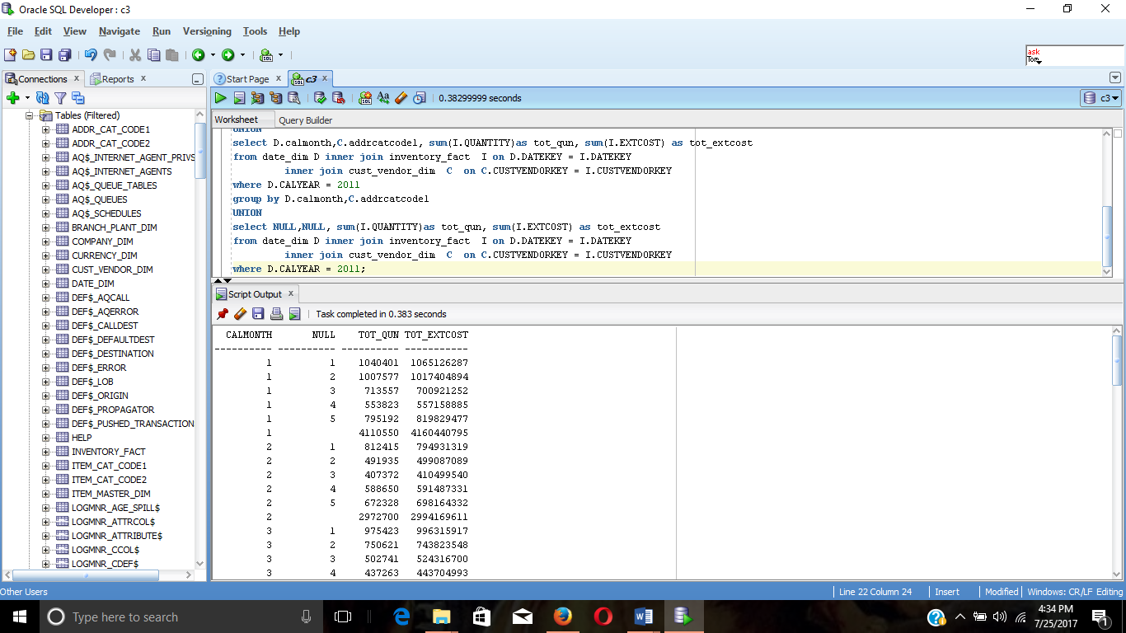

7
select B.BPNAME,C.COMPANYNAME, sum(I.QUANTITY) as tot_qunty,
sum(I.EXTCOST) as tot_extcost
from BRANCH_PLANT_DIM B inner join COMPANY_DIM C on
B.COMPANYKEY = C.COMPANYKEY
inner join inventory_fact I on B.BRANCHPLANTKEY=
I.BRANCHPLANTKEY
where I.TRANSTYPEKEY = 2
group by C.COMPANYNAME,B.BPNAME
UNION
select NULL,C.COMPANYNAME, sum(I.QUANTITY) as tot_qunty,
sum(I.EXTCOST) as tot_extcost
from BRANCH_PLANT_DIM B inner join COMPANY_DIM C on
B.COMPANYKEY = C.COMPANYKEY
inner join inventory_fact I on B.BRANCHPLANTKEY=
I.BRANCHPLANTKEY
where I.TRANSTYPEKEY = 2
group by C.COMPANYNAME
UNION
select NULL,NULL, sum(I.QUANTITY) as tot_qunty, sum(I.EXTCOST) as
tot_extcost
from BRANCH_PLANT_DIM B inner join COMPANY_DIM C on
B.COMPANYKEY = C.COMPANYKEY
inner join inventory_fact I on B.BRANCHPLANTKEY=
I.BRANCHPLANTKEY
where I.TRANSTYPEKEY = 2;
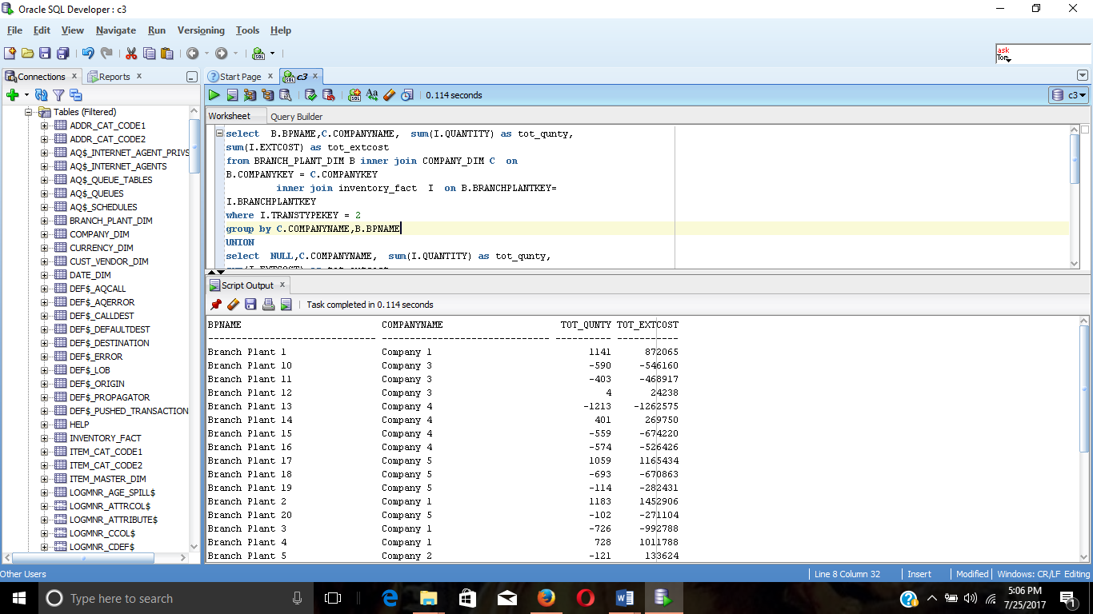

8
select D.CALYEAR,D.CALQUARTER,C.NAME, count(*) as num_transactions, sum(I.EXTCOST) as tot_extcost
from date_dim D inner join inventory_fact I on D.DATEKEY = I.DATEKEY
inner join cust_vendor_dim C on C.CUSTVENDORKEY = I.CUSTVENDORKEY
where (D.CALYEAR = 2011 or D.CALYEAR = 2012) and I.TRANSTYPEKEY = 5
group by ROLLUP((D.CALYEAR,D.CALQUARTER)),cube(C.NAME);
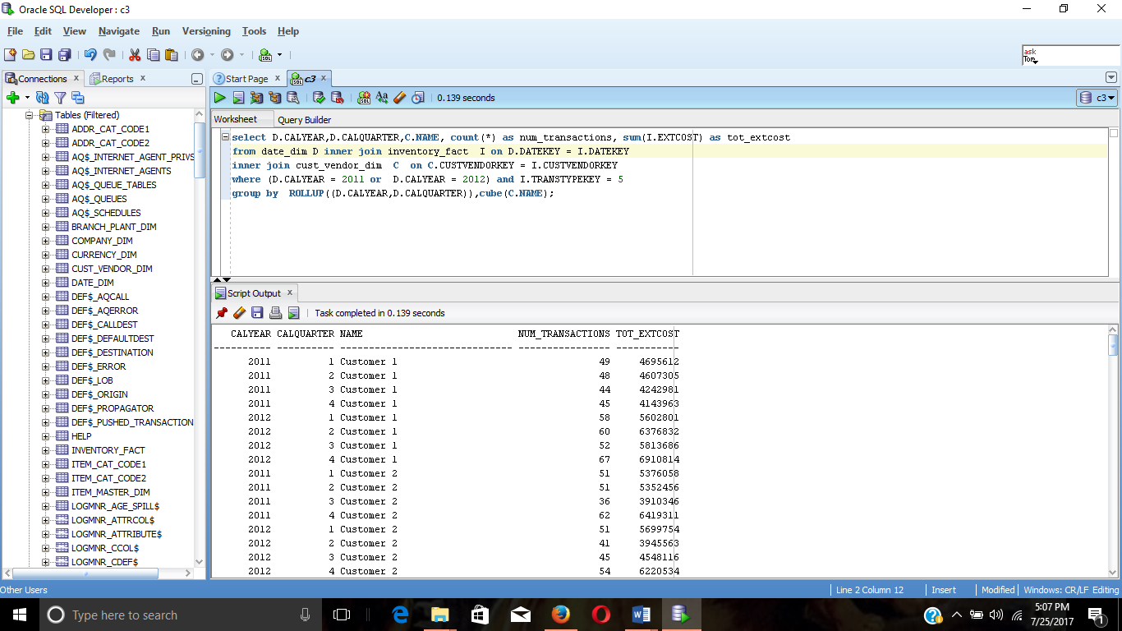

9
select C.Addrcatcode1,D.CALMONTH , sum(I.QUANTITY) as tot_qun, sum(I.EXTCOST) as tot_extcost, Grouping_Id(C.Addrcatcode1,D.CALMONTH) AS Group_Level
from date_dim D inner join inventory_fact I on D.DATEKEY = I.DATEKEY
inner join cust_vendor_dim C on C.CUSTVENDORKEY = I.CUSTVENDORKEY
where D.CALYEAR = 2011 and I.TRANSTYPEKEY = 5
group by cube(C.Addrcatcode1,D.CALMONTH);

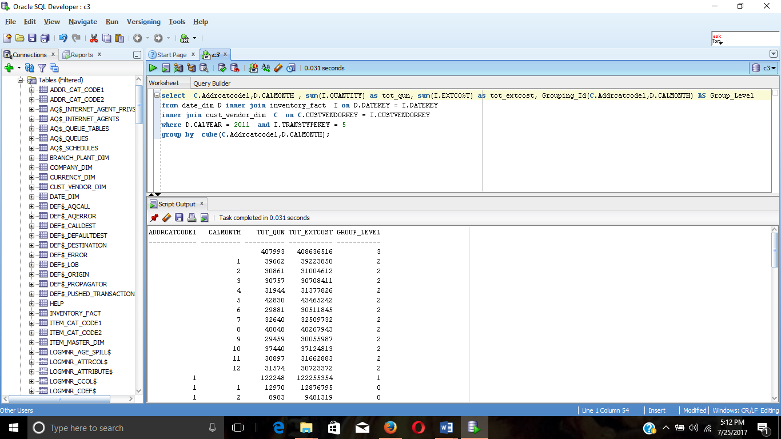

10

select D.CALYEAR,D.CALQUARTER,C.NAME, count(*) as num_transactions, sum(I.EXTCOST) as tot_extcost
from date_dim D inner join inventory_fact I on D.DATEKEY = I.DATEKEY
inner join cust_vendor_dim C on C.CUSTVENDORKEY = I.CUSTVENDORKEY
where (D.CALYEAR = 2011 or D.CALYEAR = 2012) and I.TRANSTYPEKEY = 5
group by grouping sets(C.NAME,ROLLUP(D.CALYEAR,D.CALQUARTER))
ORDER BY C.NAME,D.CALYEAR,D.CALQUARTER;

