1

SELECT c.Name, SUM(Extcost) SumExtCost, RANK() OVER ( ORDER BY SUM(Extcost) DESC ) AS RankSumCost
FROM Inventory_fact I, Cust_vendor_dim C
WHERE i.custvendorkey = c.custvendorkey
AND i.transtypekey = 5
GROUP BY c.Name;

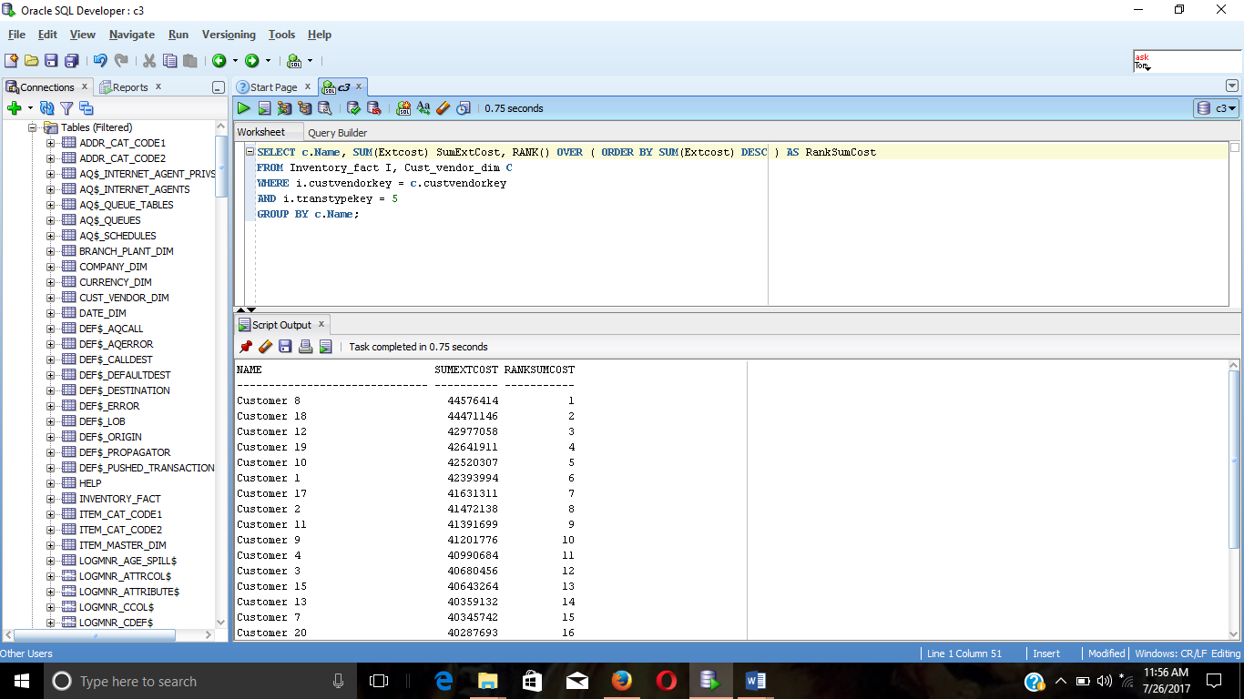

2

SELECT c.State, c.Name, SUM(Extcost) SumExtCost, RANK() OVER ( PARTITION BY State ORDER BY SUM(Extcost) DESC ) AS RankSumCost
FROM Inventory_fact i, Cust_vendor_dim c
WHERE i.custvendorkey = c.custvendorkey
AND i.transtypekey = 5
GROUP BY c.state, c.Name
ORDER BY c.State;

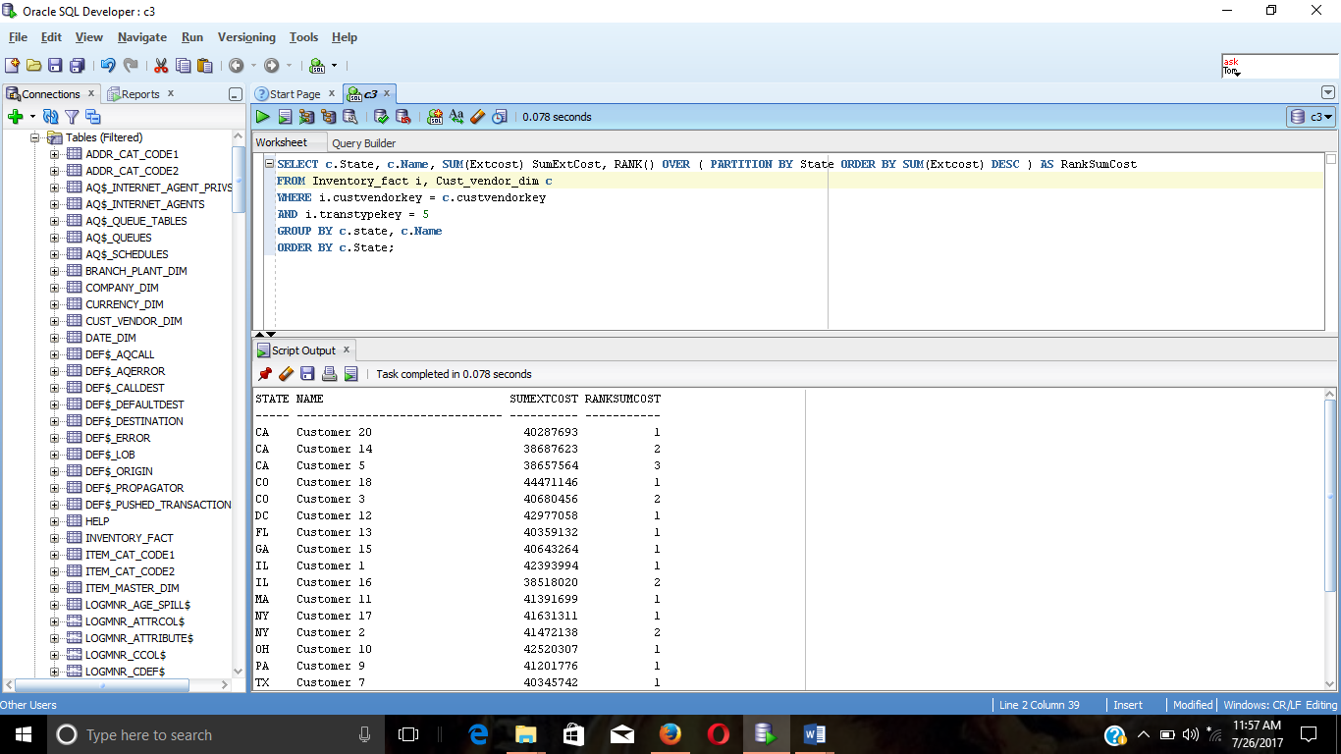

3

SELECT Name, COUNT (*) AS Transaction_Count, RANK () OVER (ORDER BY COUNT (*) DESC) Cust_Rank,
DENSE_RANK () OVER (ORDER BY COUNT (*) DESC) Cust_DenseRank
FROM Inventory_fact i, Cust_vendor_dim c
WHERE i.custvendorkey = c.custvendorkey
AND i.transtypekey = 5
GROUP BY Name;

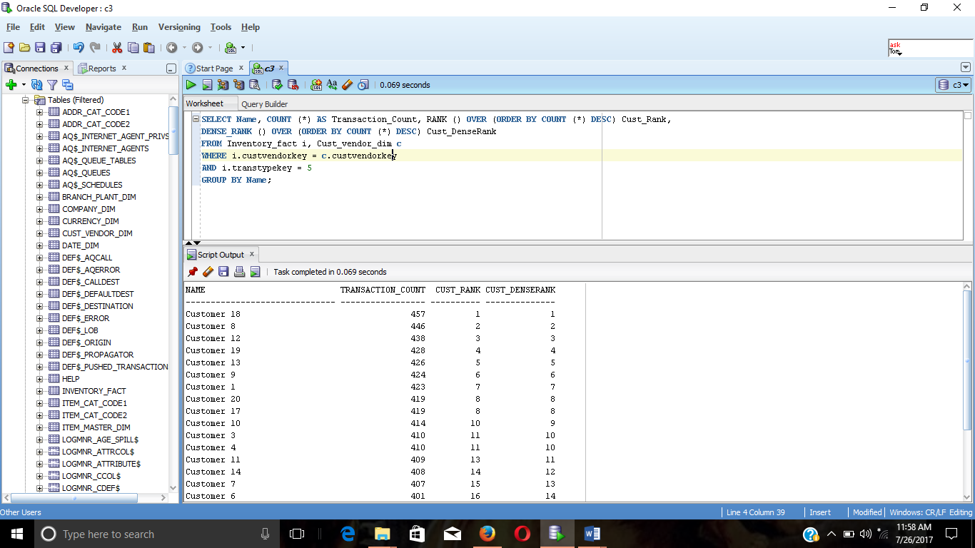

4

SELECT c.Zip, d.CalYear, d.CalMonth, SUM (ExtCost) AS Sum_ExtCost, SUM (SUM (ExtCost)) OVER
(ORDER BY c.Zip, d.CalYear, d.CalMonth ROWS UNBOUNDED PRECEDING) AS Cum_Sum_ExtCost
FROM Inventory_fact i, Cust_vendor_dim c, Date_dim d
WHERE i.custvendorkey = c.custvendorkey
AND i.datekey = d.datekey
AND i.transtypekey = 5
GROUP BY c.Zip, d.CalYear, d.CalMonth;

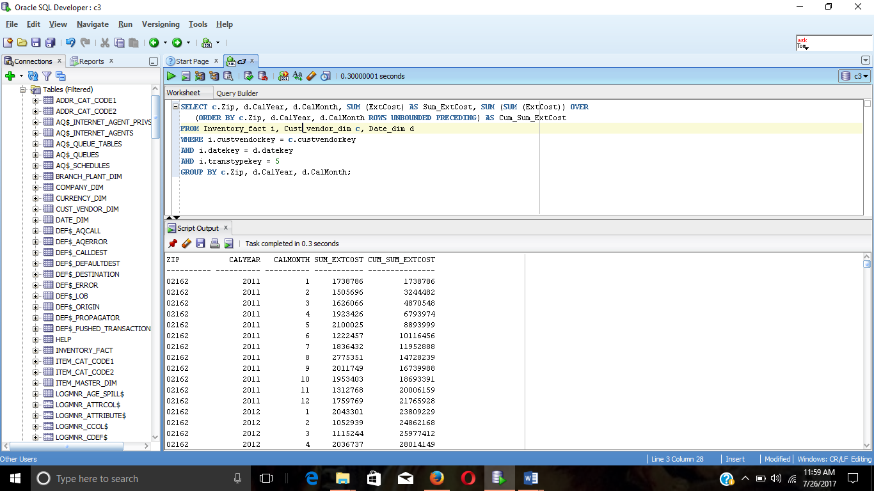

5

SELECT c.Zip, d.CalYear, d.CalMonth, SUM (ExtCost) AS Sum_ExtCost, SUM (SUM (ExtCost)) OVER
(PARTITION BY c.Zip, d.CalYear ORDER BY c.Zip, d.CalYear, d.CalMonth ROWS UNBOUNDED PRECEDING) AS Cum_Sum_ExtCost
FROM Inventory_fact i, Cust_vendor_dim c, Date_dim d
WHERE i.custvendorkey = c.custvendorkey
AND i.datekey = d.datekey
AND i.transtypekey = 5
GROUP BY c.Zip, d.CalYear, d.CalMonth;

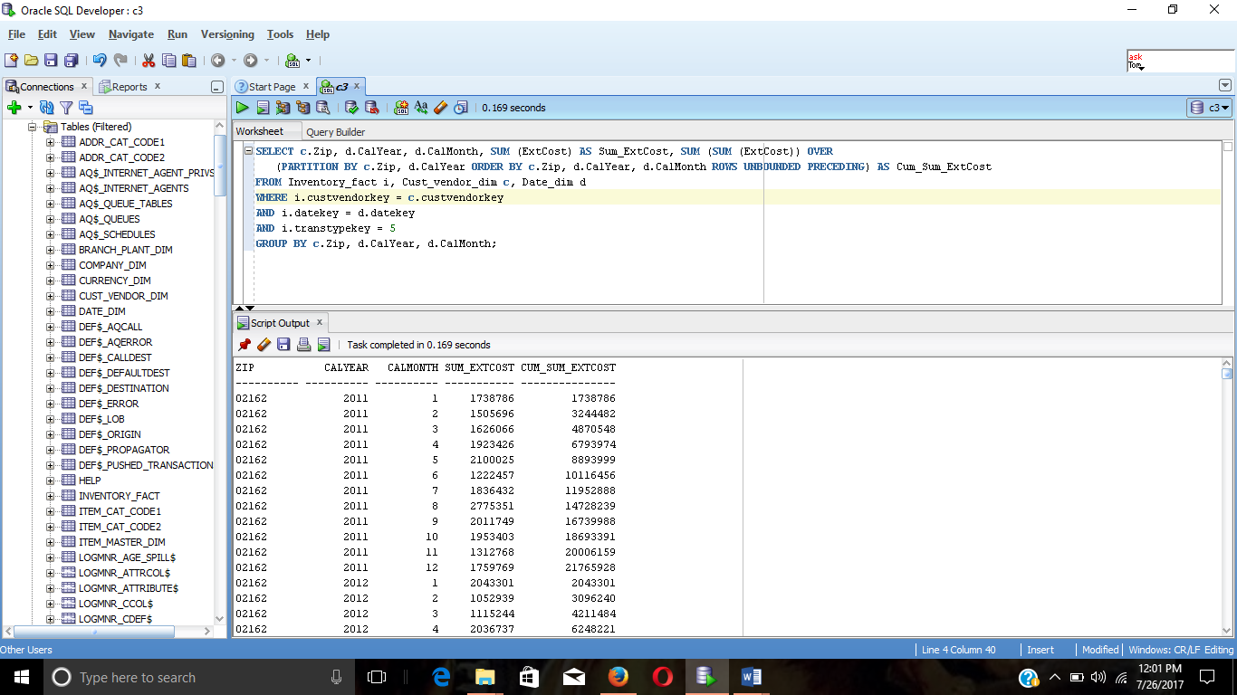

6

SELECT m.Seconditemid, SUM (Extcost) AS SumExtCost,
RATIO_TO_REPORT (SUM (ExtCost))
OVER (PARTITION BY m.Seconditemid) AS SumExtCostRatio
FROM Inventory_fact i, Item_master_dim m
WHERE i.itemmasterkey = m.itemmasterkey
AND i.transtypekey = 1
GROUP BY m.Seconditemid
ORDER BY SUM (ExtCost) DESC;

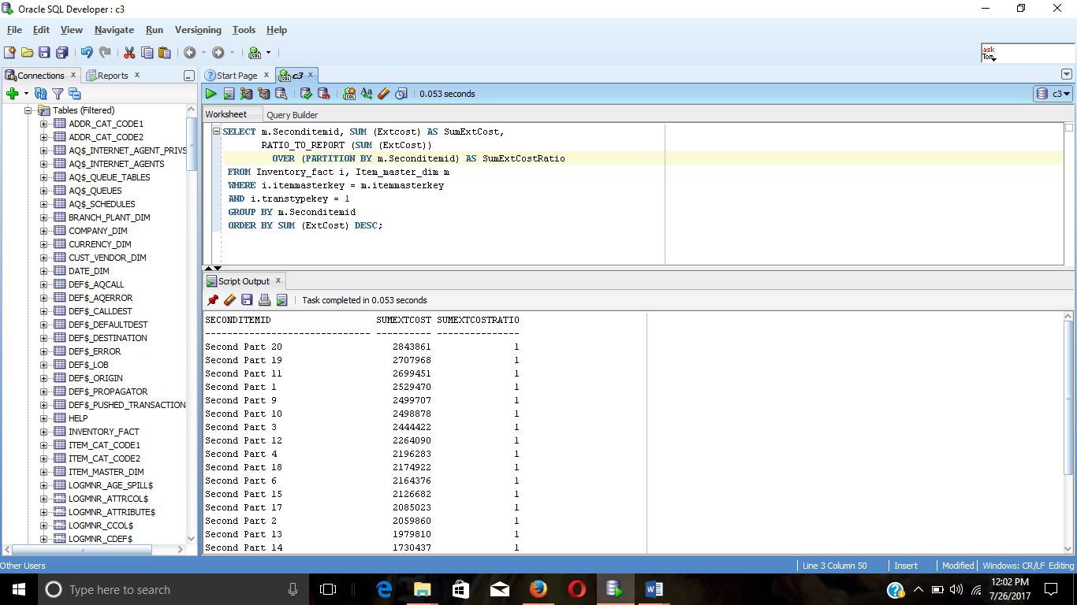

7

SELECT d.Calyear, m.Seconditemid, SUM (Extcost) AS SumExtCost,
RATIO_TO_REPORT (SUM (ExtCost)) OVER (PARTITION BY d.Calyear) AS SumExtCostRatio
FROM Inventory_fact i, Item_master_dim m, date_dim d
WHERE i.itemmasterkey = m.itemmasterkey
AND i.datekey = d.datekey
AND i.transtypekey = 1
GROUP BY d.Calyear, m.Seconditemid
ORDER BY d.Calyear ASC, SUM (ExtCost) DESC;

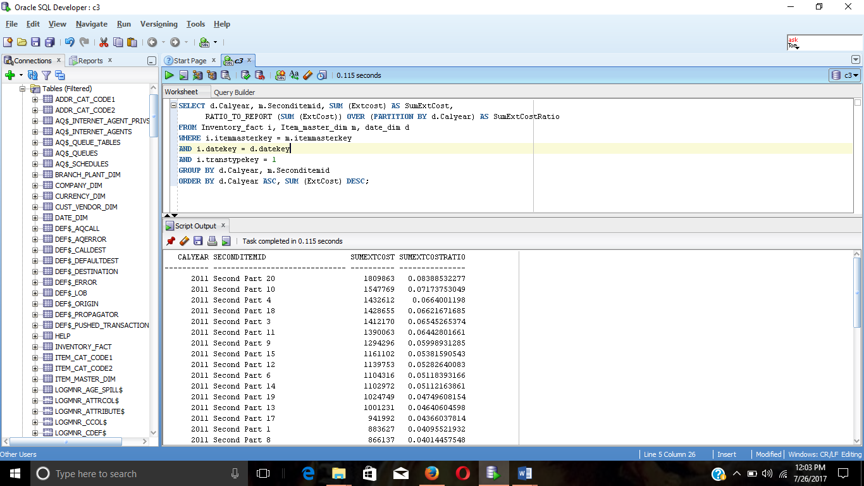

8

SELECT Bpname, Companykey, Carryingcost,
RANK() OVER (ORDER BY Carryingcost) As Rank_CarryingCost,
PERCENT_RANK() OVER (ORDER BY Carryingcost) As PercentRank_Carryingcost,
CUME_DIST() OVER (ORDER BY Carryingcost) As CumDist_Carryingcost
FROM branch_plant_dim;

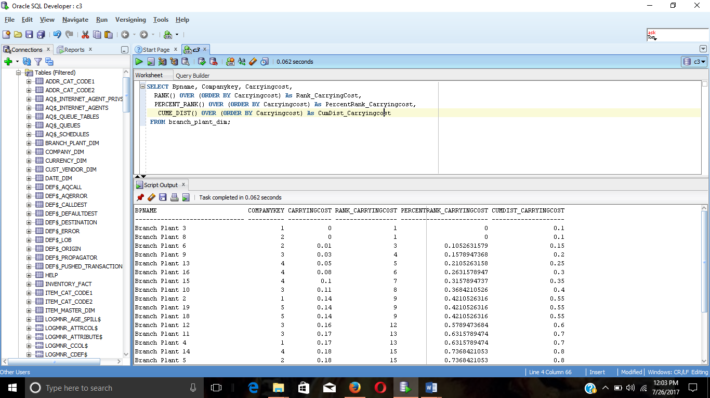

9

SELECT Bpname, Companykey, Carryingcost, CumDist_Carryingcost
FROM (SELECT Bpname, Companykey, Carryingcost,
CUME_DIST () OVER (ORDER BY Carryingcost) As CumDist_Carryingcost
FROM branch_plant_dim)
WHERE CumDist_Carryingcost <= 0.15;

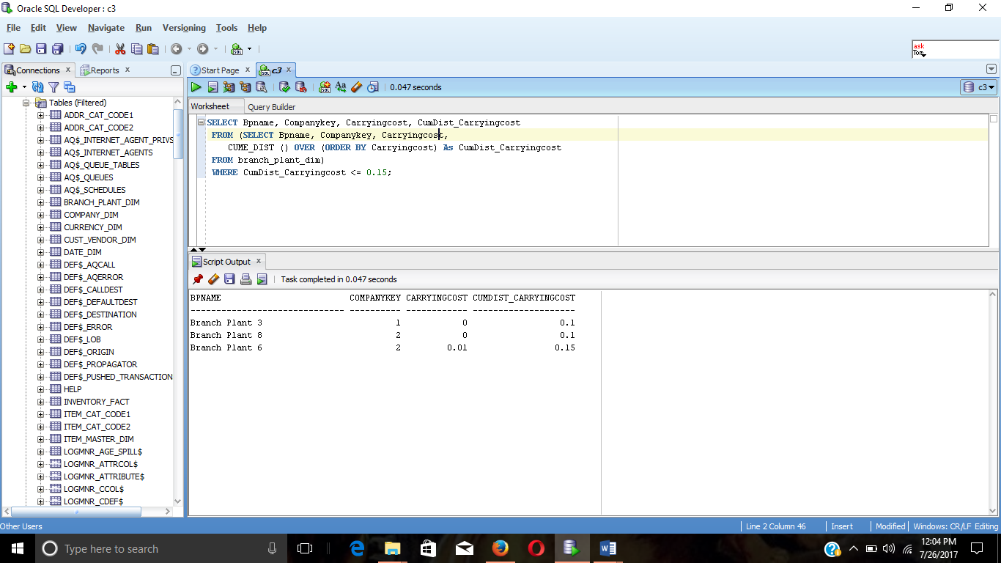

10

SELECT DISTINCT ExtCost, CUME_DIST() OVER (ORDER BY ExtCost ) As CumDist_ExtCost
FROM Inventory_fact i, Cust_vendor_dim C
WHERE i.custvendorkey = c.custvendorkey
AND c.State = 'CO'
ORDER BY ExtCost;

