The American Health Ownership Plan (AHOP)
Universal coverage, no medical bankruptcy, no job lock — built to survive a divided Congress
The premise. Health care is the largest source of financial ruin in American life, and coverage is chained to a job you can lose tomorrow. AHOP delivers universal coverage with guaranteed issue — nobody uninsurable, nobody bankrupted, nobody trapped in a bad job for the insurance. It reaches those goals through a private-insurer architecture rather than a public payer, which is precisely why it can pass: it is designed to win the votes that single-payer proposals cannot, without surrendering the outcomes that make them worth wanting.
The architecture.
LAYER 1  Coverage for everyone | Universal coverage — every resident insured, with guaranteed issue, community-style rating, and a risk-adjustment formula written into statute so insurers cannot cherry-pick the healthy. Deductibles and out-of-pocket exposure scale with income and are capped: no family is bankrupted by illness. A smart deductible puts high-value care outside cost sharing entirely — preventive screenings, prenatal care, mental-health maintenance, insulin, inhalers, and blood-pressure medication are covered from the first dollar.
LAYER 2  Accounts working families own | Health savings accounts for routine care, seeded with direct public deposits for lower-income households — progressive transfers replacing today's opaque subsidy machinery. The account is the family's property forever. Comparison tools and binding quotes are required by design: the burden falls on software, not on sick people. No one is ever asked to shop for cancer or emergency care — that sits above the deductible, where insurers negotiate on the patient's behalf.
LAYER 3  A safety net that cannot be starved | A guaranteed backstop for the poor and chronically ill, in a dedicated trust with dedicated revenue and a statutory adequacy floor that automatically adjusts revenue if funding would fall short. Unlike an appropriation, it cannot be quietly squeezed in a budget fight — it can only be cut by a recorded vote against the sick and the poor. Funded in part by a Solidarity Share on high earners' above-cap contributions.
FOUNDATION  Breaking up the hospital cartel | Confronts consolidated provider markets directly: repeal of anti-competitive entry barriers, expanded clinician supply, binding price transparency, site-neutral payments that end the hospital-ownership billing premium, and faster generics and biosimilars. Backed by a hard guarantee: where markets are concentrated and prices fail to fall, reference pricing capped at a multiple of Medicare rates activates automatically — and providers must accept it to keep federal program participation.

What it does for people. Lose your job and nothing lapses — the policy and the account are yours, and because subsidies scale with income, a layoff automatically means a lower deductible and larger support. COBRA becomes obsolete, and job lock ends. Chronic-disease care — insulin, inhalers, mental-health maintenance — is free at the point of use, because a skipped $40 refill becomes a $20,000 emergency the system pays for anyway.
Who pays. Not working families. Financing comes from ending the regressive employer tax exclusion — a $330B/yr break that disproportionately benefits high earners with gold-plated plans — with a statutory paycheck conversion legally requiring employers to hand those dollars back as wages. Existing Medicaid, CHIP, and ACA streams migrate in; high earners contribute through the Solidarity Share. The median household is provably no worse off.
The numbers (14-year model, 12-run sensitivity grid). Universal coverage at a peak cost of roughly $92B/yr — a fraction of one year of Medicare — and the ledger flips to savings by 2034. Every sensitivity variation stays favorable: the parameters move the price and timing, not the sign. And the system-wide prize is contingent on confronting provider consolidation, which is exactly where the left has been right all along.
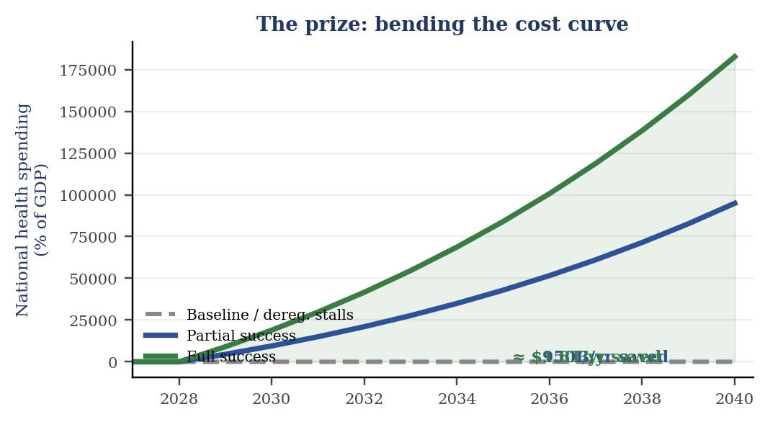  Taking on provider consolidation is where the savings live. | 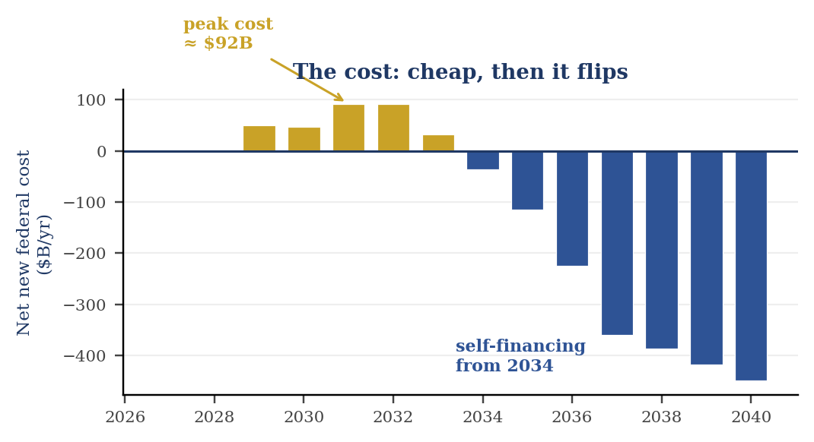  Universal coverage for ≈ $92B/yr at peak — then it pays for itself.

Why this one can pass. Every repeal-era bill scored as millions losing coverage; this one scores as a coverage gain — the weapon that killed 2017 does not exist here. It is severable by design: hospital-consolidation and price-transparency reform can move now, and covering every child in America (Title II) revives the CHIP precedent, the most passable bill in health policy. The rest is trigger-gated for the Medicare trust-fund window of the early 2030s. It is not a bill to introduce — it is the architecture to have ready when the window opens.
Eric Schultz — Independent Researcher — ORCID 0009-0006-6283-1696 — Full framework (15 pp.) and fiscal model available

