The American Health Ownership Plan (AHOP)
A market-based architecture for universal, portable, affordable American healthcare — one page
The premise. A capitalist economy runs on a healthy, mobile workforce, and the current system is engineered against that interest: prices are hidden, supply is legally cartelized, and the tax code welds coverage to employment. The diagnosis is not market failure but a market never permitted to function. AHOP is a single architecture in which every American personally owns a catastrophic policy, a health savings account, and an income-scaled subsidy relationship — portable through every job, layoff, and move.
The architecture.
LAYER 1  Catastrophic coverage | Universal catastrophic policies from competing private insurers, guaranteed issue, income-scaled deductibles (5–10% of income, capped). The risk-adjustment formula — prospective, claims-audited, with a reinsurance corridor — is written into statute, not left to rulemaking. A smart deductible exempts high-value care from all cost sharing: preventive services, prenatal care, and chronic-maintenance drugs — answering the underinsurance critique with its own evidence base.
LAYER 2  Health savings accounts | Expanded, personally owned HSAs pay for routine, shoppable care below the deductible, restoring the price signal where it works (the Singapore and Swiss existence proofs). Standardized comparison tools and binding quotes are a design requirement: the cognitive load falls on software, not on sick people. No patient is ever asked to comparison-shop for cancer or emergency care — that lives above the deductible.
LAYER 3  The AHOP Trust | A means-tested backstop for the poor and chronically ill, housed in a dedicated trust with statutory revenue and an adequacy floor that triggers automatic revenue adjustment. The safety net cannot be starved by inaction — only cut by a recorded vote. Stress-tested solvent even at zero participation in the voluntary Solidarity Share.
FOUNDATION  Deregulated delivery market | Load-bearing, and sequenced first: CON repeal, residency expansion, scope-of-practice liberalization, binding price transparency, site-neutral payments, faster generics and biosimilars. Backed by a market-first trigger — reference-price fallback activates only in concentrated markets that miss published benchmarks, and deactivates when competition arrives.

No mandate. Guaranteed Enrollment: auto-enrollment with opt-out, continuous-coverage protection (from the GOP's own 2017 bills), and Medicare Parts B/D-style late-enrollment pricing — income-scaled, capped, with automatic grace for involuntary lapses. Mandate-level participation, zero compulsion.
Financing. Almost entirely redirection, not new taxes: phased conversion of the ~$330B/yr employer tax exclusion — with a statutory paycheck conversion ensuring workers visibly receive the wages their premiums suppressed — plus migrated non-elderly Medicaid, CHIP, and ACA subsidy streams, and a voluntary Solidarity Share (25% of above-cap HSA dollars flow to the Trust).
Transition. Children first (2029) on the CHIP precedent, standing up the full machinery at a tenth of the fiscal exposure; then a demographic ratchet — young adults, then adults in tranches. Medicare is grandfathered. Job loss stops being a coverage event at all: the policy and the account are personally owned, and subsidies automatically rise when income falls.
The numbers (14-year model, adjustable levers, 12-run sensitivity grid). The transition is cheap and self-financing through redirection — stated honestly, much of the federal improvement is exclusion redirection rather than efficiency gain. Every sensitivity variation stays favorable by 2040: the parameters move the price and timing of the transition, not the sign of the outcome. The real prize is system-wide, and it is contingent: if deregulation stalls, the downside case is re-plumbing at roughly zero net federal cost.
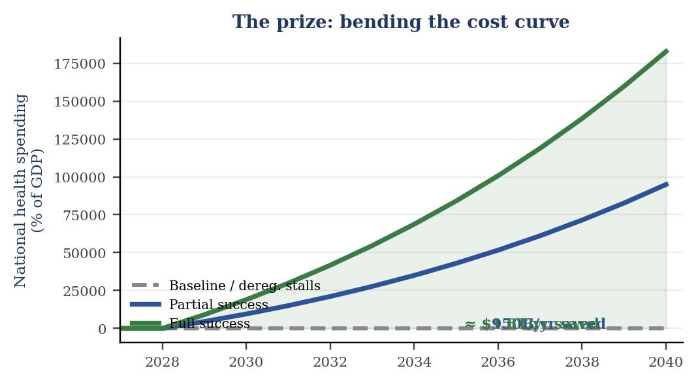  Deregulation is where the value lives — or is forfeited. | 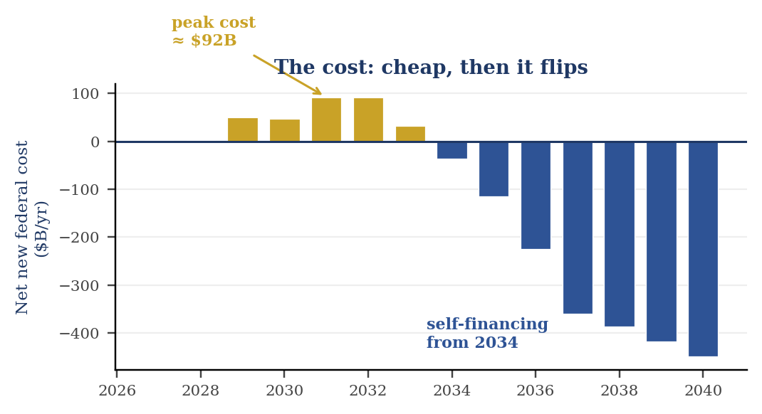  Peak cost ≈ $92B/yr; the ledger flips by 2034.

The pathway. Comprehensive market-based bills die in committee under the post-2017 targeted-changes doctrine — so AHOP is severable by design. Title I (deregulation) is reconciliation-compatible and can move now; Title II (children's coverage) is a self-contained bill in the most passable genre in health policy; the remaining titles are trigger-gated for the coming fiscal forcing event, most plausibly the Medicare trust-fund window of the early 2030s. Unlike every repeal-era predecessor, this framework scores as a coverage gain. It is not a bill to introduce — it is the architecture to have ready.
Eric Schultz — Independent Researcher — ORCID 0009-0006-6283-1696 — Full framework (15 pp.) and fiscal model available

