The American Health Ownership Plan (AHOP)
A market-based architecture for universal, portable, affordable American healthcare
Framework Draft v6 — July 2026 — Not for citation

Executive Summary
American healthcare is the most expensive in the world and delivers neither universal coverage nor market discipline. The premise of this proposal is straightforwardly capitalist: a nation's economic output depends on the health of its workforce, and a system that prices workers out of care — or chains their coverage to a particular employer — is a drag on productivity, entrepreneurship, and labor mobility. The American Health Ownership Plan (AHOP) proposes that the cure is not more government management of healthcare, nor the piecemeal deregulation of a broken structure, but a single coherent architecture in which every American personally owns three things: a catastrophic insurance policy, a health savings account, and an income-scaled relationship with a means-tested backstop.
AHOP rests on a diagnosis that the U.S. healthcare market is not a failed free market but a market that has never been permitted to function: supply is constrained by government-enforced entry barriers, prices are hidden from the people paying them, and the tax code welds insurance to employment. The plan therefore pairs a three-layer universal financing structure with an aggressive supply-side deregulation package, phased in children-first over a decade, financed almost entirely by redirecting money the system already spends. Five structural commitments are built into the architecture rather than promised alongside it: a smart deductible that exempts high-value care; a dedicated trust fund insulating the safety-net layer from appropriations politics; a statutory paycheck conversion guaranteeing that ending the employer tax exclusion shows up as wages; broad state flexibility waivers; and a market-first trigger with an automatic reference-price fallback in regions where competition fails to arrive.
A rough fiscal model accompanying this draft projects a peak transition cost of roughly $90 billion per year, a cumulative transition cost that tops out near $320 billion, and a steady state in which the federal government is several hundred billion dollars per year better off — with the caveat, developed honestly below, that much of the federal improvement reflects the redirection of the employer tax exclusion rather than efficiency gains. The genuine economic prize lives in the supply side: if deregulation compresses health cost growth by even three-quarters of a percentage point per year, the economy saves on the order of $950 billion annually by 2040.

1. The Problem and the Premise
The United States spends roughly $5 trillion a year on healthcare — approaching 18 percent of GDP, nearly double the average of peer nations — while leaving tens of millions uninsured or underinsured and producing middling aggregate outcomes. The affordability failure is usually framed as a moral problem. This proposal frames it as an economic one: unhealthy and financially insecure workers produce less, participate less, and take fewer entrepreneurial risks. Job lock — workers staying in poorly matched jobs to keep insurance — measurably suppresses business formation and wage growth. Medical debt and bankruptcy destroy household balance sheets that would otherwise fuel consumption and investment. A capitalist country should want the healthiest, most able-bodied, most mobile workforce it can get, and the current system is engineered against that interest.
The standard market-oriented diagnosis is that American healthcare violates nearly every condition a functioning market requires. Consumers cannot see prices before consuming. Supply is legally constrained: certificate-of-need laws in roughly thirty-five states require would-be competitors to seek permission from boards influenced by incumbents; residency caps throttle the physician pipeline; scope-of-practice rules idle qualified clinicians. The largest tax expenditure in the code — the exclusion of employer-paid premiums, worth more than $300 billion a year — hides costs from workers, kills price sensitivity, and attaches coverage to employment by historical accident. Where these distortions are absent, in cash-pay corners of medicine such as LASIK and elective surgery centers, prices have fallen while quality rose. AHOP generalizes that observation into a system.

2. Design Principles
Five principles govern every design choice in this plan. First, ownership: coverage and savings belong to the individual, not the employer and not the state, and travel with the person through every job change, layoff, and move. Second, universality through markets: everyone is covered, but by competing private insurers, not a public payer. Third, price signals where they work, insurance where they don't: routine, shoppable care is paid from personally owned funds; catastrophic risk is pooled; and care whose skipping predictably causes downstream catastrophe is exempted from cost sharing altogether. Fourth, subsidize people, not systems: taxpayer money flows to the individuals the market cannot serve, at market prices, rather than propping up inflated prices system-wide. Fifth, no compulsion: participation is secured through defaults and actuarial consequences, not mandates.

3. The AHOP Architecture
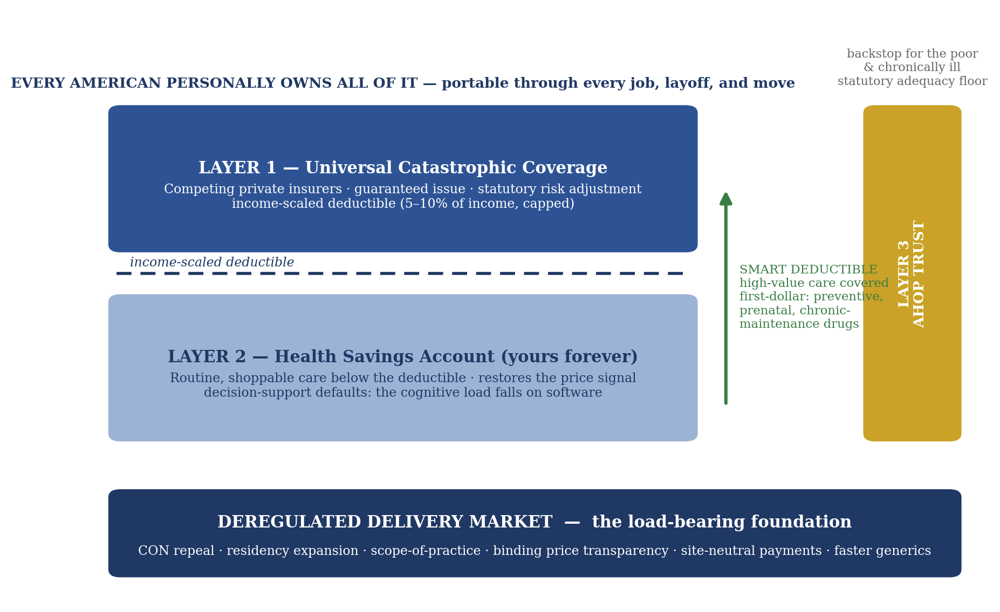
Figure 1. The AHOP architecture: three individually owned layers on a deregulated delivery market, with the smart deductible carrying high-value care past cost sharing.

Layer 1 — Universal catastrophic coverage
Every eligible resident carries a catastrophic health insurance policy purchased from competing private insurers, with guaranteed issue and community-style rating supported by inter-insurer risk adjustment. The deductible scales with household income — on the order of five to ten percent of income, capped — so that no American can be financially ruined by illness, while the policy remains genuine insurance rather than prepaid healthcare. This is the layer that delivers universality, and it is structurally similar to the regulated private universal systems of Switzerland and the Netherlands, where insurers remain profitable and competitive.

Risk adjustment: written into statute
Guaranteed issue survives only if insurers cannot profit by selecting healthy enrollees and shedding sick ones, which makes the risk-adjustment formula the single most consequential technical object in the plan — whoever writes that formula owns the market. AHOP therefore specifies the methodology in statute rather than delegating it to rulemaking, where incumbents would shape it. The design: prospective, diagnosis-based transfers among Layer 1 insurers, audited against claims rather than self-reported coding to blunt upcoding; a retrospective true-up band for aggregate misses; and a federal reinsurance corridor for individual catastrophic outliers above a statutory attachment point, so that no insurer's solvency depends on avoiding the sickest handful of enrollees. Parameters adjust by published formula on actuarial data, but the architecture — what is measured, who audits, where the corridors sit — is law, not regulation. This is the provision on which every private-market universal system stands or falls, and burying it in rulemaking is how such systems are quietly unwound. The audit machinery this requires is real and is budgeted — housed within the reinsurance-corridor line of the accompanying model — and the statute’s specificity is itself the anti-capture design: parameters move by published formula on actuarial data, not by petitions to a rulemaking docket.

The smart deductible: value-based exemptions
The deductible is deliberately not a blunt instrument. A defined schedule of high-value care is exempt from cost sharing entirely and covered from the first dollar: preventive screenings, vaccinations, prenatal care, and — critically — maintenance medications and monitoring for major chronic conditions, including insulin, statins, antihypertensives, and asthma controllers. The design follows the value-based insurance design (VBID) literature and answers the central empirical caveat of the RAND Health Insurance Experiment: cost sharing causes people to cut effective and ineffective care indiscriminately, with the harm concentrated among the poor and the chronically ill. The exempted categories are precisely those where a skipped forty-dollar refill becomes a twenty-thousand-dollar catastrophic claim that Layer 1 pays anyway; first-dollar coverage of them is therefore both the humane choice and the actuarially cheap one. Medicare Advantage has piloted VBID with bipartisan support, so the mechanism arrives pre-legitimized. This provision converts the most substantive underinsurance critique of catastrophic coverage into a design feature.

Layer 2 — Health savings accounts for routine care
Non-exempt care below the deductible is paid from a substantially expanded HSA: tax-free contributions from the individual, employers, or — for lower-income households — direct government deposits replacing today's opaque subsidy machinery. The account is the individual's property in perpetuity, like a retirement account. This layer restores the price signal for the majority of healthcare encounters, which are routine and shoppable, and it is the engine that forces providers to compete on posted prices. Singapore's mandatory-savings-plus-catastrophic model, operating at less than six percent of GDP with first-world outcomes, is the standing existence proof for the architecture. Because price signals work only if using them is easy, Layer 2 carries an explicit design requirement: standardized price-comparison interfaces, binding quotes for shoppable procedures, and sensible defaults, so that the system's cognitive load falls on software rather than on sick people. A system that requires financial sophistication to navigate has shifted its costs from the ledger to the patient, and that is a cost this framework counts.

Layer 3 — The means-tested backstop
For the persistently poor and the chronically ill whose predictable annual costs exceed what Layers 1 and 2 can absorb, a residual fund pays premiums, seeds accounts, and covers high-need care. This is where taxpayer money is concentrated — and only here. The chronically ill are the population for whom consumer price discipline genuinely does not apply, since they exceed their deductible every year; the plan's health-maximization premise therefore stands or falls on Layer 3 being adequately funded. Section 8 places Layer 3 inside a dedicated trust with statutory funding precisely so that adequacy does not depend on annual appropriations. This draft treats Layer 3 as a block obligation inherited largely from Medicaid's high-need non-elderly population, initially sized at roughly $350 billion per year in 2026 dollars, and flags it as the least certain number in the accompanying model.

The delivery side: the deregulation package
None of the financing architecture controls costs if supply remains cartelized. AHOP therefore treats the following as load-bearing, not optional: repeal or federal preemption of certificate-of-need laws; expansion of residency slots and streamlined licensure reciprocity; scope-of-practice liberalization for nurse practitioners, physician assistants, and pharmacists; binding, enforced price transparency for shoppable procedures; site-neutral payment rules that end the hospital-ownership billing premium; and accelerated approval pathways for generics and biosimilars alongside curbs on patent evergreening. These reforms are sequenced first precisely because the plan's affordability is contingent on them: they are fiscal insurance as much as policy. Capacity, finally, is people as well as permissions: new residency slots yield nothing if clinicians keep leaving the profession, and the package’s largest unheralded effect is on retention — the collapse of prior-authorization and billing complexity is the biggest administrative-burden reduction, and therefore the biggest anti-burnout lever, available to policy.

Market first, backstop if it fails: the reference-price trigger
The plan's answer to cost growth is competition, not rate regulation — but it writes the guarantee into law rather than leaving it as a promise. At launch, regional price benchmarks for a basket of common procedures are published, with a defined compression schedule. In any region where prices fail to track the schedule after the deregulation window, an automatic fallback activates: Layer 1 plans in that region pay no more than a fixed multiple of Medicare rates for benchmarked services, and the fallback deactivates when competitive pricing arrives. Two design details guard against the failure modes critics fairly predict: the multiple is set generously, by formula from commercial rates in the most competitive quartile of markets rather than by a political number; and acceptance of fallback rates in triggered regions is a condition of participation in federal health programs, foreclosing the strategy of simply refusing the benchmarked patients. And to the symmetric question — if markets can fail, why not simply regulate prices everywhere? — the answer is that the fallback is an empirical test where permanent regulation is an assertion: it imposes rates exactly where, and only for as long as, competition demonstrably fails, rather than presuming failure in every market forever. The right receives its market and a fair chance to prove it works; the left receives a statutory guarantee against the scenario in which competition never comes; and incumbent systems face a sharpened incentive to permit entry, since obstructing competition triggers the regulation they fear more. The fiscal model in Section 9 shows why this discipline matters: the plan's entire economic value is concentrated in whether prices actually compress.

4. Transition: Children First and the Demographic Ratchet
Big-bang healthcare transitions fail politically because they disrupt arrangements covering more than 150 million people at once. AHOP instead phases in by birth cohort, beginning with children — the population that is cheapest to insure, impossible to blame for its own health status, and covered by the successful bipartisan precedent of CHIP. The children's phase stands up the entire machinery — the catastrophic market, risk adjustment, HSA infrastructure, the Trust (Section 8), and Layer 3 — at roughly a tenth of full fiscal exposure, allowing the system to be debugged at small scale. Each subsequent year the covered cohort ages upward, creating a demographic ratchet: the prospect of eighteen-year-olds aging out of coverage into nothing builds organic pressure to extend the system rather than requiring a single legislative leap. Adults whose tranches have not yet arrived but who involuntarily lose employer coverage may opt in early, patching the transition-era job-loss gap and seeding a constituency of adults who have experienced the system before their mandatory phase arrives.
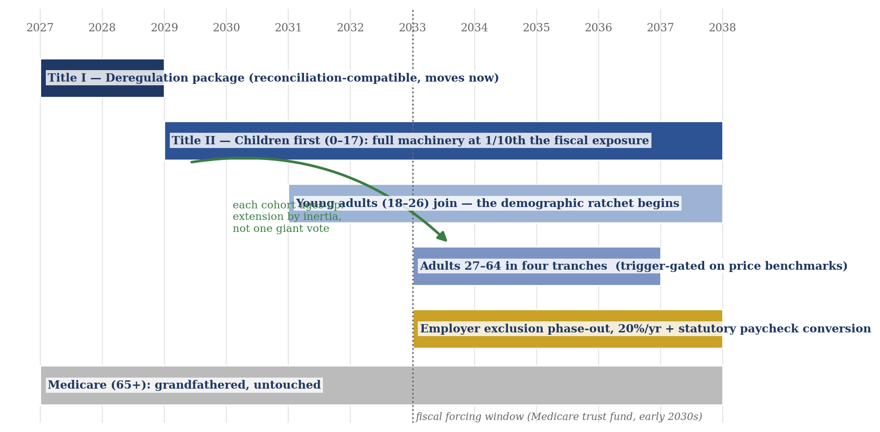
Figure 2. The transition: deregulation first, children first, then the demographic ratchet — extension by inertia rather than by one comprehensive vote.
Years | Phase | What happens
2027–2028 | Supply-side package | CON repeal incentives, residency expansion, scope-of-practice reform, binding price transparency, site-neutral payments, accelerated generic/biosimilar pathways. Price benchmarks published; the market-first clock starts.
2029 | Children first (0–17) | All children auto-enrolled in catastrophic coverage; HSA seeding for subsidized kids; Medicaid/CHIP child spending migrates into the AHOP Trust. Involuntary job-loss early opt-in opens for adults.
2031 | Young adults (18–26) | The demographic ratchet begins: the covered cohort ages up and the 18–26 population joins.
2033–2036 | Remaining adults (27–64) | Four equal annual tranches; employer tax exclusion phases out 20% per year (2033–2037) with statutory paycheck conversion; ACA subsidies and non-elderly Medicaid migrate with the tranches.
Medicare (65+) | Grandfathered | Existing Medicare beneficiaries are untouched in this draft; integration is deferred to a later phase decision.

5. Guaranteed Enrollment: Coverage Without a Mandate
AHOP contains no individual mandate. Universal participation is achieved through three mutually reinforcing mechanisms that produce mandate-level coverage rates without compulsion. First, auto-enrollment with opt-out: every eligible resident is enrolled by default in a benchmark catastrophic plan, with premiums and subsidies flowing through the tax system; anyone may affirmatively decline. The behavioral evidence here is decisive — automatic enrollment moved 401(k) participation from roughly sixty percent to roughly ninety percent without requiring anyone to do anything. Second, continuous-coverage protection, adapted from Republican legislative proposals of 2017: guaranteed issue and community rating are earned by maintaining coverage, and those who let coverage lapse face surcharges or waiting periods upon return — with both consequences income-scaled and capped, and with automatic grace for involuntary lapses: a layoff, which under this plan already triggers larger subsidies, never triggers a penalty. Continuity rules exist to discipline deliberate free-riding, not to punish financial instability. Third, late-enrollment pricing on the model of Medicare Parts B and D, whose permanent premium penalties for delayed enrollment have never been characterized as mandates in three decades of operation.
The honest pitch is that nobody is forced to buy anything; the system simply stops subsidizing the choice to free-ride. For the residual population that opts out and subsequently suffers a catastrophic event, hospitals will still treat, and the cost must land somewhere. This draft proposes retroactive enrollment with back-premiums owed, recoverable through the tax system, with Layer 3 absorbing genuinely uncollectable cases. Leaving this unspecified would be the kind of gap that unravels in a committee hearing, so it is specified.

6. Eligibility and Program Integrity
AHOP eligibility follows the same lawful-presence standards that govern current federal health programs — Medicaid, CHIP, and the ACA marketplaces. This is not a new restriction; it is the maintenance of eligibility rules that have applied under statutes enacted by both parties, and no federal subsidy dollar flows to any person not lawfully present. Four provisions complete the framework.
First, the direct-purchase allowance. Any person, regardless of status, may purchase a catastrophic policy or fund a health savings account at full, unsubsidized price with their own money. Current law paradoxically prohibits even unsubsidized exchange purchases by the undocumented; AHOP removes that prohibition while maintaining the absolute bar on subsidies. Every self-paid policy is an emergency-room bill that is not cost-shifted onto everyone else, so this provision protects the uncompensated-care savings the plan claims.
Second, the citizen-children firewall. Several million U.S.-citizen children live in households with at least one non-citizen parent. Those children are fully eligible, and the plan's children-first phase and its human-capital premise both depend on their enrollment. AHOP enrollment data is therefore statutorily walled off from immigration enforcement, on the model of the long-standing confidentiality protections for tax-return information — the same firewall that is the reason undocumented workers file federal taxes at all. The provision exists to ensure that eligible American children are actually enrolled.
Third, state extension with state funds. The federal floor is lawful presence. States that choose to extend coverage further — as several already do for children under state-funded programs — may do so through the Section 7 waiver process using exclusively state money. The federal principle is preserved; state programs are neither expanded nor abolished by federal law.
Fourth, the residual emergency fund. Federal law requires emergency departments to treat all comers, so a residual stream of uncompensated emergency care will persist under any eligibility rule. The plan retains a slimmed successor to today's Emergency Medicaid rather than pretending the stream vanishes, and the fiscal model's uncompensated-care savings are booked net of it.

7. Federalism: State Flexibility Waivers
A state that meets the federal floor — universal catastrophic protection for eligible residents, portability, the smart-deductible exemptions, and solvency of its risk-adjustment mechanism — may implement AHOP through its own machinery under a waiver process modeled on, but broader than, the ACA's Section 1332 waivers. States may administer subsidies differently, design their own reinsurance, structure their own benchmark plans, or extend eligibility and generosity beyond the floor with state funds. The federal government defines outcomes; states own implementations. This is a genuine ideological commitment to federalism rather than a concession: it gives each state a version of the system its voters chose, it relocates the most flammable coverage-definition disputes to statehouses where they are survivable, and it creates fifty laboratories whose results discipline the federal benchmarks over time. For the same reason, the federal benefits floor is defined in actuarial terms — protection against financial ruin, plus the exempt high-value schedule — rather than as an enumerated list of services, which history shows becomes the vehicle for every national culture-war dispute.

8. Financing
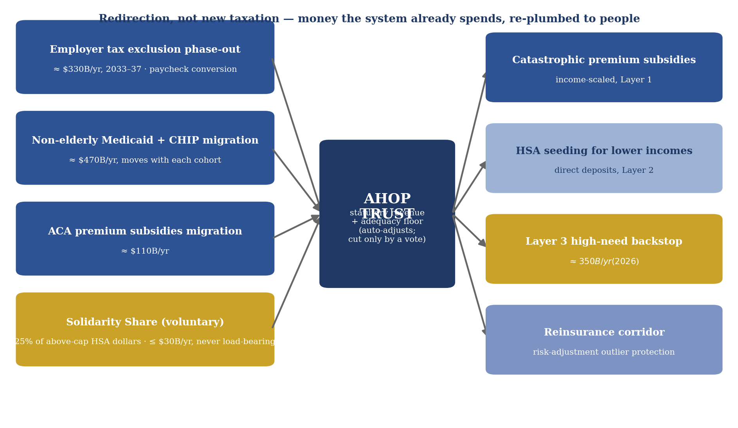
Figure 3. Financing flows: existing streams re-plumbed through the AHOP Trust to people — redirection, not new taxation.

The employer exclusion pivot and the paycheck conversion
AHOP's core financing move is the phased elimination of the employer tax exclusion — roughly $330 billion per year in forgone revenue today, growing with premiums — redirected into the catastrophic subsidies and HSA seeding of the new system. Economists across the spectrum agree employer premiums are ultimately paid by workers through suppressed wages; ending the exclusion converts an invisible compensation deduction into visible wages and personally owned coverage, and severs the link between employment and insurance in a single stroke. The exclusion phases out at twenty percent per year over 2033 to 2037, timed to the adult rollout.
Because the economic pass-through of premiums into wages is real but slow and uneven, the plan makes it statutory and visible rather than trusting it to arrive: an employer that discontinues coverage during the transition must convert its prior per-employee premium spending into wages, phased in and verified through payroll reporting for a defined window of three years, after which ordinary wage-setting resumes. Combined with a household-side offset ensuring the median household's net position is provably non-negative in official scoring, the provision converts the attack line 'they are taxing your health benefits' into the plan's own message: your employer has been quietly spending thousands of dollars of your compensation each year, and now it is visibly yours. Every predecessor reform that touched the exclusion — from the 2008 McCain plan to the ACA's Cadillac tax — died without such a mechanism; this plan does not repeat the omission.

The Solidarity Share: the HSA overflow pool
AHOP expands HSA contribution room dramatically, with a twist. Contributions up to an annual cap (illustratively $20,000) are conventional. Above the cap, contributions remain permitted and tax-advantaged — but twenty-five percent of each above-cap dollar is diverted to the Layer 3 fund as a Solidarity Share. The mechanism is voluntary: a high earner accepts a one-time haircut in exchange for decades of tax-free compounding on the retained seventy-five percent, a trade that plausibly beats a taxable brokerage account for long-horizon savers, and one whose skim rate can be tuned to the point of attractiveness. Politically, it lets the right describe a voluntary purchase of expanded tax shelter and the left describe high earners directly funding care for the poor — both accurately. The draft scores it conservatively, ramping from $10 billion to a $30 billion annual cap, and treats it as a supplement and political sweetener rather than Layer 3's foundation, since the revenue is inherently volatile and the expanded shelter's cost to the Treasury must be netted against it in any formal score.

The AHOP Trust
Layer 3 and the subsidy streams are housed in a dedicated trust fund with statutory revenue and a statutory funding formula, not an annual appropriation. The exclusion phase-out revenue, migrated Medicaid and ACA streams, and the Solidarity Share flow into the AHOP Trust by law, and outlays adjust automatically with enrollment and regional health costs. The design answers the safety-net objection that has met every market-oriented plan — that the backstop for the poor and the sick will be starved in the first budget fight — with the same structural insulation that has protected Social Security politically for nine decades. To the fiscal-conservative objection that a trust is a new entitlement, the honest answer is that it replaces Medicaid's non-elderly spending rather than adding to it, and that a visible formula with defined revenue is a capped, transparent commitment where an appropriation is an open tap.
The Trust carries a statutory adequacy floor: the formula's output for the high-need population may not fall below a defined actuarial benchmark, pegged at enactment to the actuarial value of current-law Medicaid coverage for that population and indexed to regional health costs. If Trust revenue would breach the floor, an automatic revenue adjustment activates — the safety net cannot be quietly starved by inaction, only visibly cut by a vote. No statute binds a future Congress — trust funds are accounting structures, not constitutional guarantees — so the floor’s real protection is political: it converts quiet erosion into a recorded vote against the sick and poor, which nine decades of Social Security history suggest is the strongest durability any American program achieves. The floor converts the plan's most persistent credibility gap with skeptics of market reform into a mechanical guarantee, at the cost of a contingent revenue obligation that fiscal scoring must acknowledge. Where the floor is set — not whether one exists — remains the honest open question flagged in Section 13.
Two operational notes complete the Trust design. First, it is solvent without the Solidarity Share: stress-tested at zero voluntary participation, the framework’s 2040 fiscal position changes by under five percent and peak transition cost rises by roughly $13 billion — the Share is a sweetener, never a load-bearing member. Second, because states currently define high-need eligibility and disability thresholds in widely divergent ways, migration into the Trust follows a state-by-state reconciliation schedule with hold-harmless corridors during the phase-in, converging on the federal definition over the transition rather than pretending a standardized baseline exists on day one.

9. Fiscal Projections
A rough fourteen-year fiscal model (2027–2040) accompanies this draft as a spreadsheet with fully documented assumptions and adjustable scenario levers. It is a directional sketch, not a Congressional Budget Office score: it omits behavioral responses, wage pass-through timing, macroeconomic feedback, and state budget interactions, and it grandfathers Medicare entirely. A one-way sensitivity grid accompanies the model — twelve full recalculations varying Layer 3 sizing (±30%), the adult premium (±30%), the Medicaid migration figure (±20%), the compression rate, the smart-deductible uplift, and a 25% shortfall in exclusion revenue — and every variation remains fiscally favorable by 2040: the parameters move the price and timing of the transition, not the sign of the outcome. Layer 3 and the migration figure dominate (peak cost swings between roughly $45 and $141 billion across their bounds). Its central findings are summarized below under the central scenario (supply-side reforms compress health cost growth by 0.75 percentage points annually from 2029) and the pessimistic scenario (deregulation stalls completely).
Metric | Partial dereg. success | Deregulation stalls
Peak annual net new federal cost | ≈ $92B (2031) | ≈ $100B (2032)
Cumulative net federal cost, worst point (2033) | ≈ $317B | ≈ $351B
Steady-state net federal position, 2040 (per year) | ≈ $449B better off | ≈ $333B better off
NHE as % of GDP, 2040 (baseline ≈ 22.3%) | ≈ 20.5% | ≈ 22.3%
Annual economy-wide savings vs. baseline, 2040 | ≈ $950B | ≈ $0

Three features of these results deserve emphasis. First, the transition is cheap relative to the system: the worst single year costs roughly $92 billion net, and the cumulative outlay peaks near $320 billion before offsets overtake costs around 2034. Second, the steady-state federal improvement must be interpreted honestly: roughly $650 billion of the 2040 offsets is the redirected employer exclusion, which is revenue from ending a tax break rather than an efficiency gain. The plan is best described as fiscally self-financing through redirection, not as a federal money-maker. Third, and most important, the federal ledger is nearly indifferent to whether deregulation succeeds — but the economy is not. If supply-side reform stalls, the country remains on the 22-percent-of-GDP baseline and forfeits savings approaching a trillion dollars a year. All of the plan's real value is concentrated in the deregulation package, which is why it is sequenced first, why later phases are tied to price-benchmark triggers, and why the reference-price fallback of Section 3 exists.

10. Economic Effects
The demand-side mechanics rest on the RAND Health Insurance Experiment, still the gold-standard evidence, which found that cost sharing reduces spending substantially without harming average health outcomes — but with the critical caveat that people cut effective and ineffective care indiscriminately, and that low-income and chronically ill participants fared worse. Contemporary evidence sharpens the caveat rather than retiring it: modern studies of employer populations moved onto high-deductible plans find that consumers cut effective and ineffective care alike and rarely price-shop even when comparison tools exist, and the Oregon Medicaid experiment reinforces the financial-protection findings. The framework accordingly takes its causal core from RAND and its design instruction from the modern high-deductible literature: exemptions and defaults, not exhortation. A related boundary deserves stating plainly: this framework never asks a patient to comparison-shop for cancer treatment, emergency care, or complex illness. That care lives above the deductible in Layer 1, where insurers negotiate on the patient’s behalf; consumer shopping applies only to the routine, schedulable segment — roughly a third of spending — where the cash-pay corners of today’s market already prove it works. The smart deductible of Section 3 is the structural answer to that caveat: the categories of care where indiscriminate cutting causes measurable harm are exempted from cost sharing entirely, while the price signal is preserved for the shoppable majority of encounters. The remaining calibration work — setting income scaling and seeding levels so that low-income households neither skip needed non-exempt care nor lose the price signal — is a parameter-tuning exercise flagged in Section 13.
Supply-side effects arrive on staggered timelines: clinic entry, direct primary care, and cash-pay competition respond within years, while physician supply takes a decade. Price transparency alone has mixed evidence and can even facilitate tacit collusion in concentrated markets, which is precisely why the deregulation package treats transparency and market-structure reform as inseparable. The macroeconomic story runs through labor: portable coverage ends job lock, which existing evidence links to suppressed entrepreneurship and job-switching, and the compression of administrative overhead — roughly eight percent of U.S. health spending against three percent in peer systems — releases resources to wages and consumption over a decade rather than in a single displacing shock. The transition is nonetheless redistributive, from hospital systems, insurers, and benefits administrators toward workers and new entrants, and the losers are organized while the winners are diffuse. That asymmetry, more than any economic quantity, is the plan's central political problem.

11. Portability: What Happens When You Lose Your Job
Under AHOP, nothing about coverage is attached to employment, so job loss does not create a coverage event at all. The catastrophic policy is held in the individual's name and simply continues; the HSA balance, including all past employer contributions, is the individual's property; and because subsidies scale with income, a layoff automatically triggers a lower deductible and larger premium support — the system becomes more generous at exactly the moment of vulnerability, the inverse of the COBRA regime it replaces. Two implementation requirements follow. Subsidy responsiveness must operate on monthly or quarterly income attestation rather than annual tax reconciliation, or the protection arrives a year late. And during the transition, the early opt-in for involuntary coverage loss (Section 4) covers workers whose cohorts have not yet phased in.

12. The Political Landscape
AHOP is, structurally, the McCain 2008 financing reform plus the ACA's universality mechanics plus Singapore's savings architecture — which means each party has already rejected one of its load-bearing components, and each has also proposed one. The plan's response is to answer each party's core objection inside the architecture rather than beside it. To the Democratic charge of universal underinsurance, the answer is the smart deductible, built on the same RAND evidence the charge cites. To the Democratic prediction that the backstop will be starved, the answer is the AHOP Trust with statutory revenue. To the Democratic fear that competition never arrives, the answer is the reference-price fallback that activates automatically where prices fail to compress. To the Republican charge that guaranteed enrollment is a mandate in disguise, the answer is the genuine absence of compulsion — defaults, continuous-coverage rules, and Medicare-style late pricing, mechanisms the party has itself proposed or long accepted. To the charge that ending the exclusion is a middle-class tax increase, the answer is the statutory paycheck conversion and a scored guarantee that the median household is not worse off. To the demand for federalism, the answer is waivers that give every state ownership of its implementation. Remaining criticisms — Arrow's information-asymmetry objection to consumer medicine, the regressivity history of HSAs, the churn of transitioning the covered population — are engaged in Section 13 rather than denied.
Interest-group opposition from hospital systems, insurers, and organized medicine cuts across party lines and concentrates in exactly the districts whose members sit on the relevant committees. The realistic path therefore runs through sequencing. The deregulation package polls well, splits donor classes rather than voters, and has already advanced in both red and blue states; it goes first. The children's phase leverages the CHIP precedent and the unique political immunity of covering kids. The financing overhaul — the exclusion phase-out and full adult rollout — waits for a fiscal forcing event, most plausibly the Medicare trust fund exhaustion window of the early 2030s, when Congress must legislate something large in any case. Price-benchmark triggers on the later phases give skittish legislators an off-ramp that lowers the cost of voting yes.

The legislative pathway: severable by design
The graveyard of predecessor frameworks teaches one more lesson. Comprehensive market-based bills — the Fair Care Act across three Congresses, the Health Care Fairness for All Act across two — were introduced, referred to committee, and expired without a hearing, not because their policy failed scrutiny but because they never received any: they were marker bills awaiting a window that did not open. Since 2017, both parties have operated under an explicit doctrine of narrow, targeted health legislation, and the recent record confirms it — the health provisions that have actually become law moved as discrete pieces attached to must-pass fiscal vehicles, while standalone comprehensive bills moved nowhere. AHOP is therefore drafted to be severable. Title I, the deregulation package, is designed to travel alone — it is budget-scoreable, reconciliation-compatible, and consistent with the targeted-changes doctrine. Title II, the children's phase, is a self-contained coverage bill in the CHIP genre, the most consistently passable category in American health policy, and it stands up the full machinery at small scale. The remaining titles are trigger-gated and wait, pre-drafted, for the forcing event — most plausibly the Medicare trust-fund exhaustion window of the early 2030s — at which point the decisive advantage belongs to whoever holds a ready-made, internally consistent, pre-scored architecture. Two scoring facts distinguish this framework from its predecessors when that window opens: it is a coverage expansion, so official estimates show coverage gains where every repeal-era bill showed losses; and its transition is self-financing through redirection rather than through benefit cuts. This framework is not a bill to introduce. It is the architecture to have ready.

13. Honest Vulnerabilities and Open Questions
A proposal is credible in proportion to the problems it admits. First, Layer 3 adequacy: the Trust and its statutory floor guarantee the backstop mechanically, but the floor's level is a number someone must set — the chronically ill exceed any deductible annually, consumer discipline does not apply to them, and the plan's health premise collapses if the benchmark is pegged low. Layer 3 remains the model's least certain cost. Second, calibration: the smart deductible answers the RAND caveat structurally, but the income-scaling and seeding parameters for non-exempt care are not yet tuned, and this draft does not pretend otherwise. Third, the Singapore objection: the closest existence proof for this architecture involves a government that benchmarks prices and plans supply more actively than pure-market advocates acknowledge; the reference-price fallback is this plan's version of that admission, and pure-market advocates will dislike its existence. To state the transferability claim precisely: AHOP borrows Singapore’s financing logic — personal health savings backed by catastrophic pooling — and nothing else; it does not import state hospital ownership, land economics, central supply planning, or compulsory savings, and it substitutes competition-with-a-tested-fallback for Singapore’s direct price benchmarking. The claim is that the financing architecture travels; the claim is not that Singapore does. Fourth, the exclusion politics: every serious attempt to touch the employer exclusion has died across both parties, and while the paycheck conversion is designed against that history, whether it survives sustained attack advertising is genuinely uncertain. Fifth, the Solidarity Share must be shown, in formal scoring, to raise more for the Trust than its expanded tax shelter costs the Treasury. Sixth, transition-era churn: even a decade-long phase-in reorganizes coverage for the entire non-elderly population, and the political memory of 'if you like your plan, you can keep it' sets the standard of caution. Seventh, cognitive load: a system of accounts, quotes, and choices shifts work onto patients, and for some — the elderly, the seriously ill, the simply overwhelmed — that burden is itself a cost paid in avoided care and anxiety rather than in dollars; the design answer is defaults and decision-support tooling, but whether software fully discharges the burden is an empirical question this draft cannot settle. Each of these is an open work item, not a footnote.

14. Negotiable Space and Anticipated Amendments
This document is a framework, not a bill, and it deliberately does not pre-concede the amendments a legislative negotiation would extract. It does, however, map that negotiation in advance, because a framework that anticipates the endgame is more useful to those who would carry it. The demands below are anticipated from each faction, sorted by whether the architecture can absorb them.
Amendments the architecture absorbs without damage — the expected currency of negotiation. From the left: a statutory out-of-pocket maximum layered onto the income-scaled deductible; expansion of the smart-deductible exempt schedule to include mental-health maintenance and primary care, with periodic independent review empowered to add or remove categories. From the right and center: converting the employer-exclusion repeal into a cap that ratchets down on the same schedule — a near-equivalent revenue path whose politics attach to high-cost plans rather than to every worker's benefits, and a design both parties have separately proposed in past budgets; a market-concentration gate on the reference-price fallback so it can only ever activate in demonstrably uncompetitive regions, together with a sunset and reauthorization requirement; and enforcement mechanics on the paycheck conversion, such as certification through existing benefits filings with a private right of action. From fiscal hawks: annual audit certification that the direct-purchase allowance carries zero subsidy. Each of these strengthens or merely reprices a provision; none breaks the machine, and several are improvements the framework would accept gladly.
Demands the architecture cannot absorb — the boundaries of the possible. A public option competing alongside Layer 1 plans breaks the risk-adjustment pool that guaranteed issue depends on: a plan with implicit federal backing does not bear risk the way its competitors must, and the market unravels around it. The dormant reference-price fallback is this framework's answer to the same underlying demand — a guarantee against market failure — and negotiators seeking a public backstop should be pointed there. Symmetrically, splitting the deregulation title into a standalone bill forfeits the universality that purchases support from the other side, and the fiscal analysis of Section 9 shows the financing architecture is safe precisely because it is paired with supply reform; the halves are not separable without each losing its justification. These two demands — each faction's wish to keep only the half it likes — are the anticipated stalemates, and the framework's answer to both is the same: the pairing is the plan.
The negotiating principle underneath this map: every predictable objection should be answered by converting an assurance into a mechanism — a cap, a floor, an audit, a gate, a sunset — rather than by rhetoric. The framework's core already follows that principle; the amendments above simply extend it, and their availability is the signal to every faction that a version of this plan exists that they can live with.

15. Conclusion: The Design Principle
AHOP is offered as a healthcare framework, but the method underneath it generalizes. Every commitment in this document that began as a promise ends as a mechanism: universality became auto-enrollment with actuarial consequences; safety-net adequacy became a trust with a statutory floor; wage pass-through became a certified paycheck conversion; market discipline became a concentration-gated fallback with a sunset; federal restraint became a waiver architecture; even the negotiation itself became a mapped space with named boundaries. The design principle — that a politically durable policy converts every assurance into an institution that operates by default and can be altered only by a visible vote — is the framework’s deepest claim, and it applies well beyond healthcare. What remains is empirical work, not invention: the mechanisms are specified; whether they perform as modeled is a question the sensitivity grid bounds but only implementation can answer.

Appendix A: Key Model Assumptions
The accompanying workbook (healthcare_plan_fiscal_model.xlsx) documents every input with its source or estimation basis. Headline assumptions: 2026 national health expenditure of $5.4 trillion growing 5.6 percent annually at baseline (CMS-consistent); GDP of $30 trillion growing 4 percent nominal; 38 million subsidized children at a $1,300 catastrophic premium with an 80 percent average subsidy and $800 account seed; 39 million young adults (45 percent subsidy-eligible, $2,300 premium, 70 percent subsidy); 158 million adults 27–64 (40 percent eligible, $4,800 premium, 65 percent subsidy); Layer 3 at $350 billion in 2026 dollars growing with health costs; Medicaid/CHIP migration of $470 billion; employer exclusion of $330 billion growing 5 percent annually, phased out 2033–2037; ACA subsidy migration of $110 billion; Solidarity Share revenue ramping from $10 billion to a $30 billion cap; and program administration at 3 percent of subsidy outlays. Scenario compression values of 0.00, 0.75, and 1.50 percentage points off cost growth from 2029 represent deregulation stalling, partial success, and full success respectively. Model v1.1 scores the smart-deductible premium uplift (8 percent net of avoided claims), the federal reinsurance corridor ($20 billion in 2026 dollars), and the Solidarity Share net of its tax-shelter cost (70 percent factor). Still unscored: the adequacy floor's contingent revenue trigger, the reference-price fallback (which makes the stall scenario conservative), and paycheck-conversion enforcement. The Layer 3 figure, the Medicaid migration figure, and the adult premium are the three inputs doing the most work and should be stress-tested at plus or minus 30 percent before this document is shown externally.

Appendix B: Selected References and Evidentiary Basis
The framework’s claims rest on the following representative literature, grouped by the argument each supports. Market limits and insurance economics: Arrow, ‘Uncertainty and the Welfare Economics of Medical Care’ (American Economic Review, 1963); Pauly, ‘The Economics of Moral Hazard’ (AER, 1968). Cost sharing and its hazards: Newhouse and the RAND Insurance Experiment Group, Free for All? (Harvard University Press, 1993); Brot-Goldberg, Chandra, Handel, and Kolstad, ‘What Does a Deductible Do?’ (Quarterly Journal of Economics, 2017); Finkelstein et al., ‘The Oregon Health Insurance Experiment’ (QJE, 2012) and Baicker et al. (New England Journal of Medicine, 2013). Value-based design: Chernew, Rosen, and Fendrick, ‘Value-Based Insurance Design’ (Health Affairs, 2007). Catastrophic-coverage architectures: Feldstein, ‘A New Approach to National Health Insurance’ (The Public Interest, 1971); Dolan’s universal catastrophic coverage work (Niskanen Center); Enthoven’s managed-competition literature (Health Affairs, 1993). Benefits incidence and job lock: Summers, ‘Some Simple Economics of Mandated Benefits’ (AER, 1989); Gruber, ‘The Incidence of Mandated Maternity Benefits’ (AER, 1994); Madrian, ‘Employment-Based Health Insurance and Job Mobility’ (QJE, 1994). Defaults: Madrian and Shea, ‘The Power of Suggestion’ (QJE, 2001). Provider markets and prices: Cooper, Craig, Gaynor, and Van Reenen, ‘The Price Ain’t Right?’ (QJE, 2019); Gaynor, ‘What to Do About Health-Care Markets?’ (Hamilton Project, 2020); Desai et al. on the limits of transparency tools (JAMA, 2016). Administrative costs: Himmelstein, Campbell, and Woolhandler (Annals of Internal Medicine, 2020). Comparative systems: Haseltine, Affordable Excellence: The Singapore Healthcare System (Brookings, 2013); OECD Health at a Glance series. Political durability: Pierson, ‘Increasing Returns, Path Dependence, and the Study of Politics’ (American Political Science Review, 2000); Olson, The Logic of Collective Action (1965); Tsebelis, Veto Players (2002). Baselines: CMS Office of the Actuary national health expenditure projections; Congressional Budget Office health coverage baselines; KFF Employer Health Benefits Survey. Citations are representative rather than exhaustive; a fully footnoted edition is planned for academic submission.

