GAME MECHANICS

CONTENTS:

1. COMBAT
   1. Weapons and basics
   2. Magic and skills
   3. Armor
   4. Spell and Skill chart
2. GAMEPLAY
   1. Quests
   2. Leveling up
   3. Items
   4. Mobs
   5. Mob and item chart
3. **COMBAT**
   1. **Weapons and basics**

The player will select his weapon from within the inventory alone and won’t be using a hotbar for that.

He will, however have a 5-slot-hotbar mini-hotbar (3 slots) for assigning consumables such as potions, food and scrolls, but they’ll be discussed in a later chapter.

Upon opening the inventory, the game will be paused.

The player will be able to master different weapons and use attribute points to increase the efficiency with that specific weapon (attack speed, damage etc. we will get into more detail regarding each type of weapon later).

There will be a total of 10 mastery levels for each weapon type. A mastery level is earned by **killing** enemies with that specific weapon.

The mastery levels play an important role in the game, the higher the **ML** (mastery level) the higher tier weapon you can wield.

With each **ML** you unlock skills and perks for that specific weapon, we call them COMBAT SKILLS.

Each of these **Attribute Points** will increase the player’s overall stats:

- Strength (str): Increases player's attack damage. (+1.0 AD)

- Dexterity (dex): Increases player's attack speed. (+0.25% AS)

- Intelligence (int): Increases player's magic damage. (+1.0 AP)

- Vitality (vit): Increase player's health. (+5 HP)

- Agility (agi): Increase player's walking speed. (+0.3 MS)

- Wisdom (wis): Increase player's ability to learn skill books. (+1 SBL)

Below will be a table that shows which attributes empower what weapons and after that we’ll talk about magic types and skills and armor in the next sections of this chapter.

The weapons in the table will be ordered by the impact the attribute (wp1 being the weapon affected the least) will have on the efficiency overall, there will also be some numbers defining them, but they’re going to be added at a later stage in the game-making process.

|  |  |  |  |  |  |  |
| --- | --- | --- | --- | --- | --- | --- |
| Attribute / Weapon | STR | DEX | INT | VIT | AGI | WIS |
| WP 1 | Great  Sword | Bow | Wand | Wooden Shield | Scythe | Book |
| WP 2 | DH  Axe | Crossbow | Scepter | Iron Shield | Dagger | Scythe |
| WP 3 | Chained  Mace | Hand  Crossbow |  | Reinforced Iron Shield | Hand  Crossbow |  |
| WP 4 | Sword | Short  Sword |  | Cobalt Shield |  |  |
| WP 5 | Axe | Scythe |  |  |  |  |
| WP 6 | Mace |  |  |  |  |  |

* 1. **Magic and skills**

The magic works similar to the weapons meaning there will be magic types and the more you use one type you will gain **ML** for that specific type.

A higher **ML** in a magic type will grant you the possibility to learn higher tier magic spells which can be learned through **Spell Books** or gameplay (talking to an NPC or by completing a quest).

Also, a core mechanic of our game will be Type Morphing (or just morphing) meaning that the player can combine two types of his choice that have the same mastery level.

There will be 1 skill for each morphing, one for **ML** 1-4, one for **ML** 5-8 and one for **ML** 9-10.

Each skill has an **Upgrade Level**, being different from **ML**.

The **Upgrade Level** will: increase dmg/healing/buffing done, increase cd/mana cost and increase the skill’s range (for ranged skills).

Even if there’s a single skill, it will be extremely powerful and not to be taken lightly.

The magic types will be: Fire, Water, Earth, Air, Light, Dark.

Here is the morphing table that we’ll be using:

|  |  |  |  |  |  |  |
| --- | --- | --- | --- | --- | --- | --- |
| ###### | Fire | Water | Earth | Air | Light | Dark |
| Fire | ###### | Mist | Lava | Ash | ###### | ###### |
| Water | Steam | ###### | Mud | Ice | ###### | ###### |
| Earth | Lava | Mud | ###### | Sand | ###### | ###### |
| Air | Ash | Ice | Sand | ###### | Electricity | Poison |
| Light | ###### | ###### | ###### | Electricity | ###### | ###### |
| Dark | ###### | ###### | ###### | Poison | ###### | ###### |

More combinations **may** be added as the game progresses.

* 1. **Armor**

There will be 3 armor classes and, as above they will each have a **ML**.

The armor types are: Light, Medium and Heavy.

With each **ML** gained you can choose a perk for the worn armor class.

Again the attributes you choose empower the armor’s stats:

* STR – Heavy
* DEX – Medium
* INT – Light.

The worn armor will protect 100% of the Armor Points it has for each AD damage taken. (DMG Taken = Incoming Damage – Armor Points. If the DMG Taken is a negative number the player will take 0 damage.)

* 1. **Spells and Skills**

The player will be able to select 5 skills at a time in a hotbar at the bottom of the screen.

Each weapon type will have a skill that can be accessed at a certain **ML**.

There will be 4 types of skills:

* Area of Effect (AoE)
* Damage Over Time (DoT)
* Skill Shot (SS)
* Point n Click (PnC)

**\* The table with all the Spells and** **Weapon Skills will be added at a later stage in the game-making process. \***

Below you’ll find the **Area of Effect** for each type of attack.

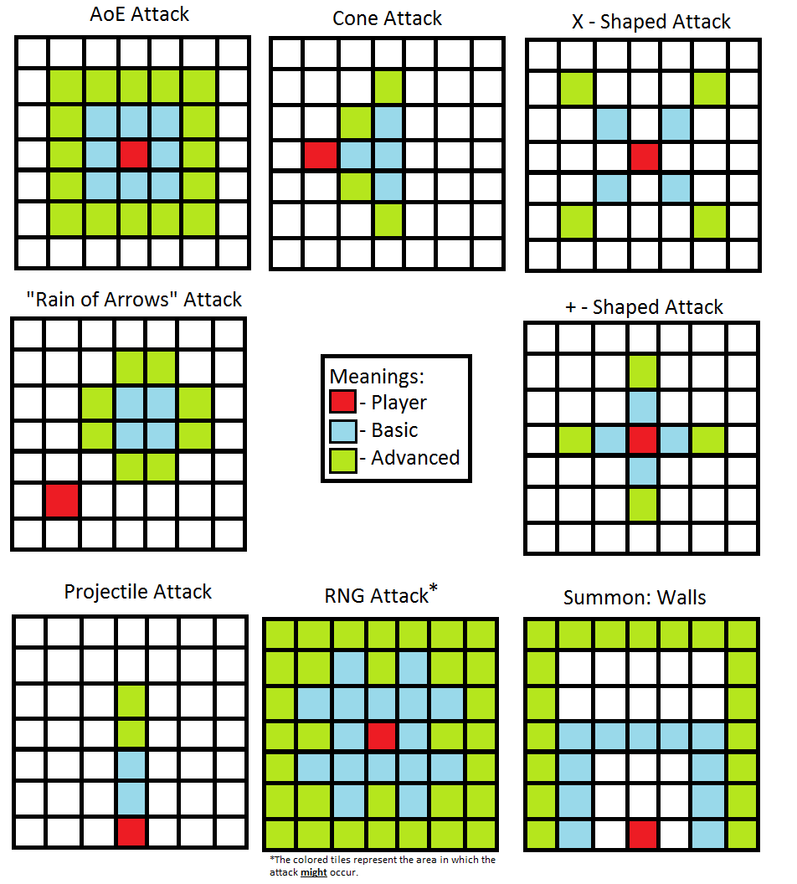

1. **COMBAT**
   1. **Quests**

The player will be able to accept quest from various NPCs throughout the game or on special occasions through collecting items such as letters or whatnot.

The quests give: Coins, XP, (occasionally) Items and Quest Items.

* 1. **Leveling Up**

There will be a maximum of 50 levels.

The player will get 7 attribute points / level to a total of 350 points.

He will spawn though with 10 attribute points to a grand total of 360 points – level 60 on each attribute if distributed evenly.

The attribute level cap however, will be 180.

* 1. **Items**

Each item will have a **Skill** and a **Name**, aside from it’s basic stats.

The **Weapon Skill** will be an active skill that the player can use. (eg.: Mace Bash, Axe Cleave, etc)

The **Weapon Name** will be a randomly selected name out of a “name pool” that empowers the weapon it is attributed to.

Below is a table with the current names in the pool and their affinity for each attribute.

|  |  |  |  |  |  |  |
| --- | --- | --- | --- | --- | --- | --- |
| ######### | STR | DEX | INT | VIT | AGI | WIS |
| Common |  |  |  |  |  |  |
| Uncommon |  |  |  |  |  |  |
| Magical |  |  |  |  |  |  |
| Crafty |  |  |  |  |  |  |
| Rare |  |  |  |  |  |  |
| Lucky |  |  |  |  |  |  |
| Unlucky |  |  |  |  |  |  |
| Quick |  |  |  |  |  |  |
| Slow |  |  |  |  |  |  |
| Tricky |  |  |  |  |  |  |
| Sweet |  |  |  |  |  |  |
| Legendary |  |  |  |  |  |  |
| Mythical |  |  |  |  |  |  |
| God-Tier |  |  |  |  |  |  |

**\* The numbers will be added at a later stage in the game-making process. \***

* 1. **Mobs aka Monsters**

The World-Map will have areas where certain mobs spawn.

Each area will have it’s own monster level spawning range and will not scale with the player’s level.

There will be about 30 different mobs in the game at it’s release and the count **may** increase as the development continues.

* 1. **Mobs and Item Charts**

**\* The chart will be added at a later stage in the game-making process. \***