**Python Introduction**

Python is a general purpose, dynamic, high level, and interpreted programming language. It supports Object Oriented programming approach to develop applications. It is simple and easy to learn and provides lots of high-level data structures.

Python is easy to learn yet powerful and versatile scripting language, which makes it attractive for Application Development.

Python's syntax and dynamic typing with its interpreted nature make it an ideal language for scripting and rapid application development.

Python supports multiple programming pattern, including object-oriented, imperative, and functional or procedural programming styles.

Python is not intended to work in a particular area, such as web programming. That is why it is known as multipurpose programming language because it can be used with web, enterprise, 3D CAD, etc.

We don't need to use data types to declare variable because it is dynamically typed so we can write a=10 to assign an integer value in an integer variable.

**Python Features**

Python provides lots of features that are listed below.

1) Easy to Learn and Use

Python is easy to learn and use. It is developer-friendly and high level programming language.

2) Expressive Language

Python language is more expressive means that it is more understandable and readable.

3) Interpreted Language

Python is an interpreted language i.e. interpreter executes the code line by line at a time. This makes debugging easy and thus suitable for beginners.

4) Cross-platform Language

Python can run equally on different platforms such as Windows, Linux, Unix and Macintosh etc. So, we can say that Python is a portable language.

5) Free and Open Source

Python language is freely available at offical web address.The source-code is also available. Therefore it is open source.

6) Object-Oriented Language

Python supports object oriented language and concepts of classes and objects come into existence.

7) Extensible

It implies that other languages such as C/C++ can be used to compile the code and thus it can be used further in our python code.

8) Large Standard Library

Python has a large and broad library and prvides rich set of module and functions for rapid application development.

9) GUI Programming Support

Graphical user interfaces can be developed using Python.

10) Integrated

It can be easily integrated with languages like C, C++, JAVA etc.

**Python History and Versions**

Python laid its foundation in the late 1980s.

The implementation of Python was started in the December 1989 by Guido Van Rossum at CWI in Netherland.

In February 1991, van Rossum published the code (labeled version 0.9.0) to alt.sources.

In 1994, Python 1.0 was released with new features like: lambda, map, filter, and reduce.

Python 2.0 added new features like: list comprehensions, garbage collection system.

On December 3, 2008, Python 3.0 (also called "Py3K") was released. It was designed to rectify fundamental flaw of the language.

**Python Applications**

Python is known for its general purpose nature that makes it applicable in almost each domain of software development. Python as a whole can be used in any sphere of development.

Here, we are specifing applications areas where python can be applied.

1) Web Applications

We can use Python to develop web applications. It provides libraries to handle internet protocols such as HTML and XML, JSON, Email processing, request, beautifulSoup, Feedparser etc. It also provides Frameworks such as Django, Pyramid, Flask etc to design and development web based applications.

2) Desktop GUI Applications

Python provides Tk GUI library to develop user interface in python based application. Some other useful toolkits wxWidgets, Kivy, pyqt that are useable on several platforms. The Kivy is popular for writing multi - touch applications (Android Mobile and tab).

3) Software Development

Python is helpful for software development process. It works as a support language and can be used for build control and management, testing etc.

4) Scientific and Numeric

Python is popular and widely used in scientific and numeric computing. Some useful library and package are SciPy, Pandas, IPython etc. SciPy is group of packages of engineering, science and mathematics.

5) Business Applications

Python is used to build Bussiness applications like ERP and e-commerce systems. Tryton is a high level application platform.

6) Console Based Application

We can use Python to develop console based applications. For example: IPython.

7) Audio or Video based Applications

Python is awesome to perform multiple tasks and can be used to develop multimedia applications. Some of real applications are: TimPlayer, cplay etc.

8) 3D CAD Applications

To create CAD application Fandango is a real application which provides full features of CAD.

9) Enterprise Applications

Python can be used to create applications which can be used within an Enterprise or an Organization. Some real time applications are: OpenErp, Tryton, Picalo etc.

10) Applications for Images

Using Python several application can be developed for image. Applications developed are: VPython, Gogh, imgSeek etc.

**First Python Program**

In this Section, we will discuss the basic syntax of python by using which, we will run a simple program to print hello world on the console.

Python provides us the two ways to run a program:

1. Using Interactive interpreter prompt
2. Using a script file

Let's discuss each one of them in detail.

Interactive interpreter prompt

Python provides us the feature to execute the python statement one by one at the interactive prompt. It is preferable in the case where we are concerned about the output of each line of our python program.

First Python Program

Let's run a python statement to print the traditional hello world on the console. Python3 provides print() function to print some message on the console. We can pass the message as a string into this function. Consider the following image.

First Python Program

Here, we get the message "Hello World !" printed on the console.

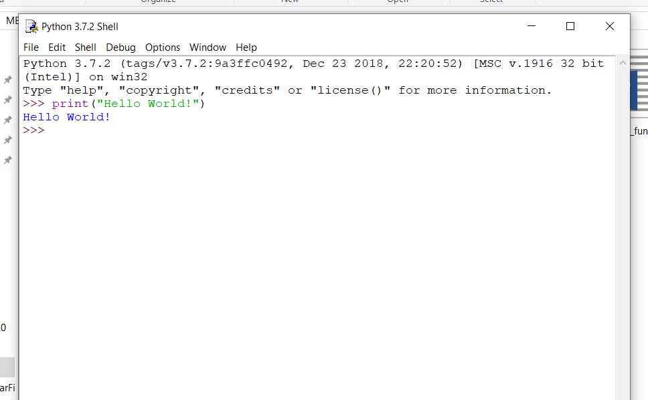

Using a script file

Interpreter prompt is good to run the individual statements of the code. However, we can not write the code every-time on the terminal.

We need to write our code into a file which can be executed later. For this purpose, open an editor like notepad, create a file named first.py (python used .py extension) and write the following code in it.

Print ("hello world"); #here, we have used print() function to print the message on the console.

To run this file named as first.py, we need to run the following command on the terminal.

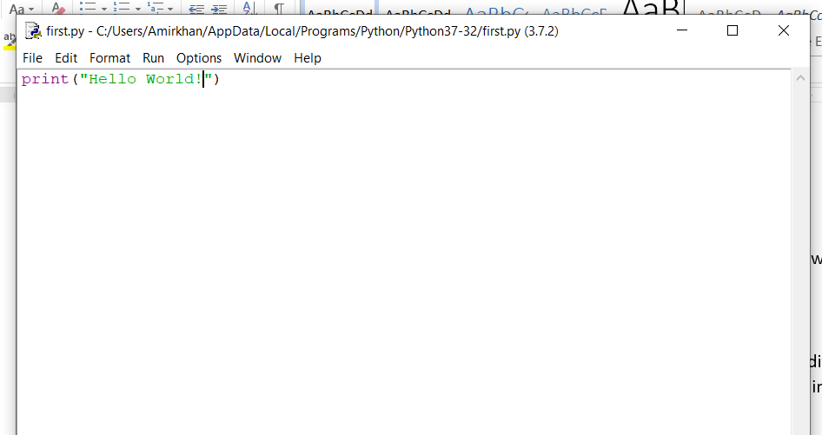

$ python3 first.py