- 配置开发者证书，修改SetupApplication.bat文件需要修改的部分
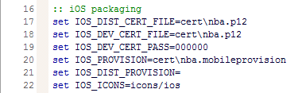

内容：
:: iOS packaging
set IOS_DIST_CERT_FILE=cert\nba.p12
set IOS_DEV_CERT_FILE=cert\nba.p12
set IOS_DEV_CERT_PASS=000000
set IOS_PROVISION=cert\nba.mobileprovision
set IOS_DIST_PROVISION=
set IOS_ICONS=icons/ios

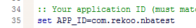

内容：
set APP_ID=com.rekoo.nbatest

