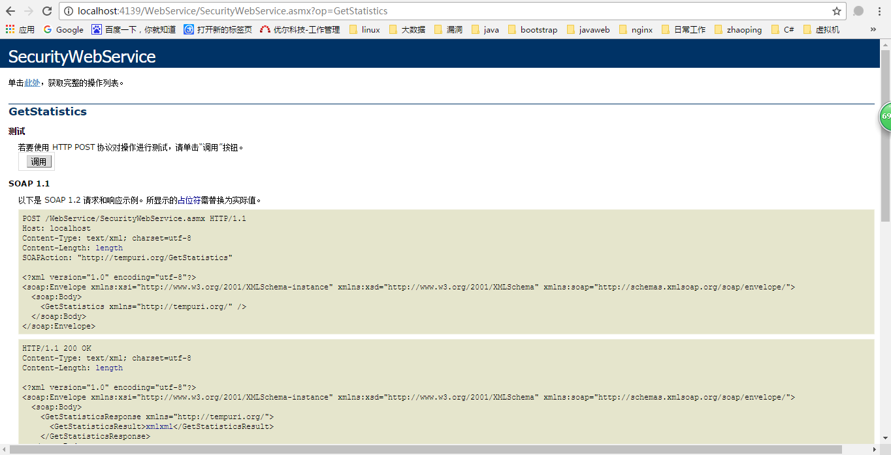

1. 获取最新指标数量接口

<http://localhost:4139/WebService/SecurityWebService.asmx/GetStatistics>

返回结果：

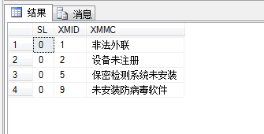

1. 获取指标的具体数据

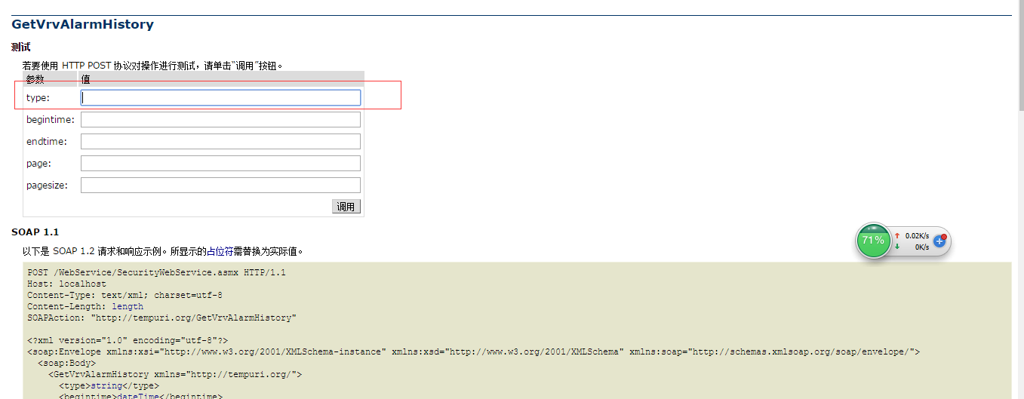

<http://localhost:4139/WebService/SecurityWebService.asmx?op=GetVrvAlarmHistory>

Type：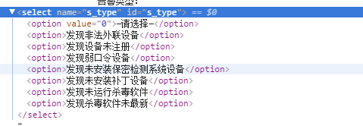

返回结果：

{"total":1,"rows":[{"ID":1,"ClassName":"sdfsf","DeptName":"asfsadf","AlarmType":"sdfsdfsf","DeviceName":"sdfsf","IPAddress":"192.168.1.1","Status":"0","Dt":"2016-11-25T00:00:00"}]}