TreeMap Zonal Validation

2024-02-14

Landfire zone: 16

Run name: 2016_Orig_Test_keepinbag_UT_Uintas_rect_maxpx1000_nT12

Variable: canopy_cover 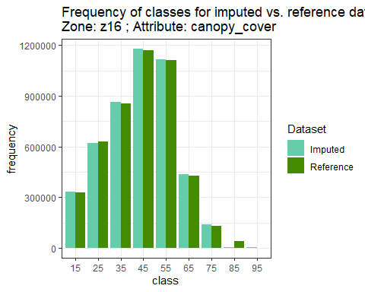

## Warning: Removed 1 rows containing missing values (`geom_point()`).

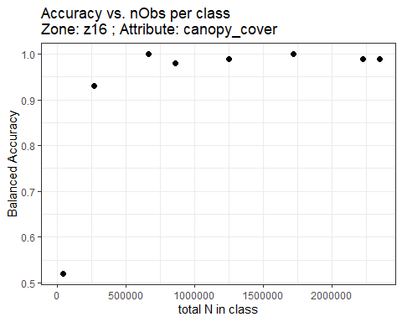

Confusion Matrix
Zone: z16 ; Attribute: canopy_cover

|  | **Reference** | | | | | | | | | | |
| --- | --- | --- | --- | --- | --- | --- | --- | --- | --- | --- | --- |
| **Predicted** | **15** | **25** | **35** | **45** | **55** | **65** | **75** | **85** | **95** | **Sum** | **Producer's Acc** |
| **15** | 328936 | 1676 | 166 | 906 | 565 | 613 | 311 | 10 | 0 | 333183 | **0.99** |
| **25** | 149 | 617780 | 98 | 675 | 841 | 1353 | 963 | 476 | 0 | 622335 | **0.99** |
| **35** | 1049 | 1110 | 853450 | 2276 | 2443 | 2248 | 486 | 175 | 0 | 863237 | **0.99** |
| **45** | 281 | 6897 | 1244 | 1163815 | 2370 | 2585 | 1357 | 93 | 0 | 1178642 | **0.99** |
| **55** | 3 | 772 | 211 | 2164 | 1102826 | 4421 | 3441 | 610 | 0 | 1114448 | **0.99** |
| **65** | 15 | 271 | 138 | 419 | 1868 | 413853 | 10927 | 7159 | 0 | 434650 | **0.95** |
| **75** | 0 | 0 | 0 | 11 | 374 | 793 | 110209 | 29601 | 0 | 140988 | **0.78** |
| **85** | 0 | 56 | 66 | 103 | 73 | 173 | 161 | 1225 | 0 | 1857 | **0.66** |
| **95** | 5 | 223 | 28 | 613 | 580 | 328 | 0 | 0 | 0 | 1777 | **0** |
| **Sum** | 330438 | 628785 | 855401 | 1170982 | 1111940 | 426367 | 127855 | 39349 | 0 | 4691117 | **NA** |
| **User's Acc** | 1 | **0.98** | **1** | **0.99** | **0.99** | **0.97** | **0.86** | **0.03** | **NA** | **NA** | **NA** |
| **Overall accuracy** | | | | | | | | | | | **0.98** |

Variable: canopy_height 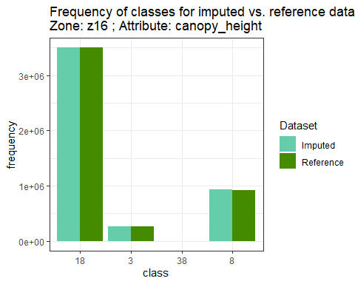

## Warning: Removed 1 rows containing missing values (`geom_point()`).

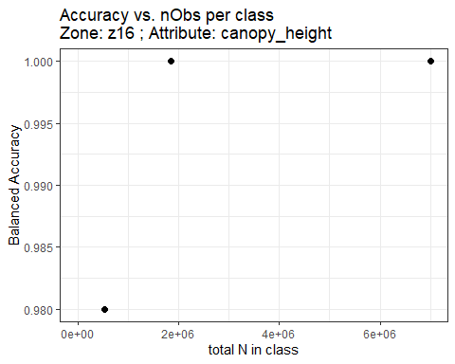

Confusion Matrix
Zone: z16 ; Attribute: canopy_height

|  | **Reference** | | | | | |
| --- | --- | --- | --- | --- | --- | --- |
| **Predicted** | **3** | **8** | **18** | **38** | **Sum** | **Producer's Acc** |
| **3** | 259701 | 830 | 117 | 0 | 260648 | **1** |
| **8** | 11508 | 919850 | 2941 | 0 | 934299 | **0.98** |
| **18** | 80 | 0 | 3496089 | 0 | 3496169 | **1** |
| **38** | 1 | 0 | 0 | 0 | 1 | **0** |
| **Sum** | 271290 | 920680 | 3499147 | 0 | 4691117 | **NA** |
| **User's Acc** | 0.96 | **1** | **1** | **NA** | **NA** | **NA** |
| **Overall accuracy** | | | | | | **1** |

Variable: EVT_GP 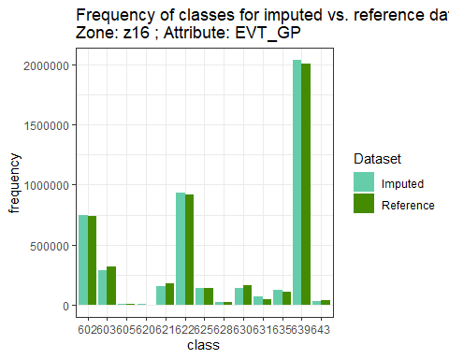

## Warning: Removed 1 rows containing missing values (`geom_point()`).

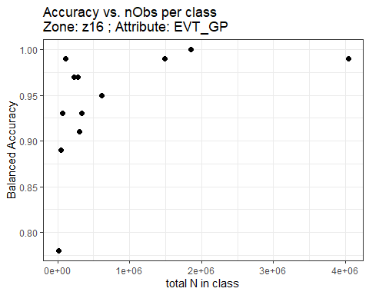

Confusion Matrix
Zone: z16 ; Attribute: EVT_GP

|  | **Reference** | | | | | | | | | | | | | | |
| --- | --- | --- | --- | --- | --- | --- | --- | --- | --- | --- | --- | --- | --- | --- | --- |
| **Predicted** | **602** | **603** | **605** | **620** | **621** | **622** | **625** | **628** | **630** | **631** | **635** | **639** | **643** | **Sum** | **Producer's Acc** |
| **602** | 731894 | 4784 | 823 | 0 | 2144 | 126 | 491 | 268 | 835 | 172 | 558 | 43 | 1280 | 743418 | **0.98** |
| **603** | 681 | 288093 | 9 | 0 | 102 | 66 | 19 | 66 | 35 | 0 | 99 | 8 | 505 | 289683 | **0.99** |
| **605** | 0 | 0 | 5220 | 0 | 1099 | 0 | 0 | 10 | 2998 | 0 | 24 | 0 | 0 | 9351 | **0.56** |
| **620** | 0 | 0 | 142 | 0 | 997 | 0 | 0 | 223 | 1641 | 0 | 0 | 0 | 0 | 3003 | **0** |
| **621** | 0 | 2 | 154 | 0 | 153470 | 0 | 0 | 1380 | 3073 | 0 | 67 | 0 | 28 | 158174 | **0.97** |
| **622** | 2017 | 1391 | 193 | 0 | 3877 | 917510 | 1340 | 351 | 3288 | 119 | 924 | 7 | 718 | 931735 | **0.98** |
| **625** | 825 | 6275 | 28 | 0 | 330 | 144 | 129565 | 104 | 292 | 2 | 1525 | 134 | 1055 | 140279 | **0.92** |
| **628** | 0 | 0 | 0 | 0 | 0 | 1 | 0 | 19659 | 0 | 0 | 23 | 0 | 0 | 19683 | **1** |
| **630** | 30 | 6 | 1332 | 0 | 1827 | 1 | 1 | 3279 | 132148 | 0 | 523 | 0 | 4 | 139151 | **0.95** |
| **631** | 840 | 4177 | 581 | 0 | 1497 | 83 | 95 | 53 | 14021 | 45637 | 529 | 7 | 203 | 67723 | **0.67** |
| **635** | 74 | 424 | 623 | 0 | 12120 | 1 | 167 | 67 | 2200 | 0 | 105230 | 12 | 6 | 120924 | **0.87** |
| **639** | 5631 | 13031 | 78 | 0 | 239 | 26 | 6236 | 26 | 63 | 17 | 1152 | 2008720 | 1127 | 2036346 | **0.99** |
| **643** | 25 | 186 | 3 | 0 | 12 | 1 | 0 | 0 | 0 | 0 | 87 | 0 | 31333 | 31647 | **0.99** |
| **Sum** | 742017 | 318369 | 9186 | 0 | 177714 | 917959 | 137914 | 25486 | 160594 | 45947 | 110741 | 2008931 | 36259 | 4691117 | **NA** |
| **User's Acc** | 0.99 | **0.9** | **0.57** | **NA** | **0.86** | **1** | **0.94** | **0.77** | **0.82** | **0.99** | **0.95** | **1** | **0.86** | **NA** | **NA** |
| **Overall accuracy** | | | | | | | | | | | | | | | **0.97** |

Variable: disturb_code 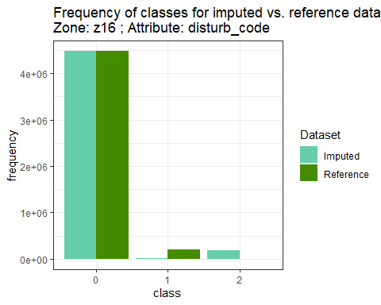

## Warning: Removed 1 rows containing missing values (`geom_point()`).

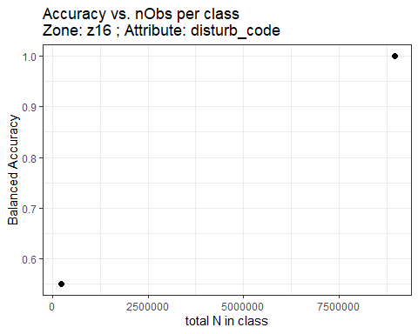

Confusion Matrix
Zone: z16 ; Attribute: disturb_code

|  | **Reference** | | | | |
| --- | --- | --- | --- | --- | --- |
| **Predicted** | **0** | **1** | **2** | **Sum** | **Producer's Acc** |
| **0** | 4480755 | 72 | 0 | 4480827 | **1** |
| **1** | 0 | 20427 | 0 | 20427 | **1** |
| **2** | 0 | 189863 | 0 | 189863 | **0** |
| **Sum** | 4480755 | 210362 | 0 | 4691117 | **NA** |
| **User's Acc** | 1 | **0.1** | **NA** | **NA** | **NA** |
| **Overall accuracy** | | | | | **0.96** |

Variable: disturb_year 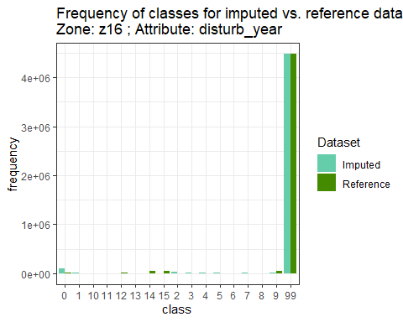

## Warning: Removed 1 rows containing missing values (`geom_point()`).

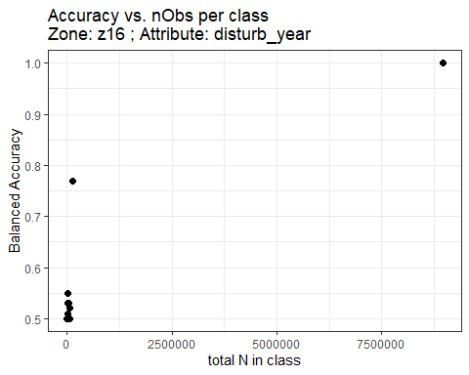

Confusion Matrix
Zone: z16 ; Attribute: disturb_year

|  | **Reference** | | | | | | | | | | | | | | | | | | |
| --- | --- | --- | --- | --- | --- | --- | --- | --- | --- | --- | --- | --- | --- | --- | --- | --- | --- | --- | --- |
| **Predicted** | **0** | **1** | **2** | **3** | **4** | **5** | **6** | **7** | **8** | **9** | **10** | **11** | **12** | **13** | **14** | **15** | **99** | **Sum** | **Producer's Acc** |
| **0** | 10209 | 1350 | 1580 | 3283 | 1950 | 1006 | 0 | 839 | 2166 | 27706 | 74 | 2792 | 3595 | 2802 | 23915 | 25243 | 0 | 108510 | **0.09** |
| **1** | 753 | 38 | 169 | 235 | 201 | 35 | 0 | 130 | 104 | 1933 | 0 | 129 | 115 | 284 | 1928 | 1447 | 0 | 7501 | **0.01** |
| **2** | 1482 | 186 | 204 | 340 | 1056 | 95 | 0 | 159 | 341 | 8161 | 49 | 424 | 735 | 298 | 8642 | 3883 | 0 | 26055 | **0.01** |
| **3** | 1028 | 99 | 366 | 564 | 89 | 125 | 0 | 53 | 171 | 2333 | 25 | 117 | 1059 | 402 | 3634 | 1862 | 0 | 11927 | **0.05** |
| **4** | 740 | 79 | 322 | 345 | 253 | 102 | 0 | 243 | 544 | 3505 | 12 | 600 | 597 | 536 | 2764 | 5900 | 0 | 16542 | **0.02** |
| **5** | 2142 | 59 | 142 | 383 | 211 | 35 | 0 | 109 | 287 | 3431 | 10 | 150 | 904 | 250 | 4196 | 1759 | 0 | 14068 | **0** |
| **6** | 184 | 16 | 56 | 68 | 21 | 17 | 0 | 1 | 47 | 1229 | 0 | 163 | 218 | 87 | 1746 | 556 | 0 | 4409 | **0** |
| **7** | 622 | 99 | 131 | 320 | 95 | 111 | 0 | 45 | 221 | 3226 | 9 | 306 | 438 | 297 | 1749 | 2141 | 0 | 9810 | **0** |
| **8** | 308 | 23 | 30 | 94 | 7 | 14 | 0 | 11 | 67 | 895 | 6 | 7 | 246 | 150 | 2485 | 258 | 0 | 4601 | **0.01** |
| **9** | 529 | 117 | 24 | 33 | 170 | 40 | 0 | 37 | 130 | 2168 | 4 | 48 | 84 | 40 | 2498 | 945 | 0 | 6867 | **0.32** |
| **10** | 0 | 0 | 0 | 0 | 0 | 0 | 0 | 0 | 0 | 0 | 0 | 0 | 0 | 0 | 0 | 0 | 0 | 0 | **NA** |
| **11** | 0 | 0 | 0 | 0 | 0 | 0 | 0 | 0 | 0 | 0 | 0 | 0 | 0 | 0 | 0 | 0 | 0 | 0 | **NA** |
| **12** | 0 | 0 | 0 | 0 | 0 | 0 | 0 | 0 | 0 | 0 | 0 | 0 | 0 | 0 | 0 | 0 | 0 | 0 | **NA** |
| **13** | 0 | 0 | 0 | 0 | 0 | 0 | 0 | 0 | 0 | 0 | 0 | 0 | 0 | 0 | 0 | 0 | 0 | 0 | **NA** |
| **14** | 0 | 0 | 0 | 0 | 0 | 0 | 0 | 0 | 0 | 0 | 0 | 0 | 0 | 0 | 0 | 0 | 0 | 0 | **NA** |
| **15** | 0 | 0 | 0 | 0 | 0 | 0 | 0 | 0 | 0 | 0 | 0 | 0 | 0 | 0 | 0 | 0 | 0 | 0 | **NA** |
| **99** | 0 | 0 | 32 | 1 | 0 | 0 | 0 | 0 | 0 | 11 | 0 | 11 | 11 | 0 | 4 | 2 | 4480755 | 4480827 | **1** |
| **Sum** | 17997 | 2066 | 3056 | 5666 | 4053 | 1580 | 0 | 1627 | 4078 | 54598 | 189 | 4747 | 8002 | 5146 | 53561 | 43996 | 4480755 | 4691117 | **NA** |
| **User's Acc** | 0.57 | **0.02** | **0.07** | **0.1** | **0.06** | **0.02** | **NA** | **0.03** | **0.02** | **0.04** | **0** | **0** | **0** | **0** | **0** | **0** | **1** | **NA** | **NA** |
| **Overall accuracy** | | | | | | | | | | | | | | | | | | | **0.96** |