TreeMap Zonal Validation

2023-12-14

Landfire zone: 16

Run name: testRows_7500_7900

## Variable: canopy_cover

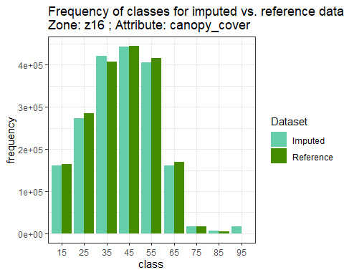

## Warning: Removed 1 rows containing missing values (`geom_point()`).

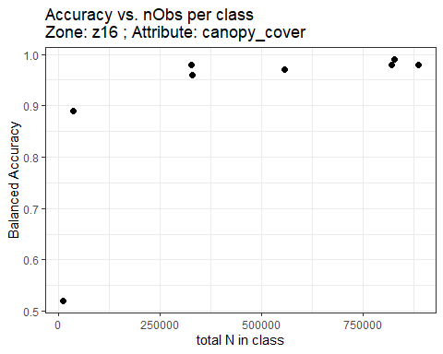

## Variable: canopy_height

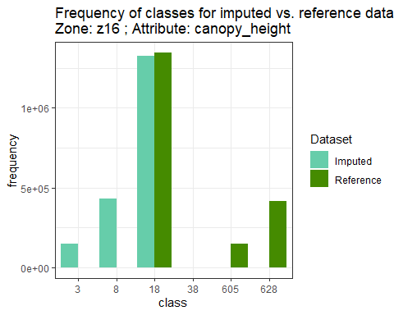

## Warning: Removed 2 rows containing missing values (`geom_point()`).

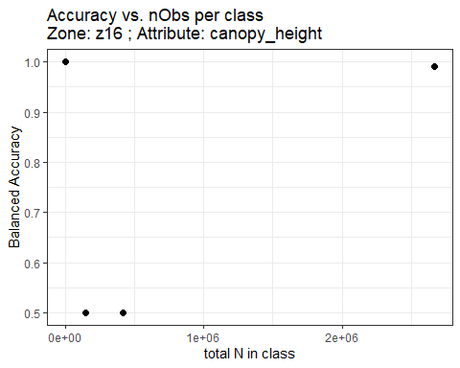

## Variable: EVT_GP

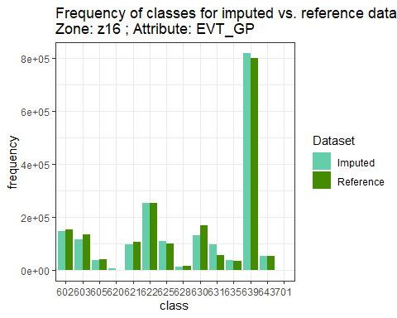

## Warning: Removed 1 rows containing missing values (`geom_point()`).

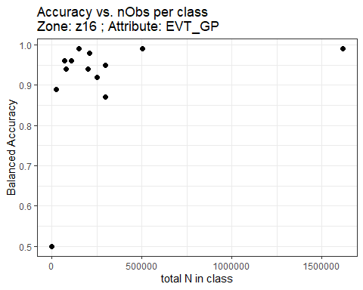

## Variable: disturb_code

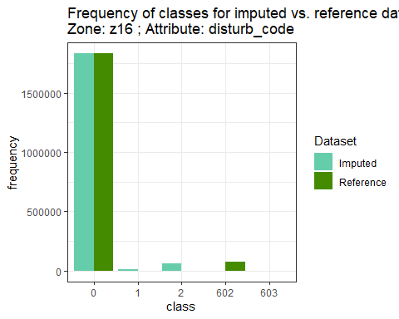

## Warning: Removed 2 rows containing missing values (`geom_point()`).

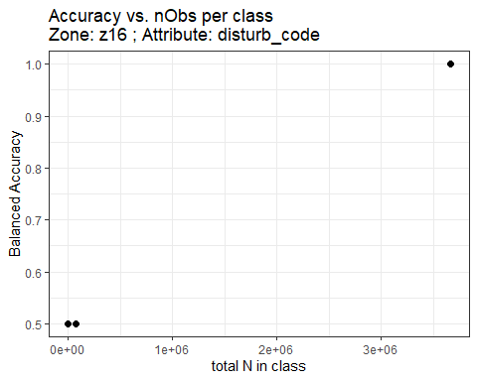

## Variable: disturb_year

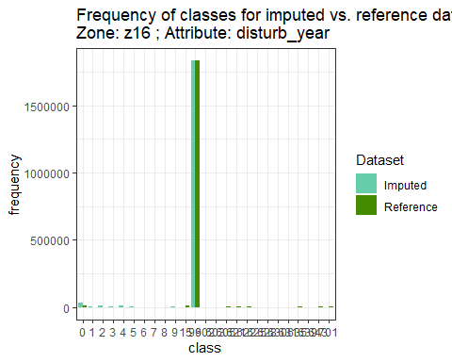

## Warning: Removed 9 rows containing missing values (`geom_point()`).

