Instructions for downloading an elevation file from the USGS Rapid Data Delivery System (RDDS) for use in WindNinja and WindWizard

Jason Forthofer

04.15.2011

The Rapid Data Delivery System (RDDS) (formerly called “Fire Data Ordering”) from the USGS is an interactive web based GIS tool useful for downloading the elevation files required for use in the WindNinja and WindWizard wind modeling programs. The tool allows users to zoom into the desired area and extract a seamless elevation file in one of the correct formats for WindNinja (ASCII Raster, GeoTIFF, or ERDAS Imagine) or WindWizard (ASCII Raster). A brief set of instructions describing the DEM extraction and download process is given below. More detailed instructions can be found on the RDDS viewer web page.

Step 1: In your web browser (such as Internet Explorer or Firefox) go to the RDDS web site: http://firedata.cr.usgs.gov . Left-click on the “Request Access” link to obtain a user name and password for this website. Once you have a user name and password, left-click on the “Access Viewer” link. A new window should open, enter the username and password when asked.

Step 2: Use the web mapping program and your mouse buttons to navigate to the area you are interested in.

Step 3: When you are zoomed into your area of interest, left-click the “Order Data” button at the top. Then left-click and drag a box around the area you want to download. The window shown below will open that allows you to select the products that you want.

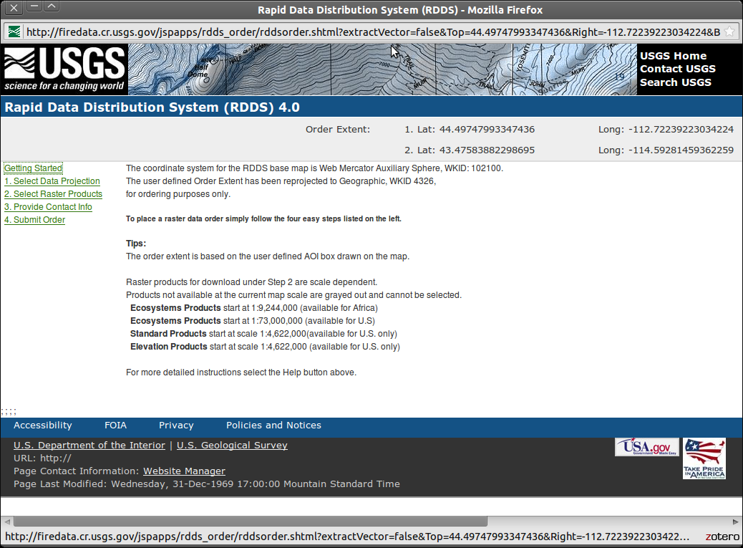

Step 4: Left-click the link on the left labeled “1. Select Data Projection”. Select either “UTM” or “ALBERS” (note that UTM is recommended if you don’t have a preference) for the projection. Select a datum, if you don’t know what datum you should use, NAD83 or WGS84 are usually good choices. Depending on what projection you selected, there will be some other input fields below “Datum”. The defaults should be fine, but you may edit these fields if you want (and know what you are doing).

Step 5: Left-click the link on the left labeled “2. Select Raster Products”. Under the section labeled “Elevation Product(s)” check the “DEM” check box. Just above this check box, there are options for what type of file format you want. The choices are ASCII Grid, GeoTiff, and ERDAS IMAGINE. WindNinja can read any of these file types, whereas WindWizard can only read the ASCII Grid file type. ASCII Grid is the most common file type in wildland fire, since it is also the file type used by FlamMap and FARSITE. The advantage of GeoTiff and ERDAS IMAGINE files are that they are much smaller files (binary compressed) and the projection/datum information is embedded in the file, rather than as a separate .prj file like ASCII Grid files.

Step 7: Left-click the link on the left labeled “3. Provide Contact Info”. In the “ORDER NAME” text box, type descriptive text that will be used in the file name. Possibilities include the fire name, such as “south_canyon_fire” or a geographic feature name such as “Bitteroot_River”. Spaces are not recommended, instead you can use the underscore character “_”. Fill out the other fields on this page (name, email, etc.).

Step 9: Left-click the link on the left labeled “4. Submit Order”. An order confirmation window should appear. You can close this window. Soon, two emails will be sent to you. The first is an order confirmation email. The second contains a link to the location were the elevation file can be downloaded. Left-click on this link to open the web page. On this web page, left-click on the “Download All Completed Files” button and save the .zip file to your hard drive. Now you can unzip this file using an unzip program such as WinZip. Tip: On many computers you can right-click on the .zip file in your file browser and select “Extract Here”, “Winzip->Extract Here”, or something similar. Below describes the types of files that may be present (depending on the elevation file type you picked):

*.asc → An ASCII Raster elevation file that can be read into WindNinja and WindWizard.

*.prj → A projection file that contains the GIS projection information for the *.asc file. It is a good idea to keep this with the *.asc file (in the same folder), especially if you want to use certain features in WindNinja such as output Google Earth wind files, initialize the simulation from a weather forecast model, compute diurnal flow, etc.

*.tif → A GeoTiff elevation file that can be read into WindNinja. All projection/datum information is contained in the file, so a *.prj file is not necessary.

*.img → An ERDAS IMAGINE elevation file that can be read into WindNinja. All projection/datum information is contained in the file, so a *.prj file is not necessary.

*.txt → This is a text file from RDDS describing the area that the elevation file covers. You do not need this file for wind simulations in WindNinja or WindWizard.

Now you should have a seamless elevation file in a format that can be read directly into WindNinja or WindWizard.

