WindNinja Tutorial 3: Point Initialization

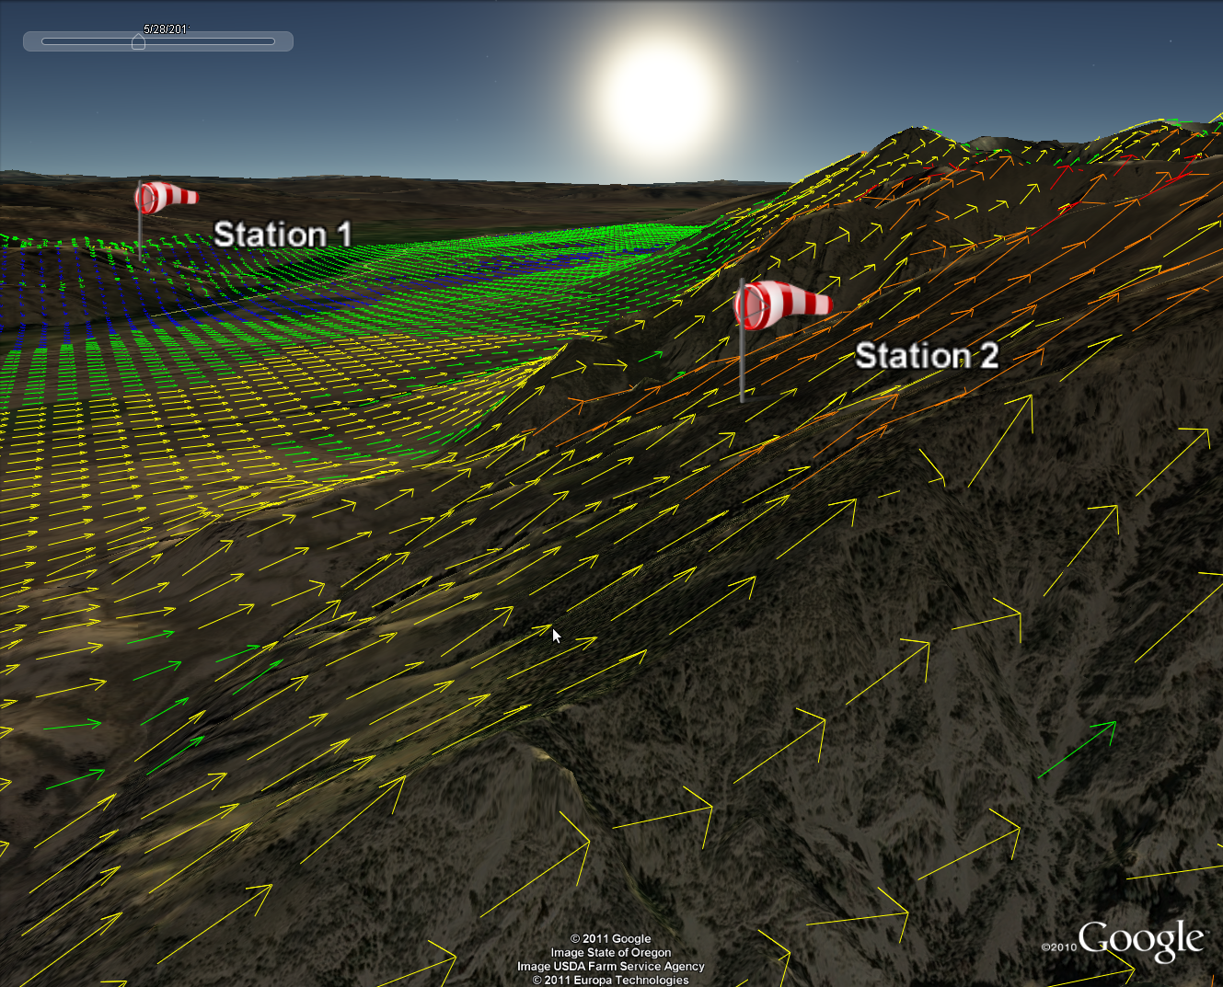

04/04/2017

Introduction

Welcome to WindNinja Tutorial 3: Point Initialization. This tutorial will step you through the process of running a WindNinja simulation that is initialized by location specific wind information. Note that the point initialization option is not currently available for use with the momentum solver. This tutorial assumes you have already gone through WindNinja Tutorial 1: The Basics and WindNinja Tutorial 2: Diurnal Winds and Non-neutral Stability. After this tutorial, you should feel comfortable using data from weather stations or other observations to initialize your WindNinja runs.

Note: All user required actions in this tutorial are shown in red.

What is point initialization?

The point initialization technique in WindNinja allows users to provide input values of wind speed, direction, cloud cover, etc. at specified location(s) on the landscape. This information is used to drive the simulation, and the final output wind fields will match your inputs at these locations. Typically, the input information comes from observations at weather stations such as Remote Automated Weather Stations (RAWS) and METARs or from manual measurements done on wildland fires. But other possibilities exist, and users could even use this method to “craft” their own wind fields. For readability, this tutorial (and WindNinja) will call these locations “weather stations”, although, as mentioned they don't necessarily have to be actual weather stations. You can have as many weather stations as you like, and the stations are not even constrained to be located in the modeling domain.

How does point initialization work?

Internally, WindNinja reads in all of your weather stations and fills the simulation domain horizontally using an inverse distance squared interpolation method. There is a user controlled parameter that allows users to control the radius of influence of each station, if desired. Then the domain is filled vertically using a vertical wind profile. Next, diurnal winds are added to this wind field if they are enabled. Finally, the WindNinja mass-conservation solver is run, including non-neutral stability effects if that option is turned on. Internally in WindNinja, if this solver was only run once, the resulting wind field would not necessarily match the “measured” wind values at the weather stations anymore (since the winds have been adjusted everywhere to conserve mass). So instead, WindNinja runs in an iterative way. After one solver run is finished, WindNinja checks the new wind field to see how close it is to the “measured” values. If it isn't close enough (less than 0.1 m/s difference), WindNinja slightly adjusts the weather station values and does a new run (i.e., horizontally interpolate, fill vertically, add diurnal, run mass-conservation solver). This process is repeated until the solved wind field is within 0.1 m/s of the measured values at every weather station. This is all done automatically by WindNinja, so this process is transparent to the user.

Because of its iterative nature, simulations using the point initialization method normally take longer than other types of initialization methods. Also, there is currently no way to “batch” process many point initialization simulations at the same time.

Getting Started

Start WindNinja by going to Start -> Programs -> WindNinja-3.2.0 -> WindNinja-3.2.0.

Input

Surface Input

In the navigation tree, left-click on “Surface Input”.

In the input panel, load an elevation file or download one.

If you are just practicing, you can use an elevation file provided in the WindNinja installation. They can be found by going to Start->Programs->WindNinja-3.2.0->Example Files. In the file browser that opens, you will see the elevation file called “mackay.tif”. This file also has a prebuilt example “station file” provided that will be discussed later.

Select the dominant vegetation type, mesh resolution, and time zone.

Diurnal Input

Local diurnal slope winds can optionally be included in a point initialization run. It is normally recommended that diurnal winds be used since it adds more realism to the simulation and increases the simulation time only slightly.

Left-click on “Diurnal Input” in the navigation tree, then check the “Use Diurnal Wind” check box in the input panel.

Stability Input

The stability model can optionally be turned on to simulate an atmosphere that is not necessarily neutrally stable. For this tutorial we will not turn on this model, so leave the “Use Stabililty” check box unchecked.

Wind Input

Editing the station file

Left-click on “Point Intialization” in the navigation tree, which is located under “Wind Input”. In the input panel below, check the “Point Initialization” check box.

Currently, the only way to enter the required inputs at your weather stations is by building a text file called a “station file”. The format of this file is comma delimited (*.csv). Since the syntax is important, it is recommended that you edit an existing station file rather than write one from scratch.

An example station file is provided with your installation and can be accessed by going to Start->Programs->WindNinja-3.0->Example Files. In the file browser that opens, open the file called “mackay_wx_stations.csv” in a spreadsheet program such as Microsoft Excel or LibreOffice Calc. Be sure that it opens as a comma separated file. You can also let WindNinja write a blank station file for you to edit by selecting Tools->Write a blank station file from the menu at the top of the WindNinja window.

The example station file viewed in a spreadsheet program is shown in Table 1 below. This file has been built to work with the provided elevation file called “mackay.tif”.

Note that the station file could also be opened and edited in a simple text editor such as WordPad or NotePad, but it is more convenient and less error prone in a spreadsheet program. Also be aware that in a text editor it doesn't look exactly like Table 1, instead there will be commas separating each field.

Table 1. An example of a station file viewed in a spreadsheet program. For clarity, formatting (colors, etc.) has been added and the table has been split in half to fit on this page.
continued

The format of a station file is that the first row is a header that tells you what goes in the corresponding columns. The header fields may contain a textual description of the column, units information, and/or a list of valid values. Every row below the header row represents one weather station. A short description of each column is given below.

Station_Name
This is whatever you want to name the weather station, spaces are allowed here. An example is “Deer Peak RAWS”.

Coord_Sys
This is the coordinate system that you will be specifying the location of the station in (later). The two possible choices are “PROJCS” and “GEOGCS”. PROJCS stands for “projected coordinate system”. If you use this, you will specify the location of the station in x,y coordinates in meters. The projection you are actually using is the one that the elevation file is in (for example, UTM, Albers, etc.). This might be useful if you are viewing your elevation file and locating the weather stations in a GIS, since the GIS probably outputs locations in the elevation file's projected coordinate system. The other choice, GEOGCS, stands for “geographic coordinate system” or in other words latitude and longitude. So if you want to specify the location of the station in latitude and longitude, use GEOGCS. This would be useful if you knew the latitude/longitude of the weather station or had coordinates from a GPS or were using something like Google Earth to determine where the station will be (since the default in Google Earth is to output position in latitude/longitude).

Datum
This is the datum that will be used for specifying the location of your weather station. The possible choices are “WGS84”, “NAD83”, or “NAD27”. Note that if you specified PROJCS in the last column for Coord_Sys, then the datum defined by the elevation file will also be used automatically by WindNinja, so in that case it doesn't matter what you choose (but you need to put something here as a place holder). Also note that if you are using Google Earth to obtain the lat/long of a weather station, Google Earth uses “WGS84”.

Lat/YCoord
This is either the latitude or y-coordinate of the weather station, depending on your choice for the Coord_Sys earlier.

Lon/XCoord
This is either the longitude or x-coordinate of the weather station, depending on your choice for the Coord_Sys earlier.

Height
This is the height of the measured wind above the surrounding vegetation (measured as the distance above the vegetation, not necessarily above the ground). Typically this might be 20 feet or 10 meters.

Height_Units
The units your height is measured in. Valid choices are “meters” or “feet”.

Speed
This is the wind speed at the weather station.

Speed_Units
The units of the wind speed. Valid choices are “mph”, “kph”, or “m/s”.

Direction
This is the wind direction, using the normal meteorologic convention that it is the direction that the wind comes from. So for example, if the wind was blowing from west to east, it would be a direction of 270.

Temperature
Air temperature at the station. This is used in the diurnal submodel. It should be noted that the simulated wind is not very sensitive to this value and anything close should be adequate.

Temperature_Units
The units of temperature. Valid choices are “F” or “C”.

Cloud_Cover
The percent cloud cover (not fractional cloud cover). The valid range is 0-100. This is used in the diurnal and non-neutral stability submodels.

Radius_of_Influence
This is an option that allows you to limit the horizontal distance that the weather station can affect. If you specify a distance less than zero, this is a special flag that tells WindNinja that this station has no imposed distance limit. Your default should be to enter a value less than zero (like “-1”) to use no distance limit for most stations. An actual distance limit could be used if you think your weather station is being influenced by local factors and doesn't represent the larger scale wind well. This might be the case if the station was located in the lee wind area of a mountain where the measured wind was affected by the mountain's wake. Note that you should have at least one weather station without a distance limit (value less than zero) so that the whole simulation domain will be filled with initial wind values.

Radius_of_Influence_Units
The distance units of the radius of influence. Valid choices are “feet”, “miles”, “meters”, and “km”.

Open the example station file or write a blank one and edit it for your scenario. If you open it in a spreadsheet program, be sure to save it as a comma delimited file (*.csv).

Load the station file into WindNinja by left-clicking the “Read Station File” button and selecting your file.

Enter the date and time for the simulation in the Point Initialization input panel. The drop down arrow brings up a calendar to help you pick the date. The time can be entered by highlighting the time and typing in a new value. Note that this date and time box will be grayed out if the diurnal or non-neutral models were not enabled.

For your convenience, there is a button at the bottom of the input panel called “Write Station Kml” that will write a Google Earth file showing the locations of the weather stations and input values.

Left-click the “Write Station Kml” button if you want a kml file of your weather stations.

Output

WindNinja writes all the same output files as explained in the earlier tutorials. The naming convention for the output files is similar to the “Domain Average Wind” initialized simulations except that the text “point” is added after the elevation file name to specify that this was a point initialization run. Also, the input speed and direction are absent since there could be multiple input speeds and directions for one run (if you had more than one weather station). All the output files are written to the folder where the elevation file is located.

In the navigation tree, left-click on “Output” and select the “Output Height”, “Output Speed Units”, and “Clip output by:” values you desire.

Choose the types of output files you would like by left-clicking the type in the navigation tree and filling out the corresponding input panel.

If you enable the Fire Behavior output files, note that the percent cloud cover file that is produced during a point initialized run is a gridded file that uses inverse distance squared weighted interpolation to fill the grid based on the input values at the weather stations.

Solve

Left-click on “Solve” in the navigation tree. Set the number of processors you would like using the “Number of Processors” spin box. Finally, left-click the “Solve” button to start the simulation.

The typical simulation time for an average dual core computer in 2011 should be around 10-60 seconds depending on the computer, domain size, simulation resolution, etc.

When the simulation is finished, close the progress window.

Another handy feature in WindNinja is the “Open Output Files Path” button on the Solve page. If you click this, it will open the folder where all of the output files for the last run were written to.

This concludes WindNinja Tutorial 3: Point Initialization.

