How to download an elevation file using WindNinja
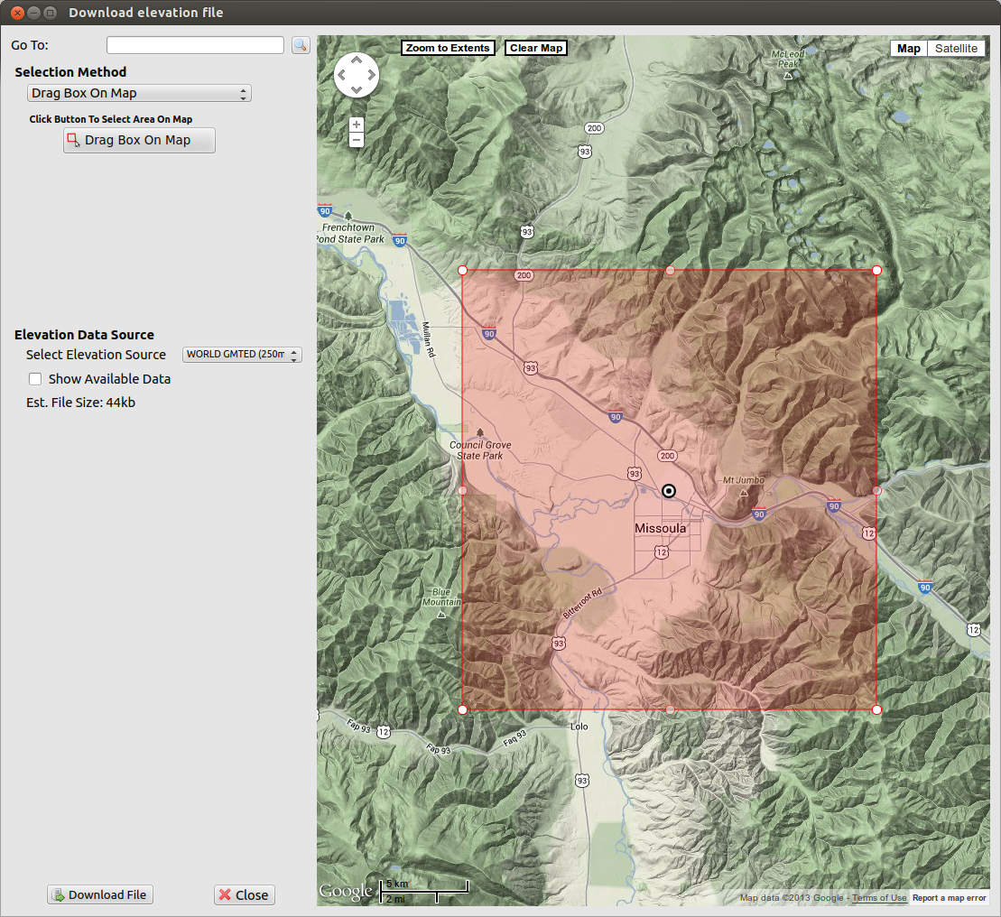

06/20/13

Introduction

This document describes the functionality built into WindNinja to download elevation files for wind modeling. We call this utility the “elevation file grabber”. It allows you to use a custom Google Maps™ interface to zoom into and select a desired area for wind modeling. The elevation data for this area is downloaded by WindNinja from a USGS server and saved to a file on your computer. There is also a command line version of the elevation file grabber that is described here. The specific options available and work flow are described below.

To open the elevation file grabber window, start WindNinja and click Surface Input in the navigation tree at the top of WindNinja, then click the Download File button as shown below.

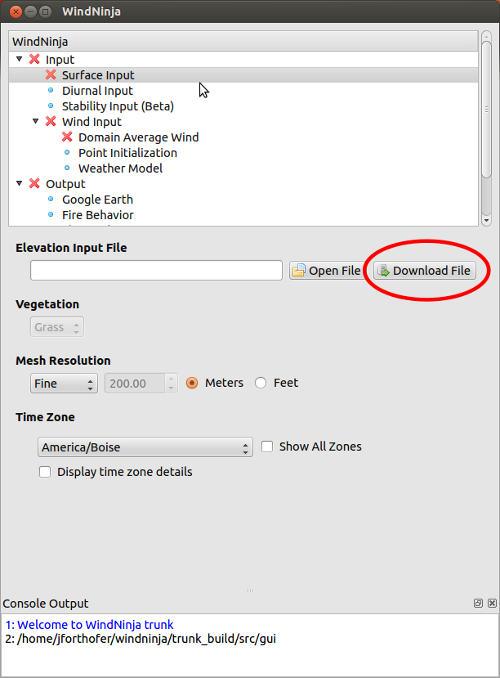
The Download Elevation File window will open. This window is divided into two areas as highlighted in red in the image below. These areas are discussed in the next two sections.

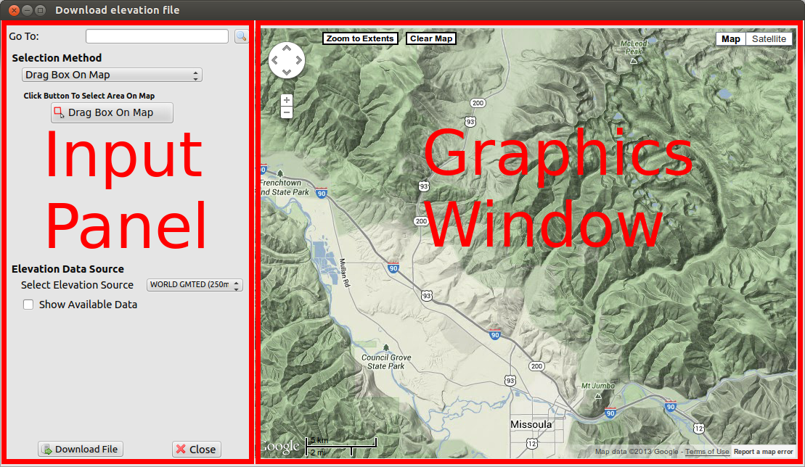

Graphics window
The graphics window is an interactive mapping display used to navigate into the desired wind simulation area. This window uses a customized version of the popular Google Maps™ software. Various different base maps are available using the 'Map' and 'Satellite' buttons in the upper right corner. There are several ways to pan and zoom the map. Using a mouse, you can pan with the left button and zoom using a mouse scroll wheel. You can also left-click the navigation controls in the upper left corner of the graphics window. Last, the keyboard can be used to pan (arrow keys) and zoom (plus and minus keys).

Input panel
Zoom to geographic location
At the top of the panel, there is a 'Go To:' text box where you can type in geographic locations to quickly zoom to. Some example searches are: “Missoula, MT”, “Pikes Peak, CO”, and “Redfish Lake, ID”.

Download area selection method
Below the 'Go To:' text box is the Selection Method group of buttons and text boxes that allow you to define the area you want to download. This download area is a rectangular box that will be drawn over the map in the graphics window. There are four different ways to define this rectangular box that can be chosen from the drop-down box. They are:

- Drag Box On Map
By clicking the Drag Box On Map button, you can then left-click and drag on the graphics window to define a box of the desired size.
- Enter Bounding Box
This option allows you to enter the latitude and longitude bounds for the box.
- Click Center Point
This option allows you to click a center point on the map to define the center of the box and then enter the size of the box.
- Enter Center Point
With this method, you enter the center point coordinates of the box and the box size.
After using any of the methods above, a transparent red box will be drawn in the graphics window showing the area you've defined. If you want, you can enlarge or shrink this box in the graphics window by dragging the sides or corners. You can also move the box by dragging the center icon. The Zoom To Extents button in the graphics window will zoom the view to fit the box. The Clear Map button will clear the box.

Elevation data source
There are 3 possible online data sets to download elevation data from. These are listed in the Select Elevation Source drop-down box. The main difference between these data sets is the spatial resolution and extent. The table below briefly describes these differences. You should be sure to choose a data set that covers your simulation area.
Data set name | Resolution | Spatial extent | Data description
US SRTM | 30 meters | Contiguous US, Hawaii, Puerto Rico, southern part of Alaska | Data from the Shuttle Radar Tomography Mission (SRTM)
WORLD SRTM | 90 meters | Between approximately -60° and +60° latitude | Data from the Shuttle Radar Tomography Mission (SRTM)
WORLD GMTED | 250 meters | Between approximately -60° and +85° latitude | Global Multi-resolution Terrain Elevation Data 2010 (GMTED2010)

You can check the Show Available Data check-box to display a blue polygon on the map outlining the chosen data set's extents.

Download the file
Once you have defined your download area and selected the elevation data source, click the Download File button at the bottom to download the elevation file. A window will open to allow you to specify a file name and location. The downloaded file is a geotiff file (*.tif) in a best fit UTM projection and a WGS84 datum. After the file is successfully downloaded, you can close the Download elevation file window and the downloaded file will be automatically loaded into the main WindNinja window.

