 Designing and Developing Applications on the Cloud

Student Name : Toh Ke Jian

Intake Code : UC3F1702SE

Course Code : CT071-3-3-DDAC

Supervisor Name : Dr. Kalai Anand A/L Ratnam

Due Date : 20th November 2017

# Acknowledgement

I would like to thank my lecturer of this subject, Dr. Kalai Anand for providing and teaching me the knowledge needed for this assignment and a good guideline is given so that I will be able to know what are the things that needed to be done in this assignment.

Table of Contents

Acknowledgement

1,0 Introduction 1

2.0 Project Plan 2

3.0 Design 3

3.1 Use Case Diagram 3

3.2 Class Diagram 3

3.2.1 Account View Model 3

3.2.2 Identity Model 4

3.2.3 Manage View Model 4

3.2.4 Account Controller 5

3.2.5 Flight Controller 6

3.2.6 Home Controller 6

3.2.7 Manage Controller 7

3.2.8 App_Start 8

3.3 Architecture Diagram 8

4.0 Implementation 9

4.1 Assumption 9

4.2 Justification of services used 9

4.2.1 Web Application 9

4.2.2 Traffic Manager 9

4.2.3 SQL Database 9

5.0 Test Plan & Testing Discussion 11

5.1 Unit Testing 11

5.2 Performance Testing 11

6.0 Conclusion 12

7.0 References 13

# 1,0 Introduction

For this assignment, a web application on the online flight booking system will need to be developed and the web application will then need to be host on the cloud which is provided by the Microsoft azure. The objectives of this assignment is mainly focus on the implementation and the use of the cloud services such as implementing the web app, SQL database on the cloud. A functional system need to be implemented and the performance of the application on the cloud need to be tested.

# 2.0 Project Plan

|  |  |  |  |
| --- | --- | --- | --- |
| Task Name | Duration | Start | Finish |
| 1.0 Introduction | 1 day | Sat 17-11-18 | Sat 17-11-18 |
| 2.0 Project Plan | 1 day | Sun 17-11-19 | Sun 17-11-19 |
| **3.0 Design** | **7 days** | **Thu 17-10-26** | **Fri 17-11-03** |
| 3.1 Use Case | 1 day | Thu 17-10-26 | Thu 17-10-26 |
| 3.2 Class Diagram | 1 day | Fri 17-10-27 | Fri 17-10-27 |
| 3.3 Architecture Diagram | 5 days | Mon 17-10-30 | Fri 17-11-03 |
| **4.0 Implementation** | **15 days** | **Fri 17-11-03** | **Tue 17-11-21** |
| 4.1 Code | 13 days | Fri 17-11-03 | Sun 17-11-19 |
| **4.2 Justification of services used** | **1 day** | **Mon 17-11-20** | **Mon 17-11-20** |
| 4.2.1 Web Application | 1 day | Mon 17-11-20 | Mon 17-11-20 |
| 4.2.2 Traffic Manager | 1 day | Mon 17-11-20 | Mon 17-11-20 |
| 4.2.3 SQL Database | 1 day | Mon 17-11-20 | Mon 17-11-20 |
| 5.0 Test Plan & Testing Discussion | 1 day | Sun 17-11-19 | Sun 17-11-19 |
| 6.0 Conclusion | 1 day | Sat 17-11-18 | Sat 17-11-18 |
| 7.0 References | 1 day | Sat 17-11-18 | Sat 17-11-18 |

# 3.0 Design

## 3.1 Use Case Diagram

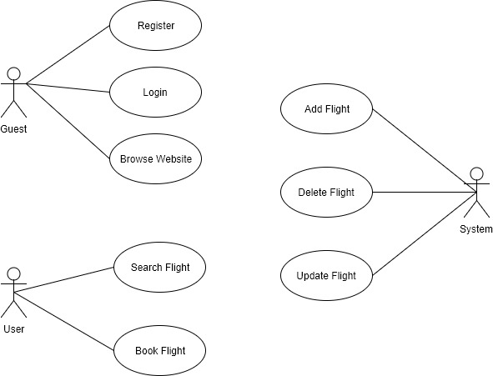

## 3.2 Class Diagram

### 3.2.1 Account View Model

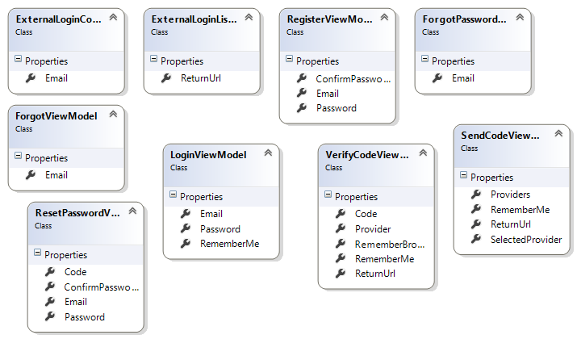

### 3.2.2 Identity Model

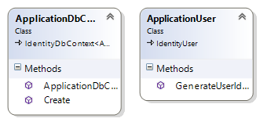

### 3.2.3 Manage View Model

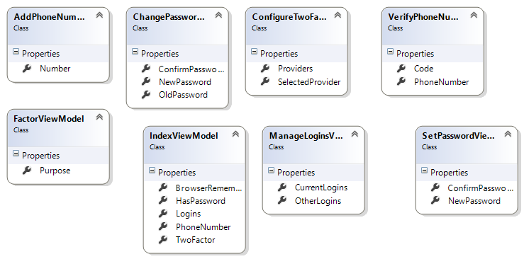

### 3.2.4 Account Controller

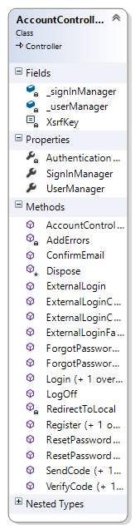

### 3.2.5 Flight Controller

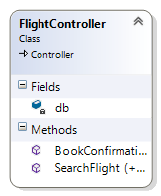

### 3.2.6 Home Controller

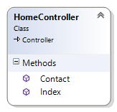

### 3.2.7 Manage Controller

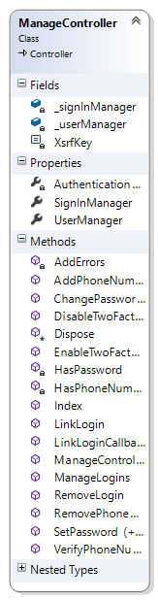

### 3.2.8 App_Start

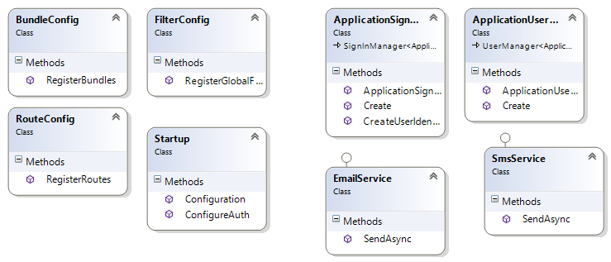

## 3.3 Architecture Diagram

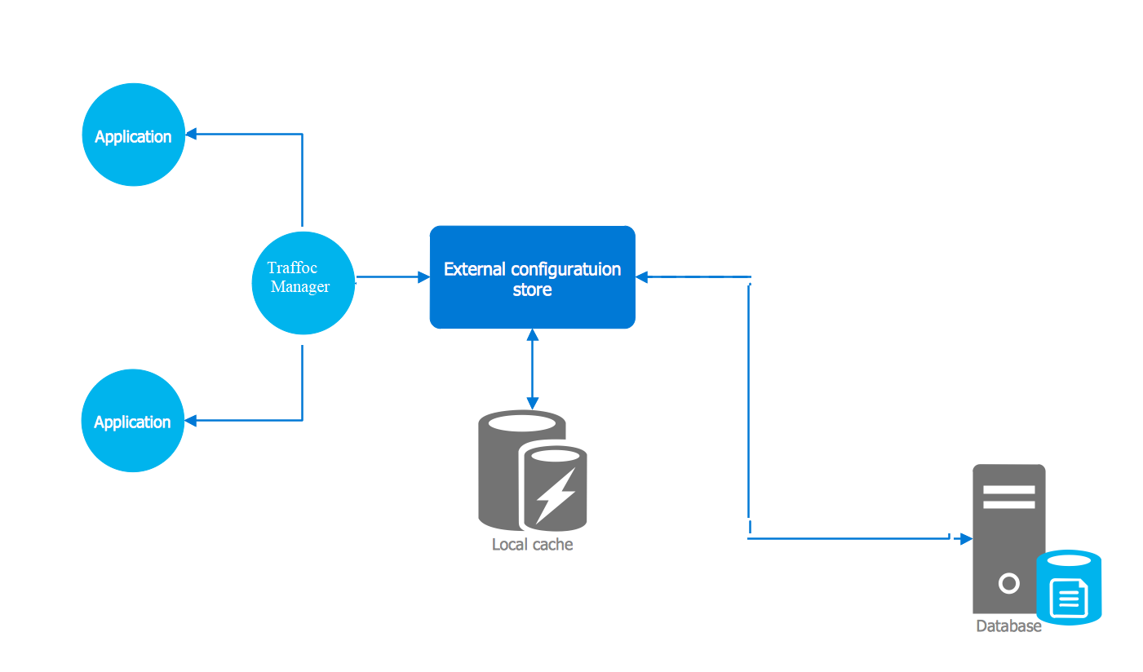

# 4.0 Implementation

## 4.1 Assumption

Services Expected to be used is web app services, traffic manager and SQL database and assuming that the maximum cost that is going to be used is RM150.00.

## 4.2 Justification of services used

### 4.2.1 Web Application

The previous UIA flight booking system is a system that running as a web application so by moving it into the cloud services, web app service is being used to remain it as a web application. Azure web apps provides few function such as security, load balancing, auto scaling and automated management. With the use of web app on the azure cloud service, it provides multiple languages and frameworks that can be used. PowerShell and few scripts will also be able to run as a background services. It provides the ability to scale up or scale out the server either manually or automatically when it is required. (Microsoft Azure 2017)

### 4.2.2 Traffic Manager

The traffic manager service is used to control the distribution of user traffic for service endpoint in different datacenters. Traffic Manager service use the DNS to direct client requests to the nearest endpoint based on traffic routing and health of the endpoints. Traffic manager will be able to improve the availability of a critical application. If one of the endpoint is down, the traffic manager will direct the clients to another endpoint which is functioning. (Microsoft Azure 2017) This service is used for the UIA flight booking system that company has been experiencing DOS so with the used of traffic manager, if one of the endpoint is being DOS the application will still able to be functioning as the clients will be redirect to another endpoint which is safe.

### 4.2.3 SQL Database

Azure SQL Database is a relational database-as a service using the Microsoft SQL Server Engine. SQL Database is a reliable and secure database which has high-performance that allows you to build data-driven applications and websites in the programming language of your choice without having you to manage the infrastructure. (Microsoft Azure 2017) As for the UIA flight booking system, database will be needed to store the flight data and to retrieve data from the database so the SQL database service which is provided by the Azure is being chose.

# 5.0 Test Plan & Testing Discussion

## 5.1 Unit Testing

|  |  |  |  |  |
| --- | --- | --- | --- | --- |
| Test Case | Origin | Destination | Expected Output | Actual Output |
| 1 | Blank | Blank | Show Error message | Show Error message |
| 2 | Blank | “Destination” | Show Error message | Show Error message |
| 3 | “Origin” | Blank | Show Error message | Show Error message |
| 4 | “Origin” | “Destination” | Display Result | Display Result |

## 5.2 Performance Testing

A performances testing has been done by setting a user load as 250 and the duration is set to 1 minute. Below is the output that gotten after the performance testing has been done.

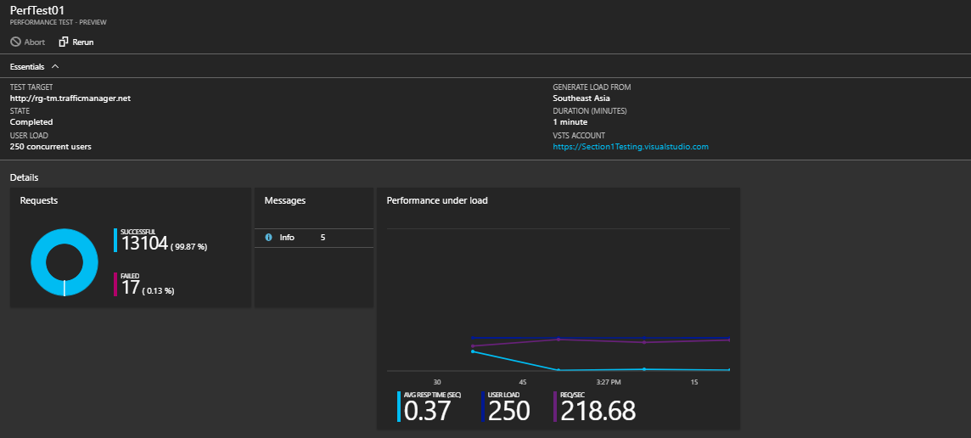

# 6.0 Conclusion

In conclusion, after doing the assignment, I have more know about how to use the Microsoft Azure and what Microsoft Azure are about to done. I have also learned that cloud computing will be able to provide benefits to different type of user depends on the prices they can afford.

# 7.0 References

Microsoft Azure (2017) Overview of Traffic Manager [Online] Available at: https://docs.microsoft.com/en-us/azure/traffic-manager/traffic-manager-overview [Accessed: 18 November 2017]

Microsoft Azure (n.d.) Web Apps Documentation [Online] Available at: https://docs.microsoft.com/en-us/azure/app-service/ [Accessed: 18 November 2017]

Microsoft Azure (n.d.) Azure SQL Database Documentation [Online] Available at: https://docs.microsoft.com/en-us/azure/sql-database/ [Accessed: 18 November 2017]