Note For Approval
Date | 20 May 2026
Subject | Renewal of Adobe Digital Experience (DX) Platform Services for IndiGo Digital Ecosystem
Final Price, Terms, Contract Period etc. | Final Price, Terms, Contract Period etc.  - Contract Term Proposed: 01 Jun 2026 – 31 May 2027 (12 Months)  - Alternate Option Evaluated: 24-Month Renewal  - Billing Cycle: Semi-Annual Advance Billing  - Payment Terms: Net 45 Days  - Commercials for 1-Year Renewal: USD 3,505,345  - Adobe has offered improved commercials for a longer tenure commitment.  Commercial Comparison  Area 1-Year Renewal 2-Year Renewal  Commercial Benefit Lower Better Commercials  Strategic Flexibility High Limited  Long-Term Lock-in Limited Higher  Future Benchmarking / Migration Assessment Possible Restricted  Recommendation Recommended Not Recommended at Present
Preface & Key Points | - Renewal covers:  - Adobe Experience Manager (AEM)  - Adobe Analytics  - Adobe Campaign  - Adobe Target  - Existing customer journeys, analytics instrumentation, personalization flows, campaign orchestration, content operations, APIs, and dependent integrations are tightly integrated within Adobe ecosystem.  - Non-renewal may impact:  - Customer-facing Digital Channels  - Campaign Execution  - Analytics Visibility  - Content Publishing  - Personalization Services  - Ongoing Digital Initiatives
Participating Vendors | • Adobe Systems Software Ireland Ltd.
Vendor Justification | - Adobe is the incumbent enterprise platform provider supporting IndiGo’s Digital Experience ecosystem.  - Existing integrations, cloud services, analytics instrumentation, customer journeys, campaign workflows, and personalization capabilities are already operational within Adobe ecosystem.  - Renewal ensures continuity of live production operations and avoids immediate disruption across customer-facing Digital channels.  - While better commercials are available for a 2-year commitment, a 1-year renewal is recommended to retain strategic flexibility for future Digital platform decisions.  - The shorter renewal period enables IndiGo to:  - Conduct fresh market benchmarking  - Evaluate alternate enterprise platforms  - Assess AI-enabled and next-generation Digital capabilities  - Review migration feasibility and long-term architecture strategy
Strategic Roadmap & Future Benchmarking | - During the renewal tenure, IndiGo proposes to initiate a parallel RFP and benchmarking exercise for future-state Digital Experience platforms.  - Evaluation scope will include:  - Alternate Digital Experience Platforms  - AI / Agentic Capabilities  - Analytics & Campaign Alternatives  - Commercial Benchmarking  - Migration Complexity & Transition Planning  - Long-Term Strategic Alignment  - This approach provides sufficient time for future platform assessment and possible sunset planning for existing Adobe ecosystem before subsequent renewal cycles.
Commercials | 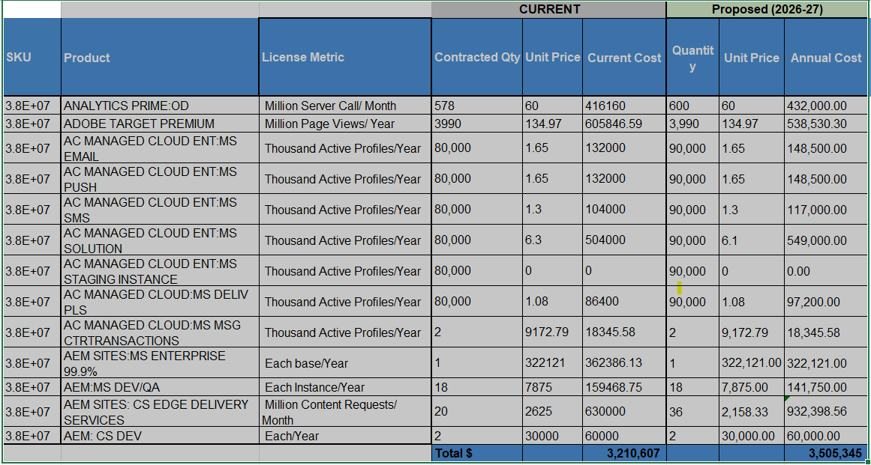
Recommendation on which approval is being sought | Approval is sought for renewal and continuation of Adobe Digital Experience platform services and associated enterprise managed/cloud services for the period 01 Jun 2026 to 31 May 2027.
Prepared By | ------------------  Rinika Gautam
Reviewed By | ------------------  Gaurav Yadav
Approved By | Charu Verma Sanjay Jha  ------------------ ------------------  Neetan Chopra Vineet Mittal  ---------------------------- ----------------------------

