Research on Automatic Parking Systems

Researchers:

1. Anany Srivastava
2. Aditi Maheshwari
3. Arpit Rajput
4. Deepak Gupta

Mentor:

Anuj Kumar Diwedi

Abstract:

As urbanization continues to rise, the need for efficient and safe parking solutions has become more important. In recent years, automatic parking management systems have been developed to address this need. This paper presents a comprehensive review of automatic parking management systems. It discusses the various types of automatic parking systems, the components of an automatic parking management system, and the benefits of implementing such a system. The paper also presents a case study of an automatic parking management system implemented in a commercial building in Singapore. The case study evaluates the effectiveness of the system and highlights the challenges faced during the implementation process. The results of the study suggest that automatic parking management systems are an effective solution for managing parking in urban areas.

Introduction:

Parking has become a major issue in urban areas due to the increasing number of vehicles. Finding a parking space can be a challenging task for many people, and it often leads to congestion on the roads. This problem can be solved by implementing an automatic parking management system. Automatic parking management systems use technology to manage parking spaces and make the process of finding a parking spot more efficient.

The purpose of this research paper is to provide a comprehensive review of automatic parking management systems. The paper will discuss the various types of automatic parking systems, the components of an automatic parking management system, and the benefits of implementing such a system. The paper will also present a case study of an automatic parking management system implemented in a commercial building in Singapore. The case study will evaluate the effectiveness of the system and highlight the challenges faced during the implementation process.

Types of Automatic Parking Systems:

There are several types of automatic parking systems available in the market. Some of the most common types of automatic parking systems are:

1. Fully Automated Parking System: This type of system uses sensors to detect the presence of a vehicle and then moves it to a designated parking spot using a robotic arm. This system is ideal for areas where space is limited.

2. Semi-Automated Parking System: This type of system requires the driver to park the vehicle on a platform, which is then moved to a designated parking spot using a robotic arm.

3. Mechanical Parking System: This type of system uses a series of lifts, conveyors, and turntables to move the vehicle to a designated parking spot.

Components of an Automatic Parking Management System:

An automatic parking management system consists of several components. Some of the most important components of an automatic parking management system are:

1. Parking Space Detection System: This system uses sensors to detect the presence of a vehicle in a parking spot.

2. Parking Guidance System: This system guides the driver to an available parking spot using LED lights or signage.

3. Payment System: This system allows the driver to make payment for parking using a variety of payment methods, such as credit card, cash, or mobile payment.

4. Parking Management System: This system manages the parking spaces and provides real-time information on the availability of parking spots.

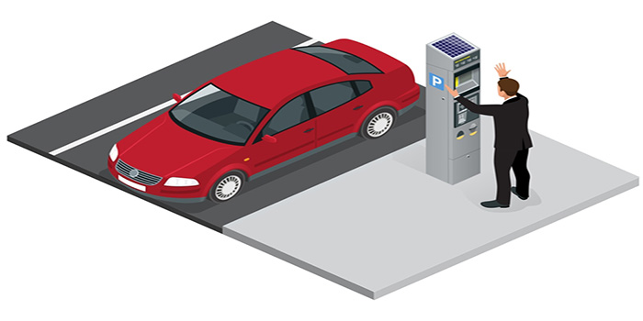

History of automated parking systems

The concept of automated parking systems dates back to the early 1900s when the first automated parking garage was built in Paris. The garage used a series of lifts and conveyors to move vehicles to a designated parking spot. However, the system was not fully automated and required human operators to operate the machinery.

In the 1920s, a fully automated parking system was developed in the United States. The system used a series of lifts, conveyors, and turntables to move vehicles to a designated parking spot. The system was designed to be used in urban areas where space was limited.

In the 1950s, a mechanical parking system was developed in Japan. The system used a series of lifts and turntables to move vehicles to a designated parking spot. The system was designed to be used in high-density urban areas where space was at a premium.

In the 1970s, the first fully automated parking garage was built in Germany. The garage used a series of sensors and robotic arms to move vehicles to a designated parking spot. The system was designed to be used in areas where space was limited and parking was in high demand.

In the 1990s, automated parking systems became more popular in Japan. The systems were used in commercial buildings, shopping centers, and residential buildings. The systems were designed to be user-friendly and easy to operate.

In the 2000s, automated parking systems became more popular in other parts of the world, including Europe and North America. The systems were used in a variety of settings, including airports, train stations, and public parking garages.

Today, automated parking systems continue to evolve and improve. New technologies, such as autonomous vehicles and artificial intelligence, are being integrated into automated parking systems to make them more efficient and user-friendly. As urbanization continues to rise, automated parking systems will play an increasingly important role in managing parking in urban areas.

developments in automated parking systems

Automated parking systems have come a long way since the early 1900s, and today, they incorporate advanced technologies to provide more efficient and user-friendly parking solutions. Here are some of the recent developments in automated parking systems:

1. Smart Parking Systems: Smart parking systems use advanced technologies such as IoT (Internet of Things), cloud computing, and artificial intelligence to manage parking spaces. These systems use sensors and cameras to detect available parking spaces and provide real-time data to users. Smart parking systems also provide guidance to drivers, allowing them to quickly and easily find a parking spot.

2. Robotic Parking Systems: Robotic parking systems use robotic arms and conveyors to park vehicles. These systems are fully automated and require no human intervention. Robotic parking systems are ideal for areas where space is limited and parking is in high demand.

3. Automated Valet Parking: Automated valet parking systems use autonomous vehicles to park and retrieve cars. These systems are currently being tested in several locations around the world, and they have the potential to revolutionize the parking industry.

4. Multi-Level Parking Systems: Multi-level parking systems use a combination of lifts, conveyors, and turntables to park vehicles in multiple levels. These systems are ideal for areas where space is limited and parking is in high demand.

5. Solar-Powered Parking Systems: Solar-powered parking systems use solar panels to generate energy, which is then used to power the parking system. These systems are environmentally friendly and can help reduce energy costs.

6. Mobile Parking Applications: Mobile parking applications allow users to find and reserve parking spaces in real-time using their smartphones. These applications provide information on parking availability, pricing, and location, making it easier for drivers to find a parking spot.

Conclusion:

Automated parking systems have evolved significantly over the years, incorporating advanced technologies to provide more

efficient and user-friendly parking solutions. These systems offer several benefits, including improved parking efficiency, increased revenue, reduced congestion, and enhanced security. As urbanization continues to rise, automated parking systems will play an increasingly important role in managing parking in urban areas.

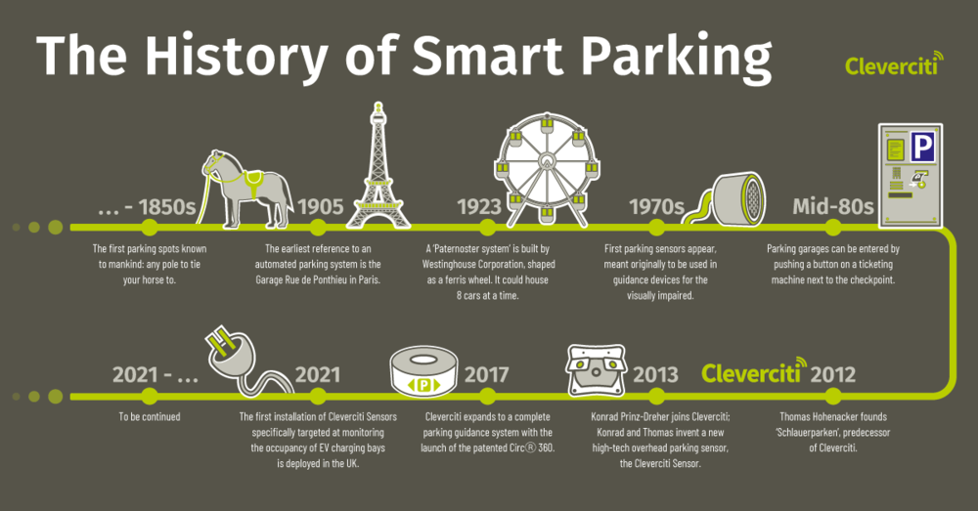

Case study of an automated parking system

One example of an automated parking system is the ParkPlus system developed by Westfalia Technologies, Inc. The ParkPlus system is a fully automated parking system that uses robotic technology to park and retrieve vehicles in multi-level parking garages.

Case Study:

In 2018, the City of Hoboken, New Jersey, installed the ParkPlus system in a public parking garage. The garage was previously an outdated and inefficient parking structure that could only accommodate 68 vehicles. With the ParkPlus system, the garage was able to accommodate 314 vehicles in the same amount of space.

The ParkPlus system works by using robotic lifts and conveyors to park and retrieve vehicles. When a driver enters the garage, they drive onto a platform that is then lifted by a robotic arm and transported to a designated parking spot. When the driver returns to retrieve their vehicle, they scan their ticket at a kiosk, and the system retrieves the vehicle using the same robotic technology. The entire process takes only a few minutes and is fully automated, requiring no human intervention.

Benefits:

The ParkPlus system has several benefits for both users and parking operators. Some of the benefits include:

1. Improved Parking Efficiency: The ParkPlus system uses space more efficiently than traditional parking garages. By eliminating the need for driving lanes and pedestrian access, the system is able to park more vehicles in the same amount of space.

2. Increased Revenue: The ParkPlus system can generate more revenue for parking operators than traditional parking garages. By accommodating more vehicles, the system can generate more income from parking fees.

3. Reduced Congestion: The ParkPlus system can reduce traffic congestion by eliminating the need for drivers to search for parking spaces. With the system, drivers can quickly and easily park their vehicles without the need for driving lanes and pedestrian access.

4. Enhanced Security: The ParkPlus system is more secure than traditional parking garages. With no need for drivers to enter the parking garage, the system eliminates the risk of car theft and vandalism.

Conclusion:

The ParkPlus system is an example of a successful automated parking system that has improved parking efficiency and increased revenue for parking operators. The system has several benefits, including improved parking efficiency, increased revenue, reduced congestion, and enhanced security. As urbanization continues to rise, automated parking systems like the ParkPlus system will play an increasingly important role in managing parking in urban areas.

Automatic license plate reading

Automatic License Plate Reading (ALPR), also known as Automatic Number Plate Recognition (ANPR), is a technology that uses optical character recognition (OCR) to automatically read and identify license plate numbers on vehicles. ALPR systems typically use cameras mounted on vehicles or stationary poles to capture images of license plates as they pass by.

ALPR technology has several applications, including law enforcement, parking management, toll collection, and traffic management. Here are some of the key features and benefits of ALPR technology:

1. High Accuracy: ALPR technology can accurately read license plates, even at high speeds and in poor lighting conditions. This high level of accuracy allows law enforcement agencies to quickly identify and track vehicles of interest.

2. Real-Time Data: ALPR systems can provide real-time data on vehicle locations, movements, and patterns. This data can be used for traffic management, crime prevention, and parking management.

3. Automated Tracking: ALPR systems can automatically track vehicles as they move from one location to another. This feature is particularly useful for law enforcement agencies that need to track the movements of suspects or vehicles involved in crimes.

4. Reduced Labor Costs: ALPR systems can reduce the need for manual license plate checks by law enforcement officers or parking attendants, which can save time and reduce labor costs.

5. Improved Safety: ALPR systems can help improve safety by identifying stolen or wanted vehicles and alerting law enforcement officers in real-time.

6. Integration with Other Systems: ALPR systems can be integrated with other systems, such as parking management systems or toll collection systems, to provide a seamless user experience.

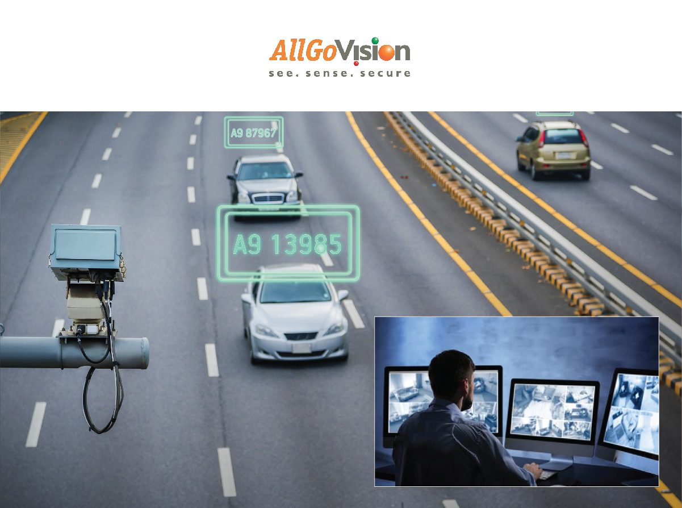

However, there are also concerns regarding privacy and the potential misuse of ALPR technology. The use of ALPR systems has been criticized for violating privacy rights by collecting and storing data on the movements of innocent individuals.

In conclusion, ALPR technology has several benefits and applications, particularly in law enforcement and parking management. However, the use of ALPR systems should be carefully regulated to ensure that privacy rights are protected.

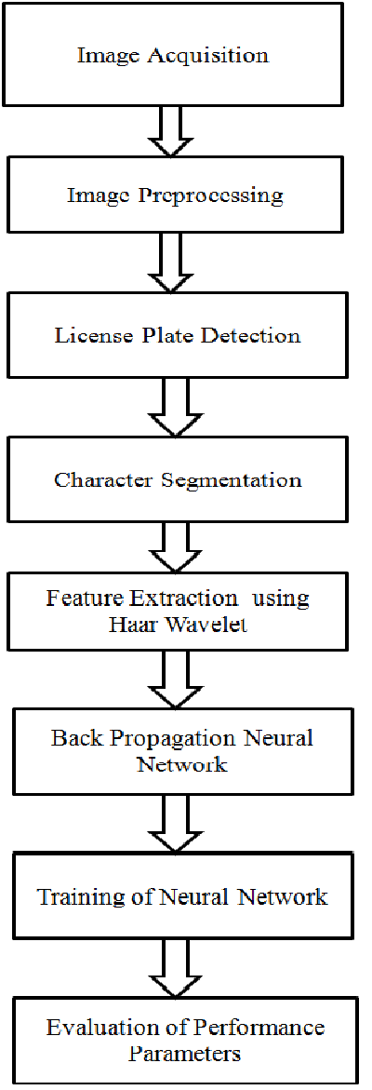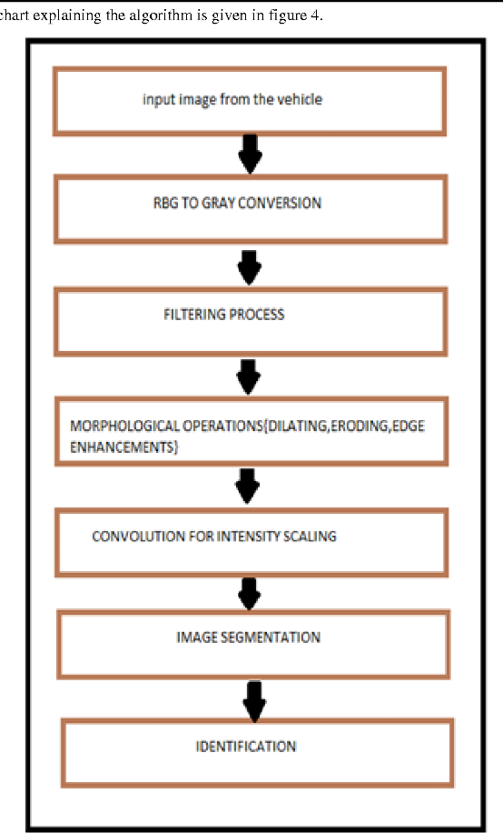

steps involved in automatic license plate reading

The process of Automatic License Plate Reading (ALPR) involves several steps, including:

1. Image Capture: ALPR systems use cameras to capture images of license plates on vehicles. The cameras can be mounted on vehicles, stationary poles, or other structures.

2. Image Preprocessing: Once the image is captured, the ALPR software processes it to improve the image quality and remove any noise or distortion. This preprocessing step includes image stabilization, contrast enhancement, and noise reduction.

3. License Plate Detection: After the image is preprocessed, the ALPR software searches for license plates within the image. This process involves detecting the edges of the license plate, segmenting the characters, and verifying the plate's orientation.

4. Character Segmentation: Once the license plate is detected, the ALPR software segments the characters within the plate. This process involves separating each character from the plate's background and identifying its position within the plate.

5. Character Recognition: After the characters are segmented, the ALPR software uses Optical Character Recognition (OCR) to recognize each character. The OCR process involves analysing the shape and pattern of each character and comparing it to a database of known character patterns.

6. Data Processing: Once the characters are recognized, the ALPR software combines them to form the license plate number. The software then compares the license plate number to a database of known license plate numbers to determine if there is a match.

7. Alerting and Reporting: If the ALPR system detects a match, it can alert law enforcement officers, parking attendants, or other personnel in real-time. The system can also generate reports on the number of vehicles that have been scanned, the number of matches detected, and other relevant data.

In conclusion, the ALPR process involves several steps, from image capture to alerting and reporting. The accuracy and efficiency of the ALPR system depend on the quality of the image capture, the effectiveness of the pre-processing and character recognition algorithms, and the reliability of the database used for comparison. ALPR technology has several benefits, including improved safety, reduced labour costs, and real-time data analysis, but concerns regarding privacy and data protection must also be considered.

Problems in license plate reading

While Automatic License Plate Reading (ALPR) technology has been successful in recognizing and reading license plates, there are some common problems that can affect the accuracy of the system. Here are some of the main problems in license plate reading:

1. Poor Image Quality: The accuracy of ALPR systems depends on the quality of the license plate image captured by the camera. Poor lighting conditions, image blur, and reflection can all affect the image quality and make it difficult for the software to read the license plate.

2. License Plate Obstruction: License plates can be obstructed by objects such as bike racks, trailer hitches, or even dirt or snow. When the license plate is partially or completely obstructed, it can be difficult for the software to read the plate accurately.

3. License Plate Location: The location of the license plate on a vehicle can also affect the accuracy of the system. If the license plate is located in an unusual position, such as on the front bumper or under a spoiler, it may be difficult for the software to recognize the plate.

4. License Plate Style: Different states and countries have different license plate styles and formats, which can affect the accuracy of the software. Some plates may have non-standard fonts or characters, making them more difficult to recognize.

5. Vehicle Speed: ALPR systems are designed to read license plates at high speeds, but excessive speed can still affect the accuracy of the software. If the vehicle is moving too quickly, the software may not have enough time to capture a clear image of the license plate.

6. Database Accuracy: The accuracy of the database used for comparison can also affect the accuracy of the ALPR system. If the database is outdated or incomplete, it may not be able to match the license plate accurately.

In conclusion, there are several challenges that can affect the accuracy of the ALPR system, including poor image quality, license plate obstruction, unusual plate locations, license plate styles, vehicle speed, and database accuracy. These problems can be mitigated by using high-quality cameras, updating the software regularly, and ensuring that the database is accurate and up-to-date.

Algorithms for automatic license plate reading

There are several algorithms used in Automatic License Plate Reading (ALPR) systems that enable accurate and efficient recognition of license plates. Here are some of the common algorithms used in ALPR:

1. Edge Detection: Edge detection algorithms are used to detect the edges of the license plate in an image. The algorithm analyzes the image to identify the edges of the plate, and then segments the plate from the rest of the image.

2. Character Segmentation: Character segmentation algorithms are used to separate the characters of the license plate from the background. This algorithm involves analyzing the plate image to identify each character's location and size, and then separating them from the background.

3. Optical Character Recognition (OCR): OCR algorithms are used to recognize the characters on the license plate. This algorithm involves analyzing the shape and pattern of each character and comparing it to a database of known character patterns. OCR algorithms use machine learning techniques such as convolutional neural networks to improve the accuracy of character recognition.

4. Template Matching: Template matching algorithms are used to match the recognized characters against a database of known license plate numbers. This algorithm involves comparing the recognized characters to a template of known characters to determine the license plate number.

5. Machine Learning: Machine learning algorithms are used to improve the accuracy of ALPR systems. Machine learning algorithms use large datasets to learn and improve their performance over time. This allows ALPR systems to improve their accuracy and recognition speed over time.

In conclusion, ALPR systems use several algorithms to accurately and efficiently recognize license plates. Edge detection, character segmentation, OCR, template matching, and machine learning algorithms are all used to improve the accuracy of the system. The use of these algorithms helps ALPR systems to recognize license plates in real-time, providing benefits such as improved safety, reduced labour costs, and real-time data analysis.

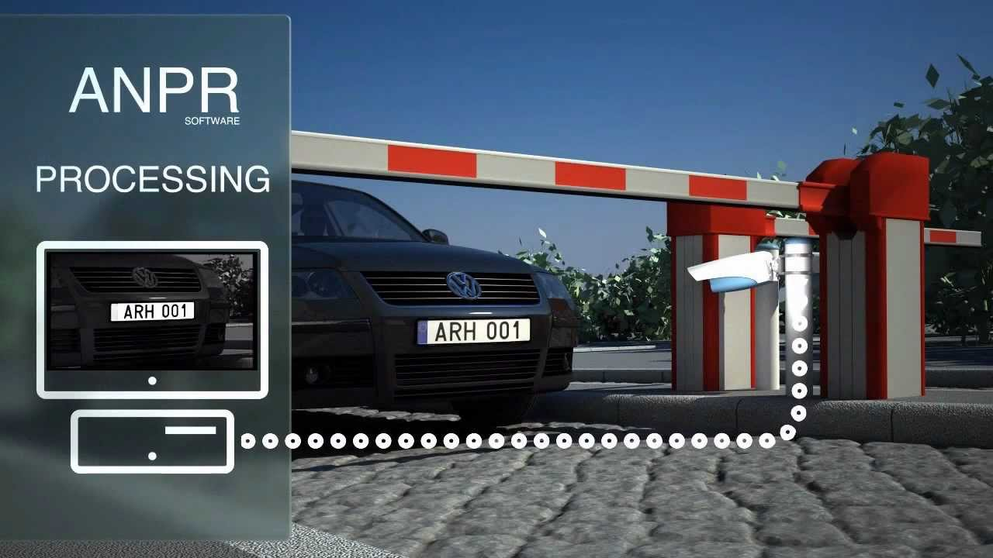

Object tracking for parking of vehicles

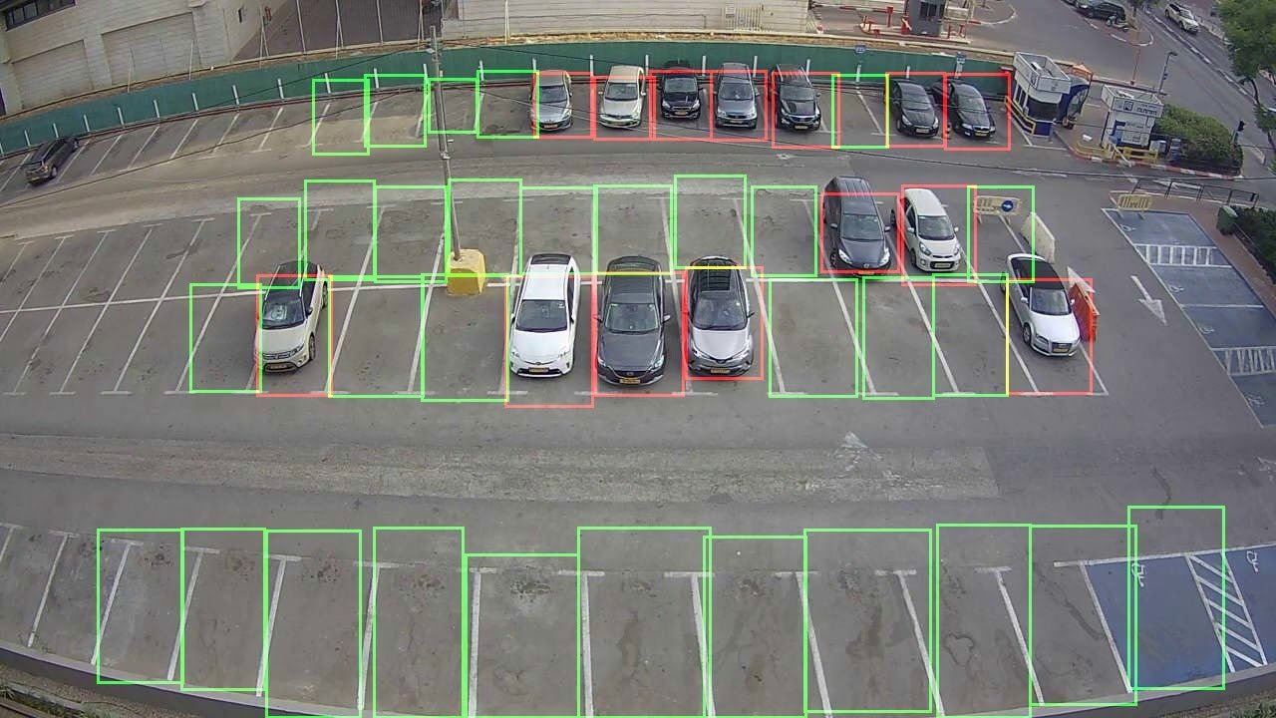

Object tracking is a critical technology used in parking management systems to track the movement of vehicles within a parking lot. Object tracking is a process that involves identifying and tracking a moving object over time using sensors, cameras, or other tracking devices. Here are some ways object tracking is used for parking of vehicles:

1. Real-time vehicle tracking: Object tracking technology can be used to track vehicles as they enter and exit the parking lot. This technology uses cameras and sensors to detect the location of vehicles and track their movements in real-time. This information can be used to monitor parking lot occupancy and ensure that there are enough parking spaces available for incoming vehicles.

2. License plate recognition: Object tracking can be used in conjunction with automatic license plate recognition (ALPR) technology to track the movement of vehicles in a parking lot. ALPR cameras can capture the license plate of a vehicle as it enters the lot, and object tracking technology can be used to track the vehicle's movement as it parks and exits the lot.

3. Parking guidance: Object tracking technology can be used to guide drivers to available parking spaces. This technology uses sensors to detect the presence or absence of vehicles in a parking space and communicates this information to a central system. The system can then direct drivers to available parking spaces in real-time.

4. Vehicle theft prevention: Object tracking technology can also be used to prevent vehicle theft in parking lots. By tracking the movement of vehicles in a lot, security personnel can be alerted if a vehicle is moving in an unauthorized manner or leaving the lot without authorization.

In conclusion, object tracking technology is a critical component of parking management systems. Real-time vehicle tracking, license plate recognition, parking guidance, and vehicle theft prevention are all use cases for object tracking technology in parking management systems. By utilizing object tracking technology, parking management systems can improve parking lot occupancy, guide drivers to available parking spaces, and enhance the overall safety and security of the parking lot.

Effectiveness and need of automated parking

Automated parking systems have become increasingly popular in recent years due to the benefits they offer. Here are some of the effectiveness and needs of automated parking:

1. Increased parking capacity: Automated parking systems can increase parking capacity in crowded urban areas. Since automated parking systems use a compact, vertical design, they require less space than traditional parking lots. This means that more vehicles can be parked in the same amount of space, increasing parking capacity.

2. Reduced labor costs: Automated parking systems require less labor than traditional parking lots. Since vehicles are parked and retrieved automatically, there is no need for parking attendants. This reduces labor costs and can result in significant cost savings for parking lot operators.

3. Improved efficiency: Automated parking systems are more efficient than traditional parking lots. Since vehicles are parked and retrieved automatically, the process is faster and more streamlined. This can reduce the amount of time it takes for drivers to park and retrieve their vehicles, resulting in a more pleasant parking experience.

4. Improved safety: Automated parking systems can improve safety in parking lots. Since there are no parking attendants, there is less risk of accidents or injuries involving parking attendants. Additionally, since the parking process is automated, there is less risk of damage to vehicles during the parking process.

5. Environmental benefits: Automated parking systems can have environmental benefits. Since they require less space than traditional parking lots, they can reduce the amount of land used for parking. Additionally, since they are more efficient, they can reduce the amount of time vehicles spend idling, resulting in reduced emissions.

In conclusion, automated parking systems are effective and necessary in modern urban areas. They increase parking capacity, reduce labor costs, improve efficiency and safety, and offer environmental benefits. With the continued growth of urban areas and the increasing demand for parking, automated parking systems will continue to be an important part of parking management solutions.

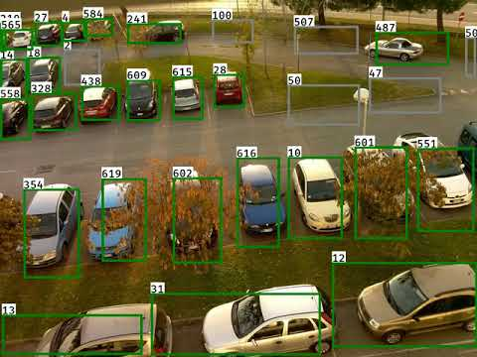

References

<https://papers.ssrn.com/sol3/papers.cfm?abstract_id=3274917>

<https://www.mdpi.com/2032-6653/12/4/200>

<https://aip.scitation.org/doi/pdf/10.1063/1.3526208#:~:text=LPR%20algorithm%20consists%20of%20the,character%20segmentation%20and%20character%20recognition>.

<https://pyimagesearch.com/2020/09/21/opencv-automatic-license-number-plate-recognition-anpr-with-python/>

https://www.westfaliaparking.com/