# Egress Estimator Tool

## Introduction

This software tool is intended to help the user estimate the time that would be required for building evacuation by stairs, elevators, or a combination of both. It employs a simple calculation based on calculation techniques for movement in hallways and stairwells by Nelson and Mowrer[1] and a model of elevator evacuation by Klote[2]. While the tool considers occupant loading, the capacity and number of stairs and elevators in a building, the details of occupant behavior, environmental effects, or damage due to an emergency event, and other potentially important events are not included. If more details analyses are needed, other simulation tools should be employed (see, for example, reference [3]).

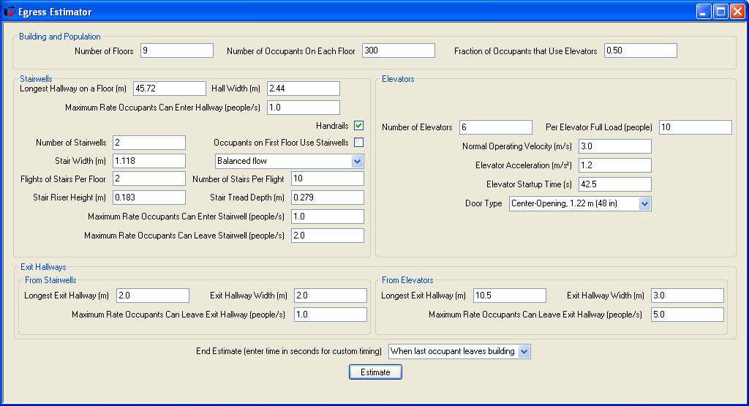

The program input is divided into several areas that allow the user to define details of building occupants, stairwells, elevators, and building exits.

## Building and Population



For the simple estimates in this tool, the building is defined by the number of floors in the building, the number of occupants on each floor of the building, and the fraction of building occupants who use the elevators during evacuation.

**Number of Floors:** Input the number of floors in the building. For the simple estimates in this tool, all floors of the building are assumed to be occupied. If the building includes unoccupied floors with mechanical or other equipment, these would normally not be included in the input. The number or height of stairs in each flight can be adjusted upward to account for the additional height of the unoccupied floors.

**Number of Occupants On Each Floor:** The average number of building occupants on each floor of the building. For the simple estimates in this tool, all floors are assumed to have the same number of occupants.

## Stairwell Inputs

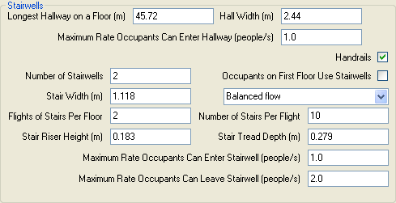

For stairwell evacuation, occupant travel is comprised of travel from a single compartment, from the compartment to a stairwell in a hallway, and down a stairway.

**Longest Hallways on a Floor (m):** As a conservative estimate, input the longest distance occupants would have to travel from their starting point to a stairwell for evacuation. For this simple tool, all hallways (and stairwells) are assumed to be identical.

**Hall Width:** Input the width of the hallway occupants use to travel from their starting point to the stairwell for evacuation.

**Maximum Rate Occupants Can Enter Hallway (people/s):** A typical value for flow through a single doorway is 1 person/s. If there are multiple doorways opening onto the hallway or obstructions to entering the hallway, this value may be increased or decreased as appropriate. The SPFE handbook includes additional information on movement speed as a function of width and occupant density.

**Number of Stairwells:** The number of stairwells in the building that are used for occupant egress. For this simple tool, all stairwells are identical and are assumed to serve all floors of the building.

**Handrails:** If checked, the effective width of the stairwells is reduced and stairwell movement speeds are modified to account for typical handrails on each side of the stairwell.

**Occupants on Fire Floor Use Stairwells:** Check this box if occupants on the first floor typically used the same egress path as occupant on the stairwells. When checked, occupants from the first floor merge with occupants from higher floors (see merging options below) as part of the egress calculation.

**Merging Options:** By default, occupants entering the stairwell at a floor alternate with those descending the stairs from higher floors. This is selected as “balanced flow.” If other deference behaviors are typical in the building or part of the building’s emergency plan, an input may be selected to allow those descending from higher floors to take priority over those entering the stairwell (those entering will wait until those from the higher floors have passed below their entry floor) or to allow those entering the stairwell to take priority over those already in the stairwell (those already in the stairwell from higher floors will wait until everyone entering a floor is in the stairwell before continuing their descent).

**Stair Width (m):** Input the full width of the stairwell.

**Flights of Stairs Per Floor:** Input the typical number of flights of stairs from (landing to landing) between floors. For this simple tool, all flights of stairs are assumed to be identical throughout the building.

**Number of Stairs Per flight:** Input the number of stairs in each flight of stairs. For this simple tool, the number of stairs in each flight is assumed to be the same throughout the building.

**Stair Riser Height (m):** Input the height of each stair measured from tread to tread.

**Stair Tread Depth (m):** Input the size from front to back of each stair tread.

**Maximum Rate Occupants Can Enter Stairwell (people/s):** A typical value for flow through a single doorway is 1 person/s. If there are multiple doorways opening onto the stairwell or obstructions to entering the hallway, this value may be increased or decreased as appropriate. The SPFE handbook includes additional information on movement speed as a function of width and occupant density.

**Maximum Rate Occupants Can Leave Stairwell (people/s):** A typical value for flow through a single doorway is 1 person/s. If there are multiple doorways opening from the stairwell or obstructions when leaving the hallway, this value may be increased or decreased as appropriate. The SPFE handbook includes additional information on movement speed as a function of width and occupant density.

## Elevator Inputs



For elevator evacuation, occupant travel is defined by the capacity of the elevators and the travel speed of the elevator. For this simple tool, elevator evacuation is assumed to proceed as follows: Elevators initially travel to the exit floor (as in standard Phase I recall). Once the elevators reach the discharge floor, evacuation begins with the highest occupied floor. Once the highest floor is completely evacuated to the discharge floor, evacuation proceeds with the next highest occupied floor and continues until the entire occupant population is evacuated. It is assumed that the same fraction of occupants on all floors use the elevator for evacuation. In practice, it is likely that some occupants on the lower floors will use the stairs. If a more detailed analysis is required, more complex evacuation models are available.

**Number of Elevators:** Input the number of elevators used for occupant evacuation. For this simple tool, all elevators in the building are assumed to be identical and operate as a group during evacuation. This assumption will tend to slightly overestimate the time required for elevator evacuation.

**Per Elevator Full Load (people):** Input the capacity of each elevator.

**Normal Operating Velocity (m/s):** Input the normal full operating velocity of the elevator car.

**Elevator Acceleration (m/s2):** Elevator motion starts with constant acceleration, followed by a transitional acceleration until constant velocity motion at the normal operating velocity is attained. Input the constant acceleration. Transitional acceleration is determined by the software.

**Elevator Startup Time (s):** The time from activation of the alarms (for example) to the start of the round trips that evacuate people. Input the time spent before the actual evacuation by elevator cars begins. Most typically, it is computed to be the time required to bring a fully loaded elevator car from the most distant floor to the discharge floor. If this is not satisfactory, a larger or smaller value may be used.

If the elevators are operated automatically during evacuation, one starts the elevator evacuation after all of the elevators have been moved to the discharge floor and anyone in the elevators have left the elevators. In the case of manual elevator operation, the time for elevator operators to reach the cars must be included.

**Door Type:** Select from a range of elevator door types and widths. This input impacts the door opening and closing times for each elevator car at the beginning and end of each trip.

## Exit Hallway Inputs



Travel from the stairwells and elevators are assumed to be through exit hallways. The length and width of the hallways may be different for the stairs and elevators. One or more doorways at the end of each hallway allow occupants to reach a point of safety. For elevators, this “hallway” may simply be an elevator lobby at the base of the elevators that exits through one or more doorways to a point of safety.

Three inputs define the exit path for the stairs and elevators:

**Longest Exit Hallway (m):** Input the length of the exit hallway from the stairs or the elevators to the building exit or another point of safety.

**Exit Hallway Width (m):** Input the width of the exit hallway from the stairs or the elevators.

**Maximum Rate Occupants Can Leave Hallway (people/s):** A typical value for flow through a single doorway is 1 person/s. If there are multiple doorways opening onto the hallway or obstructions to entering the hallway, this value may be increased or decreased as appropriate. The SPFE handbook includes additional information on movement speed as a function of width and occupant density.

## Program Outputs



Once appropriate inputs for the building are input to the software, the “Estimate” button begins calculation of occupant egress from the building. The user is prompted for a filename and location to store the results of the calculation (as a comm.-separated file that can be read into most spreadsheet programs for further analysis or display.



During the simulation, the number of occupants evacuated and the evacuation time is displayed. When the calculation is complete, the total number of occupants and total evacuation time is shown.



Detailed information on occupant location throughout the evacuation is available in the comma-separated spreadsheet file created during the simulation.

## References

1. Nelson, H. E. and F. W. Mowrer, “Emergency Movement,” Chapter 3‑14 in *SFPE Handbook for Fire Protection Engineering*, 3rd Ed., National Fire Protection Association and Society of Fire Protection Engineering, 2002.
2. Klote, J. H., “Method for Calculation of Elevator Evacuation Time,” J. of Fire Protection Engineering, Vol. 5, No. 3, 86-96, 1993.
3. Kuligowski, E. D. and R. D. Peacock, “Review of Building Evacuation Models,” Natl. Inst. Stand. Technol., Technical Note 1471, 2005.