ARK Community Forums is an informative website designed to inform fans of the newest DLC in the infamous Ark game. The following document goes over how the sites files work together and php functions used in its creations.

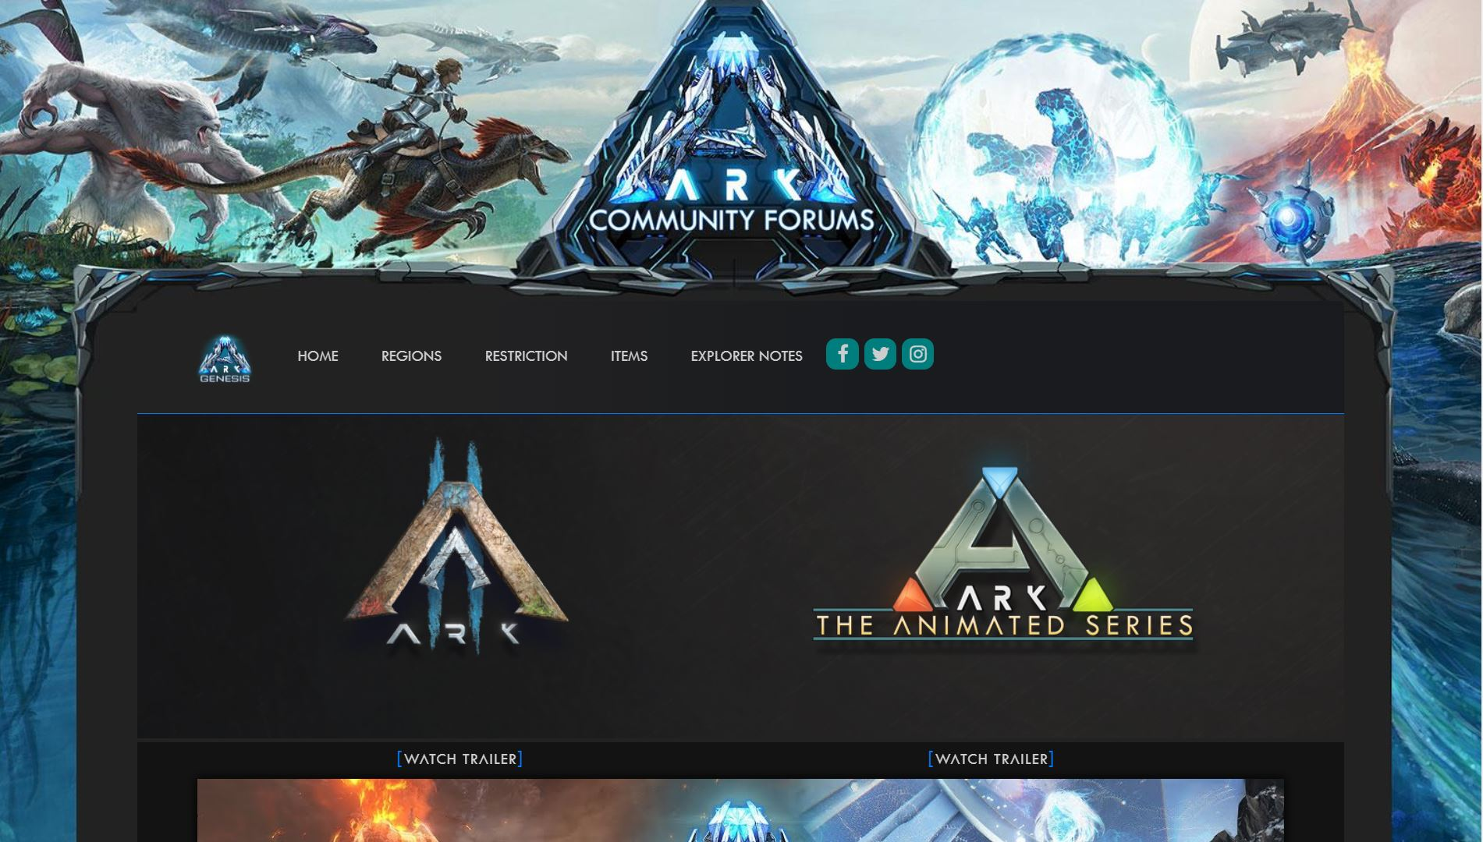

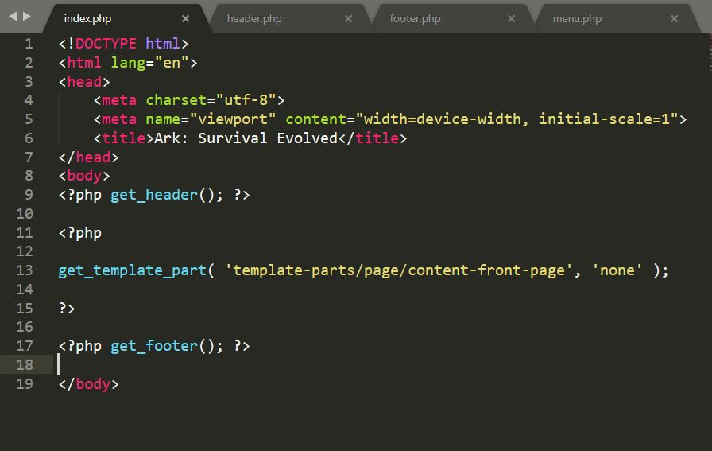

The following attachment is an excerpt. The code seen on line 9, receives the header.php template. The code on line 13, receives from template-parts/page/ content-front-page.php, content-front-page.php contain all the from HTML code that display on the front of the page. The code seen on line 17, receives the footer.php template.

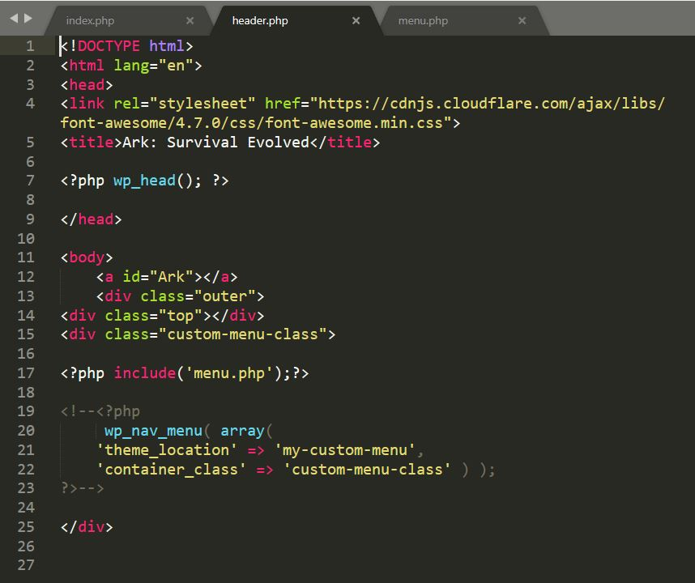

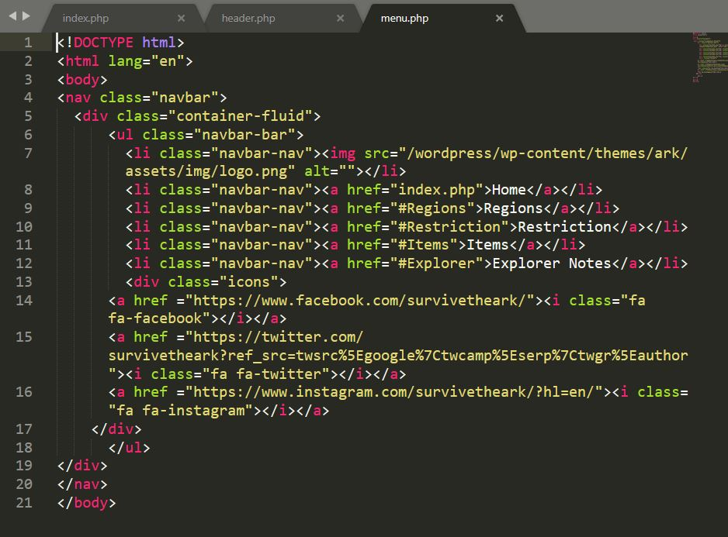

In the header, the code on line 17, receives Navigation Bar from menu.php

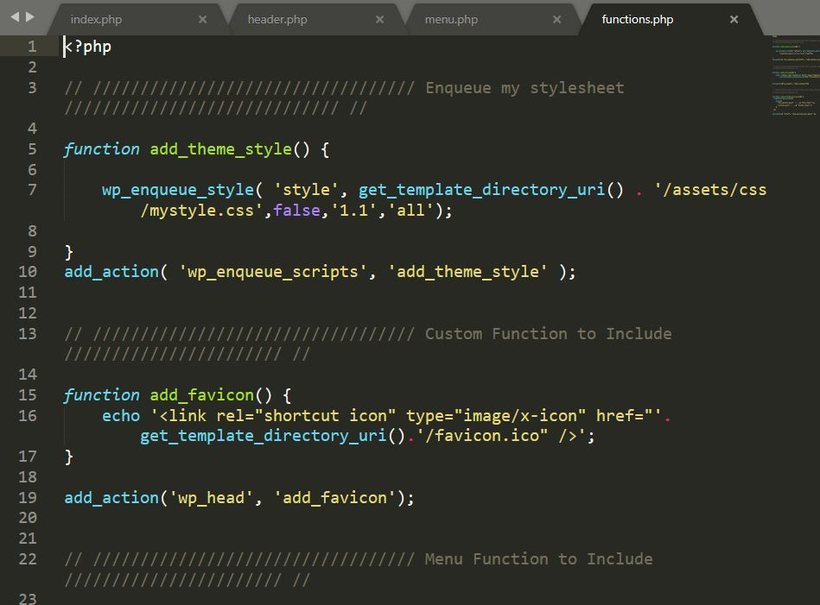

This attachment shows how I link my CSS file to the website, the code on line 5 – line 9 is creating a function that enqueues the CSS style to the template_directory. Line 10 then calls this function.