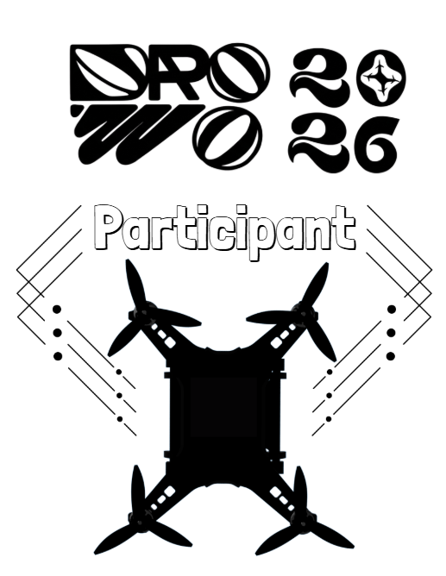
Tricouri | Bucati
Participant | 53

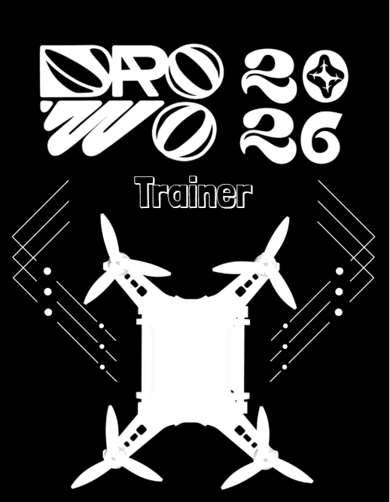

Trainer | S | 9
 | M | 5
 | L | 6

Total 20

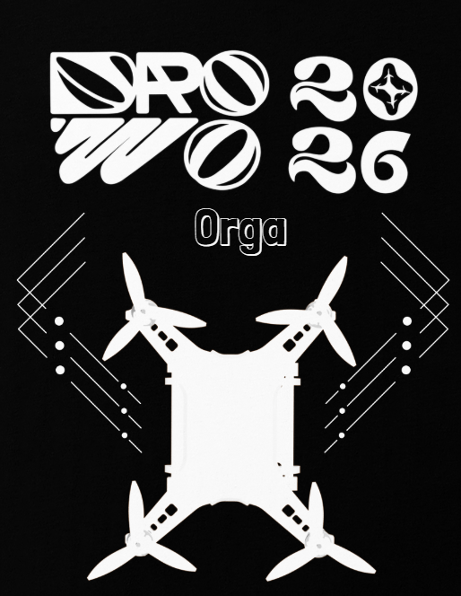

Orga | S | 1
 | M | 3
 | L | 4
 | XL | 1
 | XXL | 1

Total 10

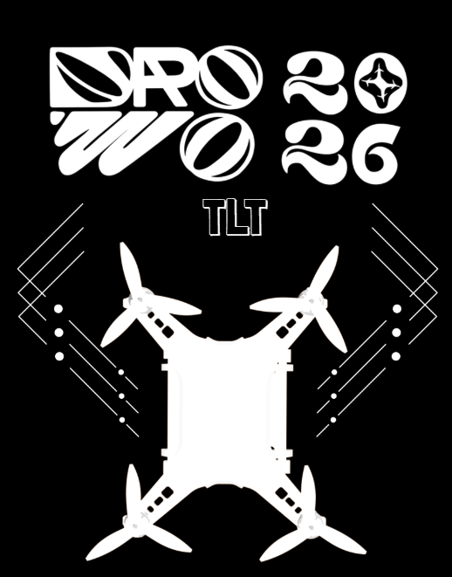
TLT | M | 1

Total 1

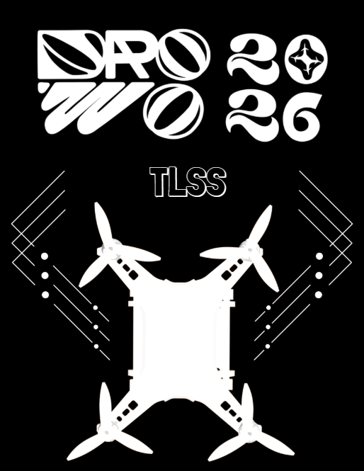

TLSS | M | 2
 | L | 2

Total 4

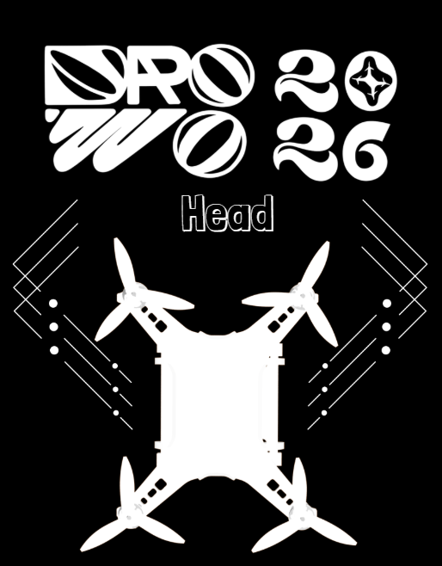

Head | M | 1
 | L | 2
 | XXL | 1

Total 4

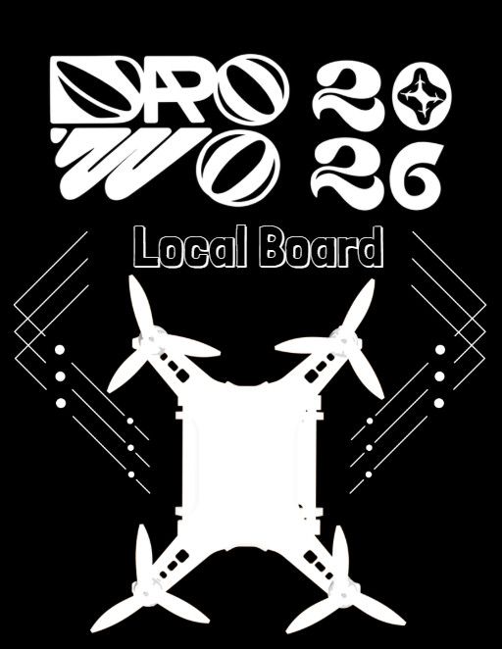

Local Board | S | 3
 | M | 1
 | L | 1
 | XL | 2

Total 7

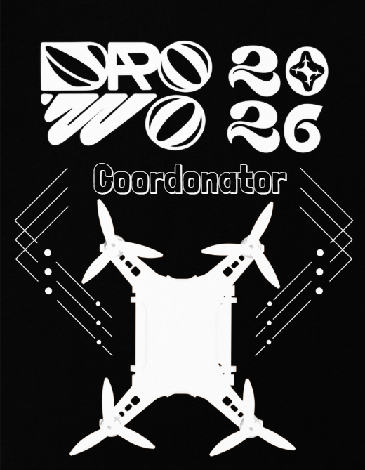

Coordonator | S | 1

Total 1

