MA323 Lab 12
Ashish Kumar Barnawal – 180123006

Question 1.
Seeing from the below graphs generated by the program, the output from LCG is unpredictable and looks random while output from Van der Corput sequence are predictable and follow pattern. Therefore they’re not suitable for random number generation.
The graph generated from Van der Corput sequence, consists of infinitely many lines with slope 1, which converge to point . The equation of the lines can be written as

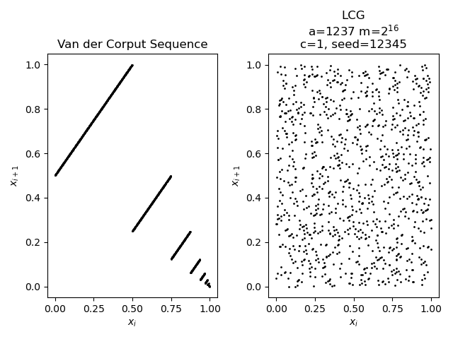
However seeing the distribution, we can observe that the output from Van der Corput is very uniform compared to LCG even when N is small. Van der Corput sequences are have low disperancy even though they’re deterministic
The LCG had the following parameters:
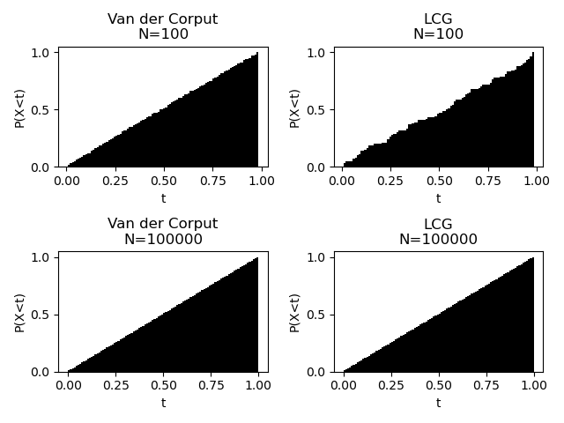

Question 2.
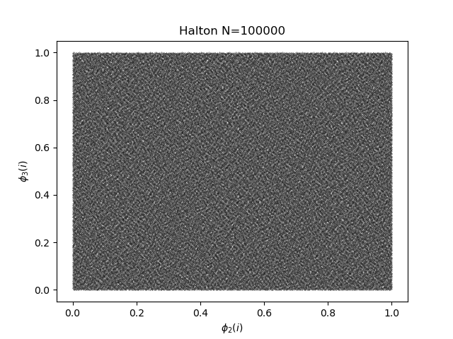
Halton sequences is used to generate low-discrepancy sequences in . In this case, . We can see that even for small number of terms, the graph looks quite uniform.
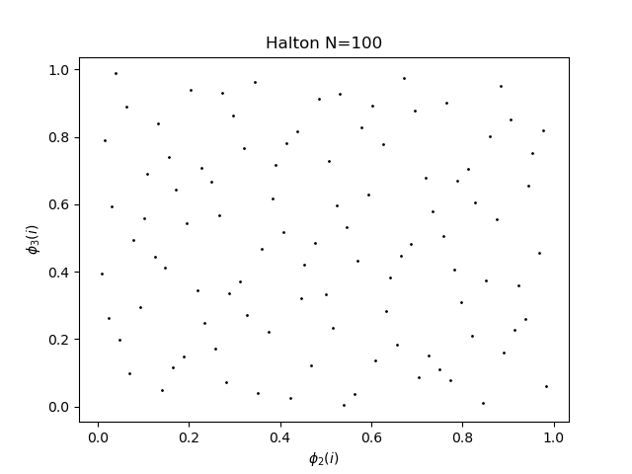
The Halton sequence below was generated as .

