Term Paper – MA473 (2021)
Higher order method for Black-Scholes PDE
Akshat Gupta – 180123002
Ashish Barnawal – 180123006
Karan Gupta – 180123064

Introduction
Based on the following assumptions Black and Scholes derived the Black Scholes formula
- The asset price follows geometric brownian motion i.e.
- The risk-free interest rate is r is constant until expiration date
- Investors can borrow and lend at risk-free ratese
- The stock doesn’t pay dividends
- The market is frictionless (no tax/transaction costs and all securities are divisible)
- No risk-free arbitrage oppurtunity exists
- Security trading is continuous
- Option is a European option

Based on above, The Black-Scholes PDE is given by:

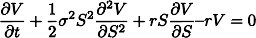

with terminal conditions:

For European call option:

For European put option

The solution can be found analytically to be:

For European call,
For European put,

where,
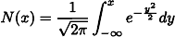

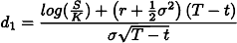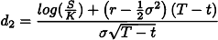

Space discretization

Fourth order central finite difference

We write the formula as:

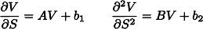

where

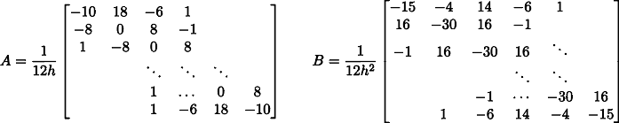

Thus the BS PDE can be written as

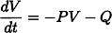 where 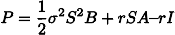 and 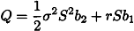

Fourth order compact finite difference scheme

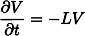

where

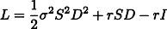

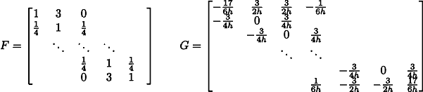
and
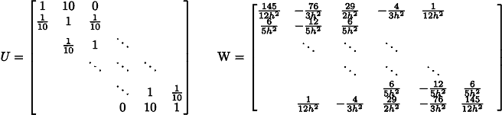

Time discretization

Crank Nicolson method

For 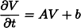

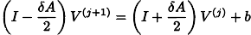

BDF4 method

For 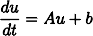 the scheme is given by

Grid refinement
Transform
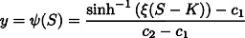

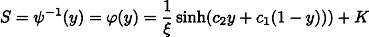

where

The Black-Scholes PDE transforms to:

Results

Compact Finite Difference + BDF4

Grid Size | Error | Order
10x10 | 0.031667
20x20 | 0.009247 | 1.775868
40x40 | 0.000782 | 3.563366



Compact Finite Difference + Crank Nicolson

Grid Size | Error | Order
10x10 | 0.032057
20x20 | 0.009247 | 1.793653
40x40 | 0.000782 | 3.563347

Compact Finite Difference + Crank Nicolson + Grid Refinement

Grid Size | Error | Order
10x10 | 0.017660
20x20 | 0.005036 | 1.810200
40x40 | 0.000613 | 3.039027

Compact Finite Difference + BDF4 + Grid Refinement

Grid Size | Error | Order
10x10 | 0.015779
20x20 | 0.003903 | 2.015336
40x40 | 0.000256 | 3.930728

