Credit Card Fraud Detection
Project Progress Report
Submitted in Partial Fulfillment of the Requirements for the Degree of
BACHELOR OF TECHNOLOGY
in
COMPUTER SCIENCE & ENGINEERING

By
NAME | ROLL NO.
EKTA MANGAL | 1900950100028



DEPARTMENT OF COMPUTER SCIENCE & ENGINEERING
MGM’s College of Engineering & Technology, Noida
August, 2022

TABLE OF CONTENTS

Page No.

CERTIFICATE
ABSTRACT
CHAPTER 1 (INTRODUCTION, BACKGROUND OF THE PROBLEM,
STATEMENT OF PROBLEM etc.)
1.1. Literature review………………………………………………………………………………. 1
1.2. Problem definition....................................................................................................................... 6
1.3. Brief introduction of the project.................................................................................................. 9
1.4. Proposed modules……………………………………………………………………………… 13
1.5. Hardware & Software requirements………………………………………………………….... 16
REFERENCES ........................................................................................................................................... 18

CERTIFICATE

This is to certify that Project Report entitled “Credit Card Fraud Detection” which is submitted by Ekta Mangal (1900950100028) in partial fulfillment of the requirement for the award of degree B. Tech. in Department of Computer Science and Engineering of MGM’s College of Engineering and Technology which is affiliated by AKTU Lucknow, is a record of the candidates own work carried out by them under my supervision. The matter embodied in this report is original and has not been submitted for the award of any other degree.

Date: August,2022 Supervisor Signature:
Name of Supervisor: Navin Kumar Trivedi
Designation: H.O.D

DECLARATION

I hereby declare that this submission is our own work and that, to the best of our knowledge and belief, it contains no material previously published or written by another person nor material which to a substantial extent has been accepted for the award of any other degree or diploma of the university or other institute of higher learning, except where due acknowledgment has been made in the text.

Signature: Ekta
Name: EKTA MANGAL
Roll No.: 1900950100028
Date: AUGUST,2022

ABSTRACT

Abstract—
It is vital that credit card companies are able to identify fraudulent credit card transactions so that customers are not charged for items that they did not purchase. Such problems can be tackled with Data Science and its importance, along with Machine Learning, cannot be overstated. This project intends to illustrate the modelling of a data set using machine learning with Credit Card Fraud Detection. The Credit Card Fraud Detection Problem includes modelling past credit card transactions with the data of the ones that turned out to be fraud. This model is then used to recognize whether a new transaction is fraudulent or not. Our objective here is to detect 100% of the fraudulent transactions while minimizing the incorrect fraud classifications. Credit Card Fraud Detection is a typical sample of classification. In this process, we have focused on analysing and pre-processing data sets as well as the deployment of multiple anomaly detection algorithms such as Local Outlier Factor and Isolation Forest algorithm on the PCA transformed Credit Card Transaction data.

Keywords—
Credit card fraud, applications of machine learning, data science, isolation forest algorithm, local outlier factor, automated fraud detection.

CHAPTER 1

INTRODUCTION
'Fraud' in credit card transactions is unauthorized and unwanted usage of an account by someone other than the owner of that account. Necessary prevention measures can be taken to stop this abuse and the behaviour of such fraudulent practices can be studied to minimize it and protect against similar occurrences in the future. In other words, Credit Card Fraud can be defined as a case where a person uses someone else’s credit card for personal reasons while the owner and the card issuing authorities are unaware of the fact that the card is being used. Fraud detection involves monitoring the activities of populations of users in order to estimate, perceive or avoid objectionable behaviour, which consist of fraud, intrusion, and defaulting. This is a very relevant problem that demands the attention of communities such as machine learning and data science where the solution to this problem can be automated. This problem is particularly challenging from the perspective of learning, as it is characterized by various factors such as class imbalance. The number of valid transactions far outnumber fraudulent ones. Also, the transaction patterns often change their statistical properties over the course of time.
These are not the only challenges in the implementation of a real-world fraud detection system, however. In real world examples, the massive stream of payment requests is quickly scanned by automatic tools that determine which transactions to authorize. Machine learning algorithms are employed to analyse all the authorized transactions and report the suspicious ones. These reports are investigated by professionals who contact the cardholders to confirm if the transaction was genuine or fraudulent. The investigators provide a feedback to the automated system which is used to train and update the algorithm to eventually improve the fraud-detection performance over time.
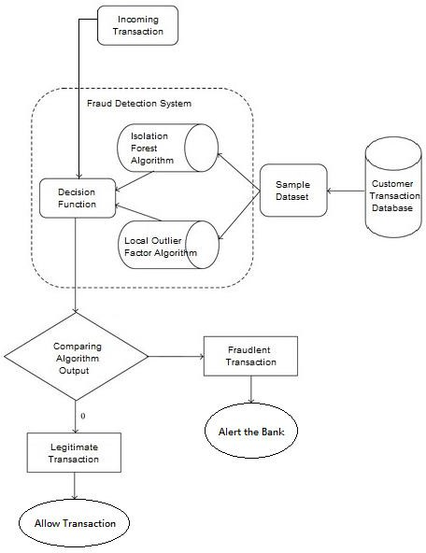
Fraud detection methods are continuously developed to defend criminals in adapting to their fraudulent strategies. These frauds are classified as:
• Credit Card Frauds: Online and Offline
• Card Theft
• Account Bankruptcy
• Device Intrusion
• Application Fraud
• Counterfeit Card
• Telecommunication Fraud
Some of the currently used approaches to detection of such fraud are:
• Artificial Neural Network
• Fuzzy Logic
• Genetic Algorithm
• Logistic Regression
• Decision tree
• Support Vector Machines
• Bayesian Networks
• Hidden Markov Model
• K-Nearest Neighboor
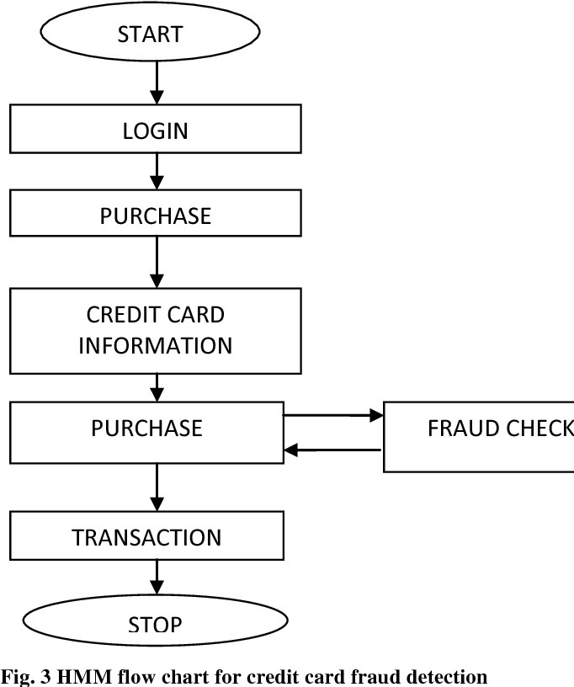

  - LITERATURE REVIEW
Fraud act as the unlawful or criminal deception intended to result in financial or personal benefit. It is a deliberate act that is against the law, rule or policy with an aim to attain unauthorized financial benefit. Numerous literatures pertaining to anomaly or fraud detection in this domain have been published already and are available for public usage. A comprehensive survey conducted by Clifton Phua and his associates have revealed that techniques employed in this domain include data mining applications, automated fraud detection, adversarial detection. In another paper, Suman Research Scholar, GJUS&T at Hisar HCE presented techniques like Supervised and Unsupervised Learning for credit card fraud detection. Even though these methods and algorithms fetched an unexpected success in some areas, they failed to provide a permanent and consistent solution to fraud detection.
A similar research domain was presented by Wen-Fang YU and Na Wang where they used Outlier mining, Outlier detection mining and Distance sum algorithms to accurately predict fraudulent transaction in an emulation experiment of credit card transaction data set of one certain commercial bank. Outlier mining is a field of data mining which is basically used in monetary and internet fields. It deals with detecting objects that are detached from the main system i.e. the transactions that aren’t genuine. They have taken attributes of customer’s behaviour and based on the value of those attributes they’ve calculated that distance between the observed value of that attribute and its predetermined value.
Unconventional techniques such as hybrid data mining/complex network classification algorithm is able to perceive illegal instances in an actual card transaction data set, based on network reconstruction algorithm that allows creating representations of the deviation of one instance from a reference group have proved efficient typically on medium sized online transaction.
There have also been efforts to progress from a completely new aspect. Attempts have been made to improve the alertfeedback interaction in case of fraudulent transaction. In case of fraudulent transaction, the authorised system would be alerted and a feedback would be sent to deny the ongoing transaction.
Artificial Genetic Algorithm, one of the approaches that shed new light in this domain, countered fraud from a different direction.
It proved accurate in finding out the fraudulent transactions and minimizing the number of false alerts. Even though, it was accompanied by classification problem with variable misclassification costs.

  - PROBLEM STATEMENT

The problem statement chosen for this project is to predict fraudulent credit card transactions with the help of machine learning models.
In this project, we will analyse customer-level data which has been collected and analysed during a research collaboration of Worldline and the Machine Learning Group.
The dataset is taken from the Kaggle Website website and it has a total of 2,84,807 transactions, out of which 492 are fraudulent. Since the dataset is highly imbalanced, so it needs to be handled before model building.

1.3 BRIEF INTRODUCTION OF PROJECT
The approach that this paper proposes, uses the latest machine learning algorithms to detect anomalous activities, called outliers. The basic rough architecture diagram can be represented with the following figure:

When looked at in detail on a larger scale along with real life elements, the full architecture diagram can be represented as follows:
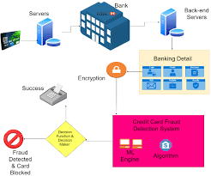
First of all, we obtained our dataset from Kaggle, a data analysis website which provides datasets. Inside this dataset, there are 31 columns out of which 28 are named as v1-v28 to protect sensitive data. The other columns represent Time, Amount and Class. Time shows the time gap between the first transaction and the following one. Amount is the amount of money transacted. Class 0 represents a valid transaction and 1 represents a fraudulent one. We plot different graphs to check for inconsistencies in the dataset and to visually comprehend it:
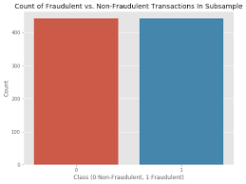
This graph shows that the number of fraudulent transactions is much lower than the legitimate ones.
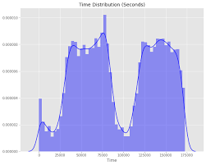
This graph shows the times at which transactions were done within two days. It can be seen that the least number of transactions were made during night time and highest during the days.
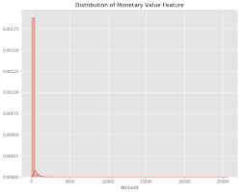
This graph represents the amount that was transacted. A majority of transactions are relatively small and only a handful of them come close to the maximum transacted amount. After checking this dataset, we plot a histogram for every column. This is done to get a graphical representation of the dataset which can be used to verify that there are no missing
any values in the dataset. This is done to ensure that we don’t require any missing value imputation and the machine learning algorithms can process the dataset smoothly.
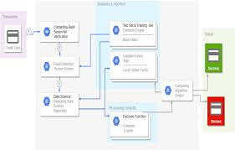
After this analysis, we plot a heatmap to get a coloured representation of the data and to study the correlation between out predicting variables and the class variable. This heatmap is shown below:
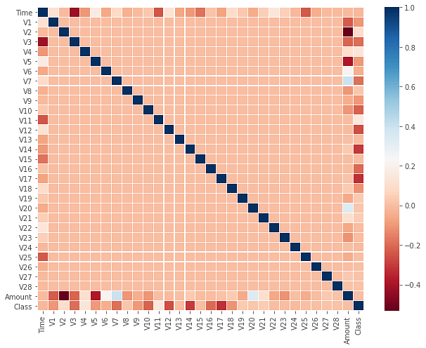
The dataset is now formatted and processed. The time and amount column are standardized and the Class column is removed to ensure fairness of evaluation. The data is processed by a set of algorithms from modules. The following module diagram explains how these algorithms work together: This data is fit into a model and the following outlier detection modules are applied on it: • Local Outlier Factor • Isolation Forest Algorithm These algorithms are a part of sklearn. The ensemble module in the sklearn package includes ensemble-based methods and functions for the classification, regression and outlier detection. This free and open-source Python library is built using NumPy, SciPy and matplotlib modules which provides a lot of simple and efficient tools which can be used for data analysis and machine learning. It features various classification, clustering and regression algorithms and is designed to interoperate with the numerical and scientific libraries. We’ve used Jupyter Notebook platform to make a program in Python to demonstrate the approach that this paper suggests. This program can also be executed on the cloud using Google Collab platform which supports all python notebook files. Detailed explanations about the modules with pseudocodes for their algorithms and output graphs are given as follows:
    - Local Outlier Factor
It is an Unsupervised Outlier Detection algorithm. 'Local Outlier Factor' refers to the anomaly score of each sample. It measures the local deviation of the sample data with respect to its neighbours. More precisely, locality is given by k-nearest neighbours, whose distance is used to estimate the local data. The pseudocode for this algorithm is written as:
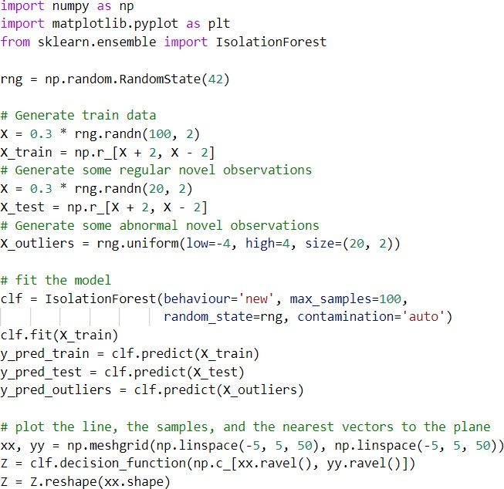
On plotting the results of Local Outlier Factor algorithm, we get the following figure:
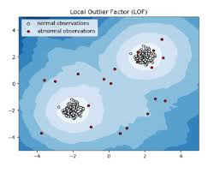

    - Isolation Forest Algorithm
The Isolation Forest ‘isolates’ observations by arbitrarily selecting a feature and then randomly selecting a split value between the maximum and minimum values of the designated feature. Recursive partitioning can be represented by a tree, the number of splits required to isolate a sample is equivalent to the path length root node to terminating node. The average of this path length gives a measure of normality and the decision function which we use. The pseudocode for this algorithm can be written as:
By comparing the local values of a sample to that of its neighbours, one can identify samples that are substantially lower than their neighbours. These values are quite amanous and they are considered as outliers. As the dataset is very large, we used only a fraction of it in out tests to reduce processing times. The final result with the complete dataset processed is also determined and is given in the results section of this paper.
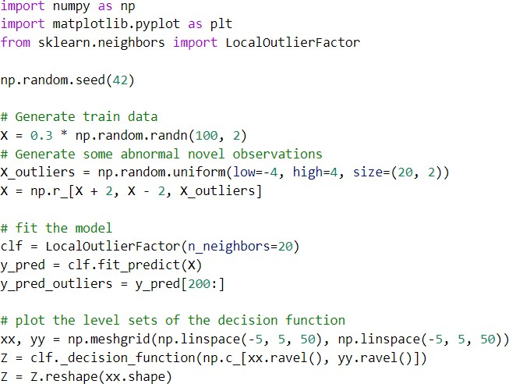

On plotting the results of Isolation Forest algorithm, we get the following figure:
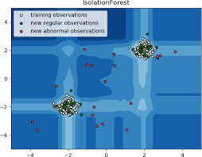
Partitioning them randomly produces shorter paths for anomalies. When a forest of random trees mutually produces shorter path lengths for specific samples, they are extremely likely to be anomalies. Once the anomalies are detected, the system can be used to report them to the concerned authorities. For testing purposes, we are comparing the outputs of these algorithms to determine their accuracy and precision.

  - PROPOSED MODULES

1.4.1. LOGISTIC REGRESSION:
  - Logistic regression works with sigmoid function because the sigmoid function can be used to classify the output that is dependent feature and it uses the probability for classification of the dependent feature. This algorithm works well with less amount of data set because of the use of sigmoid function if value the of sigmoid function is greater than 0.5 the output will 1 if the output the sigmoid function is less than 0.5 then the output is considered as the 0. But this sigmoid function is not suitable for deep learning because the if deep learning when we back tracking from the output to input we have to update the weights to minimize the error in weight update. we have to do differentiation of sigmoid activation function in middle layer neuron then results in the value of 0.25 this will affect the accuracy of the module in deep learning.

    - DECISION TREE:
  - Decision tree can be used for the classification and regression problems working for both is same but some formulas will change. Classification problem uses the entropy and information gain for the building of the decision tree model. entropy tell about how the data is random and information gain tells about how much information we can get from this feature. Regression problem uses the gini and gini index for the building of the decision tree model. In classification problems the root node is selected by using information gain that the root node t id selected by using is having the high information again and low entropy. In Regression problems the root node is selected by using gini , the feature which is having the less gini is selected as the root here Depth of the tree can be determined by using hyper parameter optimization, this can be achieved by Using grid search cv algorithm.

1.4.3. RANDOM FORESTS:
  - The random forest randomly selects the features that is independent variables and also randomly selects the rows by row sampling and the number of decision tree can be determined by using hyper parameter optimization. For classification problem statement the output is the maximum occurrence outputs from each decision tree models inside the random forest. This is one the widely used machine learning algorithm in real word scenarios and in deployed models. And in most of the Kaggle computation challenges this algorithm is used to solve the problem statement.

1.4.4. NAÏVE BAYES:
  - Naïve Bayes is the machine learning algorithm for classification problem, which work on the property of Bayes theorem. It can be implemented by using features in data set independent feature as input and dependent feature as a output, the same thing what is behind the Naïve Bayes theorem is applied here to calculate probability of the dependent feature with respect to independent features.

    - ANN MODEL:
  - Artificial neural networks in deeps learning can be used to replace the machine learning algorithms for better prediction, ANN is having different types of layers such as input layer, number middle layers having activation function for the action of neurons and the output layer having some kind of activation function like sigmoid and weight initialization and reinitialization in backward propagation for reducing the error between actual and predicted values.

1.5. HARDWARE AND SOFTWARE REQUIREMENTS:

1.5.1 Hardware Requirements-
- RAM
- Motherboard
- Hard Disk
- Intel Processor
- GPU

1.5.2. Software Requirements-
- Python 3.10.0
- Python Numpy
- Python Pandas
- JupyterHub
- Visual Code
- Git
- My SQL

REFERENCES
Examples of Journal Article referencing:
1. Drucker, D. C., "Photoelastic Separation of Principal Stresses by Oblique Incidence", Journal of Applied Mechanics, Vol. 65, pp. 156-160, 1943.
2. Maiers, J., and Sherif, Y. S. , "Application of Fuzzy Set Theory," IEEE Transactions on Systems, Man, and Cybernetics, Vol. SMC-15, No.1, pp. 41-48, 1985.
Example of Book referencing:
3. Doe, N., Control System Principles, New York: John Wiley, 1999.
Example of Referencing of an Article in a Book:
4. Hwang, C. J., "Rule-based Process Control,"in E. Kumarmangalam and L. A. Zadeh (Eds.), Approximate Reasoning in Intelligent Systems, Decision and Control, pp. 145-158,
Oxford: Pergamon Press, 1987.
Example of referencing of a B. Tech. Report:
5. Nayak, T., "Application of Neural Networks to Nuclear Reactors," M.Sc. Report, U.P. Technical University, 2005.
Example of referencing of a Ph. D. Dissertation:
6. Muskìn, H. L., "Development of A Knowledge-Based System for a Nuclear Power Plant," Ph.D. Dissertation, U. P. Technical University, 2003.
Example of referencing of a Conference Paper :
7. Lokhande, R., Arya, K. V., and Gupta, P., "Identification of Parameters and Restoration of Motion Blurred Images", Proceedings of the 2006 ACM Symposium on Applied Computing (SAC 2006), pp. 89-95, Dijon, France, April 2- 7, 2006.
Example of referencing of a Paper presented at Conference but not Published :
8. Lokhande, R., and Gupta, P., "Identification of Parameters of Motion Images", presented at 5th International Conference on Cyber Systems, New Delhi, India, April 12- 17, 2004
Example of referencing of a Report [Technical, Internal, or Memoranda]: :
9. Das, A. R., Murthy D., and Badrinath J., A Comparison of Different Biometrics Traits, RSRE Memorandum No. 4157, RSRE Malvern, 2001.
Example of referencing of a Manual
10. Bell Telephone Laboratories Technical Staff, Transmission System for Communications, Bell Telephone Laboratories, 1995.
Example of referencing of a Class Note
11. "Signal integrity and interconnects for high-speed applications," class notes for ECE 497-JS, Department of Electrical and Computer Engineering, University of Illinois at Urbana-Champaign, Winter 1997.
Example of referencing of a Private Communication
12. Banerjee, T., (Private Communication), 1998
Example of referencing of an Article from Internet
13. Biometrics Group, Indian Institute of Technology Kanpur, "Multimodal Biometrics System," December 2006, http://www.cse.iitk.ac.in/users/biometrics.html
14. Gupta, P. (pg@iitk.ac.in), "Biometrics System," Usenet post to sci.electronics.design, July 4, 2007.
Example of referencing of an Article from Catalog
15. Catalog No. MWM-1, Microwave Components, M. W. Microwave Corp., Brooklyn, NY
Example of referencing of an Article from Application Note
16. Hewlett-Packard, Appl. Note 935, pp. 25-29.
Example of referencing of an Article from Application Note
17. Kar, K. and Majumder, D., "Fuzzy Controller Component," U. S. Patent 23,160,040, December 21, 2006.

