

毕业设计（论文）的外文文献翻译

原始资料的题目/来源： The Development of a Web-based Claims System/IEEEXplore

翻译后的中文题目： 基于网络的报销系统的开发

专 业 计算机科学与技术
学 生 刘连兴
学 号 140410126
班 号 1404101
指导教师 闫健恩
翻译日期 2018年6月17日
外文文献的中文翻译
摘要-这项研究的主要目的是为马来西亚玻璃市大学（UniMAP）的工作人员开发一个计算机系统，通过电子媒体进行报销。由于这个系统是基于网络的，工作人员可以随时随地在任何地点提出报销。这种方法不仅可以克服人为错误，而且更加高效，快速和准确。并且，该系统还可以节省时间，精力和管理成本。在这项研究中，选择了Active Server Pages（ASP）来进行计算并生成报告。系统开发完成后，使用手动模拟的表格进行测试。目的是使研究人员能够与使用开发系统进行比较，以便检测系统中手动模拟的错误或缺陷。

关键词-系统开发; Web应用程序;ASP; 在线报销; 电脑化的手动系统。

一、介 绍
计算机技术的出现已经在很多方面彻底改变了我们的生活。它不再是精英阶层的垄断者，而是已经到达了群众。对于用户来说，他们可能拥有自己的个人电脑，但对于穷人来说，他们可以通过各种方式感受到指定地点的互联网和电子邮件等计算机系统。对于一些人来说，这是可以通过雇用别人进行利润丰厚的业务的时代。
这种以计算机技术形式出现的新科学知识的影响改变了我们学习的方式; 我们思考的方式; 我们沟通的方式以及与前几代完全不同的其他许多行为特征。 因此，我们的年轻人的计算机素养正在快速增长。
即使早在小学的儿童也已经接触到计算机系统，教育当局和家长教师协会（PTA）已经为他们提供了学校计算机俱乐部下的计算机实验室。现在计算机素养已达到前所未有的高度，远远超出了城市地区和农村的界限。简而言之，它将成为我们的生活方式，对于那些仍然是电脑文盲的人来说，在这个不断变化的世界中会感到不适应。这就是计算机系统对当代和下一个无限的影响和意义。
在工作场所，计算机系统绝对是必不可少的，它们是不可或缺的。
随着计算机技术的发展和进步，任何组织都不能落后。他们别无选择，只能最终跟上他的步伐。事实上，很快就可以预见，行政官僚机构将成为过去的事物，并最终被计算机系统取代。
本研究旨在为马来西亚玻璃市大学（UniMAP）的工作人员开发一个基于网络的报销系统，这些工作人员必须执行任务外派或参加UniMAP当局指导的课程。目前，所有报销都必须通过报销人填写报销表格手动提出。 这是一个非常繁琐的过程并且非常耗时。报销人通常不得不提到马来西亚财政部通告，检查他们每次报销时都不确定的权利。

二、概念框架
在目前的人工报销系统下，报销表格必须填写并通过部门分支机构来回传递给财务部门。通过在线进行，报销人可以随时随地执行。在线报销的好处很多，其中包括取消行政官僚机构，避免人为错误和不必要的延误。
借助基于网络的报销系统，UniMAP财务部门能够控制和监测从同一账户向报销人提供的任何自付费用。与通过一堆报销表格进行手动操作相比，点击右键可以轻松完成。与上述有关的另一个目标是，该系统能够从报销人提出的未清偿自助清单中提取信息。
基于网络的报销系统的另一个重要目的是在同一个月内提出多项报销。例如，如果工作人员在月初出差，然后回来并立即提交报销，报销随即进行处理。之后，工作人员可能会被另一个机构要求再次出差，例如在本月中旬或者本月底之后再次出差并提交另一个请求。在这种情况下，工作人员将在同一个月内提交两份报销。无论是故意的还是其他的错误，都会使报销具有可疑性，特别是在报销里程超过500公里时。根据我们的财务条例，对于里程报销，对于前500公里，501至1000,1001至1700和1701及以上，每公里工作人员应享福利分为递减顺序。该系统能够自动累积距离并相应显示每公里费率的权利分。
如果报销人拿出预付款或外派预付款，只要报销人将旅行日期作为旅行申请的日期加上，系统能够从实际报销中扣除数额。在这种情况下，目标是帮助减轻处理报销的人的负担。

三、方法
在任何系统开发中，该方法对确保所采取步骤的描述是一致的非常重要。这被称为系统开发生命周期（SDLC），通常称为瀑布模型和线性周期。它被称为瀑布模型的原因非常明显，如图1所示。
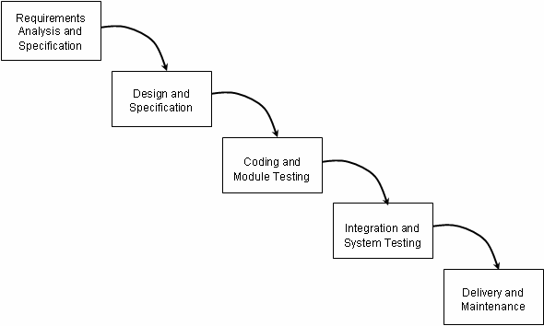
图1 软件生命周期的瀑布模型
SDLC方法与已知的结构化系统分析和设计密切相关。它涉及在开发信息系统方面采取的一系列步骤如下：
- 问题定义（问题陈述）
一旦收到用户对系统开发的请求，就会进行研究以确定要解决的问题。
- 可行性研究报告（可行性报告）
这部分的主要目标是明确界定系统项目的范围和目标，并确定前面定义的问题的替代解决方案。
- 系统分析阶段（本系统的规格）
检查当前系统并记录其规格。它应该包含对当前系统如何工作以及如何工作的理解。
- 系统设计阶段（建议系统的规格）
研究当前系统的规格，以确定需要哪些变化来纳入用户需求，目前系统尚未满足这些需求。这个阶段的结果将包括新的规范，它必须描述拟议的系统将做什么以及它将如何工作。
- 系统构造（程序，文档和用户手册）
编程系统并生成用户以及系统的程序文档。
- 系统测试和评估（测试和评估结果以及系统可以提供给用户/客户端）
测试，验证和刚刚构建的系统的验证。

四、用户需求分析
在任何系统开发中，第一步是分析用户需求，以了解和记录他们的规格或要求。 在基于网络的报销系统开发中，研究人员对一些UniMAP的员工进行了调查，以进行用户需求分析。之后是收集UniMAP认为需要的所有信息的数据集。
尽管马来西亚财政部的财政通函存在已经实施的程序，但UniMAP可能还有其他一些特殊要求，即用户需要做的。在这种情况下，用户必须提供所需的规格。如有必要，将对系统进行调整以符合用户要求和规格。

五、系统设计
系统开发是本研究的主要部分，也是本研究的关键。在开始开发之前，必须首先确定用户需求的清晰度。因此，用户需求和规格分析的结果必须给予应有的考虑和最优先考虑。在这项研究中，系统的开发包括设计架构; 用户界面; 工作流程图; 数据流图和数据库。
1、架构
基于网络的报销系统由三个子系统组成。 用户，即报销人端有一个子系统，使用户能够登录到在线服务器; 自助申请; 在基于Web的环境中提交旅行和里程报销。 其他两个子系统是针对另外的用户端，即部门和助学部门的，主要用于处理提交的在线表格。
系统中有三台服务器，分别是代理服务器，Web服务器和文件服务器。以下描述了它们执行的每个服务器的特定功能：
- 代理服务器
代理服务器是Internet连接的地方。因此，没有它，组织中的整个网络将无法访问互联网。
- Web服务器
Web服务器是托管网站的地方。它为要访问的网站提供必要的网络空间。
- 文件服务器
文件服务器是存储信息数据的地方。它可以是文档，数据库，图像，音频等形式。图2说明了基于Web的报销系统的体系结构。
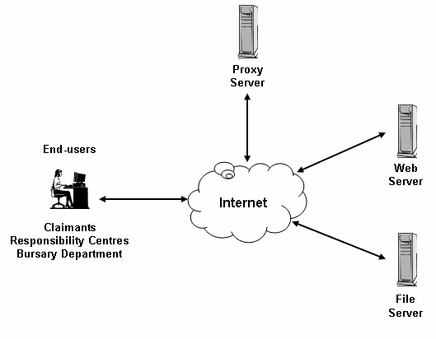
图2 基于网络的报销系统架构
2、用户界面
用户界面为最终用户提供图形用户界面（GUI）以访问基于Web的报销系统。图3显示了三个不同终端用户子系统的用户界面图。
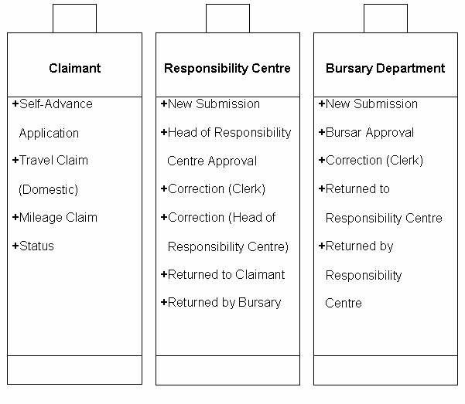
图3 用户子系统端用户界面图
3、工作流程
工作流程设计是设计一个包含一系列过程步骤和命令的图表，来表现产生期望结果的步骤^{[2]}。在基于网络的报销系统中，流程是三种形式的流程，即自主提交申请，旅行和里程报销。
首先，用户必须选择要执行的任务。一旦任务开始，该过程必须在一个完整的循环中结束。如果用户由于无法遵守而被卡在整个过程的某处，则用户可以继续该过程，或者在用户可以继续进行之前纠正当前阶段的问题。如果用户未能识别和纠正问题，则用户必须返回到初始阶段并重新开始。
工作流程图是以符号的方式设计的，即矩形表示处理，菱形表示决策制定（if-else语句）。
尽管有三种形式正在处理中，实际上只有两种处理流程。自助提前申请流程图如图4所示，而旅行和里程申请由于共享相同的流程而组合在一起，如图5所示。
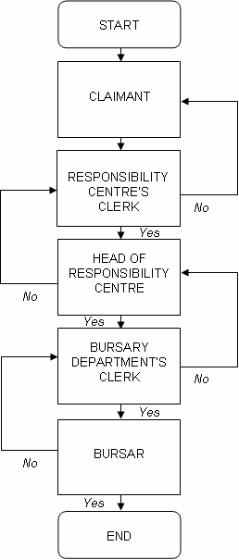
图4 自助提交应用程序流程图
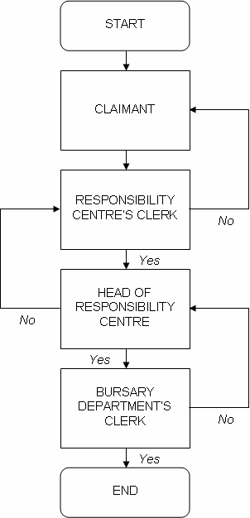
图5 旅行和里程报销流程图
4、数据流
数据流图（DFD）是一个图形表示，描述了通过系统的数据流以及由该系统执行的任务或过程^{[3]}。对于基于网络的报销系统，数据流是三个不同级别用户（即报销人，各部门和助理部门）的表格流程，它们在处理每种表格时都有其自身的功能。
该图以许多符号表示系统的方式进行设计。大多数数据流建模方法使用四种符号来表示四种系统组件^{[3]}。表示组件的符号是圆圈表示进程;矩形代表外部实体;中间有一条线的矩形表示数据存储区;最后箭头代表数据流^{[4]}。以数据流图的形式描绘了一个图表，其中要记录的信息被绘制成图。在这种情况下，有三种不同级别的用户可以使用表单进行处理并记录系统内每个级别的信息。系统的数据流图如图6所示。
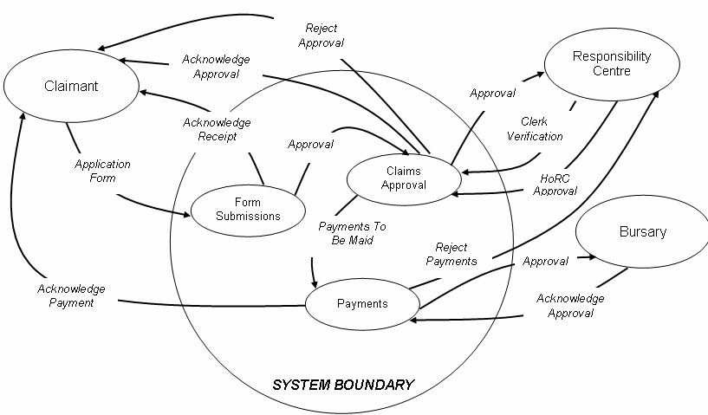
图6基于Web的报销系统数据流图
5、数据库
在这次学术演习中，用于开发此系统的数据库是Microsoft Access，它允许存储数据，其中所有用户的身份和密码都保存在内部。除工作人员的个人信息数据库外，还包含所有工作人员应享权利的数据库。如果将来马来西亚财政部修改有关报销的权利或任何其他指令，只需更改各个部分即可轻松更新或修改。数据修改过程不会影响已保存信息的其他部分。数据库还允许插入和存储所有声明的信息。

六、编码
计算机编程通常缩写为编程或编码系统，是编写，测试，调试或故障排除以及维护计算机程序源代码的过程。没有这些，系统不是一个系统，因为它根本没有任何功能，所以它被认为是系统的核心。
脚本写作由一系列代码组成，并按预期执行。作为系统开发人员或程序员，可以按照他们想要的方式执行脚本，根据需要考虑系统的最终用户规范和要求。这个框架将在ASP中实现，ASP是前面提到的一种Web编程语言。
一旦系统插入编码，它必须进行运行和测试，以确保它处于正常工作状态，并按照最终用户的意图执行。如果编码中有任何错误，则必须进行调试或排除故障，以找出导致错误的线路。程序员必须通过再次执行整个测试过程来确定并修复错误，以确保错误修正。

七、结果
该系统是通过应用一个应用程序和一些Web编程语言以及上一章所述的方法开发的。已经使用了必要的工具来使系统对用户友好，以便用户在使用该系统时不会有困难。该研究涵盖了操纵用户的所有基本特征，并使他们能够提交他们的主张，而不必担心除旅行信息之外的其他事项，因为该系统将处理所有其他任务。
此外，研究人员还将数据库与ASP整合在一起，以便系统执行一项任务，例如数据库根据其工资为系统提供员工权利。在系统从数据库中提取信息之后，它能够进行自动计算，从而该过程已经在ASP中编程。
上面提到的GUI，研究人员曾使用Microsoft FrontPage来设计和开发其所有的屏幕布局，颜色，按钮等。所有必要的工具都被用于构建系统的视图，这是为了不使用户的视力变得简单色彩太多或屏幕不清晰。图7和图8显示了已捕获的系统主屏幕的屏幕截图。
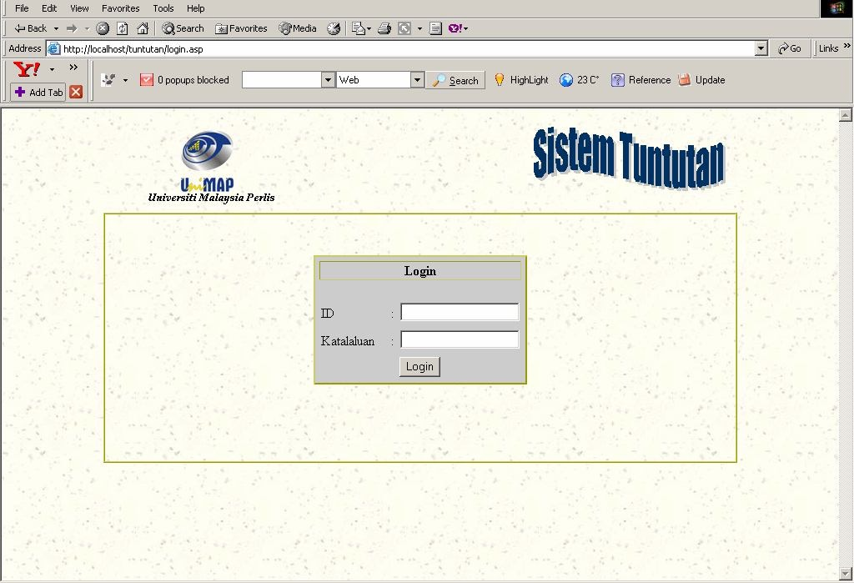
图7 登入界面

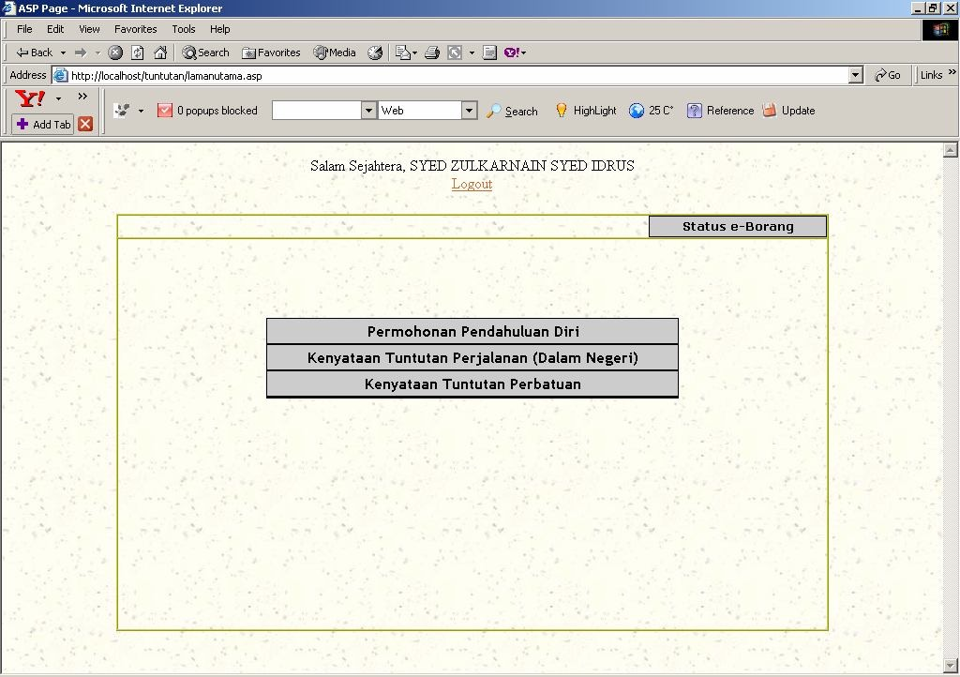
图8 主界面
系统完成后，进行测试以确定系统的有效性和准确性。前面已经提到，只有30套手动旅行和里程报销已经用于测试。表1中的结果显示了与计算机化系统相符的手册形式的数量。
表1 手动报销测试
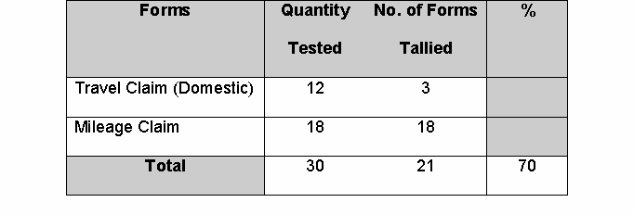
已经分析了基于表1的结果，发现总体结果是70％正确的报销。 但是，“里程报销”设法实现了100％修正，即超过18次。从研究人员的观察，“里程报销”似乎是一个直截了当的主张，因此每个报销人都获得了他或她的权利。在这种情况下，它不涉及用餐和/或每日津贴。因此，只要求里程报销。
另一方面，旅行报销只有25％的正确率，即超过12的3％。这种特殊情况被认为是棘手的，因为它涉及各种应享权利，例如用餐或每日津贴; 酒店或住宿津贴，如果已经给予早餐或午餐或晚餐，则分别从膳食津贴中扣除20％，40％或40％。最重要的是，报销人还可以报销里程数，不论是否收到实际支出。

八、结论
这项研究的概念化是为了发现一种方法或一种工具，可以取代传统的填写表格的方法，每次工作人员必须执行公务或出席课程。如前所述，这项研究的主要目标是取消行政官僚机构并采用能够以有效的方式执行相同功能的计算机系统，从而快速，准确和无人为错误。
无疑已经开发的基于网络的报销系统已被证明可以按照预期的方式运作。经过测试并与经过传统方法的模拟声明相比较，总体结果非常惊人。从已经过测试的模拟样本中，系统获得了30％的手工报销，这些报销存在某种错误。很明显，这些并不是由于系统的不准确性造成的，而实际上是由于目前人工报销做法中的人为错误造成的。因此，该系统能够检测并克服缺陷^{[5]}。
这些错误可能是由于报销人没有意识到他们有资格在马来西亚财政通告中存在，报销人在总部以外执行超过8小时但不到24小时的公务，有权要求获得日津贴遵循膳食津贴津贴的一半。报销人看到在餐费和日津贴之间出现混淆。
如果系统处理的报销要比通过传统的手动方法处理速度更快，效率更高，那么这种情况就不会发生，因此系统可以节省大量时间。因此，本研究开始时确定的其他主要目标已经实现。
外文文献的原稿
Abstract–The main purpose of this study is to develop a computer system for University Malaysia Perlis (UniMAP) staff to make claims via electronic media. Since this system is Web-based, staff can make claims anywhere, anytime and at any locations. This method can overcome not only human errors but also more efficient, fast and accurate. Therefore, this system can also save time, effort, and administrative costs. In this study, Active Server Pages (ASP) has been chosen to make the calculation and also to generate reports. After the system has been developed, a test was conducted using forms that have been simulated manually. The purpose is to enable the researcher to make comparison with the ones made using the developed system in order to detect errors or flaws from the manual simulation in the system.

Keywords-system development; web application; ASP; online claims; computerised manual system.

I. INTRODUCTION
The advent of computer technologies have revolutionised our life in many ways. It is no longer the monopoly of the elite class, but also has reached the masses. For the haves, they may posses their own personal computers, but for the have-nots there are various ways that they can feel the touch of the computer systems such as Internet and e-mails at designated places. For some, this is the time to make lucrative business of hiring them according to hours.
The impact from this explosion of new scientific knowledge in the form of computer technologies have altered the way we learn; the way we think; the way we communicate and many other behavioural traits that are completely different from the earlier generations. Thus, computer literacy is fast growing among our young citizens.
Even children as early as Primary schools have been exposed to computer systems, whereby the education authorities and Parent-Teacher Associations (PTAs) have provided them with computer laboratories under the schools’ computer clubs. Computer literacy now has reached an unprecedented height and has gone far beyond the boundaries of urban areas into the rural areas. In short, it will become our way of life and for those who are still computer illiterate, will feel themselves out of place in this changing world. Such is the influence and significance of computer systems for the present generation and the next ad infinitum.
At the work place, computer systems are overwhelmingly essential that they cannot do without.
No organisations can afford to lag behind with the development and progress of computer technologies. They have no choice but to keep up with it sooner or later. In fact, very soon it can be predicted that administrative bureaucracies will become things of the past and ultimately be replaced by computer systems.
This study is meant to develop a Web-based Claims system for Universiti Malaysia Perlis (UniMAP) staff who have to perform duties outstation or attending courses directed by UniMAP authorities. Currently, all claims have to be made manually by filling up the claim forms by the claimants. This is a very tedious process and time consuming. It is not unusual for the claimants that they have to refer to the Treasury Circulars Malaysia to check on their entitlements that they are unsure of each time they have to make claims.

II. CONCEPTUAL FRAMEWORK
Under the present manual claims system, the claim forms will have to be filled up and travelled back and forth to the Bursary Department through the substation of Responsibility Centres. By doing it online, the claimants can execute it from anywhere and at anytime. The advantages of online claims are many and among them are to do away with administrative bureaucracies, avoiding human errors and unnecessary delays.
By means of the Web-based Claims system, UniMAP Bursary Department is able to control and monitor any self-advance payments made to the claimants from the same account. This can be done with ease by clicking the right key as compared to the present manual system of going though piles of claim forms. One other objective related to the above is that the system is able to pick up from the list of outstanding self-advance made to the claimants.
One other important purpose of Web-based Claims system is to pick up more than one claim within the same month. For instance, if a staff goes outstation at the beginning of the month, then comes back and submits the claim immediately, the claim then goes for processing. Later, the staff may be ask to make another trip by another authority, say middle of the month or perhaps end of the month, comes back and submits another claim. At this point, the staff would have two claims submitted within the same month. This mistake whether deliberate or otherwise, renders the claim as dubious particularly when it comes to claiming for mileage exceeding 500 kilometres. Under our financial regulations, vis-à-vis the mileage claims, for the first 500, 501 to 1000, 1001 to 1700 and 1701 and above, the staff entitlement rate cents per kilometre is in descending order. This system is able to accumulate automatically the distance and display the entitlement cents per kilometre rates accordingly.
If the claimants take any advances for going outstation, the system is able to deduct the amount taken from the actual claims made provided the claimants insert the dates travelled as dates applied for the trip. In this case, the objective is to help lessen the burden of the person processing the claims.

III. METHODOLOGY
In any system development, the methodology is very important as to ensure that descriptions of the steps taken are in coherent manner. This is known as Systems Development Life Cycle (SDLC) and often referred to as the waterfall model and linear cycle. The reason it is referred to as the waterfall model is very much obvious as illustrated in Fig. 1 ^{[1]}.

Fig. 1 The Waterfall Model of the Software Life Cycle
The methodology SDLC is closely connected with what is known as structured systems analysis and design. It involves series of steps to be undertaken in the development of information systems as follows: -
- Problem Definition (Problem Statement)
Upon receiving a request from the user for systems development, a study is carried out to identify the problem to be solved.
- Feasibility Study (Feasibility Report)
The main objective of this part is to clearly define the scope and objectives of the systems project and to identify alternative solutions to the problem defined earlier.
- Systems Analysis Phase (Specifications of the Present System)
Examine the current system and to document its specifications. It should contain the understanding of HOW the present system works and WHAT it does.
- Systems Design Phase (Specifications of the Proposed System)
The specifications of the current system are studied to determine what changes will be needed to incorporate the user needs, which have not been met by the system presently. The output of this phase will consist of the new specifications, which must describe both WHAT the proposed system will do and HOW it will work.
- Systems Construction (Programs, Their Documentation and User Manuals)
Programming the system and produce the user as well as the program documentations for the system.
- System Testing and Evaluation (Test and Evaluation Results, and the System Ready to be Delivered to the User / Client)
Testing, verification and validation of the system just built.

IV. USER REQUIREMENTS ANALYSIS
In any systems development, the first step is to analyse the user requirements in order to understand and document their specifications or requirements. In the case of the Web-based Claims system development, the researcher surveyed some of UniMAP’s staff for the purpose of carrying out the user requirements analysis. This is followed by collections of data towards the acquisition of all the information deemed necessary by UniMAP.
Despite the existence of Treasury Circulars from the Ministry of Finance, Malaysia and the procedures that had already been imposed, there could be other requirements peculiar to UniMAP that users need to be able to do. Under such circumstances, users must provide the specifications required. If necessary, adjustments will be made to the system in order to comply with user requirements and specifications.

V. SYSTEM DESIGNS
System development is the major part of this study and it is also the crux of this study. Prior to the commencement of its development, the clarity of user requirements must be first established. Therefore, the results of the analysis of user requirements and specifications must be given due considerations and top priority. In this study, the development of the system consists of designing the Architecture; the User Interface; the Process Flow Diagrams; Data Flow Diagrams and Database.
A. Architectural
The Web-based Claims system consists of three sub- systems. There is a sub-system for the end-user namely Claimants that enables users to login to the online servers; apply for self-advances; submit travel and mileage claims in a Web-based environment. The other two sub-systems are for the end-users namely Responsibility Centres and Bursary Department, which are mainly for processing the online forms submitted.
There are three servers within the system namely Proxy Server, Web Server and File Server. The following describe each of the server’s specific functions in which they perform: -
- Proxy Server
The Proxy Server is where the Internet gets its connection. Hence, without it, the entire network in an organisation will not be able to access the Internet.
- Web Server
The Web Server is where the websites are hosted. It provides the necessary Web space for a website to be sited.
- File Server
The File Server is where data of information is stored. It can be in a form of documents, databases, images, audios, etc. Fig. 2 illustrates the architecture of the Web-based Claims system.
Fig. 2 Web-based Claims System Architecture
B. User Interface
The user interface provides the end-users with a Graphical User Interface (GUI) to access the Web-based Claims system. Fig. 3 illustrates the diagram of the user interface for three different end-users sub-system.
Fig. 3 End-users Sub-systems User Interface Diagram
C. Process Flow
The Process Flow Design is the designing of a diagram with a set of process steps and order for performing the process steps to produce a desired result^{[2]}. In the case of the Web-based Claims system, the process flow is the flow of the three forms namely Self-Advance Application, Travel and Mileage Claims.
Firstly, the user must select a task in which to perform. Once a task has started, the process must end in one complete loop. If the user is stuck somewhere along the process due to the inability to comply, the user can either start the process from the beginning or rectify the problem(s) of the current stage before the user can proceed any further. If the user fails to identify and rectify the problem(s), the user then must return to the initial stage and begin all over again.
The Process Flow diagram has been designed in the manner of symbols namely rectangle represents processing and the diamond shape represents decision- making (an if-else statement).
Even though, there are three forms that are being processed, in actual fact, there are only two process flows. The Self-Advance Application process flow diagram is illustrated in Fig. 4, whereas the Travel and Mileage Claims are combined because they share the same process flow and this is illustrated in Fig. 5.
Fig. 4 Self-Advance Application Process Flow Diagram
Fig. 5 Travel and Mileage Claims Process Flow Diagram
D. Data Flow
The Data Flow Diagram (DFD) is a graphical representation that depicts the flow of data through a system and the tasks or processes performed by that system ^{[3]}. In the case of the Web-based Claims system, the data flow is the flow of forms at three different levels of users namely the Claimant, the Responsibility Centres and the Bursary Department with its own functionalities in processing each form.
The diagram has been designed in the manner in a number of symbols to represent systems. Most data flow modelling methods use four kinds of symbols to represent four kinds of system components ^{[3]}. The symbols that represent the components are namely circle represents processes; rectangle represents external entities; rectangle with a line in between represents data storages; and finally arrows represent data flows.
^{[4]} illustrated a diagram for which an information to be recorded is sketched in a form of a data flow diagram. In this case, there are three different levels of users with forms that can be processed and recorded information with for each level within the system. The system’s data flow diagram is illustrated in Fig. 6.
Fig. 6 Web-based Claims System Data Flow Diagram
E. Database
For this academic exercise, the database to be used in the development of this system is the Microsoft Access that enables to store data, where all users’ identification and password details are kept inside. Apart from the staff’s personal information database, it also contains the database of all the staff’s entitlements. If in future, should the Ministry of Finance, Malaysia revise the entitlements or any other directives pertaining to claims, it can be updated or amended easily by just changing the respective parts. This process of data amendments will not affect other parts of the information that have been kept. The database also allows all claims’ information to be inserted and stored.

VI. CODING
Computer programming, which is often shortened to programming or coding of a system, is the process of writing, testing, debugging or troubleshooting and maintaining the source code of computer programmes. Without all these, a system is not a system, as it will not have any functionality at all, therefore it is considered as the core of the system.
The script writing consists of series of codes in lines and will perform as intended. As a system developer or programmer, taking into consideration of the end-user specifications and requirements of a system as desired by executing scripts the way they wanted it. The framework for this will be implemented in ASP, which is a Web programming language that had been mentioned earlier.
Once the system has been inserted with the coding, it has to be run and tested to make sure that it is in working order and performs as the end-users’ intention. Should there be any error(s) in the coding, it must then be debugs or troubleshoot in order to find out which are the line(s) that are causing the error(s). The programmer must identify and fix the error(s) by performing the whole testing process once again to ensure that it is error-free.

VII. RESULTS
The system has been developed by applying an application and some of the Web programming languages along with the methodology stated in the previous chapter. The necessary tools have been utilised in order to make to system user-friendly so that users will not have difficulties in using the system. The research has embraced all the essential features to manoeuvre users and enable them to submit their claims without having to worry about other matters besides their travelling information, as the system will handle all the other tasks.
Furthermore, the researcher has also integrated the database with ASP in order to enable the system to perform a task such as the database provides the system with staff entitlements based on their salary. After the system had extracted the information from the database, it was able to make automatic calculations, whereby the process has been programme in ASP.
The GUI as mentioned, which the researcher had used Microsoft FrontPage to design and develop all its screen layouts, colours, buttons etc. All the necessary tools had been used in building the system’s view was done with simplicity in order not to cloud users’ eyesight with too many colours or obscure screens. Fig. 7 and Fig. 8 illustrate the screenshots of the main screens of the system that have been captured.
Fig. 7 Login Screen
Fig. 8 Main Page
Once the system has been completed, a test was conducted in order to find out the validity and accuracy of the system. It has been mentioned earlier, only sets of 30 manual travel and mileage claims had been used for the testing. The result in Table 1 shows the number of manual forms that are tallied with the computerised system.
Table 1: Manual Claims Testing
The result that was based from Table 1 has been analysed and it was found to be that the overall result is 70% correct claims. However, Mileage Claim managed to achieve 100% corrects i.e. 18 over 18. From the researcher’s observation, Mileage Claim seems to be a straightforward claim, whereby each and every claimant got his or her entitlements correct. In this case, it does not involve in meal and/or daily allowances. Thus, merely claiming for the mileage claims.
Travel Claim on the other hand, achieved scantily of only 25% correct i.e. 3 over 12. This particular case is considered tricky as it involves various entitlements, such as meal and/or daily allowances; hotel and/or lodging allowances and if breakfast or lunch or dinner has been given, 20%, 40% or 40% will be deducted respectively from the meal allowance entitlement. On top of that, claimants can also claims for their mileage and with or without receipts of actual expenditure.

VIII. CONCLUSIONS
The conceptualisation of this study was to discover a method or an instrument that could replace the traditional method of filling up the forms each time when staff have to perform official duties outstation or attending courses. As stated earlier, the main objective of this study was to do away with administrative bureaucracies and adopt a computer system that could perform the same function in an efficient manner resulting in fast, accurate and free from human errors.
The Web-based Claims system that had been developed without doubt has been proven that it can function in the manner that had been expected. After going through the test and by comparison with simulated claims, which had gone through the traditional method, the overall result was quite astonishing. From the simulated samples that had been tested, the system picked up 30 % of the manual claims, which had mistakes of some sort. It was obvious that these were not due to the system’s inaccuracy, but in actual fact was due to human errors in the current practice of claiming manually. Hence, the system is able to detect and overcome flaws [5].
The errors could perhaps be due to the claimants’ unawareness of their entitlement of the existence in the Treasury Circulars Malaysia, claimant performing official duties outside Head Office for the duration of more than 8 hours but less than 24 hours is entitle to claim for Day Allowance following the rate of half of Meal Allowance entitlement. The claimants seen to be confused between meal and day allowance.
This could not have happened had the claims been processed by the system which is very much faster and more efficient than processing through the traditional manual method, hence the system save a lot of their time. Thus, the major objectives among others that have been set at the beginning of this study have been met.

