# Domino’s Pizza Picker

1. DB design [here on Google Drive](https://drive.google.com/file/d/1hKM_VXVuW0-Ze13YROwblyjxCo7SYP19/view?usp=sharing)
2. Pizzas table
   1. Columns:
      1. Id NVARCHAR(128)
         1. PK
      2. SauceId NVARCHAR(128) NOT NULL
         1. Relates to Id in topping table
      3. Topping1Id NVARCHAR(128) NOT NULL
         1. Relates to Id in Topping table
      4. Topping2Id NVARCHAR(128) NOT NULL
         1. Relates to Id in Topping table
      5. Topping3Id NVARCHAR(128) NOT NULL
         1. Relates to Id in Topping table
      6. Eaten BIT NOT NULL
         1. Whether or not pizza has been eaten
      7. DateEaten DATETIME
         1. Date pizza was eaten. Date default value if not eaten
      8. Rating REAL
      9. Comment NVARCHAR(MAX)
   2. The 3 topping columns cannot have the same topping twice
      1. This requires a CHECK constraint, which apparently can’t be done using code first in entity framework. One way to achieve this would be to use method outline here (<https://stackoverflow.com/questions/13232777/check-constraint-entity-framework>) that describes creating a migration and then adding a call to Sql() method in the Up() override that would define the constraint:  
           
         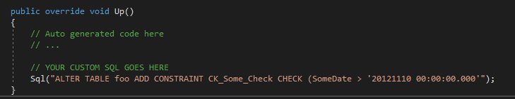
      2. Would want to use Topping1Id <> Topping2Id AND Topping1Id <> Topping3Id AND Topping2Id <> Topping3Id
      3. Also use the code to check this when adding a pizza
      4. Should probably just create the table(s) in SQL for using Data First instead
3. Sauces table
   1. Columns
      1. Id NVARCHAR(128) PRIMARY KEY
      2. Name NVARCHAR(30)
4. Toppings table
   1. Columns
      1. Id NVARCHAR(128) PRIMARY KEY
      2. Name NVARCHAR(30)
      3. IsMeat BIT NOT NULL
         1. Whether or not the topping is a meat
      4. IsCheese BIT NOT NULL
         1. Whether or not the topping is a cheese