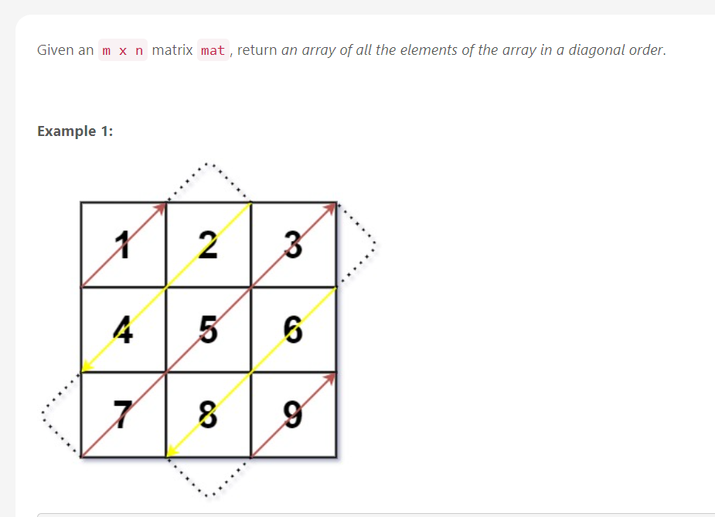

**Input:** mat = [[1,2,3],[4,5,6],[7,8,9]]

**Output:** [1,2,4,7,5,3,6,8,9]

**Example 2:**

**Input:** mat = [[1,2],[3,4]]

**Output:** [1,2,3,4]

// My First Solution

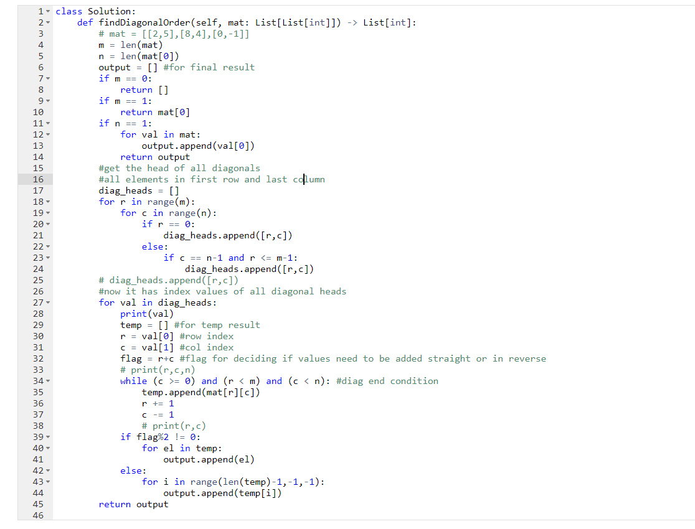

// My first medium submission

Result ->

|  |
| --- |
|  |
|  |

200 ms (77%)

17.7 mb (17%)

// Second Solution

// inspired, how to find diagonal heads

// cleaner solution, on next page

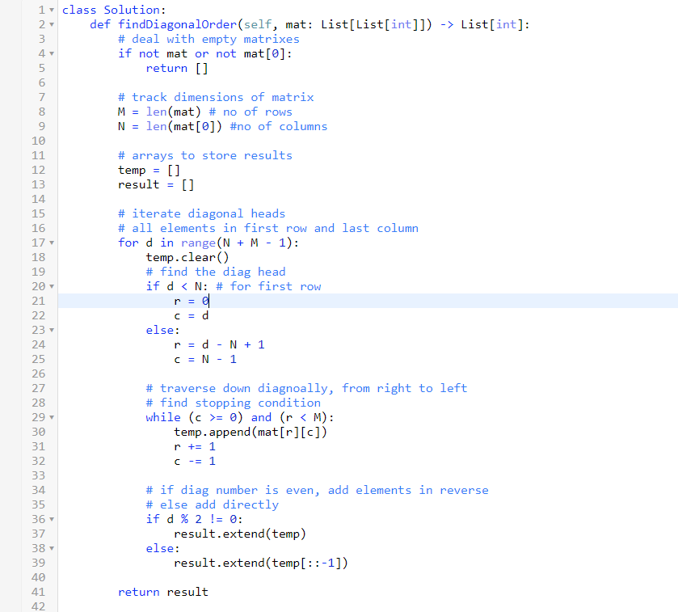

// Third solution, inspired by net, pretty smart trick

// code – self.

