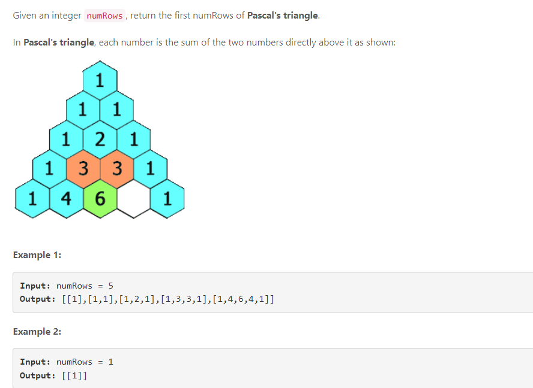

// My first solution

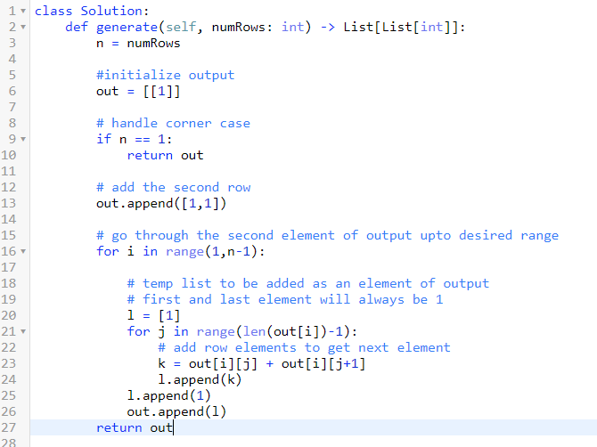

Result ->

**14 / 14** test cases passed.

Runtime: **35 ms (62%)**

Memory Usage: **13.9 MB (93%)**